Name: .......................................................................................... Index Number ……...………
School: ................................................................... Candidate’s Signature ……………………
Date…………………………

443/1
AGRICULTURE PAPER 1

March/April, 2023.
Time: 2 hours

AGRICULTURE PAPER 443/1

ARISE AND SHINE TRIAL EXAMINATIONS -2023
Kenya Certificate of Secondary Education (KCSE)

Instructions to Candidates
- Write your name, index number in the spaces provided.
- This paper has three sections A, B and C.
- Answer all the questions in section A and B in the spaces provided.
- Answer any two questions in section C.

For Examiner’s Use Only

SECTION | QUESTIONS | MAXIMUM  SCORE | CANDIDATE’S  SCORE
A | 1 – 13 | 30
B | 14 – 17 | 20
C | 18 | 20
 | 19 | 20
 | 20 | 20
 | Total Score | 90

SECTION A (30 MARKS)
Answer All the Questions in This Section in the Spaces Provided

- State two biotic factors that are useful in agricultural production. (1 mark)

............................................................................................................................................................
..........................................................................................................................................................
- Give four reasons why it is important to stake tomatoes. (2 marks)

............................................................................................................................................................
.......................................................................................................................................................................................................................................................................................................................
............................................................................................................................................................
- State two methods of utilizing sorghum as a forage crop. (1mark)

............................................................................................................................................................
............................................................................................................................................................
- Give four signs that could enable a farmer to identify compost manure that is ready (2 marks)
............................................................................................................................................................
...................................................................................................................................................................................................................................................................................................................................................................................................................................................................................
............................................................................................................................................................
- List four farming practices that may help to achieve minimum tillage on a farm. (2 marks)

................................................................................................................................................................................................................................................................................................................................................................................................................................................................................................................................................................................................................................................
- Give four reasons why seed selection is important in the establishment of crops. (2 marks)

...............................................................................................................................................................................................................................................................................................................................................................................................................................................................................................................................................................................................................................................
............................................................................................................................................................

- Give four reasons for keeping breeding records in a dairy farm. (2 marks)

............................................................................................................................................................
............................................................................................................................................................
.......................................................................................................................................................................................................................................................................................................................
- State two characteristics of shifting cultivation. (1 mark)
............................................................................................................................................................
...........................................................................................................................................................
- State four factors that determine spacing of crop. (2 marks)

............................................................................................................................................................
............................................................................................................................................................
............................................................................................................................................................
............................................................................................................................................................
- Differentiate between olericulture and pomoculture as used in crop production. (1 mark)

.......................................................................................................................................................................................................................................................................................................................
............................................................................................................................................................
............................................................................................................................................................
- State two characteristics of a large scale farming system. (2 marks)

............................................................................................................................................................
............................................................................................................................................................
............................................................................................................................................................
- State four steps followed in land adjudication. (2 marks)

...................................................................................................................................................................................................................................................................................................................................................................................................................................................................................
............................................................................................................................................................
- State two physical agents of weathering. (1 mark)

............................................................................................................................................................
............................................................................................................................................................

SECTION B (20 MARKS)
Answer All the Questions in the Spaces Provided

- The diagram below illustrates one of the arable field crops. Study it carefully and answer the questions that follow.
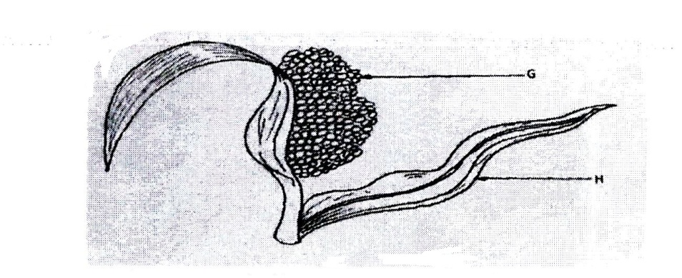
- Identify the field crop. (1 mark)
..........................................................................................................................................................
- State the common disease that attack the parts labeled G and H (2 marks)
G……………………………….……………….. H………………………………….……….

- Name a variety of the crop that is resistant to birds attack. (1 mark)
…………………………………………………………………………………………………….

- State one cultural method to control the diseases named in (b) above. (1 mark)
……………………………………………………………………………………………………

- (a) Name the deficient nutrient element in plants showing the following symptoms;
- Stunted growth, die back of the plant tips, leaves roll up and chlorosis along margins of younger leaves. (1 mark)
....................................................................................................................................................
- Yellowing of leaves appears first on lower leaves; leaves turn brown and fall prematurely, stunted growth. (1 mark)

......................................................................................................................................................

- Leaf curling, yellowing of leaves tips and edges of leaves scorched and has small mottles. (1 mark)
......................................................................................................................................................
- Purpling of leaves, stunted growth, slender stalks and lateral buds remain dormant. (1 mark)
......................................................................................................................................................

(b) The diagram below show a practice out on various crops on the farm. Study them carefully and answer the questions that follow.
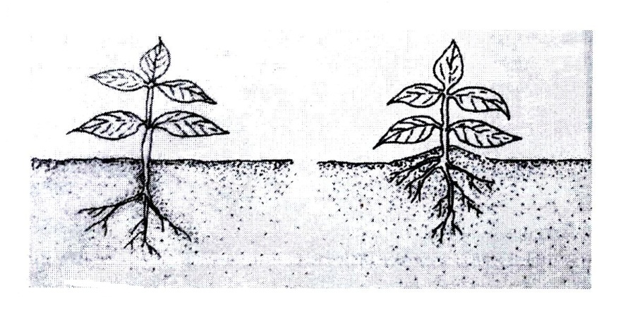
Identify the practice in the diagram above. (1 mark)
............................................................................................................................................................
- Diagram G and H below show some weeds.

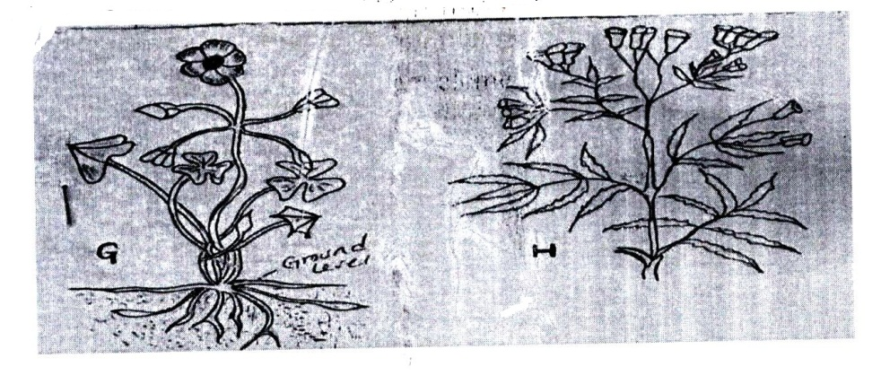
- Identify the weeds G and H. (2 marks)
G ..................................................................................................................................................
H....................................................................................................................................................
- State one economic importance of weed H (1 mark)
…………………………………………………………………………………………………
- Why is it difficult to control weed G? (1 mark)
…………………………………………………………………………………………………
- Name an example of a systematic herbicide which can be used to control weed G (1 mark)
…………………………………………………………………………………………………

- Study the structure below and answer the questions that follow.
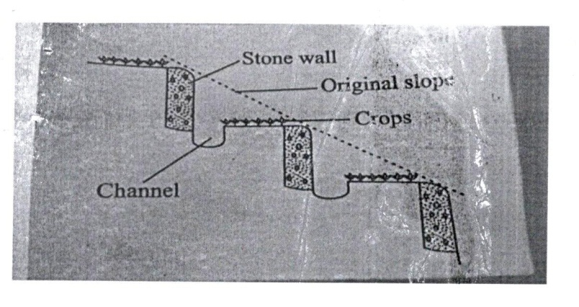
- Identify the type of terrace illustrated above (1 mark)
……………………………………………………………………………………………………..
- Under what two circumstances should the construction of the above terrace be justified?
………………………………………………………………………………………………………............................................................................................................................................................
- Name two other types of terraces.
………………………………………………………………………………………………………………………………………………………………………………………………………………

SECTION C (40 MARKS)
Answer Any Two Questions From This Section In The Spaces Provided.
- (a) Describe the production of tomatoes under the following;
- Transplanting. (5 marks)
- Field management practices. (5 marks)

(b) Give six advantages of drip irrigation. (6 marks)
(c) Describe the precautions a farmer should put into consideration when harvesting cotton. (4 marks)

- (a) Outline various ways through which vegetation cover reduces soil erosion. (4 marks)
(b) Outline various conditions which necessitate land clearing. (4 marks)
(c) Give six benefits of planting annual crops early. (6 marks)
(d) Describe six practices carried out in a vegetable nursery to ensure healthy seedlings at transplanting (6 marks)
- (a) Describe eight cultural methods of controlling diseases in crop production. (8 marks)
(b) Explain three ways in which biotic factors discourages agricultural production. (3 marks)
(c) State four effects of high temperature in crop production. (4 marks)
(d) Describe five ways through which a farmer can maintain soil fertility in his coffee farm. (5 marks)
………………………………………………………………………………………

………………………………………………………………………………………

………………………………………………………………………………………

………………………………………………………………………………………

………………………………………………………………………………………

………………………………………………………………………………………

………………………………………………………………………………………

………………………………………………………………………………………

………………………………………………………………………………………

………………………………………………………………………………………

………………………………………………………………………………………

………………………………………………………………………………………

………………………………………………………………………………………

………………………………………………………………………………………

………………………………………………………………………………………

………………………………………………………………………………………

……………………………………………………………………………………….

………………………………………………………………………………………………………

………………………………………………………………………………………………………

………………………………………………………………………………………

……………………………………………………………………………………
………………………………………………………………………………………

………………………………………………………………………………………

………………………………………………………………………………………

………………………………………………………………………………………

………………………………………………………………………………………

………………………………………………………………………………………

………………………………………………………………………………………

………………………………………………………………………………………

………………………………………………………………………………………

………………………………………………………………………………………

………………………………………………………………………………………

………………………………………………………………………………………

………………………………………………………………………………………

………………………………………………………………………………………

………………………………………………………………………………………

……………………………………………………………………………………….

………………………………………………………………………………………………………

………………………………………………………………………………………………………

………………………………………………………………………………………
……………………………………………………………………………………

………………………………………………………………………………………

………………………………………………………………………………………

………………………………………………………………………………………

………………………………………………………………………………………

………………………………………………………………………………………

………………………………………………………………………………………

………………………………………………………………………………………

………………………………………………………………………………………

………………………………………………………………………………………

………………………………………………………………………………………

………………………………………………………………………………………

………………………………………………………………………………………

………………………………………………………………………………………

………………………………………………………………………………………

………………………………………………………………………………………

……………………………………………………………………………………….

………………………………………………………………………………………………………

………………………………………………………………………………………………………

……………………………………………………………………………………

………………………………………………………………………………………

………………………………………………………………………………………

………………………………………………………………………………………

………………………………………………………………………………………

………………………………………………………………………………………

………………………………………………………………………………………

………………………………………………………………………………………

………………………………………………………………………………………

………………………………………………………………………………………

………………………………………………………………………………………

………………………………………………………………………………………

………………………………………………………………………………………

………………………………………………………………………………………

………………………………………………………………………………………

………………………………………………………………………………………

……………………………………………………………………………………….

………………………………………………………………………………………………………

………………………………………………………………………………………………………

………………………………………………………………………………………

……………………………………………………………………………………

………………………………………………………………………………………

………………………………………………………………………………………

………………………………………………………………………………………

………………………………………………………………………………………

………………………………………………………………………………………

………………………………………………………………………………………

………………………………………………………………………………………

………………………………………………………………………………………

………………………………………………………………………………………

………………………………………………………………………………………

………………………………………………………………………………………

………………………………………………………………………………………

………………………………………………………………………………………

………………………………………………………………………………………

………………………………………………………………………………………

……………………………………………………………………………………….

………………………………………………………………………………………………………

………………………………………………………………………………………………………

………………………………………………………………………………………
..……………………………………………………………………………………

………………………………………………………………………………………

………………………………………………………………………………………

………………………………………………………………………………………

………………………………………………………………………………………

………………………………………………………………………………………

………………………………………………………………………………………

………………………………………………………………………………………

………………………………………………………………………………………

………………………………………………………………………………………

………………………………………………………………………………………

………………………………………………………………………………………

………………………………………………………………………………………

………………………………………………………………………………………

………………………………………………………………………………………

………………………………………………………………………………………

………………………………………………………………………………………

………………………………………………………………………………………

………………………………………………………………………………………

………………………………………………………………………………………

………………………………………………………………………………………

………………………………………………………………………………………

………………………………………………………………………………………

………………………………………………………………………………………

………………………………………………………………………………………

