NAME: ……………………………………………………………………ADM NO: ……………….
DATE: ………………….

443/1
AGRICULTURE
FORM THREE
TIME: 2 HOURS

OPENER EXAMINATION TERM 3, 2022

INSTRUCTIONS TO CANDIDATES:
- This paper consists of three sections; A, B and C
- Answer ALL the questions in sections A, B and C
- All answers to be written in English

FOR OFFICIAL USE ONLY
SECTION | QUESTION | MAX. SCORE | CANDIDATE SCORE
A | 1 – 19 | 40
B | 20 – 25 | 30
C | 26 – 27 | 30
 | TOTAL | 100

SECTION A (40 MKS)
ANSWER ALL QUESTIONS IN THE SPACES PROVIDED
- Differentiate between apiculture and aquaculture in livestock production. (1 mk)
………………………………………………………………………………………………………………………………………………………………………………………………………….
- Give three reasons why primary cultivation should be done early before the onset of rains (3 mks)
………………………………………………………………………………………………………………………………………………………………………………………………………….………………………………………………………………………………………………………………………………………………………………………………………………………….

- State three benefits of possessing a land title deed (3 mks)
………………………………………………………………………………………………………………………………………………………………………………………………………….………………………………………………………………………………………………………………………………………………………………………………………………………….

- Name one exotic dairy cattle breed in Kenya which produces milk with
- Highest butter fat content ( ½ mk)

- Lowest butter fat content ( ½ mk)

- Give four reasons why burning of vegetation is discouraged as a method of land clearing. (2 mks)
………………………………………………………………………………………………………………………………………………………………………………………………………….………………………………………………………………………………………………………………………………………………………………………………………………………….

- State two reasons for tooth clipping in piglets. (1 mk)
………………………………………………………………………………………………………………………………………………………………………………………………………….

- Outline two methods of stocking a beehive ( 1mk) ………………………………………………………………………………………………………………………………………………………………………………………………………….

- Differentiate between flushing and steaming up. ( 2mks)
………………………………………………………………………………………………………………………………………………………………………………………………………….

- The table below shows gross margins of four crops that a farmer is deciding to grow.
CROP | GROSS MARGIN/HA
Cabbages | 25,000
Bananas | 16,000
French beans | 21,000
Kales | 10,000
- Which crop should the farmer grow? Give reason. (2 mks)

- What is the farmer’s opportunity cost? (1 mk)

- Outline four characteristics of the mother plant from which stem cuttings should be obtained. (2 mks)
………………………………………………………………………………………………………………………………………………………………………………………………………….
………………………………………………………………………………………………………………………………………………………………………………………………………….

- Give three reasons for seasoning timber. ( 1 ½ mks)
………………………………………………………………………………………………………………………………………………………………………………………………………….
………………………………………………………………………………………………………………………………………………………………………………………………………….

- a). State the gestation period of the livestock animals given below
- rabbit ( ½ mk)

- sow ( ½ mk )

b). Enumerate four disadvantages of natural mating. (2 mks)
………………………………………………………………………………………………………………………………………………………………………………………………………….
………………………………………………………………………………………………………………………………………………………………………………………………………….
………………………………………………………………………………………………………………………………………………………………………………………………………….

13. Describe how the following factors cause loss of soil fertility.
a). Leaching (1 mk)

b). Mono-cropping (1 mk)

14. A farmer was preparing concrete blocks by mixing ingredients in the ratio of 1:3:4. Name the ingredients represented by the numbers 1, 3 and 4. ( 1 ½ mks)

15. Outline two functions of a screen in a fishpond. (2mks)
………………………………………………………………………………………………………………………………………………………………………………………………………….
………………………………………………………………………………………………………………………………………………………………………………………………………….

16. Give three ways in which trees help in soil and water conservation. (3 mks)
………………………………………………………………………………………………………………………………………………………………………………………………………….
………………………………………………………………………………………………………………………………………………………………………………………………………….

17. List two biotic factors that affect livestock production in Kenya. (2mks)
………………………………………………………………………………………………………………………………………………………………………………………………………….

18. Name the function of the following parts in a poultry digestive system.
i. Crop (1mk)

ii. Gizzard (1mk)

19. Name the equipment used alongside each of the following
i. Trocar – (1mk)

ii. Bull – ring – (1 mk)

- Wood chisel – (1mk)

- Elastrator – (1mk)

SECTION B (30 MKS)
ANSWER ALL QUESTIONS IN THIS SECTION IN THE SPACES PROVIDED.

20. Below is a method of identifying a cow
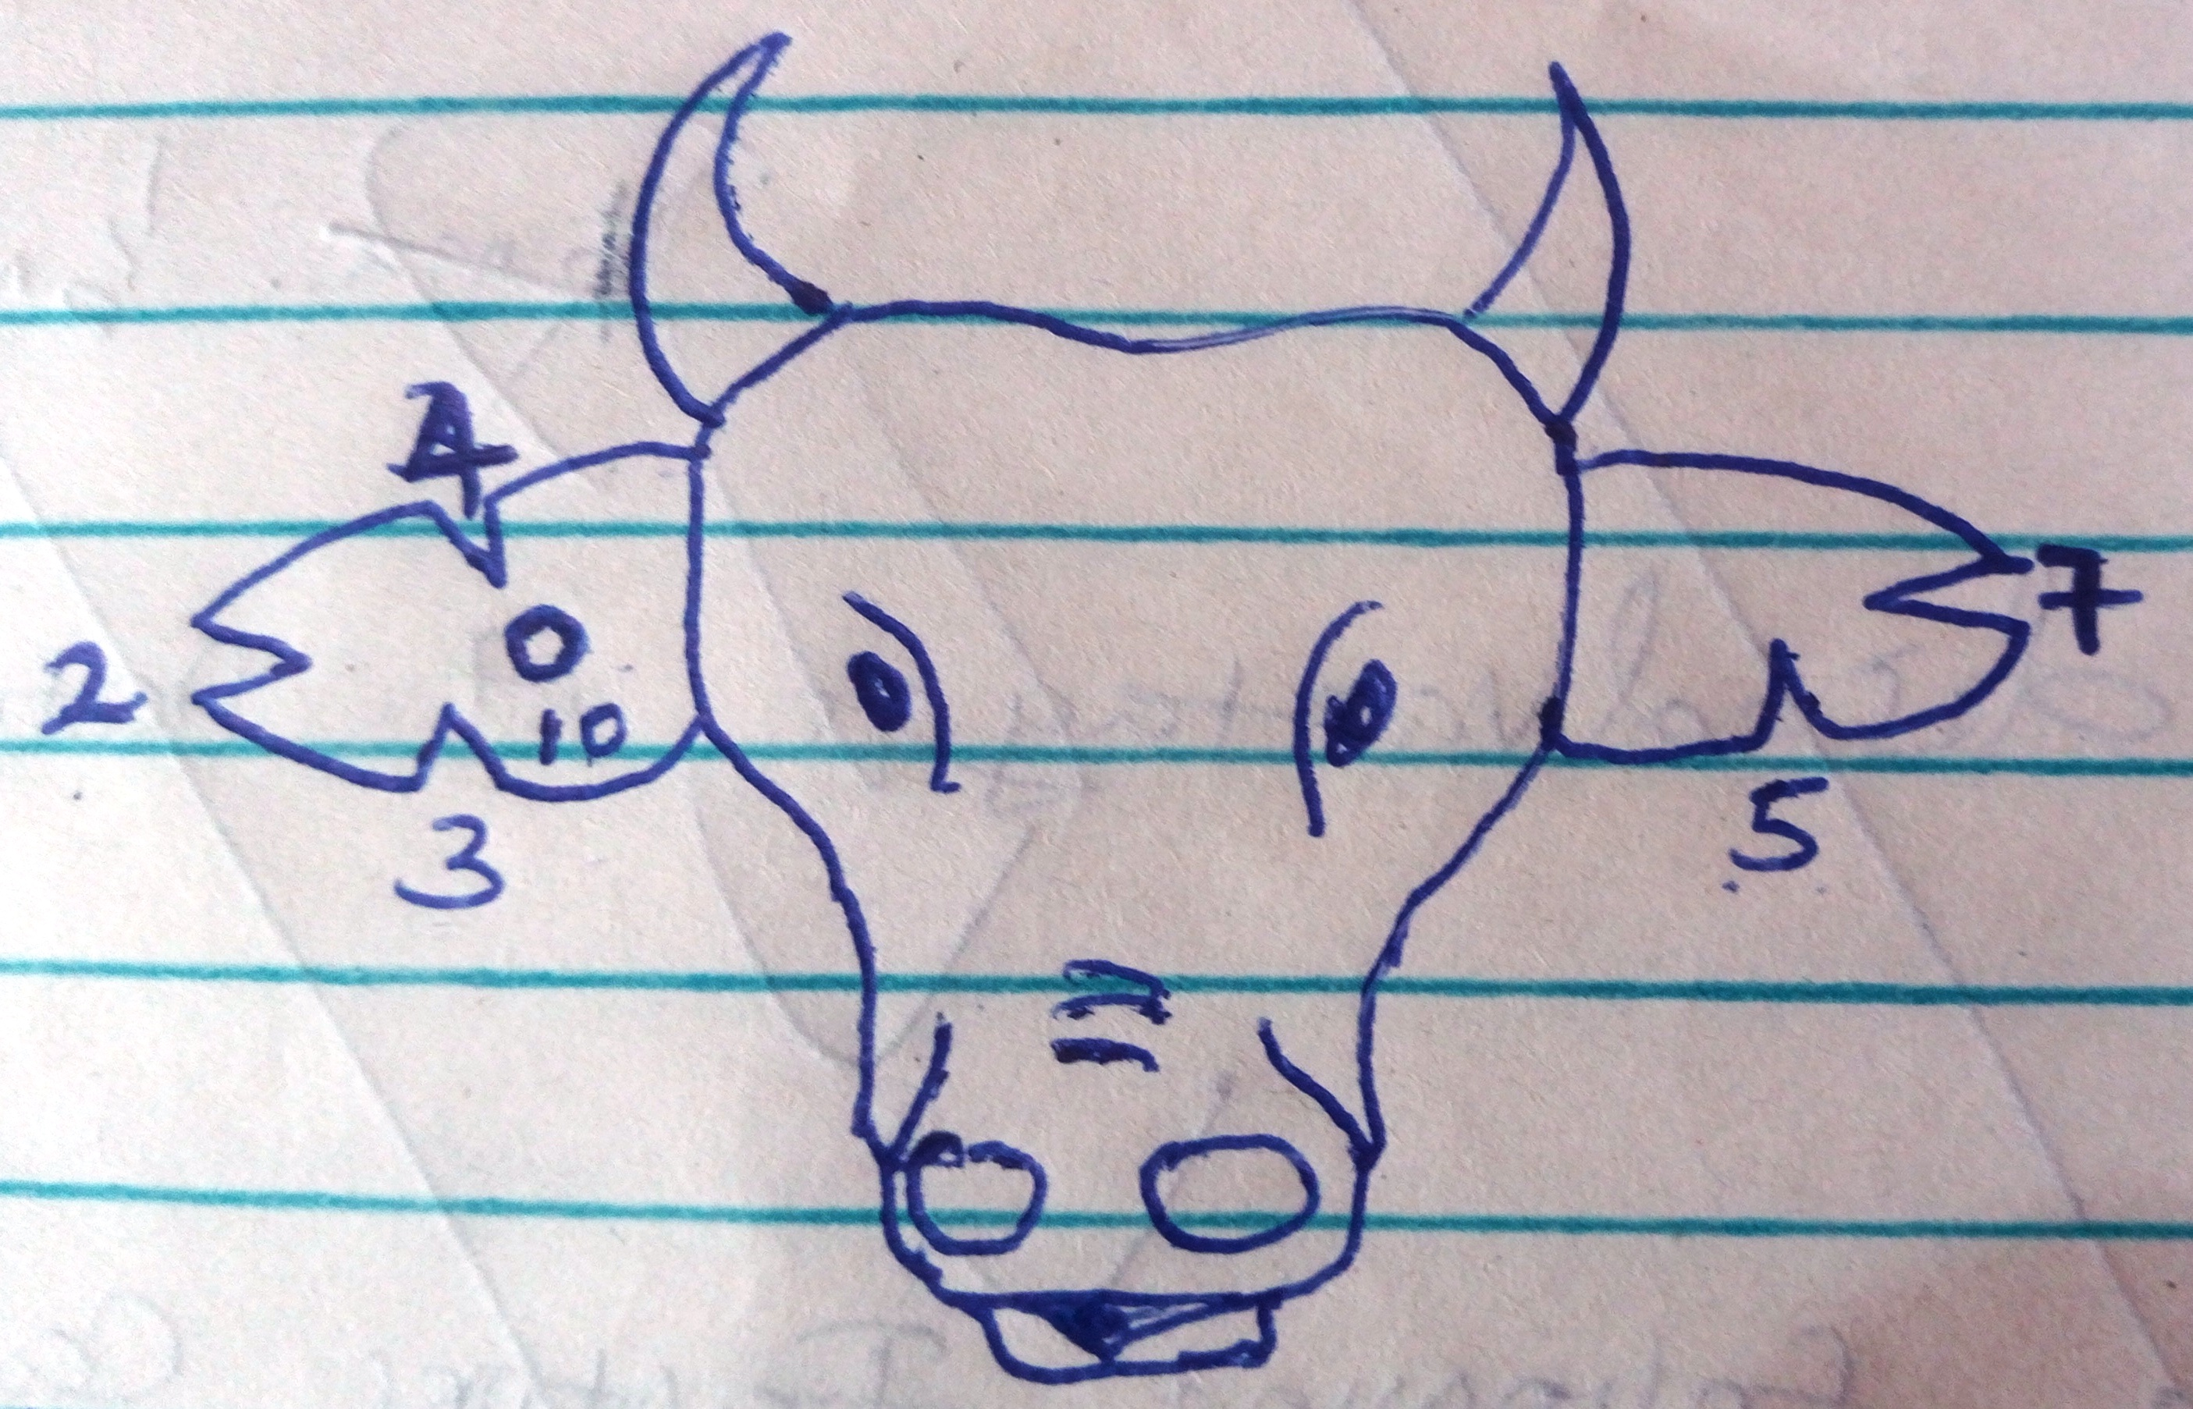

a). Name the method of identification. (1mk)

b). From the diagram, state the number of the animal. (1mk)

c). Using the diagram, illustrate how you would identify animal number 12 and 15. (2mks)

21. The diagram below illustrates various soil structures. Study them carefully and answer questions that follow.
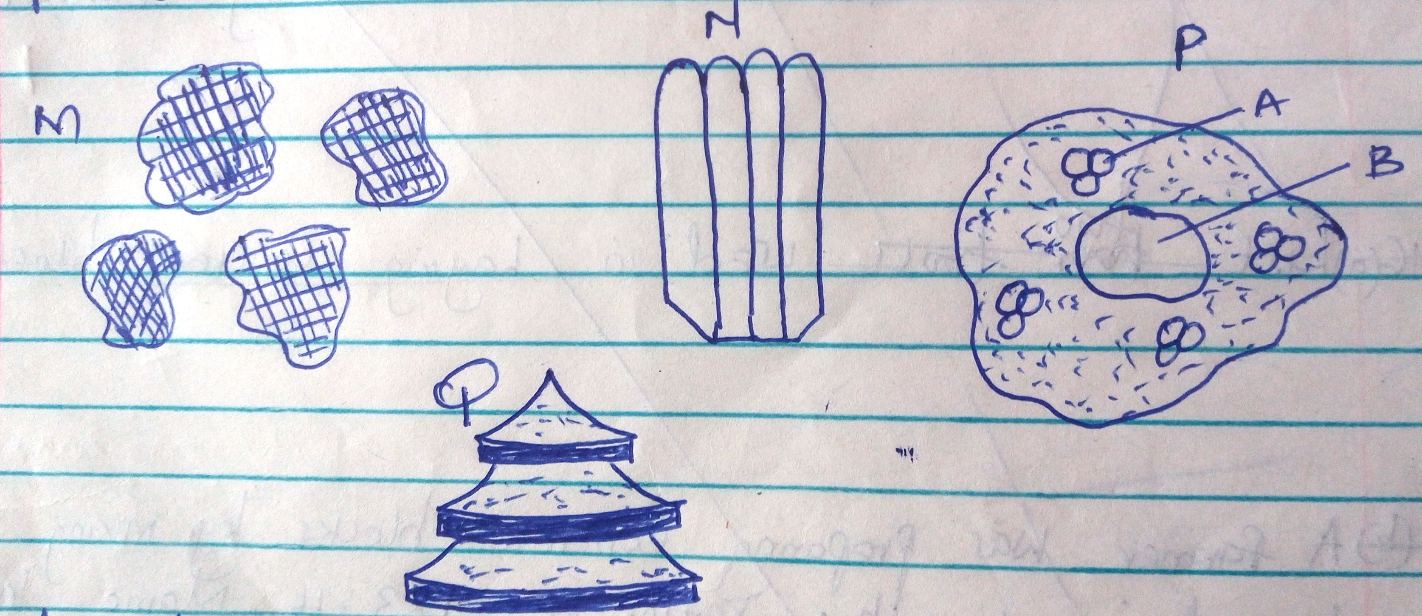

a). Name the type of soil structure labeled M, N, P and Q. (4mks)
M
N
P
Q

b). Name the parts labeled A and B in the soil structure labeled P. (2mks)

c). Describe two ways in which soil structure affects crop growth. (2mks)
………………………………………………………………………………………………………………………………………………………………………………………………………….
………………………………………………………………………………………………………………………………………………………………………………………………………….

22. The diagram below shows common farm weeds.
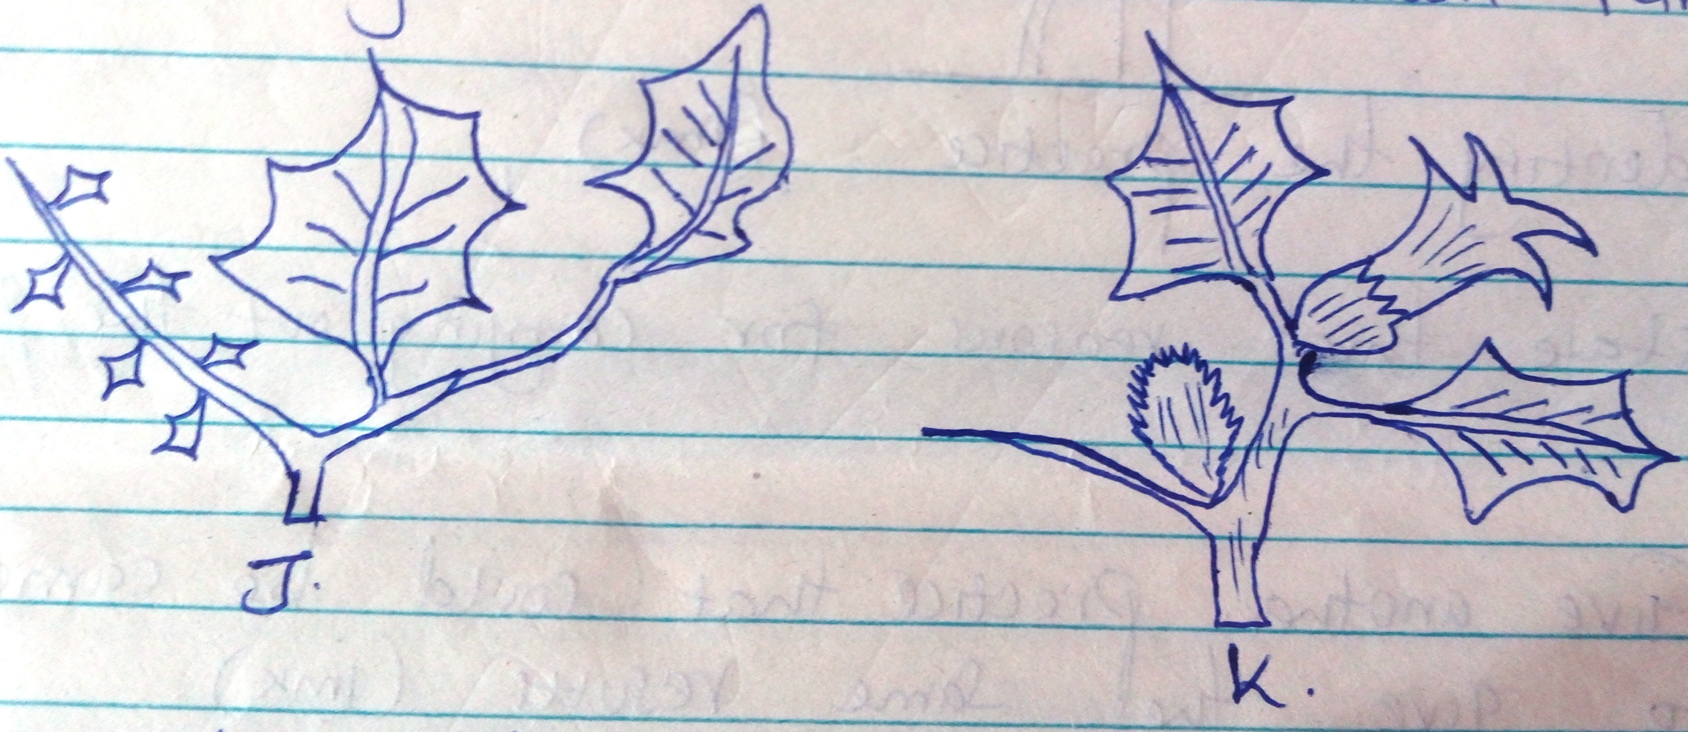

a). Identify the weeds labeled J and K. (2mks)
J
K

b). Classify weed J according to its life cycle. (1mk)

c). State one harmful effect of weed K to livestock. (1mk)

23. a). A fertilizer has the grade 10:5:15. What do the numbers 10, 5 and 15 represent? (3mks)

b). Calculate the amount of K₂O in 300kgs of a compound fertilizer 10:20:30. (2mks)

24. The diagram below illustrates a field management practice in tomatoes.

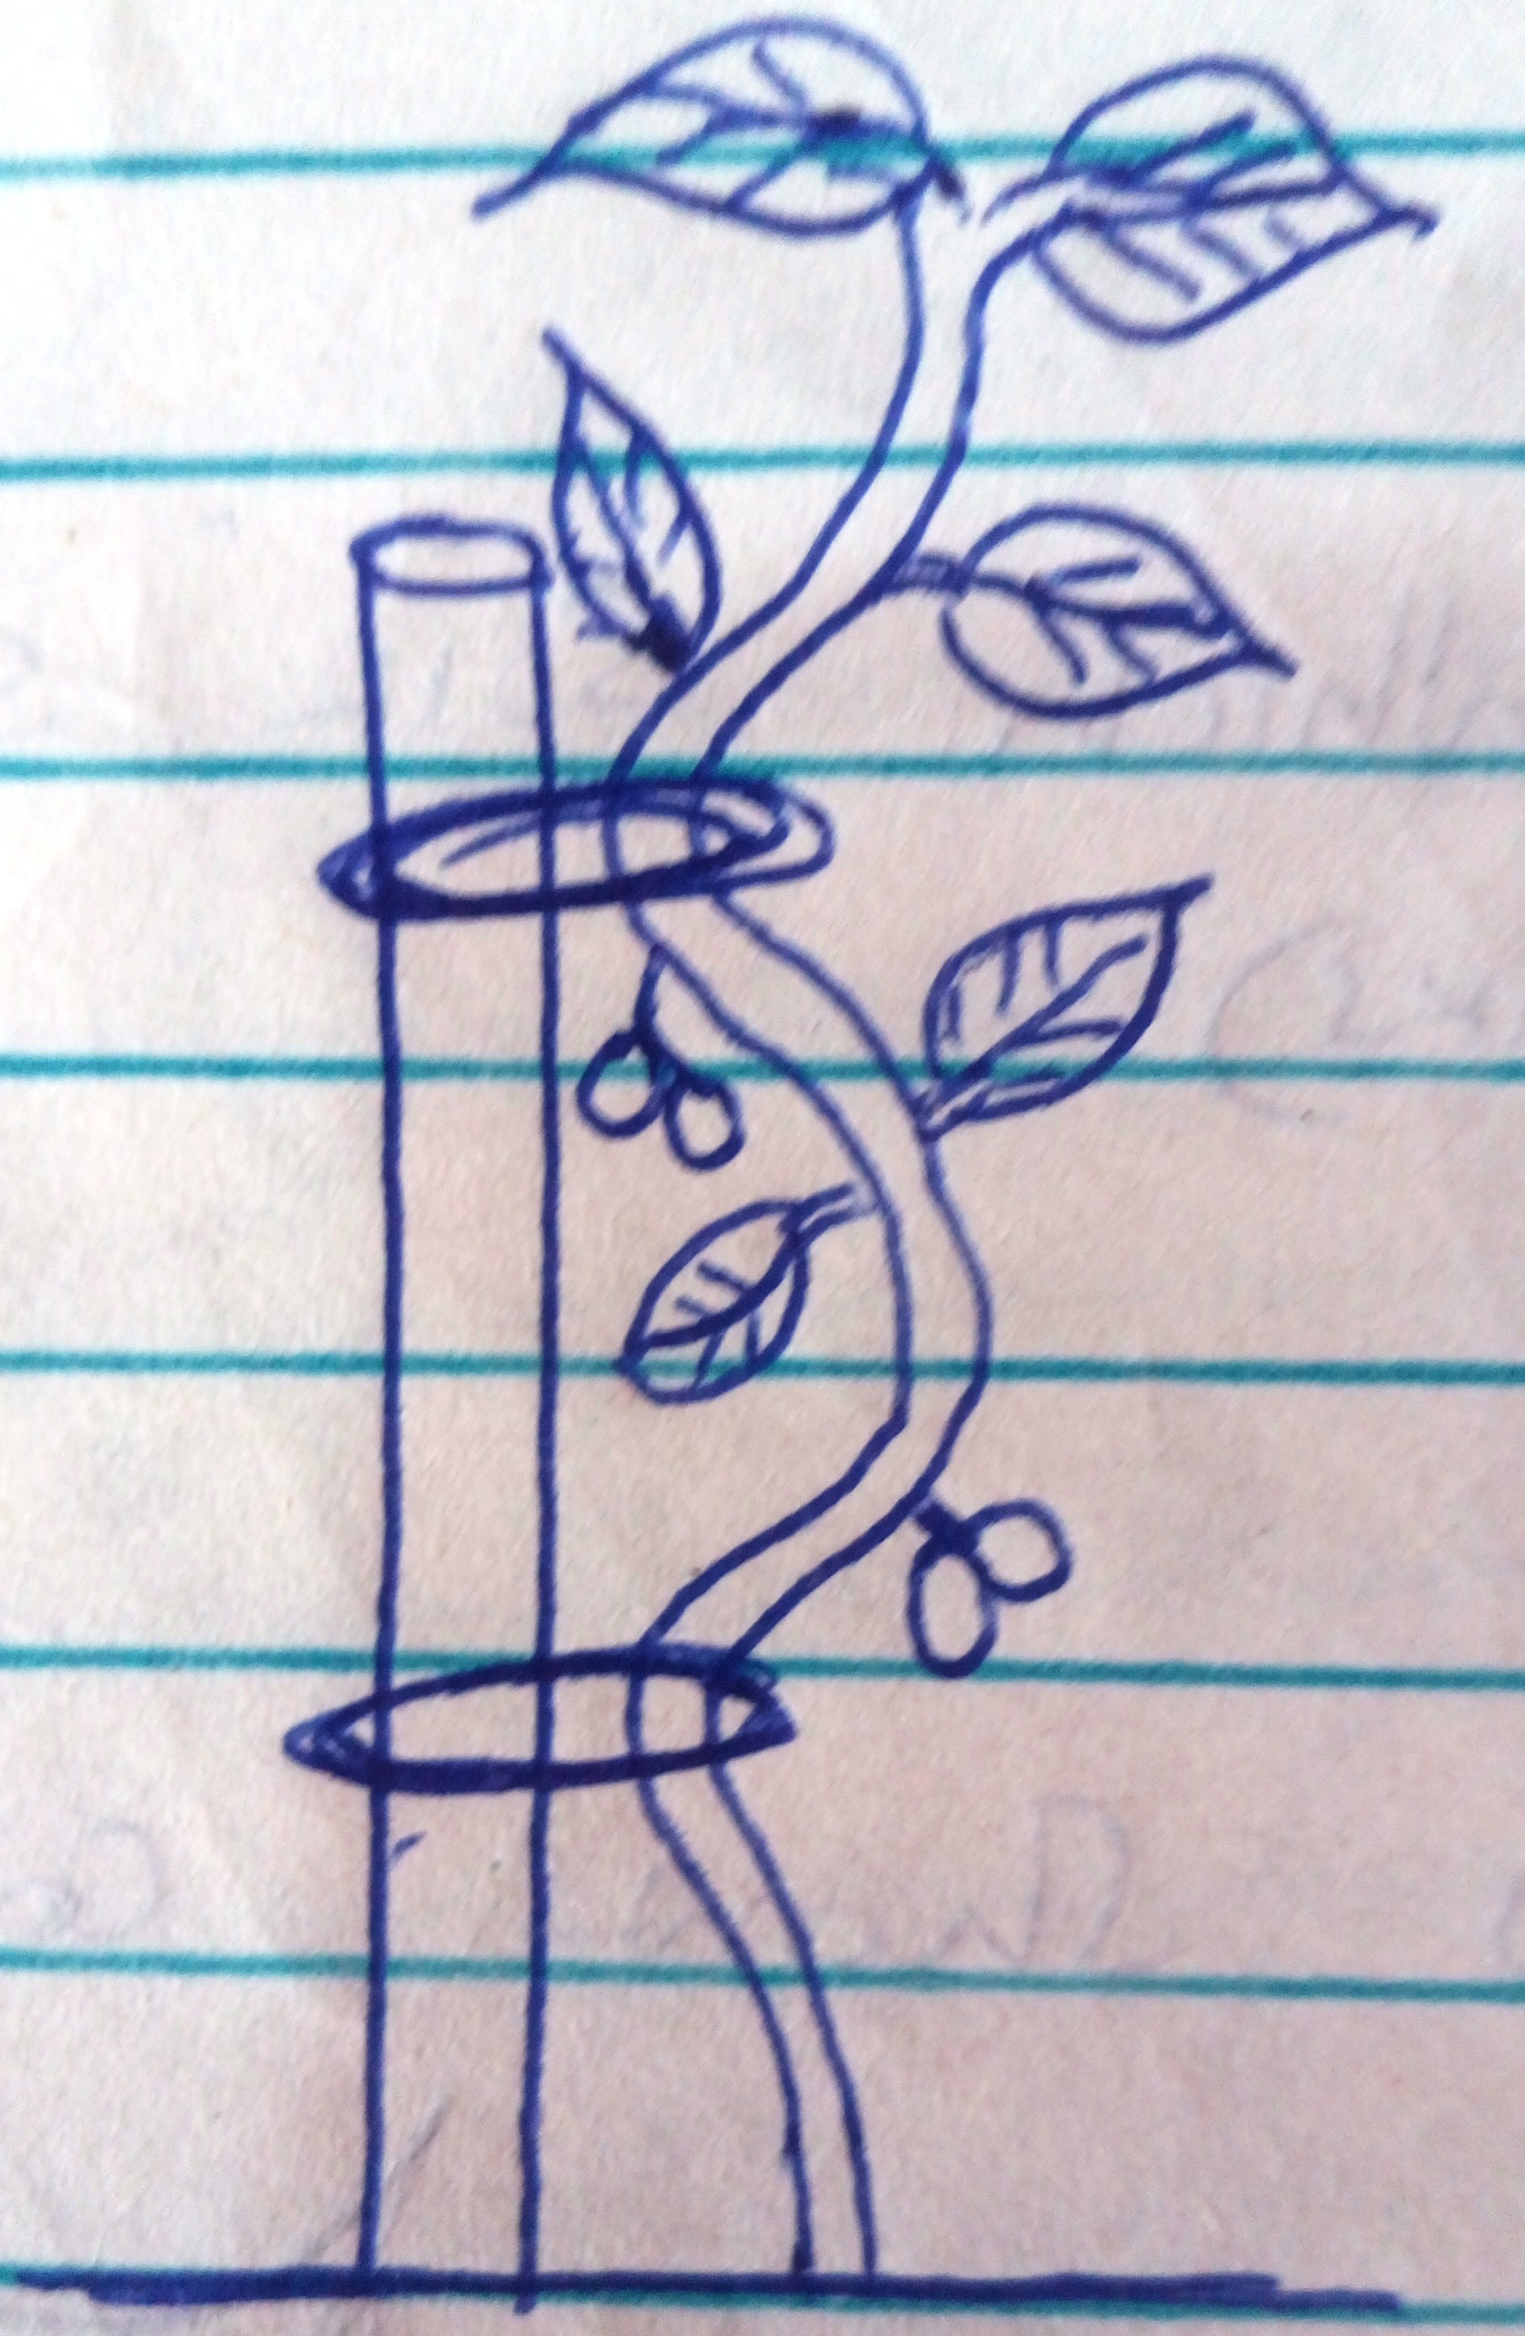

- Identify the practice. (1mk)

- State three reasons for carrying out the practice. (3mks)
………………………………………………………………………………………………………………………………………………………………………………………………………….
………………………………………………………………………………………………………………………………………………………………………………………………………….

- Give another practice that could be carried out to give the same results (1mk)

25. A dairy farmer wanted to prepare 200kgs of a calf rearing ration containing 20% DCP. The feedstuffs available were maize (10% DCP) and sunflower (35% DCP). Use the Pearson’s Square to calculate the amount of each feedstuff required. (show your working) (4mks)

SECTION C (30 MKS)
ANSWER ALL QUESTIONS IN THIS SECTION IN THE SPACES PROVIDED.
26. a). Explain the factors that influence soil erosion (5mks)
………………………………………………………………………………………………………………………………………………………………………………………………………….
………………………………………………………………………………………………………………………………………………………………………………………………………….
………………………………………………………………………………………………………………………………………………………………………………………………………….
………………………………………………………………………………………………………………………………………………………………………………………………………….

b). Describe the effects of strong wind in crop production. (5mks)
………………………………………………………………………………………………………………………………………………………………………………………………………….
………………………………………………………………………………………………………………………………………………………………………………………………………….
………………………………………………………………………………………………………………………………………………………………………………………………………….
………………………………………………………………………………………………………………………………………………………………………………………………………….
………………………………………………………………………………………………………………………………………………………………………………………………………….

c). Describe uses of water in the farm. (5mks)
………………………………………………………………………………………………………………………
………………………………………………………………………………………………………………………
………………………………………………………………………………………………………………………
………………………………………………………………………………………………………………………
………………………………………………………………………………………………………………………
………………………………………………………………………………………………………………………
………………………………………………………………………………………………………………………………………………………………………………………………………………………………………………

27. a). Describe the use of the following parts in a plunge dip
i. Collecting yard (1mk)

ii. Foot bath (2mks)
………………………………………………………………………………………………………………………………………………………………………………………………………….

iii. Roof/shelter (2mks)
………………………………………………………………………………………………………………………………………………………………………………………………………….

- Drying yard (1mk)

b). State four methods of breaking seed dormancy (4mks)
………………………………………………………………………………………………………………………………………………………………………………………………………….
………………………………………………………………………………………………………………………………………………………………………………………………………….
………………………………………………………………………………………………………………………

c). Describe transplanting of cabbage seedlings (5mks)
………………………………………………………………………………………………………………………………………………………………………………………………………………………………………………
………………………………………………………………………………………………………………………
………………………………………………………………………………………………………………………………………………………………………………………………………………………………………………
………………………………………………………………………………………………………………………
………………………………………………………………………………………………………………………

