APRIL HOLIDAY ASSIGNMENT 2023
AGRICULTURE FORM THREE
- The illustration below is a cross section of a cattle dip
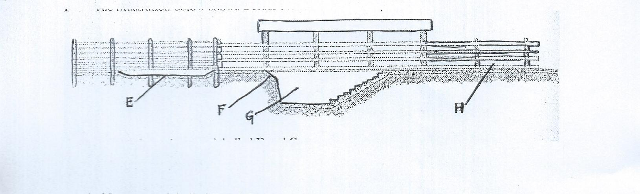
- Name parts labelled E and G
E………………………………………………………………………………… (1mk)
G………………………………………………………………………………… (1mk)
- State one use of each of the following parts labelled E, F and H (3mks)
E………………………………………………………………………………………..
F…………………………………………………………………………………………
H………………………………………………………………………………………...
2a) Describe the general uses of a fence in the farm (10mks)
- Outline five reasons for keeping livestock healthy (5mks)
- Describe the body conformation of a dairy heifer (5mks)
3a) Give reasons why embryo transfer use should be encouraged in dairy cattle breeding (8mks)
b) Explain six factors considered when culling dairy cattle (12mks)
4. a) State the function of any six parts of a zero grazing unit (6 marks)
b ) Describe five features of an ideal calf pen (5mks)
5. State four signs that indicate that a doe is about to kindle. (2 marks)
6. State three advantages of natural feeding in calf rearing. (1¹/₂ marks)
7. State four reasons for castration in pig production. (2 marks)
8. State two functions of the crop in poultry digestive system. (1 mark)
9. State four roles of worker bees in a colony. (2 marks)
10. Explain six importance of drainage as a land reclamation method. [6mks]

