NAME: ……………………………………………………………………ADM NO: ……………….
DATE: ………………….

443
AGRICULTURE
FORM TWO
TIME: 2 HOURS

OPENER TERM THREE 2022 EXAMINATION

INSTRUCTIONS TO CANDIDATES:
- This paper consists of three sections; A, B and C
- Answer ALL the questions in sections A, B and C
- All answers to be written in English

FOR OFFICIAL USE ONLY
SECTION | QUESTION | MAX. SCORE | CANDIDATE SCORE
A | 1 – 13 | 40
B | 14 – 17 | 20
C | 18 – 20 | 40
 | TOTAL | 100

SECTION A (40 MKS)
ANSWER ALL QUESTIONS IN THE SPACES PROVIDED
- Name three equipments used for large scale over head irrigation. (3mks)
……………………………………………………………………………………………………………………………………………………………………………………………………………………………………………………………………………………………………………………………………………………………………...
- Name three beef cattle breeds (3mks)
……………………………………………………………………………………………………………………………………………………………………………………………………………………………………………………………………………………………………………………………………………………………………...

- Distinguish between each of the following pair of terms as used in crop production
a). Thinning and rogueing (2mks)
………………………………………………………………………………………………………………………………………………………………………………………………………………………………………………

b). Seedling bed and nursery bed (2mks)
………………………………………………………………………………………………………………………………………………………………………………………………………………………………………………

- State three agricultural practices that pollute surface water sources (3mks)
……………………………………………………………………………………………………………………………………………………………………………………………………………………………………………………………………………………………………………………………………………………………………...

- State three benefits of using vegetative propagation in orange production (3 mks)
……………………………………………………………………………………………………………………………………………………………………………………………………………………………………………………………………………………………………………………………………………………………………...
- Name one vegetative material used to propagate each of the following:
- Bananas (1mk)
- Pineapples (1mk)
- Irish potatoes (1mk)
- Pyrethrum (1mk)
- Give two activities carried out during hardening off tomato seedlings (2mks)
……………………………………………………………………………………………………………………………………………………………………………………………………………………………………………………………………………………………………………………………………………………………………...
- Differentiate between olericulture and pomoculture (2mks)
……………………………………………………………………………………………………………………………………………………………………………………………………………………………………………………………………………………………………………………………………………………………………...

- State three advantages of shifting cultivation (3mks)
……………………………………………………………………………………………………………………………………………………………………………………………………………………………………………………………………………………………………………………………………………………………………...
- State three advantages of adding organic matter to sandy soils. (3mks)
……………………………………………………………………………………………………………………………………………………………………………………………………………………………………………………………………………………………………………………………………………………………………...
- a). Differentiate between macro – nutrients and micro – nutrients (2mks)
……………………………………………………………………………………………………………………………………………………………………………………………………………………………………………………………………………………………………………………………………………………………………...

b). State two functions of calcium in plant growth and development (2mks)
……………………………………………………………………………………………………………………………………………………………………………………………………………………………………………………………………………………………………………………………………………………………………...

- Name three implements used for primary cultivation (3mks)
……………………………………………………………………………………………………………………………………………………………………………………………………………………………………………………………………………………………………………………………………………………………………...
- State three factors that influence soil formation. (3 mks)
……………………………………………………………………………………………………………………………………………………………………………………………………………………………………………………………………………………………………………………………………………………………………...

SECTION B (2OMKS)
ATTEMPT ALL QUESTIONS
- The diagram below shows a bag of Calcium Ammonium Nitrate fertilizer.
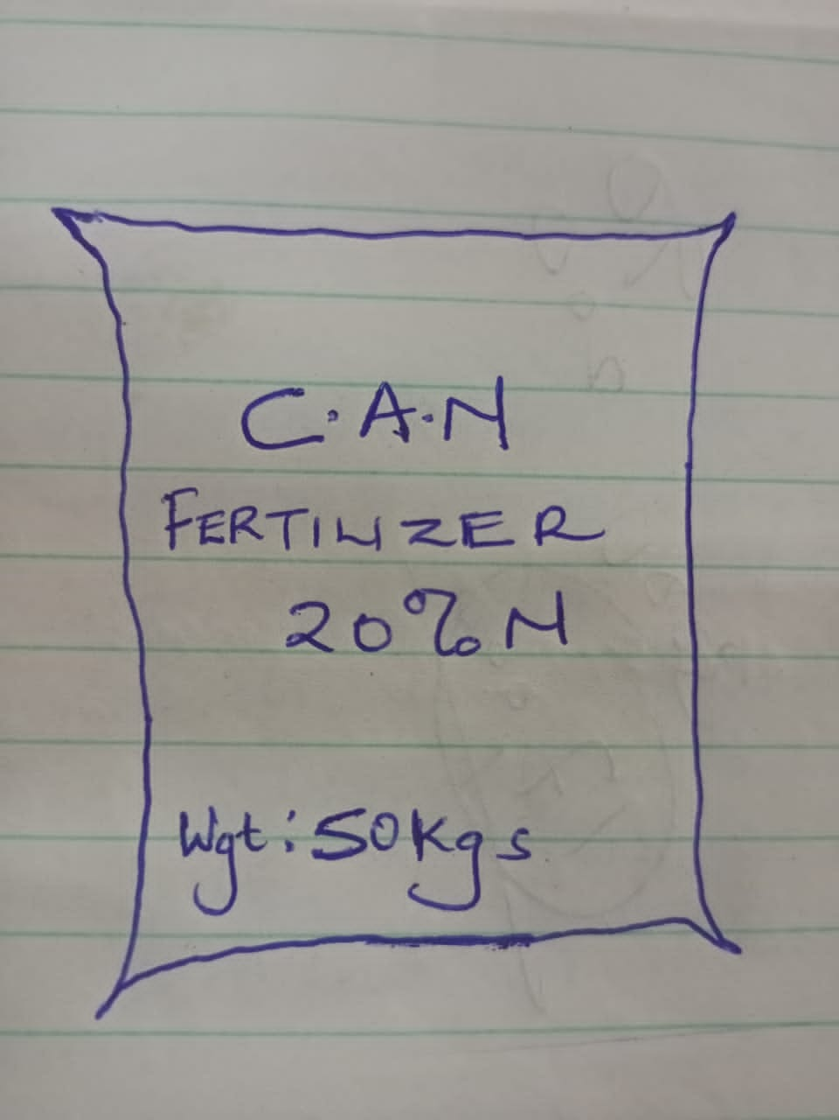

a). Classify the fertilizer (1mk)

b). Explain the effect of applying the above fertilizer on soil pH. (1mk)
……………………………………………………………………………………………………………………………………………………………………………………………………………………………………………………………………………………………………………………………………………………………………...
c). A farmer was advised to apply 50kgs of Nitrogen per hectare. How many bags of the above fertilizer will this farmer require for one hectare? Show your working. (3mks)

- Below is a diagram of a tool used in livestock rearing
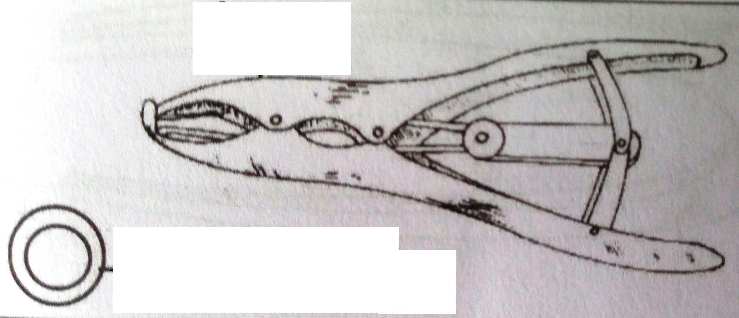

a). Identify the tool (1mk)

b). State two uses of the tool. (2mks)
……………………………………………………………………………………………………………………………………………………………………………………………………………………………………………………………………………………………………………………………………………………………………...
c). Give two reasons why farmers prefer using the tool (2mks)
……………………………………………………………………………………………………………………………………………………………………………………………………………………………………………………………………………………………………………………………………………………………………...
- The diagram below illustrates a feature observed after digging the soil several metres deep. Study the diagram and answer the questions that follow.
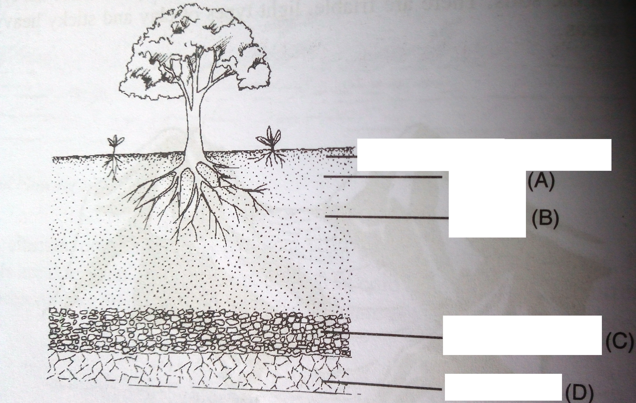
a). Identify the feature that the diagram above represents in the study of soil (1mk)

b). Name the parts of the diagram labeled A, B, C and D. (4mks)
A
B
C
D

c). State two ways in which the knowledge of the above feature would be of benefit to a farmer. (2mks)
……………………………………………………………………………………………………………………………………………………………………………………………………………………………………………………………………………………………………………………………………………………………………...

- Sabasaba Secondary School agriculture students visited a dairy cattle farm and found the following record. Study it and answer the question that follow.
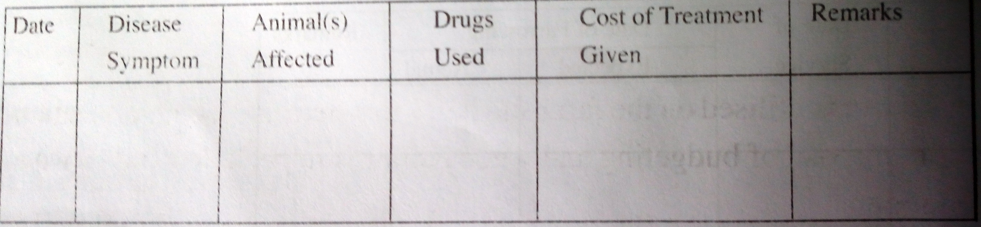
a). Name the record shown above (1mk)

b). State two importance of the above record to the farmer (2mks)
……………………………………………………………………………………………………………………………………………………………………………………………………………………………………………………………………………………………………………………………………………………………………...

SECTION C (40MKS)
ATTEMPT ALL QUESTIONS
- a). Explain seven factors that determine the spacing of a crop. (7mks)
……………………………………………………………………………………………………………………………………………………………………………………………………………………………………………………………………………………………………………………………………………………………………...……………………………………………………………………………………………………………………………………………………………………………………………………………………………………………………………………………………………………………………………………………………………………...……………………………………………………………………………………………………………………………………………………………………………………………………………………………………………………………………………………………………………………………………………………………………...……………………………………………………………………………………………………………………………………………………………………………………………………………………………………………………………………………………………………………………………………………………………………...……………………………………………………………………………………………………………………………………………………………………………………………………………………………………………………………………………………………………………………………………………………………………...

b). Explain three advantages of timely planting (3mks)
……………………………………………………………………………………………………………………………………………………………………………………………………………………………………………………………………………………………………………………………………………………………………...……………………………………………………………………………………………………………………………………………………………………………………………………………………………………………………………………………………………………………………………………………………………………...

- a). Give reasons why some seeds are established in a nursery before being transported to the seed bed. (6mks)
……………………………………………………………………………………………………………………………………………………………………………………………………………………………………………………………………………………………………………………………………………………………………...……………………………………………………………………………………………………………………………………………………………………………………………………………………………………………………………………………………………………………………………………………………………………...……………………………………………………………………………………………………………………………………………………………………………………………………………………………………………………………………………………………………………………………………………………………………...………………………………………………………………………………………………………………………
b). Giving an example, name four types of vegetables that can be grown in Kenya. (8mks)
……………………………………………………………………………………………………………………………………………………………………………………………………………………………………………………………………………………………………………………………………………………………………...……………………………………………………………………………………………………………………………………………………………………………………………………………………………………………………………………………………………………………………………………………………………………...

- a). State and explain seven ways through which soil fertility can be lost. (14 mks)
……………………………………………………………………………………………………………………………………………………………………………………………………………………………………………………………………………………………………………………………………………………………………...……………………………………………………………………………………………………………………………………………………………………………………………………………………………………………………………………………………………………………………………………………………………………...……………………………………………………………………………………………………………………………………………………………………………………………………………………………………………………………………………………………………………………………………………………………………...……………………………………………………………………………………………………………………………………………………………………………………………………………………………………………………………………………………………………………………………………………………………………...

b). State and explain six biotic factors that influence crop production. (6mks)
……………………………………………………………………………………………………………………………………………………………………………………………………………………………………………………………………………………………………………………………………………………………………...……………………………………………………………………………………………………………………………………………………………………………………………………………………………………………………………………………………………………………………………………………………………………...……………………………………………………………………………………………………………………………………………………………………………………………………………………………………………………………………………………………………………………………………………………………………...……………………………………………………………………………………………………………………………………………………………………………………………………………………………………………………………………………………………………………………………………………………………………...
……………………………………………………………………………………………………………………………………………………………………………………………………………………………………………………………………………………………………………………………………………………………………...……………………………………………………………………………………………………………………
THIS IS THE LAST PRINTED PAGE.

