APRIL HOLIDAY ASSIGNMENT 2023
AGRICULTURE FORM ONE
- a) Describe five precautions to be observed when using workshop tools. [5mks]
b) i.Give three effects of soil PH on growth of crops. [3mks]
ii) Describe two ways by which a soil of PH 3 can be raised to a PH of 6. [2mks]
- a) Describe five characteristics of plantation farming. [5mks]
- Give four characteristics of clay soils. [2mks]
- Give four reasons why ranching is important in the arid and semi- arid areas of Kenya? [2mks]
- State four effects of Hiv/AIDS and ill-health in agriculture. [2mks]
b.Name four farming practices which help to improve soil structure. [2mks]
6. The diagram below illustrates a feature observed after digging the soil several meters deep Study the diagram carefully and answer the question that follow
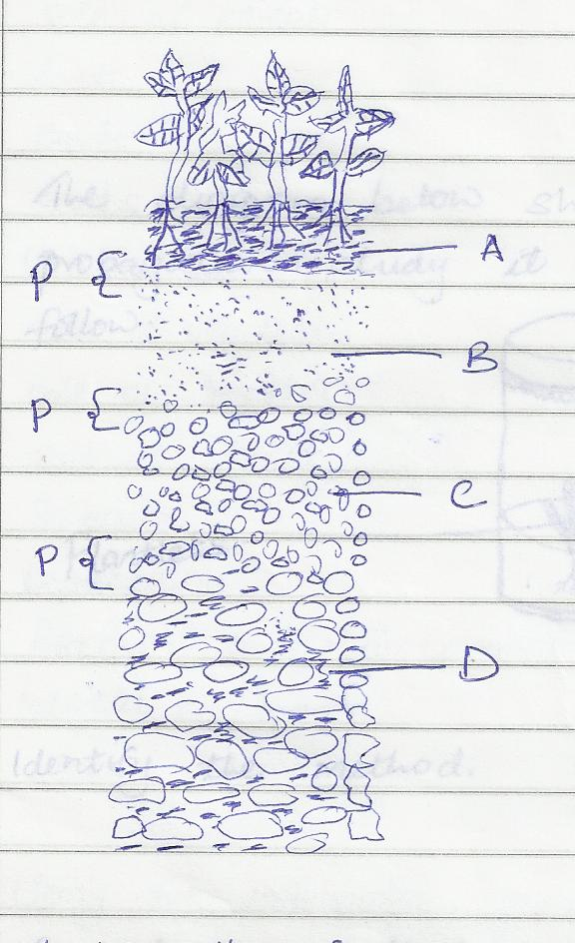
- Identify the feature that the diagram above represents in the study of soil (1mrk)
- What is the name given to the part labeled p (1mrk)
- Give a reason why part B is also referred to as layer of accumulation (1mrk)
- State two ways in which the knowledge of the above feature would be of benefit to farmer (2mrks)
- The diagram below shows some workshop tools. Study them and answer the questions that follow
7. A B

- (a) Identify the tools A and B (2mks)
- A…………………………………………………..………………………………
- B…………………………………………………..………………………………
(b) State the correct use of the tool labeled A (2mks)
(c) Explain one maintenance practice carried out on the tool A (1mk)

