Name …………………………………………….....………… Adm No…………… Class…………

School ………………………………………………………… Sign………………… Date……………

443/2
AGRICULTURE
PAPER 2
DEC 2021
TIME: 2 HOURS

LANET CLUSTER JOINT EXAMINATION - (LANJET) 2021
443/2
AGRICULTURE
PAPER 2
DEC 2021
TIME: 2 HOURS

INSTRUCTIONS TO CANDIDATES
- Write your name, index number and class in the spaces provided above.
- This paper consists of THREE SECTIONS, A, B and C.
- Answer all questions in sections A and B and any two questions in section C.
- All your answers must be written in the spaces provided in this question paper.
FOR EXAMINERS USE ONLY
SECTION | QUESTIONS | MAXIMUM SCORE | CANDIDATES SCORE
A | 1-18 | 30
B | 19-22 | 20
C | 23-25 | 40
TOTAL |  | 90

This paper consists of 12 printed pages. Candidates should check the question paper to ascertain that all pages are printed as indicated and that no pages are missing

SECTION A: (30 MARKS)
1. State four external predisposing factors of livestock diseases. (2 mks)
…………………………………………………………………………………………….
…………………………………………………………………………………………….

2. Differentiate between mothering ability and prolificacy in livestock. (2 mks)
…………………………………………………………………………………………….
…………………………………………………………………………………………….

3. State two distinguishing external characteristics of California white rabbit. (2 mks)
…………………………………………………………………………………………….
…………………………………………………………………………………………….

4. State four causes of infertility in dairy cattle. (2 mks)
…………………………………………………………………………………………….
…………………………………………………………………………………………….
…………………………………………………………………………………………….
…………………………………………………………………………………………….

5. State the functions of the following hormones in livestock:- (1 mk)

(a) Oxytocin ……………………………………………………………………….

(b) Stilbestrol ……………………………………………………………………..

6. State two reasons for clipping the upper beak in poultry management. (1 mk)
…………………………………………………………………………………………….
…………………………………………………………………………………………….

7. Name the set of tools used for the following farm operations.
(a) Controlling bloat …………………………………………………. (1 mk)

(b) Restraining an animal during agricultural show exhibition. (1 mk)

……………………………………………………………………

8. Name three types of calf pens that can be constructed on a farm. (1 ½ mks)
…………………………………………………………………………………………….
…………………………………………………………………………………………….
…………………………………………………………………………………………….

9. Give three reasons why honey harvesting is discouraged at night. (1 ½ mks)
…………………………………………………………………………………………….
…………………………………………………………………………………………….
…………………………………………………………………………………………….

10. Outline four uses of the gear box in a tractor. (2 mks)
…………………………………………………………………………………………….
…………………………………………………………………………………………….
…………………………………………………………………………………………….
…………………………………………………………………………………………….

11. Give the importance of each of the following rearing practices in calves.
(i) Single housing of calves - (1 mk)

………………………………………………………………………………………..
(ii) Removal of extra teats - (1 mk)

………………………………………………………………………………………..

12. List four essentials of clean milk production. (2 mks)
…………………………………………………………………………………………….
…………………………………………………………………………………………….
…………………………………………………………………………………………….
…………………………………………………………………………………………….

13. Give two features that enable the gizzard to carry out its functions effectively.(1 mk)

………………………………………………………………………………………….
…………………………………………………………………………………………..

14. Give the appropriate term used to describe the following in chicken:-

(i) From hatchery to 8 weeks …………………………………………….
(ii) Rendered Sterile ……………………………………………………..
(iii) Reared for meat ……………………………………………………..
(iv) Female from 8 weeks to point of lay ……………………………….

15. State four reasons that make a farmer castrate his/her billy. (2 mks)
…………………………………………………………………………………………….
…………………………………………………………………………………………….
…………………………………………………………………………………………….
…………………………………………………………………………………………….

16. List three protozoan diseases that are spread by vectors. (1 ½ mks)
…………………………………………………………………………………………….
…………………………………………………………………………………………….
…………………………………………………………………………………………….

17. Mention three methods of selection in livestock breeding. (1 ½ mks)
…………………………………………………………………………………………….
…………………………………………………………………………………………….
……………………………………………………………………………………………

18. List two diseases that attack bees in a colony. (1 mk)
…………………………………………………………………………………………….
…………………………………………………………………………………………….
…………………………………………………………………………………………….

SECTION B: (20 MARKS)
Answer all the questions in the spaces provided.

19. Below is a diagram of a grain store.

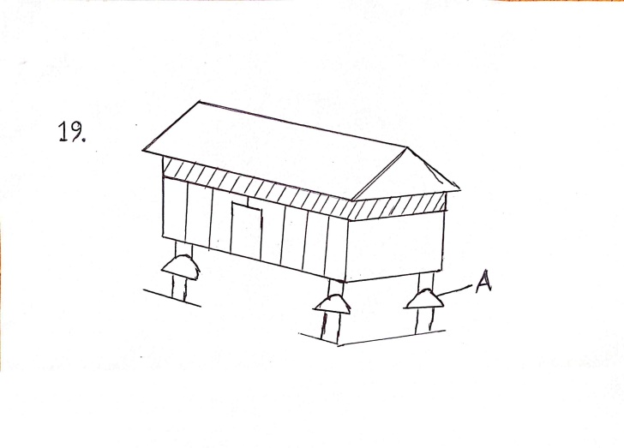

(a) Name the part labeled A. (1 mk)

……………………………………………………………………………………………..

(b) State one maintenance practice to be carried out before introducing a new produce.
(1 mk)

……………………………………………………………………………………………..
(c) Why is it important to have some open spaces on the walls of the store. (1 mk)

……………………………………………………………………………………………..
……………………………………………………………………………………………..

(d) Besides the store having open spaces, state two characteristics that make the store suitable
for storing grains. (2 mks)
……………………………………………………………………………………………..
……………………………………………………………………………………………..

20. Study the diagrams below of some workshop tools and then answer the questions.

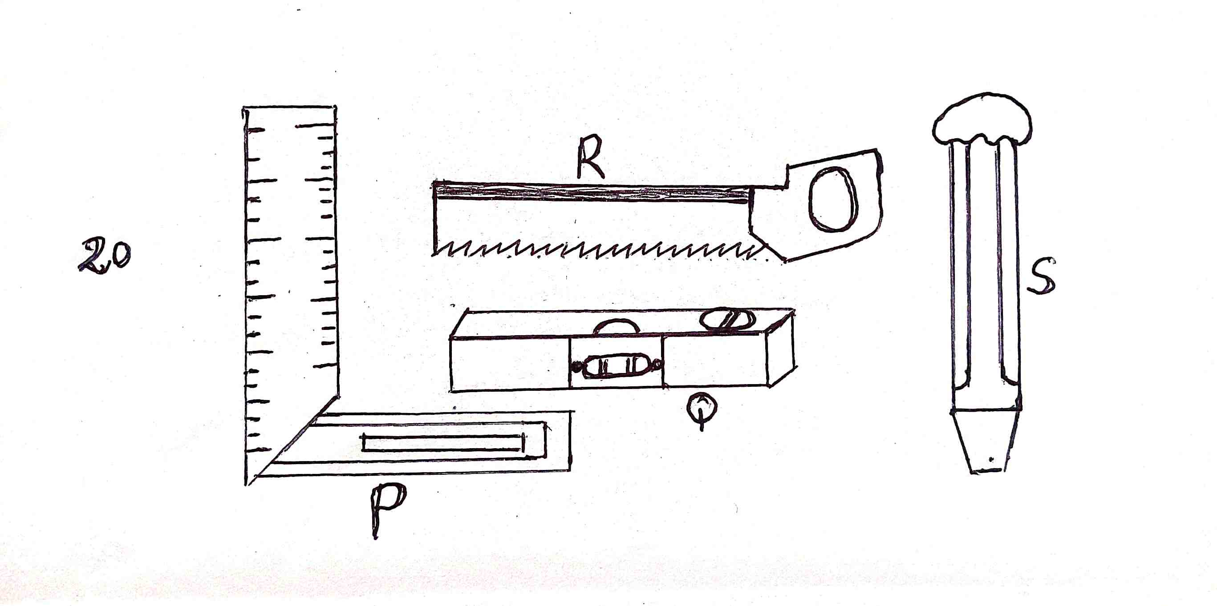
(a) Identify the tools P, Q, R and S.

P ……………………………………………. Q ……………………………….

R …………………………………………… S ………………………………..

(b) Give one use of tools P and R in the construction of a wooden feed trough.(2 mks)

P ..……………………………………………………………………………………….

R ………………………………………………………………………………………….

(c) How would the tool labeled Q be used in the construction of a calf pen? (1 mk)

……………………………………………………………………………………………..
……………………………………………………………………………………………

21. The illustration below shows livestock production equipment. Study it and answer the
questions that follow.

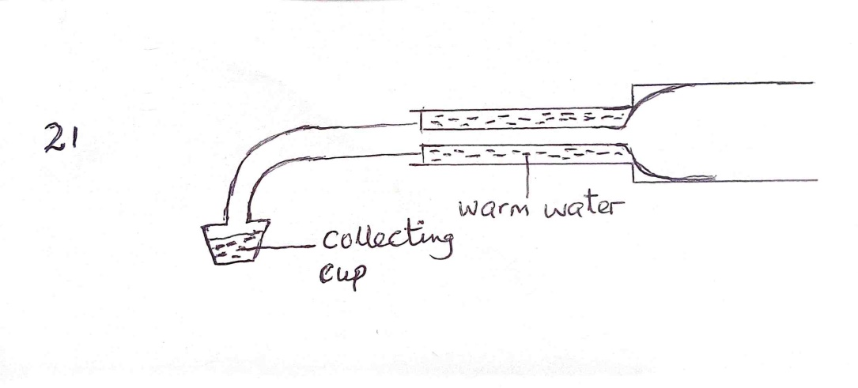

(i) Identify the equipment. (1 mk)

………………………………………………………………………………………..
(ii) What is the importance of warm water in the equipment. (1 mk)
………………………………………………………………………………………..

(iii) Describe the procedure followed when using the equipment in collection semen.

………………………………………………………………………………………..
………………………………………………………………………………………..
(3 mks)
…………………………………………………………………………………………..
……………………………………………………………………………………..
………………………………………………………………………………………..
………………………………………………………………………………………..

22. The diagram below shows a cross-section of a plunge dip. Use it to answer the questions
that follow.

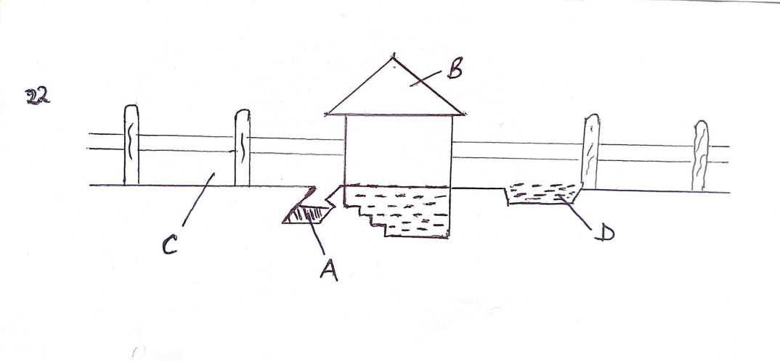
(i) Name the parts labeled A and B. (2 mks)
A ………………………………………………………
B ………………………………………………………
(ii) State the use of parts A and D. (2 mks)
A ………………………………………………………………………………..
B ………………………………………………………………………………..
(iii) State one advantage of holding cattle for some time in C. (1 mk)

……………………………………………………………………………………

SECTION C: (40 MARKS)
Answer any two questions in this section.

23. (i) Describe the life cycle of a two host tick. (5 mks)

(ii) Outline five maintenance practices carried out on tractor battery. (5 mks)

(iii) Discuss five factors considered when siting a fish pond. (10 mks)

24. (a) Explain the operational differences between a disc plough and a mouldboard plough.
(10 mks)
(b) Explain the procedure used when constructing a barbed wire fence. (10 mks)

25. (a) Describe the management of day-old chicks to the point of laying. (14 mks)

(b) Describe the precautions that should be taken when handling bees. (6 mks)
………………………………………………………………………………………………………………………………………………………………………………………………………………………………………………………………………………………………………………………………………………………………………………………………………………………………………………………………………………………………………………………………………………………………………………………………………………………………………………………………………………………………………………………………………………………………………………………………………………………………………………………………………………………………………………………………………………………………………………………………………………………………………………………………………………………………………………………………………………………………………………………………………………………………………………………………………………………………………………………………………………………………………………………………………………………………………………………………………………………………………………………………………………………………………………………………………………………………………………………………………………………………………………………………………………………………………………………………………………………………………………………………………………………………………………………………………………………………………………………………………………………………………………………………………………………………………………………………………………………………
………………………………………………………………………………………………………………………………………………………………………………………………………………………………………………………………………………………………………………………………………………………………………………………………………………………………………………………………………………………………………………………………………………………………………………………………………………………………………………………………………………………………………………………………………………………………………………………………………………………………………………………………………………………………………………………………………………………………………………………………………………………………………………………………………………………………………………………………………………………………………………………………………………………………………………………………………………………………………………………………………………………………………………………………………………………………………………………………………………………………………………………………………………………………………………………………………………………………………………………………………………………………………………………………………………………………………………………………………………………………………………………………………………………………………………………………………………………………………………………………………………………………………………………
………………………………………………………………………………………………………
………………………………………………………………………………………………………………………………………………………………………………………………………………………………………………………………………………………………………………………………………………………………………………………………………………………………………………………………………………………………………………………………………………………………………………………………………………………………………………………………………………………………………………………………………………………………………………………………………………………………………………………………………………………………………………………………………………………………………………………………………………………………………………………………………………………………………………………………………………………………………………………………………………………………………………………………………………………………………………………………………………………………………………………………………………………………………………………………………………………………………………………………………………………………………………………………………………………………………………………………………………………………………………………………………………………………………………………………………………………………………………………………………………………………………………………………………………………………………………………………………………………………………………………
………………………………………………………………………………………………………………………………………………………………………………………………………………………………………………………………………………………………………………………………………………………………………………………………………………………………………………………………………………………………………………………………………………………………………………………………………………………………………………………………………………………………………………………………………………………………………………………………………………………………………………………………………………………………………………………………………………………………………………………………………………………………………………………………………………………………………………………………………………………………………………………………………………………………………………………………………………………………………………………………………………………………………………………………………………………………………………………………………………………………………………
………………………………………………………………………………………………………
………………………………………………………………………………………………………………………………………………………………………………………………………………………………………………………………………………………………………………………………………………………………………………………………………………………………………………………………………………………………………………………………………………………………………………………………………………………………………………………………………………………………………………………………………………………………………………………………………………………………………………………………………………………………………………………………………………………………………………………………………………………………………………………………………………………………………………………………………………………………………………………………………………………………………………………………………………………………………………………………………………………………………………………………………………………………………………………………………………………………………………………………………………………………………………………………………………………………………………………………………………………………………………………………………………………………………………………………………………………………………………………………………………………………………………………………………………………………………………………………………………………………………………………
………………………………………………………………………………………………………………………………………………………………………………………………………………………………………………………………………………………………………………………………………………………………………………………………………………………………………………………………………………………………………………………………………………………………………………………………………………………………………………………………………………………………………………………………………………………………………………………………………………………………………………………………………………………………………………………………………………………………………………………………………………………………………………………………………………………………………………………………………………………………………………………………………………………………………………………………………………………………………………………………………………………………………………………………………………………………………………………………………………………………………………
………………………………………………………………………………………………………
………………………………………………………………………………………………………………………………………………………………………………………………………………………………………………………………………………………………………………………
………………………………………………………………………………………………………………………………………………………………………………………………………………………………………………………………………………………………………………………………………………………………………………………………………………………………………………………………………………………………………………………………………………………………………………………………………………………………………………………………………………………………………………………………………………………………………………………………………………………………………………………………
………………………………………………………………………………………………………………………………………………………………………………………………………………………………………………………………………………………………………………………………………………………………………………………………………………………………………………………………………………………………………………………………………

