NAME………………………………………………………………………………………IDEX NO……………………………….
SCHOOL……………………………………………………………………………………SIGN………………DATE………………..
443/1

AGRICULTURE

PAPER 1

TIME: 2 HOURS

DECEMBER, 2021

LANJET EXAMINATION (2021)
Kenya certificate of Secondary Education (K.C.S.E)

INSTRUCTIONS TO CANDIDATES

- Write your name, school and index number, in the spaces provided above.

- Sign and write the date of the examination in the spaces provided above.

- This paper consists of three sections: A, B and C.

- Answer all the questions in section A and B and any two questions from section C.

- All answers must be written in the spaces provided in this paper

For Examiner’s Use Only
SECTION | QUESTIONS |  | MAXIMUM SCORE |  | CANDIDATES SCORE
A | 1−14 |  | 30
B | 15−17 |  | 20
 |  |  | 20
C
 |  |  | 20
 | Total score |  | 90

SECTION A (30 Marks)
Answer all questions in this section in the spaces provided.
- Outline two ways in which agriculture promotes industrial growth in Kenya. (1 mark)

- State four factors considered when choosing a farming system (2mks)

3. Give four natural factors that encourage soil erosion (2mks)

4. List any four ways in which soil is deprived of its fertility. (2 marks)

5. State four factors considered when selecting a site for a tomato nursery bed. (2 marks)

6. State four reasons for intercropping. (2 marks)

7. Give four advantages of intensive farming. (2 marks)

.

8. Give four reasons why land should be prepared early in readiness for planting. (2 marks)

9. State four reasons for deep ploughing during land preparation. (2 marks)

10 State two reasons for conserving forage crops. (1mk)

11. Name two types of labour records kept in the farm. (1mk)

12. Give two ways in which mulch control the soil erosion. (1mk)

13. a) Define the following terms as used in soil fertility (2mks)
- Macro-nutrients

- Micro-nutrients

b) State four roles of nitrogen as a macro-nutrient in plant nutrition (2mks)

c) Give two methods that can be used to detect nutrient deficiency in crops (2mks)

d) Name two ionic forms through which element nitrogen is absorbed by plants (2mks)

14. Give four factors considered when classifying crop pests (2mks)

SECTION B (20 Marks)
Answer all questions in this section in the spaces provided.
15.The following illustrations show different production function curves in agricultural economics. Study them and answer the questions that follow
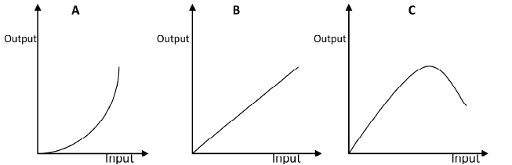

(a)Identify the production function curves labelled A and B. (2 marks)
A
B
(b) What does the law derived from the production function labelled C state? (1 mark)

(c) (i)Which one of the three production function curves is rare in Agriculture? (1mk)

(ii)Give a reason for your answer in (c)(i) above. (1 mark)

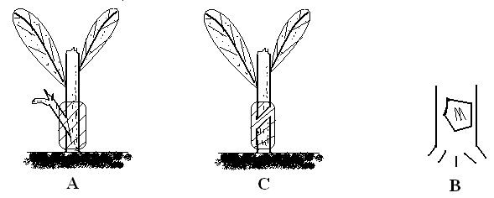
16. Study the illustrations below and answer the questions that follow

- Name the types of grafting labeled A and C above. (2 marks)
A
C
- Name any two crops propagated by method C. (2 marks)

- Give any two tools or materials used in propagation method C. (2 marks)

- Give four advantages of using grafting as a method of improving avocado fruits. (2mks)

17. Calculate the plant population in a 5.4 hectare plot of a bean crop planted at the spacing 45cm x 20cm.
Assume one plant per hole. (4 marks)

18. The diagram below illustrates a feature observed after digging the soil several metres deep Study the diagram carefully and answer the question that follow
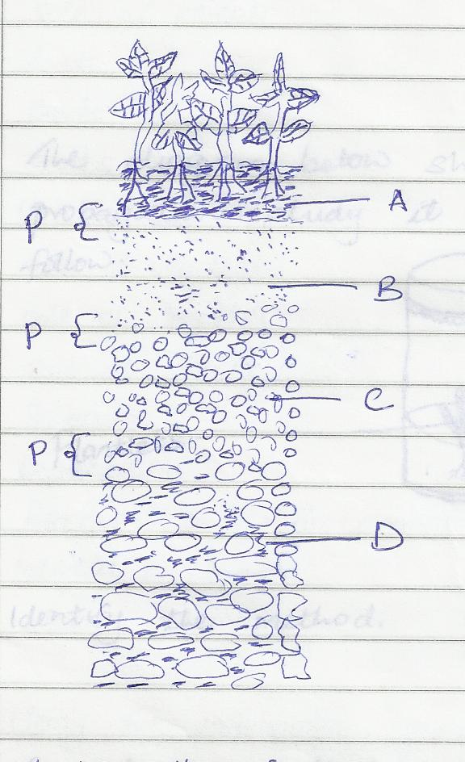

- Identify the feature that the diagram above represents in the study of soil (1mk)

- What is the name given to the part labeled P (1mk)

- Give a reason why part b is also referred to as layer of accumulation (1mk)

SECTION C (40 Marks)
Answer any two questions from this section in the spaces provided after every question.
18. a) Explain ten ways in which the Kenyan government can improve maize production to ensure food security in the country. (10mks)
b) Explain five ways in which soil fertility can be maintained. (6 mks)
c) Highlight four reasons for pruning coffee (4mks)

19. (a)Explain eight cultural methods of soil and water conservation. (8 marks)

(b)Explain four ways in which:
(i) HIV/AIDS limits agricultural production (4 marks)

(ii)Government policy improves agricultural production (4 marks)
(iii)Low level of education and technology influences agriculture.(4 marks)

- Describe production of tomatoes under the following subheadings.
- Ecological requirements. (5 marks)

- Nursery establishment and management. (8 marks)

- Control of pests. (2 marks)
- Harvesting and marketing. (5 marks)

