NAME:………………………………………….. INDEX NO…………………………
SCHOOL:……………………………………… CANDIDATE’S SIGN ……………..
DATE ………………………………
443/2
AGRICULTURE
Paper 2
2021
Time: 2 Hours

ELDORET DIOCESE EXAM 2021
Kenya Certificate of Secondary Education (K.C.S.E)

443/2
AGRICULTURE
Paper 2
2021
Time: 2 Hours
INSTRUCTIONS TO CANDIDATES
1. Write your name and index number in the spaces provided above
2. Sign and write the date of examination in the spaces provided above.
3. This paper consists of three sections: A, B and C
4. Answer all the questions in section A and B and any two questions from section C
5. Answers should be written in the spaces provided.

For Examiner’s Use Only

Section | Question | Maximum Score | Candidate’s Score
A | 1 – 20 | 30
B | 21-24 | 20
C | 25-27 | 20
 |  | 20
 | Total Score | 90

SECTION A (30 MARKS)
(Answer all the questions in this section in the spaces provided)
- Name two kinds of livestock which can be castrated using a rubber ring. (1mark)
………………………………………………………………………………………………………………………………………………………………………………………………………………………………………………………………………………………………
- Define the term “breach of birth” as used in livestock production. (1 mark)
………………………………………………………………………………………………………………………………………………………………………………………………
- a) Name the camel breed that is adapted to cooler regions and has a wooly body covering. ($\frac{1}{2}$ mark)
…….………………………………………………………………………………………..
b) Give three ways used to improve production in indigenous cattle. ($1\frac{1}{2}$ mark)
………………………………………………………………………………………………………………………………………………………………………………………………………………………………………………………………………………………………………………………………………………………………………………………………
- Give four methods of administering vaccines to livestock. (2 marks)
………………………………………………………………………………………………………………………………………………………………………………………………………………………………………………………………………………………………………………………………………………………………………………………………
- State two uses of bedding materials in a poultry house in deep litter system. (1mark)
………………………………………………………………………………………………………………………………………………………………………………………………………………………………………………………………………………………………

- Give any two pairs of livestock tools which are always used together. (1 mark)
………………………………………………………………………………………………………………………………………………………………………………………………
- List two types of feed additives. (1 mark)
………………………………………………………………………………………………………………………………………………………………………………………………………………………………………………………………………………………………
- State three factors that may lead to dip wash being exhausted or weakened while in the dip tank. ($1\frac{1}{2}$ marks)
………………………………………………………………………………………………………………………………………………………………………………………………………………………………………………………………………………………………
- State four practices which are carried out to control mastitis in lactating cows.
(2 marks)
………………………………………………………………………………………………………………………………………………………………………………………………………………………………………………………………………………………………
- Give two signs of heat in rabbits. (1 mark)
……………………………………………………………………………………………………………………………………………………………………………………………………………………………………………………………………………………………..
- State four maintenance practices carried out on the water-cooling system of a tractor
(2 marks)
……………………………………………………………………………………………………………………………………………………………………………………………………………………………………………………………………………………………………………………………………………………………………………………………………………………………………………………………………………………………...
- State four observations on the behavior of chicks which would indicate that the temperature in the brooder is too high. (2 marks)
……………………………………………………………………………………………………………………………………………………………………………………………………………………………………………………………………………………………………………………………………………………………………………………………………………………………………………………………………………………………...
- Highlights four desirable characteristics that should be considered when selecting a heifer for milk production. (2 marks)
……………………………………………………………………………………………………………………………………………………………………………………………………………………………………………………………………………………………………………………………………………………………………………………………………………………………………………………………………………………………...
- Give four functions of calcium in dairy cows. (2 marks)
……………………………………………………………………………………………………………………………………………………………………………………………………………………………………………………………………………………………………………………………………………………………………………………………………………………………………………………………………………………………...
- Name two notifiable diseases in cattle. (1 mark)
………………………………………………………………………………………………………………………………………………………………………………………………………………………………………………………………………………………………
- State any two channels through which beef is marketed in Kenya. (1 mark)
………………………………………………………………………………………………………………………………………………………………………………………………………………………………………………………………………………………………

- State four factors that may influence the pulse rate of a sheep. (2 marks)
………………………………………………………………………………………………………………………………………………………………………………………………………………………………………………………………………………………………………………………………………………………………………………………………………………………………………………………………………………………………
- List three properties of concrete that make it suitable for constructing farm building.
(1$\frac{1}{2}$mark)
………………………………………………………………………………………………………………………………………………………………………………………………………………………………………………………………………………………………………………………………………………………………………………………………
- Give four reasons why breeding boar may be culled. (2 marks)
……………………………………………………………………………………………………………………………………………………………………………………………………………………………………………………………………………………………………………………………………………………………………………………………………………………………………………………………………………………………...
- Give two functions of a footbath in a plunge cattle dip. (1 mark)
………………………………………………………………………………………………………………………………………………………………………………………………………………………………………………………………………………………………

SECTION B (20 MARKS)
(Answer all the questions in this section in the spaces provided)
- The diagram below represents an implement.
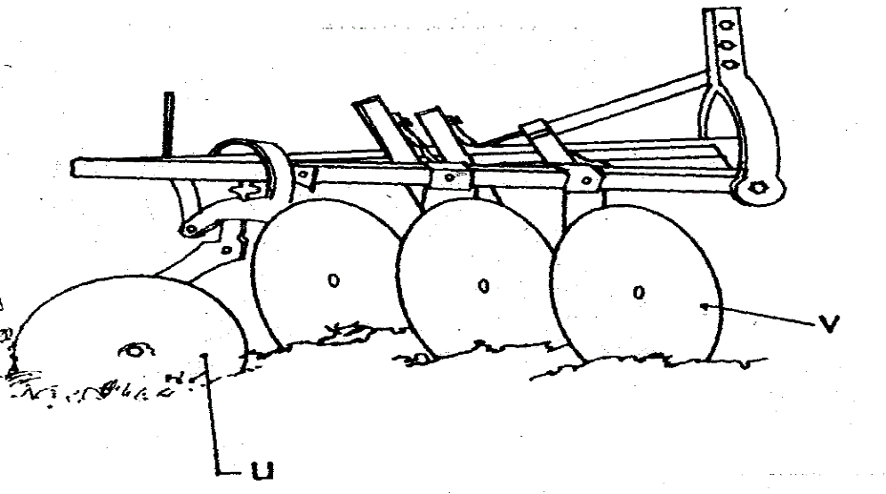
(i) Identify the implement. (1 mark)
…………………………………………………………………………………………
(ii) Name the parts labelled U and V and give one function of each. (2 marks)
U………………………………………………………………………………………
V………………………………………………………………………………………
(iii)State two ways of adjusting the depth of ploughing when using the implement. (2 marks)
………………………………………………………………………………………………………………………………………………………………………………………………………………………………………………………………………………………………
- Study the diagram of an egg below and answer the questions that follow.

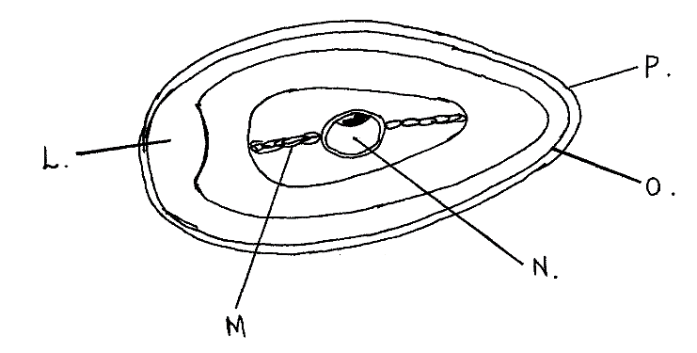
- Name the parts labeled O, and P (2 marks)
O …………………………………………………………………………………
P ……………………………………………………………………………………
- State the functions of the parts M and L. (2 marks)
M
……………………………………………………………………………………………………………………………………………………………………………………
L
……………………………………………………………………………………………………………………………………………………………………………………
iii) Why should the egg be turned during incubation. (1 mark)
………………………………………………………………………………………………………………………………………………………………………………………………

- Below is an illustration of a farm structure.
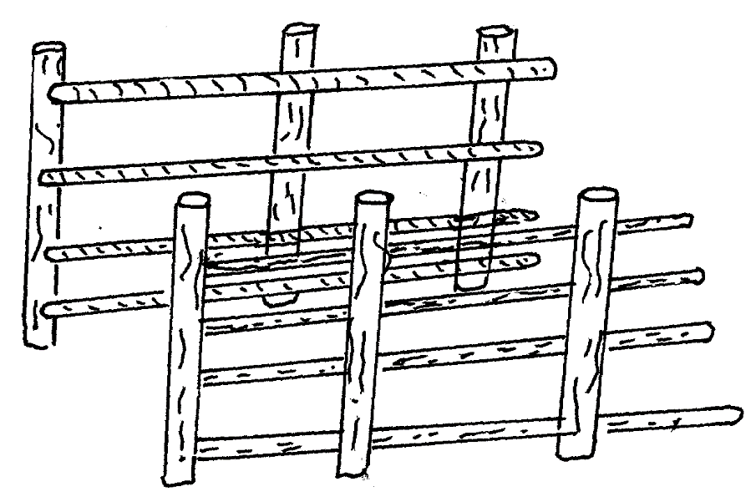
a) Identify the structure above. (1 mark)
………………………………………………………………………………………
b) State Six livestock routine practices which may be carried out in the structure above (3 marks)
………………………………………………………………………………………………………………………………………………………………………………………………………………………………………………………………………………………………………………………………………………………………………………………………………………………………………………………………………………………………………………………………………………………………
c) Give Two maintenance practices which should be carried out in the structure above. (1 mark)
………………………………………………………………………………………………………………………………………………………………………………………………………………………………………………………………………………

- The diagram below shows the farm equipment. Study it carefully and use it to answer the questions that follow.
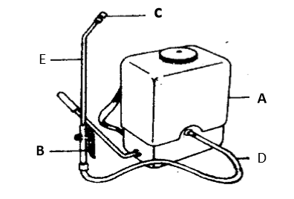

(a) Name the parts labeled A, B and C (3 marks)
A………………………………………………………………………………………
B………………………………………………………………………………………
C………………………………………………………………………………………
(b) State the use of the equipment shown above. (1 mark) ……………………………………………………………………………………………………………………………………………………………………………………
(c) Give one maintenance practice carried out on the equipment. (1 mark) ……………………………………………………………………………………………………………………………………………………………………………………
SECTION C
(Answer any two questions in this section on the spaces provided)
- a) Describe the live cycle of a named tapeworm (Taenia spp). (10 marks)
…………………………………………………………………………………………………………………………………………………………………………………………………………………………………………………………………………………………………………………………………………………………………………………………………………………………………………………………………………………………………………………………………………………………………………………………………………………………………………………………………………………………………………………………………………………………………………………………………………………………………………………………………………………………………………………………………………………………………………………………………………………………………………………………………………………………………………………………………………………………………………………………………………………………………………………………………………………………………………………………………………………………………………………………………………………………………………………………………………………………………………
b) Describe the management practices that would ensure maximum yield of fish in a fish pond. (5 marks)
………………………………………………………………………………………………………………………………………………………………………………………………………………………………………………………………………………………………………………………………………………………………………………………………………………………………………………………………………………………………………………………………………………………………………………………………………………………………………………………………………………………………………………………………………………………………………………………………………………………………………………………………………………………………………………………………………………………………………………………………………………………………………………………………………………………………………………………………
c) Explain five functions of water in nutrition. (5 marks)
………………………………………………………………………………………………………………………………………………………………………………………………………………………………………………………………………………………………………………………………………………………………………………………………………………………………………………………………………………………………………………………………………………………………………………………………………………………………………………………………………………………………………………………………………………………………………………………………………………………………………………
- (a) Discuss the management of layers from one day old to the start of laying in a deep litter system. (l0 marks)
………………………………………………………………………………………………………………………………………………………………………………………………………………………………………………………………………………………………………………………………………………………………………………………………………………………………………………………………………………………………………………………………………………………………………………………………………………………………………………………………………………………………………………………………………………………………………………………………………………………………………………………………………………………………………………………………………………………………………………………………………………………………………………………………………………………………………………………………………………………………………………………………………………………………………………………………………………………………………………………………………………………………………………………………………………………………………………………………………………………………………………………………………………………………………………………………………………………………………………………………………………………………………………………………………………………………………………………………………………………………………………………………………………………………………………………………………………………………………………
(b) State any five advantages of using animal power in the farm. (5 marks)
……………………………………………………………………………………………………………………………………………………………………………………………………………………………………………………………………………………………………………………………………………………………………………………………………………………………………………………………………………………………………………………………………………………………………………………………………………………………………………………………………………………………………………………………………………………
(c) Describe five importance of keeping animals healthy. (5 marks)
………………………………………………………………………………………………………………………………………………………………………………………………………………………………………………………………………………………………………………………………………………………………………………………………………………………………………………………………………………………………………………………………………………………………………………………………………………………………………………………………………………………………………………………………………………………………………………………………………………………………………………
- Discuss mastitis disease under the following subheading:
(i) Causal organism (1 mark)
……………………………………………………………………………………………………………………………………………………………………………………
(ii) Predisposing factors (4 marks)
……………………………………………………………………………………………………………………………………………………………………………………………………………………………………………………………………………………………………………………………………………………………………………………………………………………………………………………………………
(iii) Symptoms (4 marks)
…………………………………………………………………………………………………………………………………………………………………………………………………………………………………………………………………………………………………………………………………………………………………………………………………………………………………………………………………………………………………………………………………………………………………………………………………………………………………………………………
(iv) Control and treatment (3 marks)
……………………………………………………………………………………………………………………………………………………………………………………………………………………………………………………………………………………………………………………………………………………………………………………………………………………………………………………………………
b) Explain eight factors that affect milk composition in dairy farming. (8 marks)

……………………………………………………………………………………………………………………………………………………………………………………………………………………………………………………………………………………………………………………………………………………………………………………………………………………………………………………………………………………………………………………………………………………………………………………………………………………………………………………………………………………………………………………………………………………………………………………………………………………………………………………………………………………………………………………………………………………………………………………………………………………………………………………………………………………………………………………………………………………………………………………………………………………………………………………………………………………………………………………………………………………………………………………………………………………………………………………………………………………………………………………………………………………………………………………………………………………………………………………………………………………………………………………………………………………………………………………………………………………………………………………………………………………………………………………………………………………………………………………………………………………………………………………………………………………………………………………………………………………………………

