NAME _______________________________ ADM NO ____________ CLASS _________

443/2
AGRICULTURE
PAPER 2
APRIL 2023

INSTRUCTIONS TO CANDIDATES
a) Write your name and Admission number in the spaces provided above.
b) This paper consists of three sections A, B and C.
c) Answer all the questions in section A and B.
d) Answer any two questions in section C.
e)This paper has nine printed pages.

For Examiners Use Only
SECTION | QUESTIONS | MARKS | SCORE
A | 1 – 22 | 30
B | 23 – 26 | 20
C |  | 20
 |  | 20
TOTAL SCORE |  | 90

SECTION A (30MARKS)
- State four disadvantages of natural mating. (2marks)
-Inbreeding is not easily controlled
-Transmission of breeding diseases
-Extra feed for male animal required
-Large males can injure small females
-Wastage of semen
-Cumbersome and expensive to transport a bull to remote areas
- Give two reasons for supplementary feeding of bees (1mark)
-To supply the nutritive requirements of the colonies
-When the natural food sources are inadequate or not available
-To give them extra resources
-To improve brood rearing
-To increase multiplication
- To discourage swarmings
- Name any two methods used to identify goats. (1mark)
-Tattooing
-Ear tagging
-Branding
-Ear Notching
-Neck straps
- List three signs of lambing. (1½marks)
-Udder becomes full
-Teats are bright red in colour
-Restlessness and bleating
-Slackening of hip muscles
-Enlargement of vulva
-Mucus discharge
-Appearance of water bag
- Explain the meaning of cropping as used in fish production. (1mark)
-It’s the selective removal of fish of marketable size from a pond
- State two reasons why jersey breed is suitable than Friesian in marginal areas. (1mark)
-Can tolerate high temperatures
-It’s small in size hence require less food
-Can utilise poor pastures well
- State four methods used to control cannibalism in a flock of layers in a deep litter system. (2mark)
-Provision of ample spacing on the floor, feeders, waterers and laying boxes
-House should be dimly lit
-Dusting should be done to control external parasites
-Provision of a balanced ration
-Birds should be kept busy by providing grains into the litter and hanging greens
-New/strange birds should not be introduced
- State two reasons why we have a footbath in a cattle dip. (1mark)
-To wash off mud
-Contains chemicals (copper sulphate/ formalin) that control foot rot
- State four uses of solar energy in the farm. (2marks)
-To provide heat in houses, for cooking and boiling water
-To provide light for lighting
-For warming greenhouses
-Provides power for electronic devices in the farm such as coolers, weighing machines, etc
-Dehydrating farm produce
-Dry produce
- List four functions of water in an animal’s body. (2marks)
-Aids in digestion of food
-Aids in transportation of food nutrients in the body
-Aids in the removal metabolic waste products
-Aids in thermoregulation
-Used in the formation of products such as milk and eggs
-Maintain body shape
- State four reasons for controlling livestock diseases. (2marks)
-To increase their reproductive life
-For high production
-For regular breeding
-For the safety of the consumers
-To reduce production costs
-To reduce the spread of diseases
-To promote fast growth rate and hence early maturity
- State one importance of guard rails in a farrowing pen. (1mark) -To prevent the sow from crushing the piglets
-To prevent the sow from eating the creep feeds
- List two groups of vitamins used in livestock feeding. (1mark)
-Water soluble vitamins
-Fat soluble vitamins
- State the functions of the following farm tools
    - Shovel (½mark)
-Mixing and scooping concrete/mortar
-Measuring cement
    - Rubber ring and elastrator (½mark)
-Castration of male goats, sheep and calves
-Docking/tailing of lambs
-Dehorning
- List three control measures for fowl pox disease in poultry (1½mark)
-Killing all the affected birds
-Vaccinating of all the healthy birds by wing web at 12-16 weeks old
-Administering antibiotics (tetracycline) in drinking water
- What is a production ration? (1mark)
-It is the feed required by an animal over and above the maintenance ration to enable the animal
to produce
- State two maintenance practices carried out on slasher. (1mark)
-Repair/replace damaged handle
-Sharpen the cutting edges
-Clean after use
-Oiling to prevent rusting
-Proper storage
- Proper use
- Name the hormone responsible for milk let down (½mark)
-Oxytocin
- List any two chemicals used to treat wood against weather elements. (1mark)
-Creosote
-Pentachlorophenol
-Chromated arsenical
-Old engine oil
- State any four characteristics of exotic breeds of cattle. (2marks)
-Have no humps
-Low tolerance to high temperatures
-Highly susceptible to tropical diseases
-Have fast growth rate leading to early maturity
-Good producers of meat and milk
-Can not walk for long distances
-Have short calving Intervals of one calf per year
-Cannot survive for long without water
- State three uses of biogas on a farm. (1½marks)
-Provide heat for cooking and boiling water
-Provide electricity for electrical devices
-Provide light for lighting
-Can be used in internal combustion engine
- State four practices done to make wooden fencing posts last longer. (2marks)
-Reinforcing with concrete
-Cutting the top of the post at a slope
-Covering the top of the post with a metal plate
-Charring/slightly burning the post
-Application of wood preservative such as creosote, copper sulphate, Pentachlorophenol
-Painting
-Application of old engine oil
-Seasoning

SECTION B (20mks)
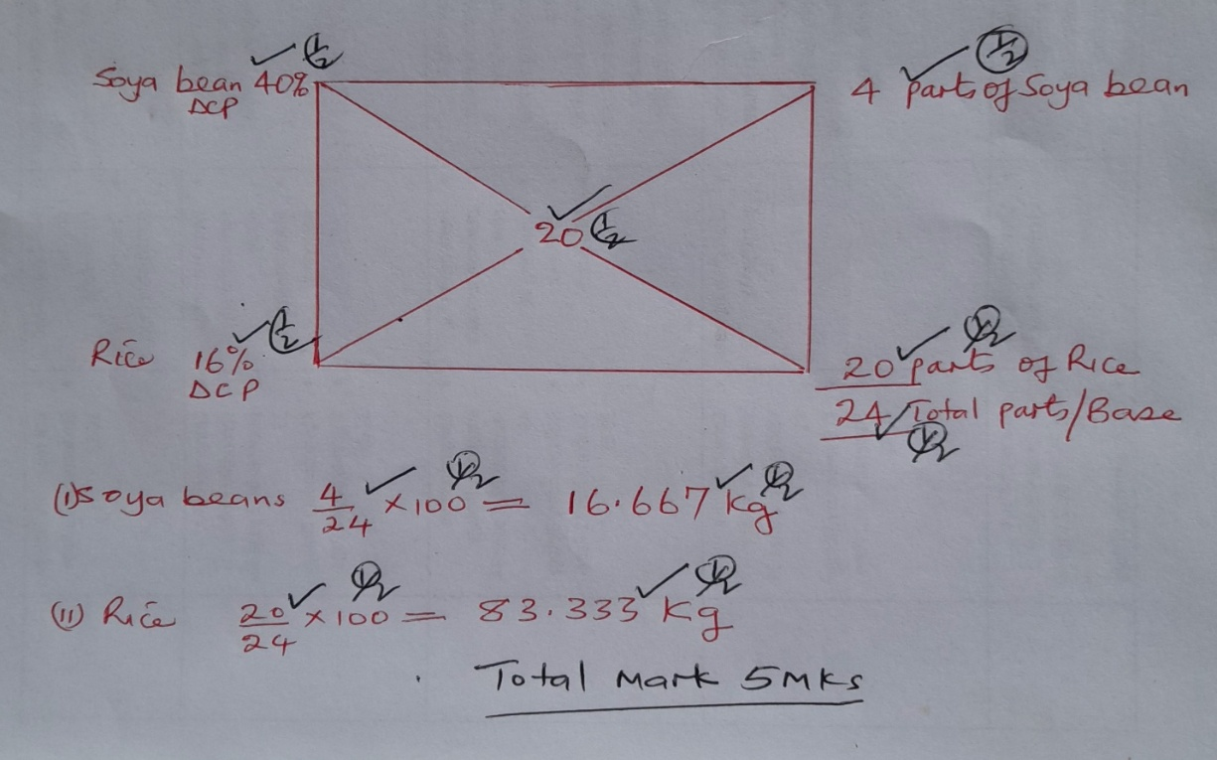
- A dairy farmer is required to prepare 100kgs of dairy meal containing 20% DCP (Digestible crude protein). Using the Pearson’s square method, Calculate the quantity of soya beans 40% DCP and rice 16% DCP the farmer requires for the dairy meal. (5marks
- The following diagrams illustrate some workshop tools. Study them carefully and answer the question that follows.

(a). Identify the tools labeled E and F (2marks)
E -Adjustable spanner
F -Ring spanner
(b). State the functional advantage tool E has over tool F. (1marks)
-Can be adjusted for sizes of bolts and nuts unlike the ring spanner which specific to certain sizes
(c) State two maintenance practice carried out on tool E. (2marks)
-Lubricate worm-screw/moving parts
-Clean after use and keep in tool rack
25. Study the diagram below of an egg and use it to answer the questions that follow.

- Name the parts labeled B, C, D and F. (2marks)
B -Inner membrane
C -Outer/shell membrane
D -Albumen
F -Chalazae
b) List any two structural qualities of an egg to be incubated. (2marks)
-Smooth shell
-Medium size (55-60g)
-Oval in shape
-Should not have cracks/hair crack
-Should not have abnormalities such as meat spots, blood and double yolk
-Porous shell
(c) Give the functions of part labeled E in a fertilized egg (1mark)
-Source of food for the embryo
26. The diagram below shows the parts of the digestive system of cattle. Study it and
answer the questions that follow.

a) Name the parts labeled N, P, R and Q. (2marks)
N -Omasum
P -Rumen
R -Pancreas
Q -Gall bladder
b) List three microbial activities that take place in part labeled P. (3marks)
-Fermentation of food
-Synthesis of non-essential amino acids
-Synthesis of vitamin B-complex and Vitamin Cs
-Break down carbohydrates into volatile fatty acids
-Breakdown of proteins into amino acids, peptides and ammonia gas
SECTION C (40MARKS)
ATTEMPT ANY TWO QUESTIONS IN THIS SECTION
27. a) Discuss the preparation of the brooder before the arrival of chicks. (5marks)
-Preparation starts 2-3 days before the arrival of chicks
-The brooder house is cleaned by removing the old litter and,
-Then it is disinfected,
-New litter is then placed to a thickness of 5-10 cm,
-It is then covered by an absorbent material such as newspapers,
-Equipment should be cleaned, disinfected and tested to ensure that they are working well,
-The brooder is then lit for 6 hours before the chicks arrive,
-Feed and water should be placed in the shallow containers,
-The brooder space should be confined with a board to prevent chicks from straying far from
the source of heat,
-The board should be round to avoid corners that cause overcrowding that can lead to
suffocation to death
- Describe the management practices carried out on ewes two weeks before mating to weaning
of lambs. (15marks)
- Flushing
-Flushing ewes by giving extra concentrates/ high plane of nutrition
-Starting at about three weeks before tupping and continued for three weeks after tupping
-Clip/crutching wool from around the vulva for easy mating
-Raddling of rams should be done if more than one is to be used, using a different colours for each ram for ease of identification and record keeping
-Allow 35-50 ewes per ram
-Tupping time should be done such that lambing coincide with when there is enough pasture
-Remove the rams from the ewes after mating

ii) Gestation
-Feed ewes on good quality pasture/concentrates 3-4 weeks before lambing (steaming Up)
-Move ewes to clean pastures 3 weeks before lambing
-Deworm ewes 2-3 weeks before lambing
-Vaccinate ewes 2-3 weeks before lambing against common diseases
-Provide clean drinking water in plenty

iii) Lambing
-Observe for the signs of lambing and supervise
-Assist where necessary
-Disinfect the navel cord immediately after lambing
-Ensure lambs suckle colostrum within the first 1-2 hours after lambing
-Dagging/clipping of wool is done around the teats after lambing to ease suckling
-Ewes that give birth to more than one lamb should be given extra feeding

iv) From birth to weaning
-weak lambs should be artificially reared
-Rejected/orphaned lambs should be introduced to foster mothers
-Keep lambs and ewes on good quality pastures
-Dock the lambs within the first 2 weeks
-Castrate male lambs that are not needed for breeding within the first 2 weeks
-Introduce creep pellets to the lambs as from the 6th week
-Dip/spray/dust the lambs when necessary against external parasites
-Treat sick lambs immediately in isolation
-Wean the lambs that 4-5 months old or when they are 22kg live weight
-Put identification marks just before weaning
-Deworm lambs before weaning
-Keep upto date records
28. (a) Outline any eight control measures for ticks. (8marks)
-Dipping/spraying/hand dressing with acaricides
-Rotational grazing /paddockings
-Ploughing land to break the life cycle of ticks
-Hand picking and killing of ticks
-Fencing off the grazing fields from straying animals and wild game
-Burning of pastures to kill various stages of ticks
-Zero grazing to avoid contact with other animals and using grass or hay free from ticks
-Biological control using birds and ants.
-Using natural substances that can kill and repel ticks such as cedar oil, Neem oil, Garlic oil, etc
(b) Outline the daily maintenance practices that should be carried out on a farm tractor. (12 marks)
-Checking engine oil daily by using a dip stick
-If oil level is low, it should be added
-The fuel level should be checked at the start of every day’s work and added if necessary
-Water level in the radiator should be checked and if possible topped up
-The level of the electrolyte should be checked daily and topped up with distilled water
accordingly
-Nuts and bolts should be tightened every day
-Lost nuts and bolts should be replaced before the day’s work starts
-Grease should be applied by using grease gun through the nipples
-Large sediments from the sediment bowl should be removed
-The tyre pressure should be checked daily before the day’s work commence
-The fan belt tension should be checked to ensure that it deflects between 1.9cm and 2.5cm
when pushed
-The brake shaft bearing should be greased
-The brake fluid level should be maintained at the recommended level
-Clean the tractors
-Replace worn-out tyres
29. (a) Describe the uses of five materials and equipment required during hand milking (10marks)
- Milking bucket
-it is used to collect milk during the milking process
-it is made of stainless steel /plastic
-it should have a capacity of 10-20 litres
2. Milking stools
Sitting on during milking or make the milker comfortable during milking
- Milk strainer
Removing solid impurities in milk e.g. hairs and dung
- Teat dip.
Dipping teats after milking to control mastitis. Contains a solution of disinfectant
- Towels.
For washing and drying the udder. They are supposed to be two.
- Feed.
Assist in stimulating milk let down
- Strip cap.
Testing for mastitis before milking
- Milking salve/jelly.
Prevent cracking of teats and mastitis.
- Weighing scale.
Measuring the amount of miilk produced by each cow for recording
Measuring amount of concentrate given during milking
- Luke warm water to clean the udder and stimulate milk let down
b) Discuss mastitis disease under the following sub –heading
- Animals affected (1mark)
-Goats
-Cows
-Pigs
- Casual organism (1mark)
-Bacteria, either Streptococcus spp, Staphylococcus spp.
- Predisposing factors (4marks)
-Incomplete milking
-Injuries on the udder and teats
-Weak sphincter muscles of teats that allow milk flow freely
-Inadequate sanitation
-Pendulous udder
-Age of the animal
-Poor milking technique
-Sex of the animal
- Control and treatment (4marks)
-Proper milking techniques
-Treatment using antibiotics intramamary
-Culling of animals that are often attacked by the disease
-Dry cow therapy
-Post milking teat disinfection or teat dipping
-Vaccination
-Improved sanitation

