Name………………………………………………………………Index Number………………..
School…………………………………………………….signature……………………….

443/2
AGRICULTURE
Paper 2
AUGUST 2021
TIME: 2HRS
TERM ONE 2021 CASPA AMUKURA PARISH EXAMINATION
443/2 AGRICULTURE

INSTRUCTIONS TO CANDIDATES
1 Write your name, school, index number and signature in the spaces provided above.
2 THIS PAPER CONSIST WITH THREE SECTIONS A , B and C. Answer all questions in sections A and B. Answer any two questions from section C.
3 Answers to all questions should be written in the spaces provided.
4 The paper has 13 printed pages and students should ascertain that all pages are printed.
FOR EXAMINERS USE ONLY
Section | Questions | Maximum Score | Candidate’s Score
A | 1 – 18 | 30
B | 19 – 23 | 20
C |  | 20
 |  | 20
 | TOTAL SCORE | 90

SECTION A (30 Marks)
Answer ALL questions in the spaces provided
1 Name the pig breed which has the following characteristics: long, large, and white body, broad and dished face, upright ears. ( ½ mk)
…………………………………………………………………………………………………………………………………………………………………………………………………………….
2 Name two non-infectious causes of livestock diseases. 1mk
…………………………………………………………………………………………………………………………………………………………………………………………………………….
- Name four materials that are collected by bees. (2mks)
…………………………………………………………………………………………………………………………………………………………………………………………………………….…………………………………………………………………………………………………………………………………………………………………………………………………………….
4.Give two reasons for the two month dry period the cow requires before parturition (1mks)
……………………………………………………………………………………………………………………………………………………………………………………………………………………………………………………………………………………………………………………
5. Outline four ways of controlling egg eating in poultry. (2mks)
………………………………………………………………………………………………………………………………………………………………………………………………………………………………………………………………………………………………………………………………………………………………………………………………………………………………………………………………………………………………………………………………………
6. (a) Name the cause of milk fever. ( ½ mk)
………………………………………………………………………………………………………
(b) Give one control measure of milk fever. ( ½ mk)
………………………………………………………………………………………………………7.State three field conditions under which a disc plough should be used instead of a mouldboard plough. $(1\frac{1}{2}mks)$
………………………………………………………………………………………………………………………………………………………………………………………………………………………………………………………………………………………………………………………
8. (a) State two disadvantages of using metal frames in construction of farm building. (1mk)
………………………………………………………………………………………………………………………………………………………………………………………………………………………………………………………………………………………………………………………
(b) Give three reasons for seasoning timber. (1 ½ mks)
………………………………………………………………………………………………………………………………………………………………………………………………………………………………………………………………………………………………………………………………………………………………………………………………………………………………
9.List four factors that influence the pulse rate of an animal (2 mks) •…………………………………………………………………………………………………………………………………………………………………………………………………………………………………………………………………………………………………………………………………………………………………………………………………………………………………………………………………………………………………………………………………..

10. State four qualities of colostrum which make it suitable for feeding newly born calf. (2mks)
……………………………………………………………………………………………………………………………………………………………………………………………………………………………………………………………………………………………………………………………………………………………………………………………………………………………………………………………………………………………………………………………………………………………………………………………………………………………………………
11 . Name two dual purpose breeds of cattle 1mk
….………………………………………………………………………………………………………………………………………………………………………………………………………………………………………………………………………………………………………………..
12. Outline four reasons for swarming of bees. (2mks)
………………………………………………………………………………………………………………………………………………………………………………………………………………………………………………………………………………………………………………………………………………………………………………………………………………………………………………………………………………………………………………………………………

13.State four reasons for steaming up in animal production. (2 mks
………………………………………………………………………………………………………………………………………………………………………………………………………………………………………………………………………………………………………………………………………………………………………………………………………………………………………………………………………………………………………………………………………

14. Give two causes of high mortality in piglets. (1mk)
………………………………………………………………………………………………………………………………………………………………………………………………………………………………………………………………………………………………………………………
15. (a) what is a notifiable disease? (1mk)
……………………………………………………………………………………………………………………………………………………………………………………………………………..
(b) Name four examples of notifiable diseases in livestock. (2mks)
………………………………………………………………………………………………………………………………………………………………………………………………………………………………………………………………………………………………………………………………………………………………………………………………………………………………………………………………………………………………………………………………………
16. Give three reasons why drenching alone is not an effective method of controlling intestinal parasites in livestock. $(1\frac{1}{2}mk$
………………………………………………………………………………………………………………………………………………………………………………………………………………………………………………………………………………………………………………………………………………………………………………………………………………………………
17. State four qualities of eggs preferred by consumers in the market (2 mks)
………………………………………………………………………………………………………………………………………………………………………………………………………………………………………………………………………………………………………………………………………………………………………………………………………………………………

18. Give four light breeds of chicken in poultry rearing. (2mks
…………………………………………………………………………………………………………………………………………………………………………………………………………………………………………………………………………………………………………………………………………………………………………………………………………………………..

SECTION B (20 Marks)
Answer all questions in this section in the spaces provided after every question
19. The illustration below show different presentation of foetus at the time of birth. Study the illustrations and answer questions that follow.
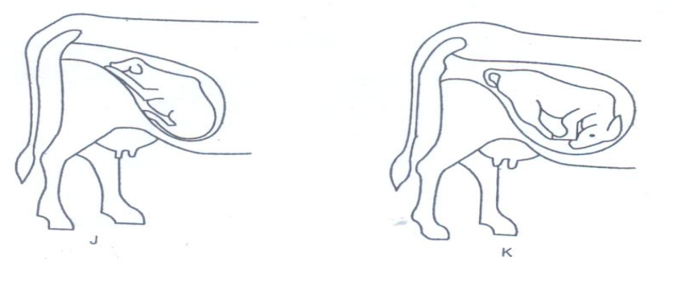
- What diagram represents the normal position of a calf at birth (1mk)
…………………………………………………………………………………………………
- What term is used to refer to position shown in diagram K? (1mk)
……………………………………………………………………………………………………
- State three signs of parturition in cattle. (3mks)
………………………………………………………………………………………………………………………………………………………………………………………………………………………………………………………………………………………………………………………………………………………………………………………………………………………………
20.Observe the tools A, B and C illustrated below then answer the questions that follow.

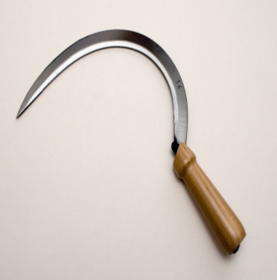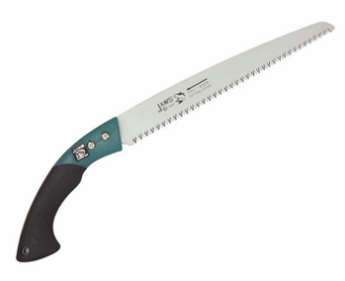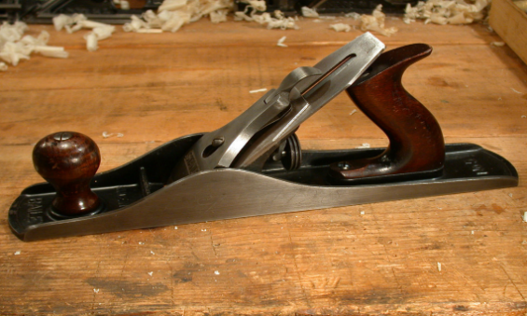
- Name tools A, B and C and state the correct use of each tool. (3mks)
Tool | Identity | Function
A
B
C

- State two maintenance practices that should be carried out to ensure that tool C is in a good working condition. (2mks)
…………………………………………………………………………………………..……………………………………………………………………………………………..……………………………………………………………………………………………...
21. The diagram below represents a poultry keeping structure.
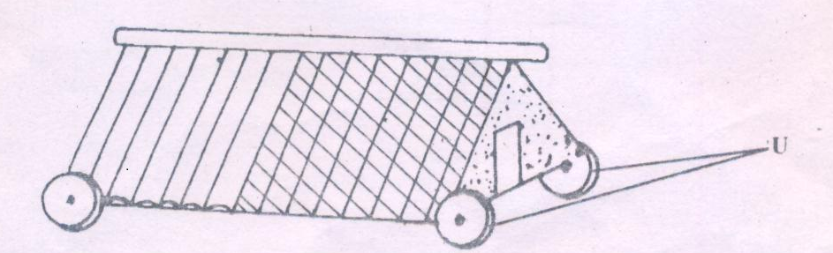
- Identify the structure. ( ½ mk)
…………………………………………………………………………………………………

ii) Identify the part labeled U. ( ½ mk)
………………………………………………………………………………………………………
iii)State the maintenance carried out on the structure illustrated above. (1mk)
………………………………………………………………………………………………………………………………………………………………………………………………………………
22. The diagrams K, L, M and N below show four possible ways of drawing milk from the teat of a cow during milking.
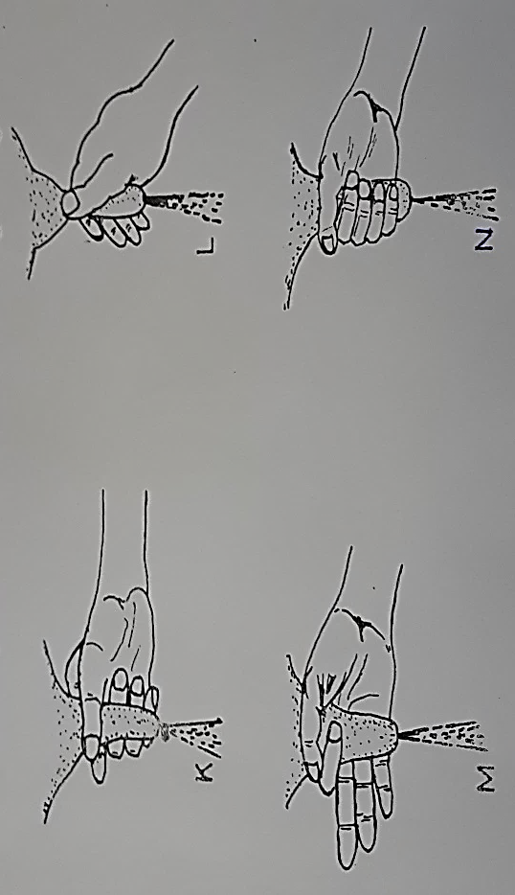

- Which diagram shows the proper way of drawing milk. (1mk)
………………………………………………………………………………………………
- How long should it take to milk a cow from the start to the end of milking. (1mk)
………………………………………………………………………………………………
- How would a milkman ensure that no milk remains in the udder at the end of milking?
(1mk)
………………………………………………………………………………………………
- Give two practices carried out on milk immediately after milking. (2mks)
………………………………………………………………………………………………………………………………………………………………………………………………………………………………………………………………………………………………
23.Below is an illustration of an activity carried out by a poultry farmer keeping layers
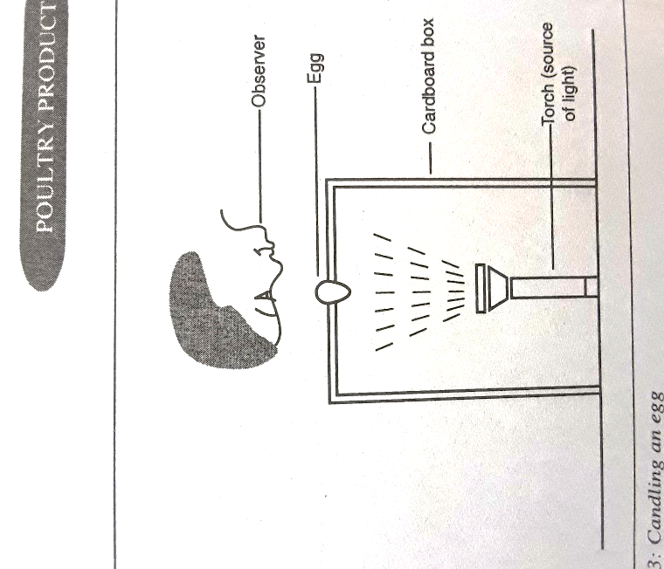
- Identify the activity carried out using the set-up. (1mk)
………………………………………………………………………………………………
- State two abnormalities in eggs that can be detected using the set-up above. (1mk)
……………………………………………………………………………………………....
- How can a farmer improve the following?
- Hardness of egg shells. ( ½ mk)
…………………………………………………………………………………………
- Yellowness of the egg yolk. ( ½ mk)
…………………………………………………………………………………………
…………………………………………………………………………………………
SECTION C (40 Marks)
Answer any two questions from this section in the spaces provided after each question.
24..Describe fish management under the following sub headings
a) Procedure for establishing a pond. 10mks
- Stocking the pond. 3mks
- Management practices that would ensure maximum harvest of fish from the pond. 5mks
- Methods of preserving fish. 2mks
25.a) State the functions of any six parts of a plunge dip. (6mks)
b) State and explain four factors considered when selecting a breeding stock. (4mks)
c) Explain five mechanical methods of controlling ticks. (10mks)
26 a) State five advantages of embryo transplant. (5mks)
b) Describe coccidiosis disease under the following sub- headings.
- Animals attacked (2mks)
- Causal organism (1mk)
- Symptoms (4mks)
- Control measures (3mks)
- A ration containing 20% DCP for growing chicks is to be obtained by mixing ground maiz containing 10% DCP and fishmeal containing 50% DCP. Calculate the amount of each feedstuff in kilograms required to prepare 200kg of the feed (5mks )
….…………………………………………………………………………………………………………………………………………………………………………………………………………………………………………………………………………………………………………………………………………………………………………………………………………………………………………………………………………………………………………………………………………………………………………………………………………………………………………………………………………………………………………………………………………………………………………………………………………………………………………………………………………………………………………………………………………………………………………………………………………………………………………………………………………………………………………………………………………………………………………………………………………………………………………………………………………………………………………………………………………………………………………………………………………………………………………………………………………………………………………………………………………………………………………………………………………………………………………………………………………………………………………………………………………………………………………………………………………………………………………………………………………………………………………………………………………………………………………………………………………………………………………………………………………………………………………………………………………………………………………………………………………………………………………………………………………………………………………………………………………………………….……………………………………………………………………………………………………………………………………………………………………………………………………………………………………………………………………………………………………………………………………………………………………………………………………………………………………………………………………………………………………………………………………………………………………………………………………………………………………………………………………………………………………………………………………………………………………………………………………………………………………………………………………………………………………………………………………………………………………………………………………………………………………………………………………………………………………………………………………………………………………………………………………………………………………………………………………………………………………………………………………………………………………………………………………………………………………………………………………………………………………………………………………………………………………………………………………………………………………………………………………………………………………………………………………………………………………………………………………………………………………………………………………………………………………………………………………………………………………………………………………………………………………………………………………………………………………………………………………………………
….……………………………………………………………………………………………………………………………………………………………………………………………………………………………………………………………………………………………………………………………………………………………………………………………………………………………………………………………………………………………………………………………………………………………………………………………………………………………………………………………………………………………………………………………………………………………………………………………………………………………………………………………………………………………………………………………………………………………………………………………………………………………………………………………………………………………………………………………………………………………………………………………………………………………………………………………………………………………………………………………………………………………………………………………………………………………………………………………………………………………………………………………………………………………………………………………………………………………………………………………………………………………………………………………………………………………………………………………………………………………………………………………………………………………………………………………………………………………………………………………………………………………………………………………………………………………………………………………………………………
….………………………………………………………………………………………………………………………………………………………………………………………………………………………………………………………………………………………………………………………………………………………………………………………………………………………………………………………………………………………………………………………………………………………………………………………………………………………………………………………………………………………………………………………………………………………………………………………………………………………………………………………………………………………………………………………………………………………………………………………………………………………………………………………………………………………………………………………………………………………………………………………………………………………………………………………………………………………………………………………………………………………………………………………………………………………………………………………………………………………………………………………………………………………………………………………………………………………………………………………………………………………………………………………………………………………………………………………………………………..………………………………………………………………………………………………………………………………………………………………………………………………………………………………………………………………………………………………………………………………………………………………………………………………………………………………………………………………………………………………………………………………………………………………………………………………………………………………………………………………………………………………………………………………………………………………………………………………………………………………………………………………………………………………………………………..………………………………………………………………………………………………………………………………………………………………………………………………………………………………………………………………………………………………………………………………………………………………………………………………………………………………………………………………………………………………………………………………………………………………………………………………………………………………………………………………………………………………………………………………………………………………………………………………………………………………………………………………………………………………………………………..………………………………………………………………………………………………………………………………………………………………………………………………………………………………………………………………………………………………………………………………………………………………………………………………………………………………………………………………………………………………………………………………………………………………………………………………………………………………………………………………………………………………………………………………………………………………………………………………………………………………………………………………………………………………………………………..…………………………………………………………………………………………………………………………………………………………………………………………………………………………………

