NAME……………………………………………………...ADM NO…………..CLASS……………
MID TERM THREE 2022
AGRICULTURE FORM 3
PAPER 1
TIME: 2HRS
SECTION A(30 Marks)
Answer ALL Questions
- State two effects of high temperatures on crop production (1 mark)

- Enumerate four types of farm records kept by farmers (2 marks)

- State two varieties of beans grown in Kenya (1 mark)

4. Highlight four reasons for staking tomatoes (2 marks)

5. List three cultural methods of weed control in crop production (3 marks)

6. Why is it important to top dress a pasture crop? (2mks)

7. List four methods of drainage (2 marks)

8. State three effects of too much application of Nitrogenous fertilizers in tomatoes (11/2 marks)

9. State five environmental factors that affect the selectivity and effectiveness of herbicides (2 ½ marks)

10. List four general symptoms of viral diseases in crops (2 marks)

11. State four importances of raising cabbage seedlings in a nursery bed (2 marks)

12. Differentiate between aquaculture and apiculture (1 mark)

13. Name two methods used to control weeds in pastures (1 mark)

14. Why is it advisable to apply Nitrogenous fertilisers to maize at knee height? (1 mark)

15. Give advantages of adding organic matter in the soil. (2 marks)

16. State four information contained in a land title deed. (2 marks)

17. What is agroforestry (1/2 marks)

18. Why is Finger millet rarely destroyed by pests in the stores (1/2 marks)

19. State any two methods of conserving forage (1mark)

SECTION B (20 Marks)
Answer ALL Questions
20. The diagram below illustrates an experiment for capillary action investigation for different soils. Study it carefully and answer the questions that follow

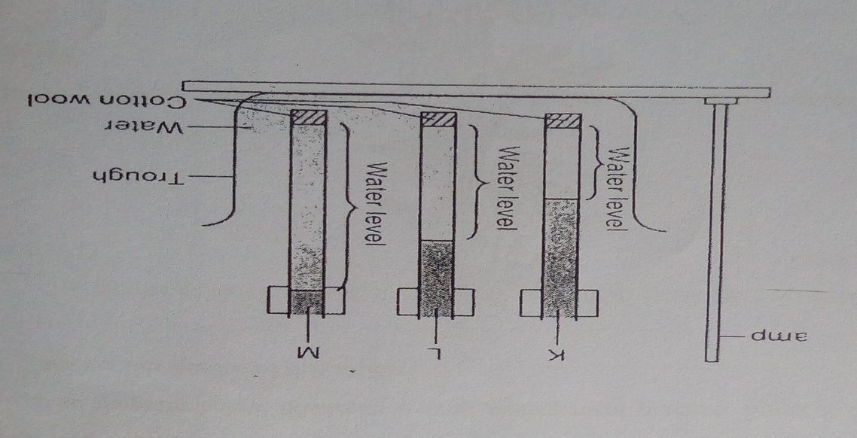
a)Name the type of soil capillary tubes labelled K,L and M (2 marks)
K-
L-
M-
b) Identify the capillarity tube with suitable soil for rice production (2 marks)

C) What is the relationship between the soil particle size and capillarity (3 marks)

21. A farmer was advised to apply 150 kg CAN/ha while topdressing his maize crop. CAN contains 21% N. Calculate the amount of Nitrogen applied per hectare (3 marks)

22. DiagramsB, C and D below show the particles of three sorghum varieties, name them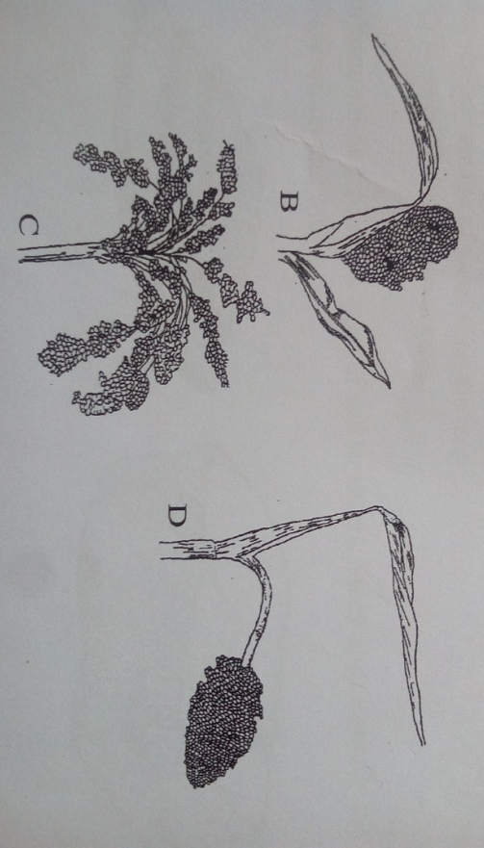
B-
C-
D-
ii) Which of the three varieties is least likely to be damaged by the birds (1/2 mark)

iii) Give a reason for your answer in (ii) above (1/2 mark)

iv) Give two methods used to control birds in a field of sorghum (2 marks)

23. The illustrations below represent types of soil structures. Study them carefully
a)Identify soil structures X and Y above (2 marks)
X-
Y-
b) Which of the soil structures is not suitable for growing maize (1 mark)

c) Give one method of improving the soil structure named in (b) above (1 mark)

SECTION C (40 marks)
Answer any two questions in this section
24. Outline the effects of wind on agricultural production (11 marks)

b) Briefly mention the importance of soil organic matter (9 marks)

25. a)Describe five different methods of pasture conservation and utilization (10 marks)

b)State and explain five factors that influence the selectivity and effectiveness of herbicides in weed control (10 marks)

26.a)Explain the precautions that should be observed in harvesting pyrethrum (3 marks)

b) Briefly describe the advantages of land consolidation as a land reform programme (7 marks)

c) Agriculture is the backbone of Kenya’s economy. Explain (10 marks)

