**NAME…………………………………………………ADM NO…………..CLASS……………**

**MID TERM THREE 2022**

**AGRICULTURE FORM TWO**

**TIME: 2HRS**

1.a) Distinguish between a feed stuff and a feed. (2mks)

b) List down the classes of feed stuffs. (1mk)

2. List factors that determine the amount of food consumed by an animal. (4mks)

3. Using the Pearson’s square method, compute a 100kg ration with 20% DCP from oats with contain 10% DCP and simsim seed cake containing 60% DCP. (5mks)

4. State four characteristics of succulent roughages. (4mks)

5 The following is an illustration of a handsaw. Study it carefully and answer the questions that follow.



(a) Name the parts labelled

**F** …………………………………………………………. (1 mark)

**G**…………………………………………………………. ( 1 mark)

(b) Explain ***three*** maintenance practices that should be carried out on the tool**.** (3 marks)

6. State four effects of parasites on livestock. (4mks)

7. Differentiate between Essential amino acids and Non –essential amino acids. (2mks)

8.a) List 3 sources of water in the body of an animal.(1 ½ mks)

b) List any five minerals essential to an animal. (2 ½ mks)

9. Name two main categories of parasite. (2mks)

10. State four symptoms of Nitrogen Deficiency in crops. (4mks)

11. Name four methods of fertilizer application. (2mks)

12. A farmer was advised to apply 150kg CAN/ha, while to dressing the maize crop.CAN contains 21% N. Calculate the amount of Nitrogen applied /ha. (3mks)

13. Give four reasons why a farmer should keep farm records. (4mks)

14. Name two species of camels. (2mks)

15. State three ways in which Nitrogen is removed from the Atmosphere. (3mks)

16. a) Name two types of planting materials. (1mk)

b) Outline four factors affecting rooting of cuttings. (4mks)

17. State three factors to consider in choosing seed rates. (1 ½ mks)

18. Differentiate between a nursery bed and a seed bed. (2mks)

19. State four factors that should be considered when selecting a nursery site. (2mks)

20. State 3 management practices carried out in a nursery bed. (1 ½ mks)

21. State any six post-harvest practices carried out on a crop. (6mks)

22 The diagram below illustrates a field management practice carried out on a fruit crop.

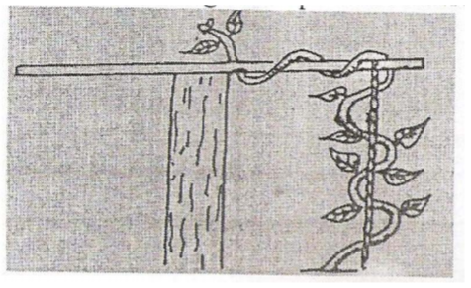  
a) Identify the practical illustrated above. (1 mark)

b) Name the most likely crop managed as illustrated in the above. (2 marks)

c) Give two reasons for carrying out the practice illustrated above. (2 marks)

23. Name two systems of farming. (1mk)

24.a) What is Nomadic pastoralism? (1mk)

**-** b) State two disadvantages of nomadic pastoralism. (2mks)

25. Outline five roles of Agriculture in the economy. (5mks)

26. Name any two types of soil structure. (2mks)

27.a) Give one use of each of the following tools and equipment; (5mks)

1. A panga
2. Shovel
3. Spade
4. Watering can
5. Strip cup

b) Name five categories of farm tools and equipment. (5mks)

28. Outline four reasons for preparing seedbed. (2mks)

29. State three importance of drainage as a land reclamation method. (3mks)