NAME……………………………………………………ADM NO……………CLASS………
MID TERM THREE 2022
AGRICULTURE FORM ONE
TIME: 1HR 30 MIN
- What do you understand by the following terms?
- Cock (1mk)

- Layer (1mk)

c) Capon (1mk)

2.Study the diagrams below and answer the questions that follows

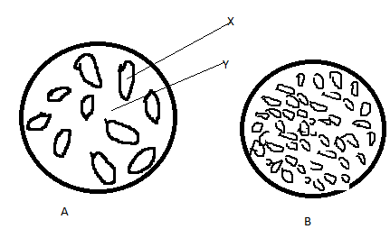

(a)Name X and Y
X…………..(1mk)
Y……………(1mk)
(bWhat type of soil are A and B(2mks)

3. Under what farming conditions is opportunity cost zero? (1mk)

4(a) What are farm records? (1mk)

(b)Name four commonly kept records used by a farmer (4mks)

5. A part from opportunity cost, state two other basic economic concepts. (2mks)

6. State four factors that determine the type of irrigation chosen by a farmer. (4mks)

7. Name four breeds of dairy goats. (4mks)

8. Outline four advantages of practicing mixed farming (4mks)

9 Name two breeds of saddlebacks . (1mk)

10. Outline four roles of agriculture in an economy. (4mks)

11. Name any four branches of Agriculture. (2mks)

12. Outline three advantages of shifting cultivation. (3mks)

13. State four biotic factors affecting agriculture production. (4mks)

14. Name four physical agents of weathering. (4mks)

15. What are the four factors influencing soil formation? (4mks)

16. . Study the diagram below and answer the questions that follow.
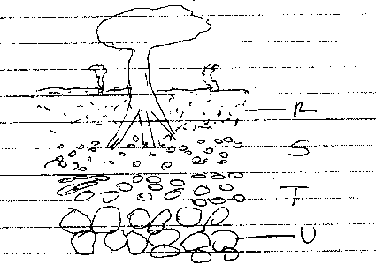

(a) What does the diagram above represent. (1mk)

(b) Name parts labelled R, S, T and U.
R (1mk)
S (1mk)
T (1mk)
U (1mk)

(c) State any three components of soil(3mks)
. 3mks)

17. What are the two main classes of soil living organisms? (2mks)

18. State three effects of HIV/AIDS on Agriculture. (3mks)

19. State three reasons for proper care and maintenance of farm tools and equipment. (3mks)

20. State the maintenance practices carried out on the following tools;
i) Hand saw (1mk)

ii) Milking churn (1mk)

iii) Jembe (1mk)

iv) Chisel (1mk)

21. State three reasons for preparing land before use. (3mks)

22. List two factors that determine the number of times a farmer would harrow his land. (2mks)

23. Give three reasons why minimum tillage is practiced. (3mks)

24. Give two reasons why the burning of bushes as a method of land clearing should be discouraged. (2mks)

25. State three importance of primary cultivation. (3mks)

26. a) State three tertiary operations carried out to suit production of crops. (3mks)

b) Name three sources of surface water. (3mks)

27. Outline the Agricultural practices that pollute water. (2mks)

28.a) What is drainage? (1mk)

b) List four types of drainage. (2mks)

29. State six ways through which soil fertility is maintained. (3mks)

