AGRICULTURE
FORM ONE M/S
MID TERM 3 2022
- What do you understand by the following terms?
- Cock (1mk)
- Mature male bird

- Layer (1mk)
-Bird kept for egg production
c) Capon (1mk)
- Bird which has been rendered sterile
2.Study the diagrams below and answer the questions that follows

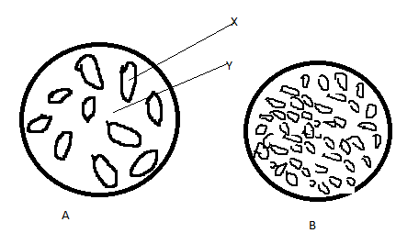

(a)Name X and Y
X water.(1mk)
Y space…(1mk)
(bWhat type of soil A and B(2mks)
Sand particles
Lumps of clay particles

- Outline four importance of keeping farm records. (4mks)

- They show the history of the farm
- Guide the farmer in planning and budgeting of farm operations
- Help in supporting insurance claims on death, theft and fire of farm assets
- Provide labour information like terminal benefits
- Helps to detect losses or theft of the farm
- Helps to compare performance of different enterprises.

- a) Under what farming conditions is opportunity cost zero? (1mk)

- When there are no alternatives.

b) What are farm records? (1mk)

- They are documents kept in the farm showing farm activities over a given period of time.

- Name four commonly kept records used by a farmer (4mks)
-Production records -Feeding records
-Inventory records - Health records
-Field operation records - Marketing records
-Breeding records - Labour records
5. A part from opportunity cost, state two other basic economic concepts. (2mks)
- Scarcity
- Preference and choice
6. State four factors that determine the type of irrigation chosen by a farmer. (4mks)
- Capital availability
- Water availability
- Type of crop to be irrigated
- Topography of the land
- Type of soil.
7. Name four breeds of dairy goats. (4mks)
- Saanen
- Toggen burg
- British alpine
- Anglo Nubian
- Jamnapari
8. Outline four advantages of practicing mixed farming (4mks)
- It makes better utilization of the available land
- There is better conservation of water and soil
- A mutual benefit exists between crops and animals
- There is diversification of farming business.
9. State five activities Agriculture entrants as an art. (5mks)
- Tilling of the land
- Construction of farm structures
- Measuring distance
- Machine operations
- Harvesting of crops
- Feeding and handling crops
- Marketing of agricultural produce
10. Outline four roles of agriculture in an economy. (4mks)
- Food supply
- Source of employment
- Provision of foreign exchange
- Source of capital
- Provision of market for industrial goods
- Source of raw materials for industries
11. Name any four branches of Agriculture. (2mks)
- Livestock production
- Crop production
- Apiculture
- Poultry keeping
- Agricultural economics
- Soil science
- Olericulture etc
12. Outline three advantages of shifting cultivation. (3mks)
- Has low capital requirements
- There is no pest and disease build up
- Soil structure is maintained
- No land disputes as land ownership is not individualized
13. State four biotic factors affecting agriculture production. (4mks)
-Pests -Predators
-Parasites -Pollinators
-Decomposers -Nitrogen fixing bacteria
-Pathogens
14. Name four physical agents of weathering. (4mks)
- Wind
- Water
- Moving ice
- Temperature
15. What are the four factors influencing soil formation? (4mks)
- Parent rock material
- Climate
- Topography
- Time

16. . . Study the diagram below and answer the questions that follow.
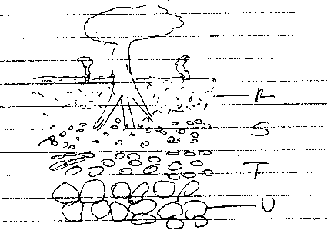

(a) What does the diagram above represent. (1mk)
Soil profile

(b) Name parts labelled R, S, T and U.
R top soil (1mk)
S sub soil (1mk)
T weathered rock (1mk)
U parent rock (1mk)

(cState any three components of soil(3mks)

Minerak matter

Organic matter

Air

Water

Living organism

17. What are the two main classes of soil living organisms? (2mks)
- The macro- organisms
- The micro- organisms
18. State three effects of HIV/AIDS on Agriculture. (3mks)
- Shortage of farm labour
- Increasing cost of living of AIDS patients and their relatives
- Low living standards
- Low food supply
- The government and NGO’s use a lot of time and resources in controlling the pandemic
19. State three reasons for proper care and maintenance of farm tools and equipment. (3mks)
- To increase durability
- To reduce the replacement cost
- Increased efficiency
- To avoid injury to the user
- To avoid damage to the tool
20. State the maintenance practices carried out on the following tools;
i) Hand saw (1mk)
-Regular sharpening of teeth should be done
ii) Milking churn (1mk)
-Clean after use
iii) Jembe (1mk)
-Broken handles should be replaced
iv) Chisel (1mk)
-Sharpen the cutting edges
21. State three reasons for preparing land before use. (3mks)
- To kill weeds
- To aerate the soil
- To encourage penetration of roots
- To encourage water infiltration
- To destroy stages of crop pests
22. List two factors that determine the number of times a farmer would harrow his land. (2mks)
- Size of planting materials
- Slope of the land
- The moisture content of the soil
- Conditions of the soil after primary cultivation
23. Give three reasons why minimum tillage is practiced. (3mks)
- To reduce cost of cultivation
- To control soil erosion
- To maintain soil structure
- To conserve moisture
- To prevent exposure of humus
24. Give two reasons why the burning of bushes as a method of land clearing should be discouraged. (2mks)
- A lot of organic matter is destroyed
- Burning kills soil micro-organisms
- Planting nutrients are destroyed
25. State three importance of primary cultivation. (3mks)
- To remove weeds
- To bury organic matter for easy decomposition
- To facilitate water infiltration and aeration
- To destroy soil-born pests by exposing them to predators and sun
- To make planting easy
26. a) State three tertiary operations carried out to suit production of crops. (3mks)
- Ridging
- Rolling
- Leveling
b) Name three sources of surface water. (3mks)
- Rivers
- Streams
- Dams
- Lakes
27. Outline the Agricultural practices that pollute water. (2mks)
- Use of inorganic fertilizers
- Use of pesticides
- Poor cultivation practices
28.a) What is drainage? (1mk)
-This is a method of removing excess water or lowering water table from marshy waterlogged land.

b) List four types of drainage. (2mks)
- Open ditches
- Underground drain pipes
- French Drains
- Cambered Beds
- Pumping
- Planting trees
29. State six ways through which soil fertility is maintained. (3mks)
- Control of soil erosion
- Crop rotation
- Control of soil PH
- Proper drainage
- Weed control
- Mixed cropping
- Minimum tillage
- Use of manure
- Use of inorganic fertilizers

