443/1

AGRICULTURE

PAPER 1
TIME: 2 HOURS
JULY/AUGUST 2021
PREMOCK 1

Name………………………………………………………. Adm No……………….
Stream…………………………………………… Date ………………………….
Sign ......................................

INSTRUCTION TO CANDIDATES
- Write your name and index number and school, Sign and write the date in the spaces
provided above.
- This paper consists of THREE sections; A, B and C.
- Answer All the questions in section A and B in the spaces provided and any TWO questions
from section C in the answer sheet provided

FOR EXAMINERS USE ONLY

SECTION | QUESTION | MAXIMUM SCORE | CANDIDATE’S SCORE
A | 1 - 17 | 30
B | 18 - 22 | 20
C |  | 20
 |  | 20
TOTAL SCORE |  | 90

SECTION A (30 MARKS)
Answer all the question in this section in the spaces provided.

1. Name the routine field practice done by:
(a) Removal of extra suckers in banana stool. (½mrk)
…………………………………………………………………………………………………………………………………………………………………………………………………………………...…………
(b) Removal of old stems down to level of top foliage in pyrethrum. (½mrk) ………………………………………………………………………………………………………………………………………………………………………………………………………………………………
(c) Removal of suckers from coffee bushes. (½mrk)
………………………………………………………………………………………………………………………………………………………………………………………………………………….…………
2. State three characteristics of phosphate fertilizers. (1½mks)
………………………………………………………………………………………………………………………………………………………………………………………………………………………………………………………………………………………………………………………………………………
3. State two physical properties of soil that influence crop production. (1mk)
……………………………………………………………………………………………………………………………………………………………………………………………………………..………………
4. Outline four ways by which crop pests are classified. (2mks)
………………………………………………………………………………………………………………………………………………………………………………………………………………………………………………………………………………………………………………………………………………………………………………………………………………………………………………………
5. State three uses of labour records in Agriculture. (1½mks)
……………………………………………………………………………………………………………………………………………………………………………………………………………………………………………………………………………………………………………………………………..……
6. Give four advantages of overhead irrigation in crop production. (2mrks)
………………………………………………………………………………………………………………………………………………………………………………………………………………………………………………………………………………………………………………………………………………………………………………………………………………………………………………………………
7. List three basic concepts in agricultural economics. (1½mrks)
………………………………………………………………………………………………………………………………………………………………………………………………………………………………………………………………………………………………………………………………………………
8. Give four varieties of tomatoes grown for processing. (2mks)
………………………………………………………………………………………………………………………………………………………………………………………………………………………………………………………………………………………………………………………………………………
9. State four pasture management practices done to enhance yields per unit area. (2mrks)

……………………………………………………………………………………………………………………………………………………………………………………………………………………………………………………………………………………………………………………………………………………………………………………………………………………………….……………………………
10. Name two macro-nutrients which classified as:
(a) Fertilizer elements. (1mrk)
………………………………………………………………………………………………………………………………………………………………………………………………………………
(b) Liming elements. (1mrk)
……………………………………………………………………………………………………………………………………………………………………………………….……………………
11. Give three ways by which pruning helps to control disease in crops. (1½mrks)

……………………………………………………………………………………………………………………………………………………………………………………………………………………………………………………………………………………………………………………………………
12. State four ways in which weeds are excellently adapted to the environment. (2mrks)

…………………………………………………………………………………………………………………………………………………………………………………………………………………………………………………………………………………………………………………………………………………………………………………………………………………………………………………………..…

13. State four factors that determine the time at which a crop is planted. (2mks)
………………………………………………………………………………………………………………………………………………………………………………………………………………………………………………………………………………………………………………………………………………………………………………………………………………………………………………………………
14. Give four factors that affected the effectiveness of a pesticide. (2mrks)
……………………………………………………………………………………………………………………………………………………………………………………………………………………………………………………………………………………………………………………………………………………………………………………………………………………………………………………..………
15. State four reasons for staking tomatoes in crop production. (2mrks)
………………………………………………………………………………………………………………………………………………………………………………………………………………………………………………………………………………………………………………………………………………………………………………………………………………………………………………………………
16 State three cultural methods of soil and water conservation. (1½mrks)
………………………………………………………………………………………………………………………………………………………………………………………………………………………………………………………………………………………………………………………………………………
17. State four benefits of having a land title deed to a farmer. (2mrks)
……………………………………………………………………………………………………………………………………………………………………………………………………………………………………………………………………………………………………………………………………………………………………………………………………………………………………………………………

SECTION B. (20 MARKS)
Answer ALL questions in this section in the spaces provided

18. Study the diagram below and answer the questions that follow. The illustrations represent
a method of crop propagation.

(a) Name the crops propagated by illustrations: (2mrks)

A.............................................................................................................

B...............................................................................................................

(b) Give three factors that promote the rooting of illustration A. (3mrks)
………………………………………………………………………………………………………………………………………………………………………………………………………………………………………………………………………………………………………………………

19 The diagram below illustrates an experiment using garden soil. Study it carefully and answer the questions that follow.
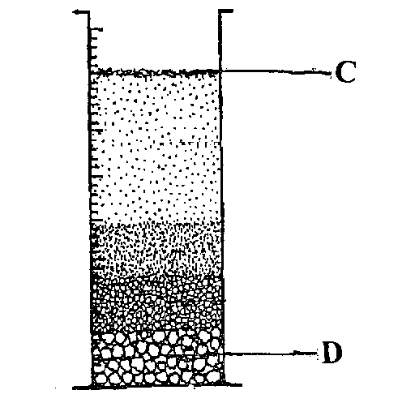

(a) What was the aim of the experiment? (1mrk)

………………………………………………………………………………………………………

(b) Name the parts labeled C and D. (2mrks)

C..............................................................................................................................

D..............................................................................................................................
(c) Name the property of soil being investigated. (1mrk)

………………………………………………………………………………………………………………………………………………………………………………………………........................

20. The illustration below shows a type of soil erosion. Study it carefully and answer the questions that follow.
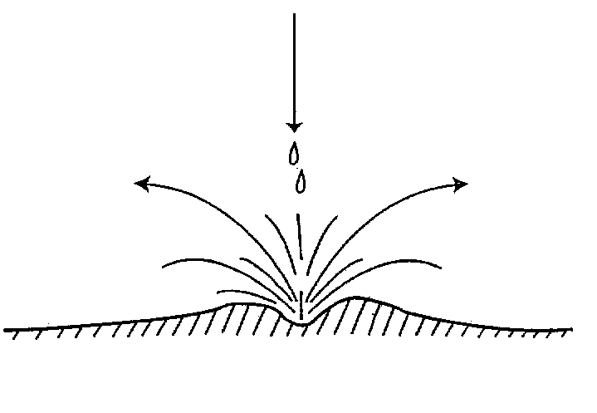

(a) Identify the type of erosion illustrated above. (1mrk)
………………………………………………………………………………………………………
(b) Give two soil factors that influence the rate of soil erosion. (2mrks)

………………………………………………………………………………………………………………………………………………………..………………………………………………........................
(c) Name one agent of soil erosion. (1mrk)

………………………………………………………………………………………………………

21. The diagram below represents a method of manure preparation. Study it carefully and answer the questions that follow.

(a) Identify the type of manure being prepared. (1mrk)

………………………………………………………………………………………
(b) Name the parts labeled E and F. (2mrks)

E..............................................................................................................

F...............................................................................................................

(c) Give four disadvantages of manures. (4mrks)
……………………………………………………………………………...…………………………………………………………………………………………………………........................................................................................................................................................................................................................................................................................................................................................................................................

SECTION C (40MARKS)
Answer any two questions from this section in the answer sheet provided

22. (a) Describe land preparation for planting of grass seeds. (4mrks)
………………………………………………………………………………………………………………………………………………………………………………………………………………………………………………………………………………………………………………………………………………………………………………………………………………………………………………………………………………………………………………………………………………………………………………………………………………………………………………………………………………………………………………………………………………………………………………………………………………………………………………………………………………………………………………………………………………………………………………………………………………………………………………………………………………………………………………………………………………………………………………………………………………………………………………………………………………
(b) Explain the precautions that should be observed during the harvesting of pyrethrum (4mks)
……………………………………………………………………………………………………………………………………………………………………………………………………………………………………………………………………………………………………………………………………………………………………………………………………………………………………………………………………………………………………………………………………………………………………………………………………………………………………………………………………………………………………………………………………………………………………………………………………………………………………………………………………………………………………………………………………………………………………………………………………………………………………………………………………………………………………………………………………………………………………………………………...……………………………………………………………………………………………………………………………………………………………………………………………………………………………………………………………………………………………………………………………………………………………………………………………………………………………………………………………………………………………………………………………………….……

(c) Explain six benefits of land consolidation in Agricultural production. (12mrks)

……………………………………………………………………………………………………………………………………………………………………………………………………………………………………………………………………………………………………………………………………………………………………………………………………………………………………………………………………………………………………………………………………………………………………………………………………………………………………………………………………………………………………………………………………………………………………………………………………………………………………………………………………………………………………………………………………………………………………………………………………………………………………………………………………………………………………………………………………………………………………………………………..………………………………………………………………………………………………………………………………………………………………………………………………………………………………………………………………………………………………………………………………………………………………………………………………………………………………………………………………………………………………………………………………………………………………………………………………………………………………………………………………………………………………………………………………………………………………………………………………………………………………………………………………………………………………
……………………………………………………………………………………………………………………………………………………………………………………………………………………………………………………………………………………………………………………………………………………………………………………………………………………………………………………………………………………………………………………………………………………………………………………………………………………………………………………………………………………………………………………………………………………………………………………………………………………………………………………………………………………………………………………………………………………………………………………………………………………………………………………………………………………………………………………………………………………………………………………………………………………………………………………………………………………………………………………………………………………………………………………………...

23. (a) Describe the field management practices that should be carried out on dry bean production. (10mrks)

……………………………………………………………………………………………………………………………………………………………………………………………………………………………………………………………………………………………………………………………………………………………………………………………………………………………………………………………………………………………………………………………………………………………………………………………………………………………………………………………………………………………………………………………………………………………………………………………………………………………………………………………………………………………………………………………………………………………………………………………………………………………………………………………………………………………………………………………………………………………………………………………...………………………………………………………………………………………………………………………………………………………………………………………………………………………………………………………………………………………………………………………………………………………………………………………………………………………………………………………………………………………………………………………………………………………………………………………………………………………………………………………………………………………………………………………………………………………………………………………………………………………………………………………………………………………………
……………………………………………………………………………………………………………………………………………………………………………………………………………………………………………………………………………………………………………………………………………………………………………………………………………………………………………………………………………………………………………………………………………………………………………………………………………………………………………………………………………………………………………………………………………………………………………………………………………………………………………………………………………………………………………………………………………………………………………………………………………………………………………………………………………………………………………………………………………………………………………………………………………………………………………………………………………………………………………………………………………………………………………………………...

(b) Explain five factors that should be considered when deciding on the depth of planting a seed. (5mrks)
………………………………………………………………………………………………………………………………………………………………………………………………………………………………………………………………………………………………………………………………………………………………………………………………………………………………………………………………………………………………………………………………………………………………………………………………………………………………………………………………………………………………………………………………………………………………………………………………………………………………………………………………………………………………………………………………………………………………………………………………………………………………………………………………………………………………………………………………………………………………

(c) Describe the characteristics of a crop suitable for green manure. (5mrks)
……………………………………………………………………………………………………………………………………………………………………………………………………………………………………………………………………………………………………………………………………………………………………………………………………………………………………………………………………………………………………………………………………………………………………………………………………………………………………………………………………………………………………………………………………………………………………………………………………………………………………………………………………………………………………………………………………………………………………………………………………………………………………………………………………………………………………………………………………………………………………………………………...………………………………………………………………………………………………………………………………………………………………………………………………………………………………………………………………………………………………………………………………………………………………………………………………………………………………………………………………………………………………………………………………………………………………………………………………………………………………………………………………………………………………………………………………………………………………………………………………………………………………………………………………………………………………
………………………………………………………………………………………………………….…

24. (a) Describe the procedure followed when collecting a soil sample from the field for testing in the laboratory (5mks)
……………………………………………………………………………………………………………………………………………………………………………………………………………………………………………………………………………………………………………………………………………………………………………………………………………………………………………………………………………………………………………………………………………………………………………………………………………………………………………………………………………………………………………………………………………………………………………………………………………………………………………………………………………………………………………………………………………………………………………………………………………………………………………………………………………………………………………………………………………………………………………………………...………………………………………………………………………………………………………………………………………………………………………
(b) Describe the benefits of using certified seeds in crop production. (5mrks)
……………………………………………………………………………………………………………………………………………………………………………………………………………………………………………………………………………………………………………………………………………………………………………………………………………………………………………………………………………………………………………………………………………………………………………………………………………………………………………………………………………………………………………………………………………………………………………………………………………………………………………………………………………………………………………………………………………………………………………………………………………………………………………………………………………………………………………………………………………………………………………………………...………………………………………………………………………………………………………………………………………………………………………………………………………………………………………………………………………………………………
……………………………………………………………………………………………………………………………………………………………………………………………………………………………………………………………………………………………………………………………………………………………………………………………………………………………………………………………………………………………………………………………………………………………………………………………………………………………………………………………………………………………………………………………………………………………………………………………………………………………………………………………………..

(c) Describe the safety precautions a farmer should take when using herbicides. (10mks)
……………………………………………………………………………………………………………………………………………………………………………………………………………………………………………………………………………………………………………………………………………………………………………………………………………………………………………………………………………………………………………………………………………………………………………………………………………………………………………………………………………………………………………………………………………………………………………………………………………………………………………………………………………………………………………………………………………………………………………………………………………………………………………………………………………………………………………………………………………………………………………………………...………………………………………………………………………………………………………………………………………………………………………………………………………………………………………………………………………………………………………………………………………………………………………………………………………………………………………………………………………………………………………………………………………………………………………………………………………………………………………………………………………………………………………………………………………………………………………………………………………………………………………………………………………………………………………………………………………………………………………………………………………………………………………………………………………………………………………………………………………………………………………………………………………………………………………………………………………………………………………………………………………………………………………………………………………………………………………………………………………………………………………………………………………………………………………………………………………………………………………………………………………………………………
………………………………………………………………………………………………………………………………………………………………………………………………………………………………………………………………………………………………………………………………………………………………………………………………………………………………………………………………………………………………………………………………………………………………………………

