MID TERM 1 EXAM TERM ONE-2023
Name: ……………………………………………………………………………… ADM: ……………… CLASS: …………..DATE………………………………… SCH…………………………………………………………………………………. AGRICULTURE PAPER 1 TIME: 2 HOURS
INSTRUCTIONS TO CANDIDATES:

• This paper contains three sections A, B and C

• Answer ALL the questions in section A and B

• Answer any Two questions from section C

• All answers should be written in the spaces provided.

FOR EXAMINERS USE ONLY

SECTION | QUESTIONS | MAX SCORE | CANDIDATES SCORE
A | 1-14 | 30
B | 15-18 | 20
C |  | 20
 |  | 20
TOTAL |  | 90

SECTION A (30MKS)

Answer ALL the questions in this section in the spaces provided

1.State two reasons why farmers should be encouraged to practice organic farming

(1mk)

………………………………………………………………………………………

…………….…………………………………………………………………………

………………………………………………………………………………………

……………………………………………………………………………………….

2. State two ways in which crop rotation controls weeds (1mk)

………………………………………………………………………………………

…………….…………………………………………………………………………

……………………………………………………………………………………….

3. Name two methods of sowing pasture crops (1mk)

………………………………………………………………………………………

…………….…………………………………………………………………………

……………………………………………………………………………………….

4. State four qualities considered when selecting seeds for planting (2mks)

………………………………………………………………………………………

…………….…………………………………………………………………………

………………………….……………………………………………………………

……………………………………….………………………………………………

………………………………………………………………………………………

………………………………………………………………………………………
5. State four advantages of crop rotation (2mks)

………………………………………………………………………………………

…………….…………………………………………………………………………

………………………………………………………………………………………

……………………………………….………………………………………………

……………………………………………………………………………………….

6. State three physical agents of weathering in soil formation (1 ½ mks)

………………………………………………………………………………………

…………….…………………………………………………………………………

………………………….……………………………………………………………

………………………………………………………………………………………

……………………………………………………………………………………….

7. Give three properties of a foliar fertilizer which makes it possible to be used as a foliar

Feed (1 ½ mks)

………………………………………………………………………………………

…………….…………………………………………………………………………

………………………………………………………………………………………

………………………………………………………………………………………

………………………………………………………………………………………

8. Give three reasons why Banana should be pruned (1 ½ mks)

………………………………………………………………………………………

………………………………………………………………………………………

………………………………………………………………………………………
………………………………………………………………………………………

………………………………………………………………………………………

………………………………………………………………………………………

9. State four factors considered when classifying crop pests (2mks)

………………………………………………………………………………………

…………….…………………………………………………………………………

………………………………………………………………………………………

……………………………………….………………………………………………

……………………………………………………………………………………….

10. Give four reasons for land fragmentation (2mks)

………………………………………………………………………………………

…………….…………………………………………………………………………

………………………….……………………………………………………………

………………………………………………………………………………………

………………………………………………………………………………………

………………………………………………………………………………………

11. State two mechanical methods used in separating soil in soil analysis (1mk)

………………………………………………………………………………………

…………….…………………………………………………………………………

……………………………………………………………………………………….

12. State three ways in which inorganic fertilizers are classified (1 ½ mks)

………………………………………………………………………………………

………………………………………………………………………………………

………………………………………………………………………………………

………………………………………………………………………………………

………………………………………………………………………………………

………………………………………………………………………………………

13. State three effects of raindrops on bare soil ( 1 ½ mks)

………………………………………………………………………………………

…………….…………………………………………………………………………

………………………….……………………………………………………………

………………………………………………………………………………………

………………………………………………………………………………………

14. Give three reasons why layering would be preferred to the use of cutting as a method of raising planting materials ( ½ mks)

………………………………………………………………………………………

…………….…………………………………………………………………………

………………………….……………………………………………………………

………………………………………………………………………………………

………………………………………………………………………………………

15. State the forms in which nitrogen is absorbed by plants (1mk)

………………………………………………………………………………………

……………………………………………………………………………………….

16. Outline four factors which effect herbraidal selectivity (2mks)

………………………………………………………………………………………

………………………………………………………………………………………

………………………………………………………………………………………

………………………………………………………………………………………

………………………………………………………………………………………

……………………………………………………………………………………….

17. State four natural factors that may influence soil erosion (2mks)

………………………………………………………………………………………

………………………………………………………………………………………

………………………….……………………………………………………………

……………………………………….………………………………………………

………………………………………………………………………………………

18. Name four disadvantages of zero grazing (2mks)

………………………………………………………………………………………

…………….…………………………………………………………………………

………………………….……………………………………………………………

……………………………………….………………………………………………

………………………………………………………………………………………

……………………………………………………………………………………….

19. Outline four factors which encourage soil erosion (2mks)

………………………………………………………………………………………

…………….…………………………………………………………………………

………………………….……………………………………………………………

……………………………………….………………………………………………

………………………………………………………………………………………

……………………………………………………………………………………….
SECTION B (20 MKS)

Answer ALL Questions in this section

20. Below are illustrations of common weeds. Study them and answer the questions that follow

A
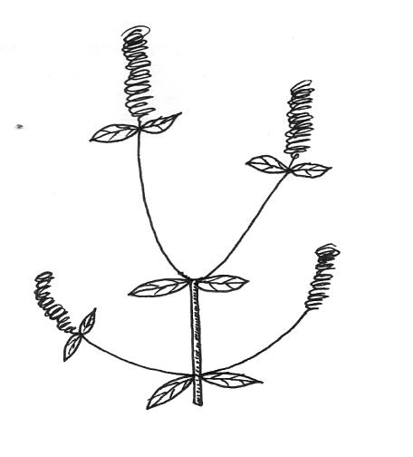

B
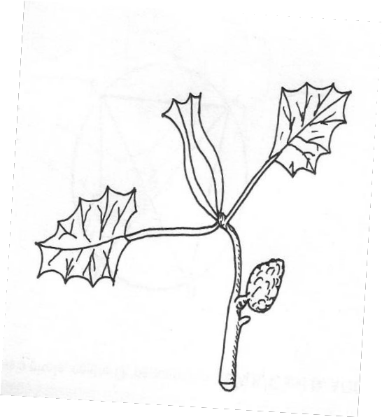

(a) Identify the weeds (2mks) A……………………………………………. B…………………………………………….
(b) State the harmful effects of the weed B above (1mk)

………………………………………………………………………………………

………………………………………………………………………………………

………………………………………………………………………………………

(c) Give four advantages of leasehold tenure systems (2mks)

………………………………………………………………………………………

………………………………………………………………………………………
………………………………………………………………………………………

………………………………………………………………………………………

………………………………………………………………………………………

………………………………………………………………………………………

21. Describe the procedure which should be followed when spraying a crop of onions using a fungicide in powder form, water and a knapsack sprayer
(5mks)

………………………………………………………………………………………

…………….…………………………………………………………………………

………………………….……………………………………………………………

……………………………………….………………………………………………

…………………………………………………….…………………………………

………………………………………………………………….……………………

22.. (a) What is soil sampling? (1 mark)

............................................................................................................................. ........

........................................................................................................................... ..........

.....................................................................................................................................

(b) Below is a method of soil sampling. Use it to answer the question that follow.

1 7

2 8

3 9

10 4

11 5

12 6
(i) What method of soil sampling is represented above? (1 mark )

………………………………………………………………………………………

………………………………………………………………………………………

(ii) name the other method of soil sampling (1mark)

………………………………………………………………………………………

……………………………………………………………………………………….

(iii) Outline three areas which should be avoided during soil sampling. (3 marks )

………………………………………………………………………………………

………………………………………………………………………………………

………………………………………………………………………………………

………………………………………………………………………………………

………………………………………………………………………………………

23. . Identify the rotational grazing system shown below (1mk)

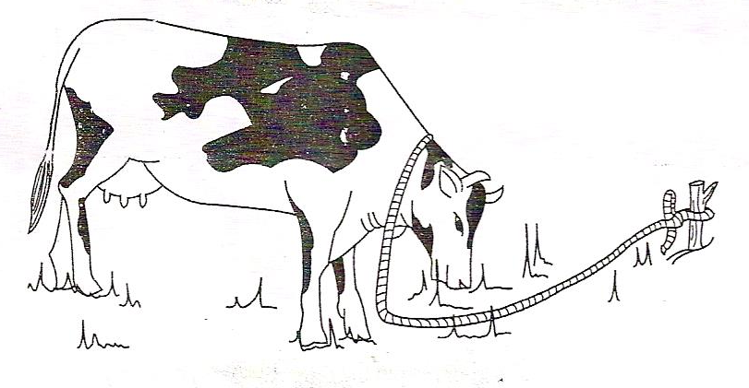

……………………………………………………………………………..

b) Give the FOUR advantages of the system named above (4mks)

………………………………………………………………………………………

………………………………………………………………………………………
………………………………………………………………………………………

………………………………………………………………………………………

………………………………………………………………………………………

………………………………………………………………………………………

SECTION C (40MKS)

Answer any two Questions in this section

24. (a) Describe harvesting of pyrethrum under the following sub-headings (i) Procedure (4mks) (ii) Precautions (6mks)
(b) Describe the safety measures observed when handling farm herbicides

(10mks)

25. Describe the production of Rhodes grass (Chloris gayana) under the following sub-headings

(a) Land preparation (5mks) (b) Pasture establishment (8mks) (c) Maintenance (7mks)
26. .(a) Discuss the production of beans under the following sub headings

(i) Land preparation (4mks)

(ii) | Varieties (2mks)
(iii) | Selection and preparation of planting materials | (5mks)
(iv) | Field management practices

(b) Explain the method and procedure of harvesting of sugarcane (4mks)
………………………………………………………………………………………

…………….…………………………………………………………………………

………………………….……………………………………………………………

……………………………………….………………………………………………

…………………………………………………….…………………………………

………………………………………………………………….……………………

……………………………………………………………………………….………

………………………………………………………………………………………

…….…………………………………………………………………………………

………………….……………………………………………………………………

……………………………….………………………………………………………

…………………………………………….…………………………………………

………………………………………………………….……………………………

……………………………………………………………………….………………

…………………………………………………………………………………….…

………………………………………………………………………………………

………….……………………………………………………………………………

……………………….………………………………………………………………

…………………………………….…………………………………………………

………………………………………………….……………………………………

……………………………………………………………….………………………

…………………………………………………………………………….…………

………………………………………………………………………………………

….……………………………………………………………………………………

………………………………………………………………………………………

………………………………………………………………………………………

