Name………………………………………………………………………Index No…………………….
School…………………………………………………………………….. Sign………………………….
Date………………………….
443/2
AGRICULTURE
September 2021
Paper 2
Time: 2 Hours

JOINT PRE - MOCK 2021

Kenya Certificate of Secondary Education (K.C.S.E)

INSTRUCTIONS TO CANDIDATES
1. Write your name and index number in the spaces provided.
2. This paper consists of three sections; A, B and C
3. Answers should be written in the spaces provided.

FOR EXAMINER’S USE ONLY
SECTION | QUESTIONS | MAXIMUM SCORE | CANDIDATE’S SCORE
A | 1 -15 | 30
 | 16 – 20 | 20
B | 21 - 23 | 20
C |  | 20  20
TOTAL SCORE |  | 90

This paper consists of 14 printed pages. Candidates should check the question paper to
Ensure that all pages are printed as indicated and no questions are missing.

SECTION A (30 MARKS)
Answer all Questions from this section in the spaces provided.
1. Under what condition would a farmer use an ox-cart instead of a tractor drawn trailer? (l mk)
………………………………………………………………………………………………………………………………………………………………………………………………………………
2. State two practices that may require special method of handling of a mature fresian cow. (1 mk)
………………………………………………………………………………………………………………………………………………………………………………………………………………
3. State any two physiological conditions of livestock that may be assessed to determine the health status of an animal. (l mk)
………………………………………………………………………………………………………………………………………………………………………………………………………………
4. Give any four precautions taken when harvesting honey. (2 mks)
………………………………………………………………………………………………………………………………………………………………………………………………………………
………………………………………………………………………………………………………………………………………………………………………………………………………………
5. Name four exotic pig breeds reared in Kenya. (2marks)
………………………………………………………………………………………........................
………………………………………………………………………………………………………………………………………………………………………………………………………………
………………………………………………………………………………………………………6. A cow gives birth to two offspring in a period of three years. One offspring is a male named Zulo and another, female named Kerio. Two years later Zulo is mated to Keroi and another offspring, called Tedi is given birth to
(i) Identify the specific system of breeding between Zulo and Keroi. (1 mk)
………………………………………………………………………………………………………
(ii) Give four disadvantages of such a system of breeding. (2 mks)
………………………………………………………………………………………………………………………………………………………………………………………………………………
………………………………………………………………………………………………………………………………………………………………………………………………………………
7. List four ways by which an animal may get infected by a disease from another. (2 mks)
………………………………………………………………………………………………………………………………………………………………………………………………………………
………………………………………………………………………………………………………………………………………………………………………………………………………………
8. Give one use for each of the following tools and equipment. (2 mks)
(i) Dibber
………………………………………………………………………………………………………………………………………………………………………………………………………………
(ii) Halter
………………………………………………………………………………………………………………………………………………………………………………………………………………

(iii) Bolus gun
………………………………………………………………………………………………………………………………………………………………………………………………………………
(iv) Shovel
………………………………………………………………………………………………………………………………………………………………………………………………………………
9. (a) State the purpose of dry cow therapy. ( ½ mk)
………………………………………………………………………………………………………………………………………………………………………………………………………………
………………………………………………………………………………………………………………………………………………………………………………………………………………
………………………………………………………………………………………………………………………………………………………………………………………………………………
(b) List four factors that affect milk let down process. (2 mks)
………………………………………………………………………………………………………………………………………………………………………………………………………………
………………………………………………………………………………………………………………………………………………………………………………………………………………
………………………………………………………………………………………………………………………………………………………………………………………………………………
………………………………………………………………………………………………………………………………………………………………………………………………………………

10. List four observable features in a cow that may indicate that it’s nearing parturition. (2 mks)
………………………………………………………………………………………………………………………………………………………………………………………………………………
………………………………………………………………………………………………………………………………………………………………………………………………………………………………………………………………………………………………………………………
11. (a) Give the meaning of the following terms as used in livestock breeds. (1½ mks)
(i) Steer
………………………………………………………………………………………………………………………………………………………………………………………………………………
(ii) Capon
………………………………………………………………………………………………………………………………………………………………………………………………………………
(iii) Kindling
………………………………………………………………………………………………………………………………………………………………………………………………………………
(b) Name the exotic beef breed of cattle with the following characteristics;
* White / cream in colour
* Heavily built
* Originated from France (½ mk)
………………………………………………………………………………………………………………………………………………………………………………………………………………
………………………………………………………………………………………………………………………………………………………………………………………………………………
12. State two indicators of prolificacy in pigs. (1 mk)
………………………………………………………………………………………………………………………………………………………………………………………………………………
………………………………………………………………………………………………………………………………………………………………………………………………………………

13. Give four reasons for providing high quality ration in the last two weeks to parturition in goats.
(2 mks)
………………………………………………………………………………………………………………………………………………………………………………………………………………
………………………………………………………………………………………………………………………………………………………………………………………………………………
14. Outline three reasons why calves should be fed on colostrum. (1½ mks)
………………………………………………………………………………………………………………………………………………………………………………………………………………
………………………………………………………………………………………………………………………………………………………………………………………………………………
15. State two ways by which each of the following aspects are achieved in a calf pen.
(a) Proper drainage. (1 mk)
………………………………………………………………………………………………………………………………………………………………………………………………………………
(b) Freedom from draught (1 mk)
………………………………………………………………………………………………………………………………………………………………………………………………………………
16. (a) Define Raddling in sheep management. (1 mk)
………………………………………………………………………………………………………………………………………………………………………………………………………………
………………………………………………………………………………………………………………………………………………………………………………………………………………
(b) State two reasons for raddling. (1 mk)
………………………………………………………………………………………………………………………………………………………………………………………………………………
17. Give two reasons why concrete floors are recommended for dairy sheds. (l mk)
………………………………………………………………………………………………………………………………………………………………………………………………………………
………………………………………………………………………………………………………………………………………………………………………………………………………………

SECTION B (20 MARKS)
Answer all the questions in this question in the spaces provided.
18. Below is a farm structure. Study it carefully and answer the questions below.
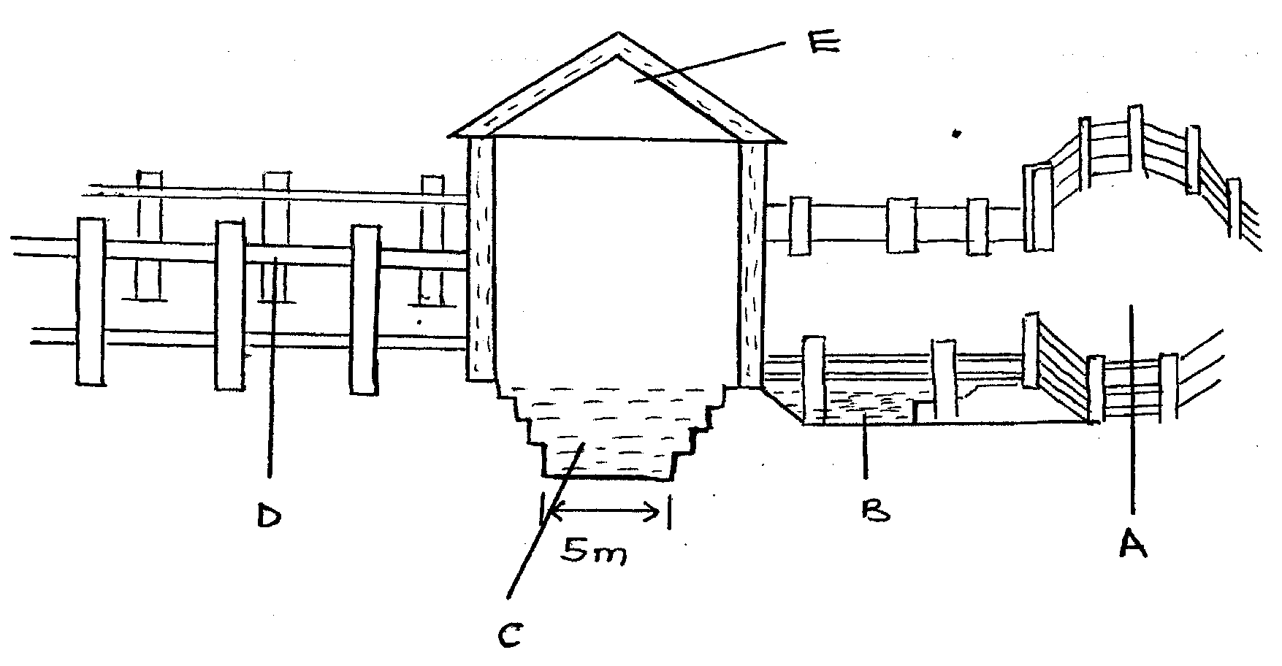

(i) What is the use of the above structure? (½ mark)
………………………………………………………………………………………………………………………………………………………………………………………………………………
(ii) State one management practice carried out on livestock before being led into the structure. ( ½ mark)
………………………………………………………………………………………………………………………………………………………………………………………………………………
(iii) State two roles played by the part labeled E. (1 mark)
………………………………………………………………………………………………………………………………………………………………………………………………………………
………………………………………………………………………………………………………………………………………………………………………………………………………………
(iv) Give the role of the parts labeled A and B. (1 mark)
A
………………………………………………………………………………………………………
B
………………………………………………………………………………………………………

(v) State four factors to consider when siting the structure in the farm. (2 marks)
………………………………………………………………………………………………………………………………………………………………………………………………………………
………………………………………………………………………………………………………………………………………………………………………………………………………………
19. (a) Study the diagram below illustrating a method of identifying a farm animal.
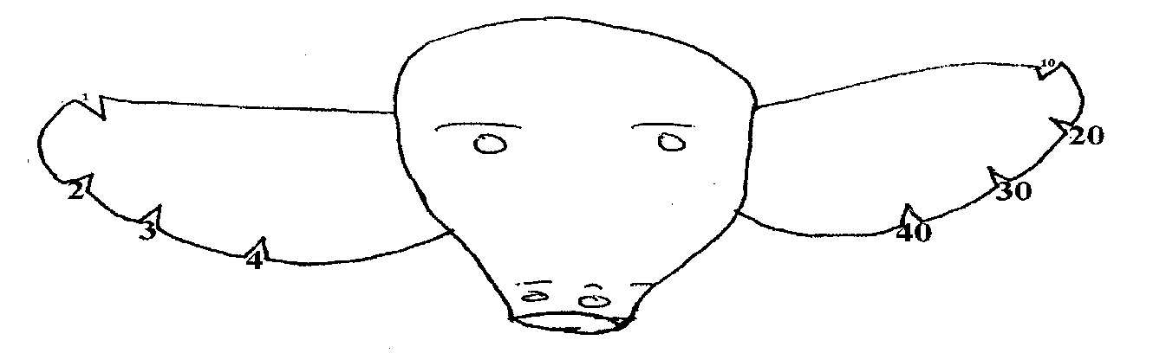
Using the above illustration draw and mark number 87 (2 mks)
………………………………………………………………………………………………………………………………………………………………………………………………………………
………………………………………………………………………………………………………………………………………………………………………………………………………………
………………………………………………………………………………………………………………………………………………………………………………………………………………
(b) Outline the procedure of castrating a piglet by use of surgical method. (4 mks)
………………………………………………………………………………………………………………………………………………………………………………………………………………
………………………………………………………………………………………………………………………………………………………………………………………………………………
………………………………………………………………………………………………………………………………………………………………………………………………………………
………………………………………………………………………………………………………………………………………………………………………………………………………………
………………………………………………………………………………………………………………………………………………………………………………………………………………

20. Study the diagram of chicken digestive system below and answer the question that follow.

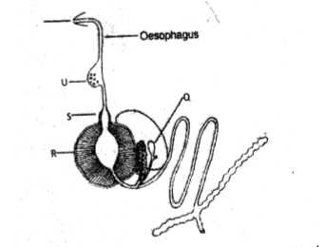

(a) Identify the parts labelled Q, R and S. (1½ mks)
Q ………………………………………………………………………………………
R ………………………………………………………………………………………
S ………………………………………………………………………………………
(b) Briefly describe the function of parts Q and R. (2 mks)
Q
………………………………………………………………………………………………………………………………………………………………………………………………………………
R
………………………………………………………………………………………………………………………………………………………………………………………………………………
(c) How can a farmer improve on digestion in the structure labelled S. ( ½ mk)
………………………………………………………………………………………………………………………………………………………………………………………………………………

21. Below is a diagram of a farm equipment. Use it to answer the questions that follow.
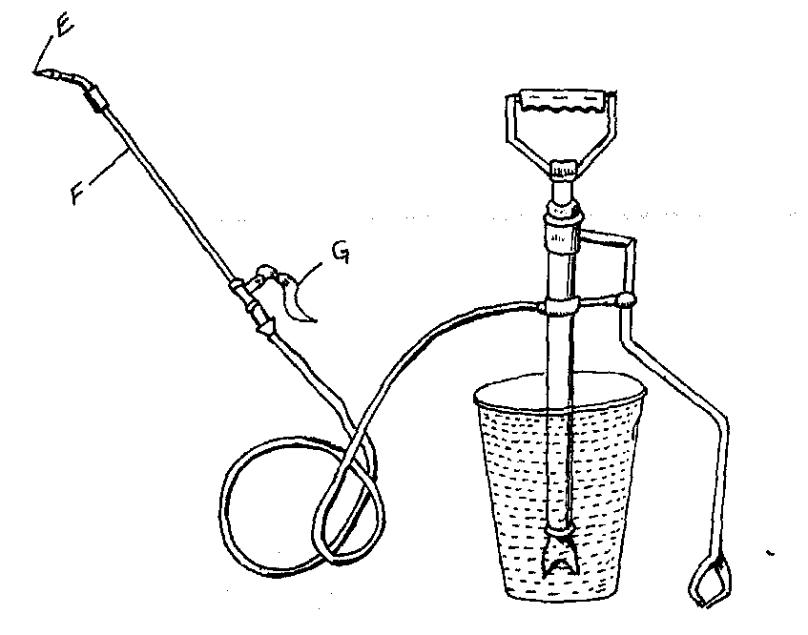

(a) Identify the equipment. ( ½ mk)
………………………………………………………………………………………………………………………………………………………………………………………………………………
(b) State the use of the equipment (1 mk)
………………………………………………………………………………………………………………………………………………………………………………………………………………
(c) Name the parts labelled G,E and F. (1½mks)
………………………………………………………………………………………………………………………………………………………………………………………………………………
………………………………………………………………………………………………………………………………………………………………………………………………………………
(d) Identify two draw backs in using this equipment compared to others that may be used for the same purpose. (2 mks)
………………………………………………………………………………………………………………………………………………………………………………………………………………
………………………………………………………………………………………………………………………………………………………………………………………………………………

SECTION C (40 MARKS)
Answer any two questions from this section in the spaces provided at the end of the section
22. (a) Discuss mastitis disease under the following subheading:
(i) Specific causal organisms (2 mks)
………………………………………………………………………………………………………………………………………………………………………………………………………………
………………………………………………………………………………………………………………………………………………………………………………………………………………
(ii) Predisposing factors (5 mks)
………………………………………………………………………………………………………………………………………………………………………………………………………………
………………………………………………………………………………………………………………………………………………………………………………………………………………
………………………………………………………………………………………………………………………………………………………………………………………………………………
………………………………………………………………………………………………………………………………………………………………………………………………………………
………………………………………………………………………………………………………………………………………………………………………………………………………………
………………………………………………………………………………………………………………………………………………………………………………………………………………
(iii) Symptoms (4 mks)
………………………………………………………………………………………………………………………………………………………………………………………………………………
………………………………………………………………………………………………………………………………………………………………………………………………………………
………………………………………………………………………………………………………………………………………………………………………………………………………………
………………………………………………………………………………………………………………………………………………………………………………………………………………
………………………………………………………………………………………………………………………………………………………………………………………………………………

(iv) Control and treatment (5 mks)
………………………………………………………………………………………………………………………………………………………………………………………………………………
………………………………………………………………………………………………………………………………………………………………………………………………………………
………………………………………………………………………………………………………………………………………………………………………………………………………………
………………………………………………………………………………………………………………………………………………………………………………………………………………
………………………………………………………………………………………………………………………………………………………………………………………………………………
………………………………………………………………………………………………………………………………………………………………………………………………………………
………………………………………………………………………………………………………………………………………………………………………………………………………………
………………………………………………………………………………………………………………………………………………………………………………………………………………
………………………………………………………………………………………………………………………………………………………………………………………………………………
………………………………………………………………………………………………………………………………………………………………………………………………………………
(b) State four ways by which a farmer can identify an animal suffering from worm
infestation. (4 mks)
………………………………………………………………………………………………………………………………………………………………………………………………………………
………………………………………………………………………………………………………………………………………………………………………………………………………………
………………………………………………………………………………………………………………………………………………………………………………………………………………
………………………………………………………………………………………………………………………………………………………………………………………………………………
………………………………………………………………………………………………………………………………………………………………………………………………………………

23.(a) Explain the various method of livestock disease control. (10 marks
………………………………………………………………………………………………………………………………………………………………………………………………………………
………………………………………………………………………………………………………………………………………………………………………………………………………………
………………………………………………………………………………………………………………………………………………………………………………………………………………
………………………………………………………………………………………………………………………………………………………………………………………………………………
………………………………………………………………………………………………………………………………………………………………………………………………………………
………………………………………………………………………………………………………………………………………………………………………………………………………………
………………………………………………………………………………………………………
………………………………………………………………………………………………………
………………………………………………………………………………………………………………………………………………………………………………………………………………
(b) Explain the predisposing factors to animal disease. (10 marks)

………………………………………………………………………………………………………………………………………………………………………………………………………………
………………………………………………………………………………………………………………………………………………………………………………………………………………
………………………………………………………………………………………………………………………………………………………………………………………………………………
………………………………………………………………………………………………………………………………………………………………………………………………………………
………………………………………………………………………………………………………………………………………………………………………………………………………………
………………………………………………………………………………………………………………………………………………………………………………………………………………
………………………………………………………………………………………………………………………………………………………………………………………………………………
………………………………………………………………………………………………………………………………………………………………………………………………………………

24. (a) Discuss the management of layers from one day old to the start of laying in a deep litter
system. (l4 mks)
………………………………………………………………………………………………………………………………………………………………………………………………………………
………………………………………………………………………………………………………………………………………………………………………………………………………………
………………………………………………………………………………………………………………………………………………………………………………………………………………
………………………………………………………………………………………………………………………………………………………………………………………………………………
………………………………………………………………………………………………………………………………………………………………………………………………………………
………………………………………………………………………………………………………………………………………………………………………………………………………………
………………………………………………………………………………………………………………………………………………………………………………………………………………
………………………………………………………………………………………………………………………………………………………………………………………………………………
………………………………………………………………………………………………………………………………………………………………………………………………………………
………………………………………………………………………………………………………………………………………………………………………………………………………………
………………………………………………………………………………………………………………………………………………………………………………………………………………
………………………………………………………………………………………………………………………………………………………………………………………………………………
…………………………………………………………………………………………………………………………………………………………………………………………………………………………………………………………………………………………………………………………………………………………………………………………………………………………
………………………………………………………………………………………………………………………………………………………………………………………………………………

(b) Explain management practices that would improve fish production. (6 mks)
………………………………………………………………………………………………………………………………………………………………………………………………………………
………………………………………………………………………………………………………………………………………………………………………………………………………………
………………………………………………………………………………………………………………………………………………………………………………………………………………
………………………………………………………………………………………………………………………………………………………………………………………………………………………………………………………………………………………………………………………………………………………………………………………………………………………………
………………………………………………………………………………………………………………………………………………………………………………………………………………
END

