443/2
AGRICULTURE
PAPER 2
TERM 3 EXAMINATION 2022 FORM 3
TIME: 2 HOURS

NAME: …………………………………………...... ADM NO: …………. CLASS: ………..

INSTRUCTIONS:
This paper consists of 3 sections; A, B and C.
Answer all questions in section A and B and any two in section C.

SECTION A (30MKS)
1. State four reasons for castration in rams. (2 mks)

2. List any four conditions that pre-dispose an animal to disease or injury (2 mks)

3. State four functions of vitamins in Livestock. (2 mks)
- Help in blood clotting
- Act as organic catalyst
4. State four factors one would consider when choosing feed (2 mks)

Cost
Age of the animal
5. State four factors that may lead to dip wash being exhausted or weakened
while in the dip tank. (2 mks)
6. Give two reasons why walls of dairy shed should be white washed instead of
painting with oil paints. (2 mks)

7. List four tools used in laying concrete blocks. (2 mks)

- Trowel
8. State four reasons for treating timber used for fencing. (2 mks)

- To prevent warping
9. State four harmful effects of ticks to livestock (2 mks)

- Transmit diseases
- Cause
10. State four symptoms of liver fluke attack, that may be observed in animals (2 mks)

11. Outline four methods of controlling the fresh water snail. (2 mks)

12. State four ways of preparing the sow for furrowing. (2 mks)

13. Give two factors that may lead to conception failure after service in heifers. (2 mks)

14. Give two causes of soft shell in eggs. (2 mks)
Lack
15. State four management practices that would ensure maximum harvest of
fish from fish pond. (2 mks)

- Control stocking rate
SECTION B: (20 MARKS)
16. Use the diagram below to answer the questions that follow.

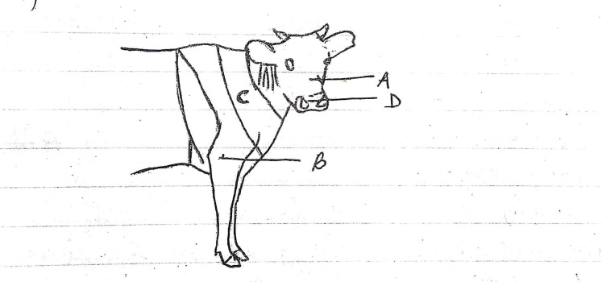

(a) Name the parts labeled A – D (2 mks)

(b) Name the breed of dairy cattle with the highest butter fat content in milk. (1 mk)

(c) Distinguish between a large white and a landrace breeds of pigs (2 mks)

17. Use the diagram below to answer the questions that follow
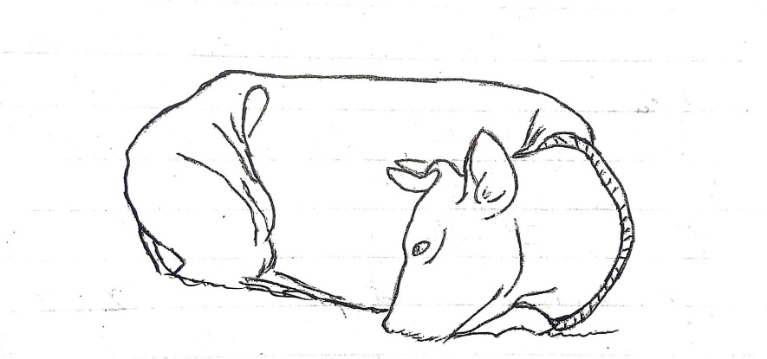

(a) Name the disease or disorder that makes the animal behave as shown
above. (1 mk)

(b) State three prevention measures of the above problem. (3 mks)

- Partial milking
(c) Define the term Pica as used in livestock nutrition. (1 mk)

18. Use the diagram below to answer the questions that follow

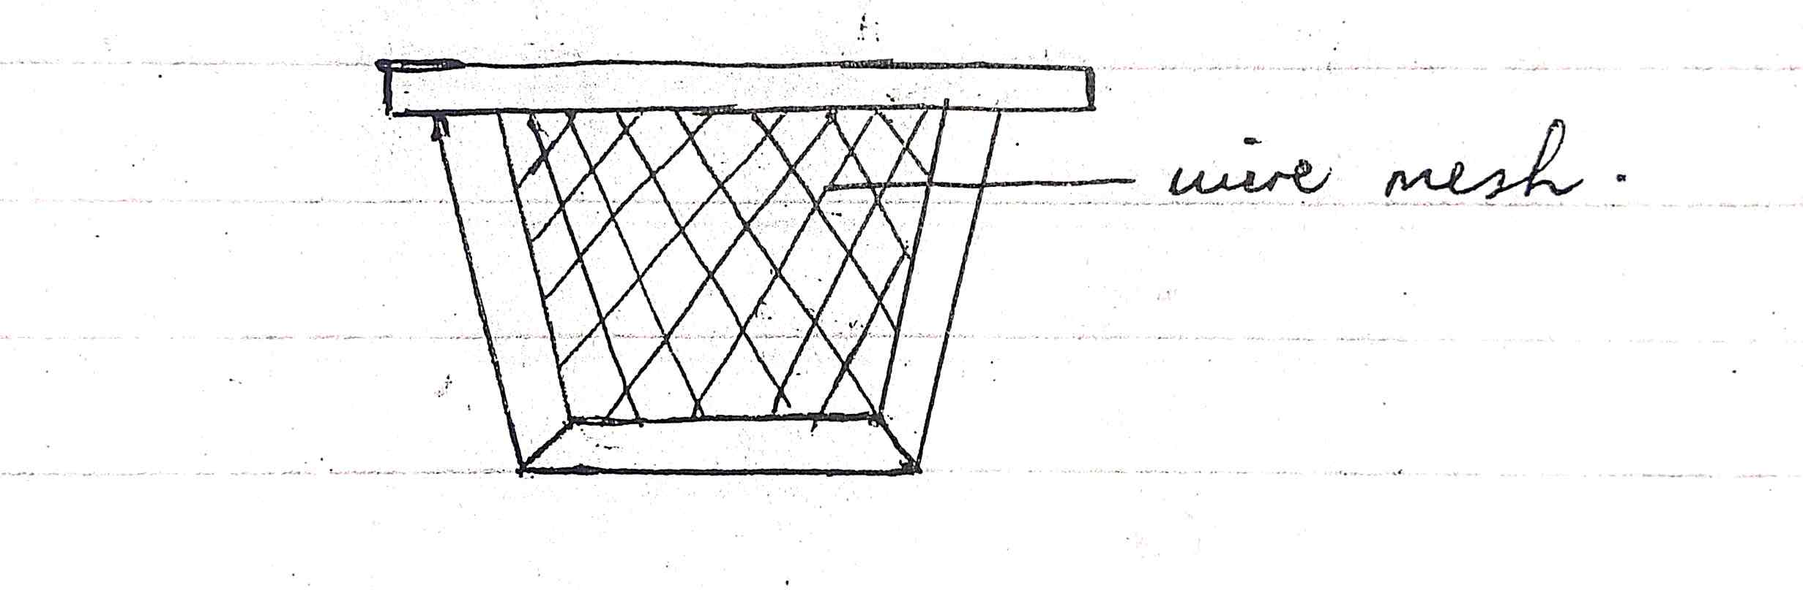
(a) Name the structure shown above. (1 mk)

(b) State the importance of the above structure where it’s used. (1 mk)

(c) State three pests that affect organisms that use the above structure. (3 mks)

19. (a) State 3 systems involved in outbreeding (3 mks)

(b) State two advantages of natural mating. (2 mks)
Less laborious (No need of checking heat signs)
SECTION C: (40 MARKS)

20. (a) Discuss the factors considered during selection of a breeding stock.
(10 marks)
(b) Discuss five methods used during identification of animals. (10 mks)

21. (a) Discuss the mechanical methods used to control ticks. (10 mks)

(b) Discuss the general effects of parasites on livestock. (10 mks)

22. (a) Discuss the structural requirements of a calf pen. (14 mks)

(b) State six methods employed in parasites and disease control in
livestock. (6 mks)

………………………………………………………………………………………………………………………………………………………………………………………………………………………………………………………………………………………………………………………………………………………………………………………………………………………………………………………………………………………………………………………………………………………………………………………………………………………………………………………………………………………………………………………………………………………………………………………………………………………………………………………………………………………………………………………………………………………………………………………………
………………………………………………………………………………………………………………………………………………………………………………………………………………………………………………………………………………………………………………………………………………………………………………………………………………………………………………………………………………………………………………………………………………………………………………………………………………………………………………………………………………………………………………………………………………………………………………………………………………………………………………………………………………………………………………………………………………………………………………………………
………………………………………………………………………………………………………………………………………………………………………………………………………………………………………………………………………………………………………………………………………………………………………………………………………………………………………………………………………………………………………………………………………………………………………………………………………………………………………………………………………………………………………………………………………………………………………………………………………………………………………………………………………………………………………………………………………………………………………………………………
………………………………………………………………………………………………………………………………………………………………………………………………………………………………………………………………………………………………………………………………………………………………………………………………………………………………………………………………………………………………………………………………………………………………………………………………………………………………………………………………………………………………………………………………………………………………………………………………………………………………………………………………………………………………………………………………………………………………………………………………
………………………………………………………………………………………………………………………………………………………………………………………………………………………………………………………………………………………………………………………………………………………………………………………………………………………………………………………………………………………………………………………………………………………………………………………………………………………………………………………………………………………………………………………………………………………………………………………………………………………………………………………………………………………………………………………………………………………………………………………………
………………………………………………………………………………………………………………………………………………………………………………………………………………………………………………………………………………………………………………………………………………………………………………………………………………………………………………………………………………………………………………………………………………………………………………………………………………………………………………………………………………………………………………………………………………………………………………………………………………………………………………………………………………………………………………………………………………………………………………………………
………………………………………………………………………………………………………………………………………………………………………………………………………………………………………………………………………………………………………………………………………………………………………………………………………………………………………………………………………………………………………………………………………………………………………………………………………………………………………………………………………………………………………………………………………………………………………………………………………………………………………………………………………………………………………………………………………………………………………………………………
………………………………………………………………………………………………………………………………………………………………………………………………………………………………………………………………………………………………………………………………………………………………………………………………………………………………………………………………………………………………………………………………………………………………………………………………………………………………………………………………………………………………………………………………………………………………………………………………………………………………………………………………………………………………………………………………………………………………………………………………
………………………………………………………………………………………………………………………………………………………………………………………………………………………………………………………………………………………………………………………………………………………………………………………………………………………………………………………………………………………………………………………………………………………………………………………………………………………………………………………………………………………………………………………………………………………………………………………………………………………………………………………………………………………………………………………………………………………………………………………………………………………………………………………………………………………………………………………
………………………………………………………………………………………………………………………………………………………………………………………………………………………………………………………………………………………………………………………………………………………………………………………………………………………………………………………………………………………………………………………………………………………………………………………………………………………………………………………………………………………………………………………………………………………………………………………………………………………………………………………………………………………………………………………………………………………………………………………………………………………………………………………………………………………………………………………………………………………………………………………………………………………………………………………………………………………………………………………………………………………………………………………………………………………………………………………………………………………………………………………………………………………………………………………………………………………………………………………………………………………………………………………………………………………………………………………………………………………………………………………………………………………………………………………………………………………………………………………………
………………………………………………………………………………………………………………………………………………………………………………………………………………………………………………………………………………………………………………………………………………………………………
………………………………………………………………………………………………………………………………………………………………………………………………………………………………………………………………………………………………………………………………………………………………………………………………………………………………………………………………………………………………………………………………………………………………………………………………………………………………………………………………………………………………………………………………………………………………………………………………………………………………………………………………………………………………………………………………………………………………………………………………
………………………………………………………………………………………………………………………………………………………………………………………………………………………………………………………………………………………………………………………………………………………………………………………………………………………………………………………………………………………………………………………………………………………………………………………………………………………………………………………………………………………………………………………………………………………………………………………………………………………………………………………………………………………………………………………………………………………………………………………………
………………………………………………………………………………………………………………………………………………………………………………………………………………………………………………………………………………………………………………………………………………………………………………………………………………………………………………………………………………………………………………………………………………………………………………………………………………………………………………………………………………………………………………………………………………………………………………………………………………………………………………………………………………………………………………………………………………………………………………………………………………………………………………………………………………………………………………………
………………………………………………………………………………………………………………………………………………………………………………………………………………………………………………………………………………………………………………………………………………………………………………………………………………………………………………………………………………………………………………………………………………………………………………………………………………………………………………………………………………………………………………………………………………

