NAME……………………………………………………..INDEX NO………………………………
SCHOOL……………………………….ADM. NO……………………CLASS………………….
AGRICULTURE
443/2
FORM 4
DECEMBER 2021
TIME 2Hrs.
KCSE KENYA CERTIFICATE OF SECONDARY EXAMINATION
INSTRUCTIONS TO CANDIDATES
- Write your Name, Index No., School, Admission No. and Class in the spaces provided.
- Write the date of the examination in the spaces provided.
- This paper contains three sections A, B and C.
- Answer all the questions in section A and B and any two questions in section C.
- All answers should be written in the spaces provided in English
- Students should check the question paper to ascertain that all 6the pages are printed as indicated and that no questions are missing.
- For examiners’ use only.

section | questions | Maximum score | Students’ score
A | 1-19 | 30
B | 20-23 | 20
C | 24 | 20
 | 25 | 20
 | 26 | 20
TOTAL SCORE |  | 90

This paper contains 12 printed pages

SECTION A(30MARKS) ANSWER ALL THE QUESTIONS .
Q1. State four functions of water in the body of livestock animals. (2marks)
........................................................................................................................................................................................................................................................................................................................................................................................................................................................................................................................................................................................................................
Q2. Differentiate between essential and non-essential amino acids. (1marks)
............................................................................................................................................................................................................................................................................................................
Q3. Give two reasons for turning eggs regularly during incubation? (1mk)
............................................................................................................................................................................................................................................................................................................
Q4. Name two functions of the crop in the digestive system of chicken. (1mk)
............................................................................................................................................................................................................................................................................................................
Q5. State four factors considered when computing a livestock ration. (2marks)
........................................................................................................................................................................................................................................................................................................................................................................................................................................................................................................................................................................................................................
Q6. Why is raddling essential in sheep management? (1mark)
............................................................................................................................................................................................................................................................................................................
Q7. State four advantages of battery cage system of poultry rearing. (2marks)
.............................................................................................................................................................................................................................................................................................................................................................................................................................................................................................................................................................................................................................................................................................................................................................................
Q8. Give a reason why the animal should not be released to the pasture when freshly sprayed with accaricide wash. (1mk)
............................................................................................................................................................................................................................................................................................................
Q9. Name two major methods of administrating drugs to livestock. (1mark)
............................................................................................................................................................................................................................................................................................................
Q10.Outline four methods used to handle livestock. (2marks)
.............................................................................................................................................................................................................................................................................................................................................................................................................................................................................................................................................................................................................................................................................................................................................................................
Q.11. State two ways in which good nutrition help to control diseases in livestock. (1mark)
............................................................................................................................................................................................................................................................................................................
Q.12.Give two reasons for flushing in sheep. (1mk)
.................................................................................................................................................................................................................................................................................................................................................................................................................................................................
Q.13. Give three factors that affect the quality of honey. (1 ½ mark)
..................................................................................................................................................................................................................................................................................................................................................................................................................................................................
Q.14. State three conditions that make a cow to withhold milk during milking.(1 ½ marks)
........................................................................................................................................................................................................................................................................................................................................................................................................................................................................................................................................................................................................................
Q.15.Name the most appropriate tools used in the following operations. (2marks)
- Removing metal chipping on a file.-.....................................................................
- Cutting wood along the grain................................................................................
- Branding................................................................................................................
- Detaching honey combs during honey harvesting...........................................….
Q.16.State four causes of infertility in cows. (2marks)
.............................................................................................................................................................................................................................................................................................................................................................................................................................................................................................................................................................................................................................................................................................................................................................................
Q.17. List four maintenance practices carried out on a disc plough. (2marks)
.............................................................................................................................................................................................................................................................................................................................................................................................................................................................................................................................................................................................................................................................................................................................................................................
Q. 18. a) Name a protozoan disease that is not transmitted by a vector. (½ marks)
......................................................................................................................................................
b) Name one vector that transmits each of the following diseases. (1mark)
- Anaplasmosis-...........................................................................................
- East coast fever-........................................................................................
c) Define the term quarantine as used in livestock production. (^{1/}₂ marks)
......................................................................................................................................................
d) What is the effect of petroleum jelly smeared on combs and wattles of birds? (1mark)
...........................................................................................................................................................................................................................................................................................................................................................................................................................................................................................................................................................................................................................................................................................................................................................................
Q.19. List down four short term services practices done on a tractor. (2marks)
.............................................................................................................................................................................................................................................................................................................................................................................................................................................................................................................................................................................................................................................................................................................................................................................
SECTION B(ANSWER ALL QUESTIONS IN THIS SECTION)
Q. 20 .The diagram illustrates a method of identification in livestock.

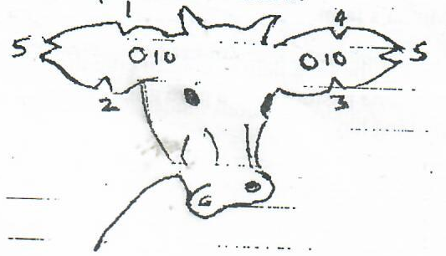
- Name the type of identification illustrated on the diagram. (1mk)
............................................................................................................................................................................................................................................................................................................
- Give the identification number of the animal illustrated on the diagram. (1mk)
............................................................................................................................................................................................................................................................................................................

- using diagram, illustrate how you can identify animal numbers 36 and 24.(2mks)
Animal No.24 | Animal No. 36

- Apart from this method of identification, give two other methods used in livestock to achieve the same purpose.
..................................................................................................................................................................................................................................................................................................................................................................................................................................................................
Q.21. Study the diagram below and answer questions that follow.
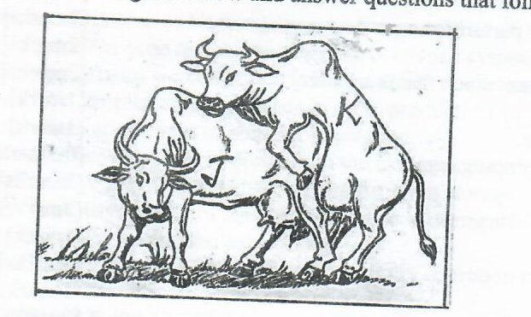
- Which of the above cows shows the signs of heat. (1mark)
............................................................................................................................................................................................................................................................................................................
- Give one reason to confirm your answer (a) above. (1mark )
..............................................................................................................................................................................................................................................................................................................................................................................................................................
- State two benefits of natural mating system. (2marks)
........................................................................................................................................................................................................................................................................................................................................................................................................................................................................................................................................................................
d) Name a disease that is easily spread by this method of mating. (1mark)
......................................................................................................................................................
Q.22. The following diagram shows a part of a roof. Study it carefully and answer the questions that follow.

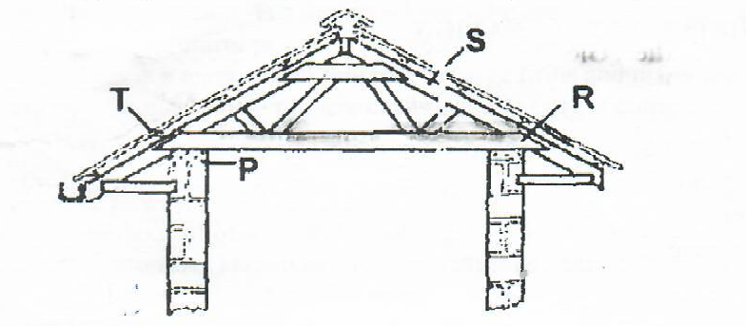

- Name the parts labelled P, T, R and S. (2marks)
P-......................................................................................................................................
T-......................................................................................................................................
R-...................................................................................................................................
S-....................................................................................................................................

- State the functions of P and T. (2marks)
P-..............................................................................................................................

T-................................................................................................................................
- Give two chemical preservatives for treating timber before use in the construction of farm structures
........................................................................................................................................................................................................................................................................................................................................................................................................................................................................................................................................................................................
Q.23. Below is a diagram of power transmission system of a tractor engine study it and answer the questions that follow.

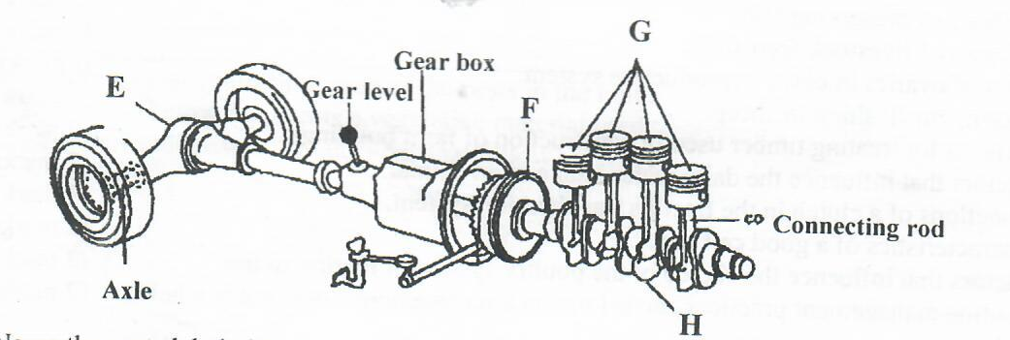
- Name the parts labeled E, F, G and H. (2marks)
E...................................................................................................................................
F...................................................................................................................................
G..................................................................................................................................
H...................................................................................................................................
- State the function of E and H.
E-...............................................................................................................................
H-................................................................................................................................
- State two precautions when handling farm tools and equipment (2marks)
............................................................................................................................................................................................................................................................................................................
SECTION C -40 MARKS; ANSWER ANY TWO QUESTION IN THIS SECTION

Q24. a) Describe the life cycle of a three host tick. (8mks)
..................................................................................................................................................................................................................................................................................................................................................................................................................................................................................................................................................................................................................................................................................................................................................................................................................................................................................................................................................................................................................................................................................................................................................................................................................................................................................................................................................................................................................................................................................................................................................................................................................................................................................................................................................................................................................................................................................................................................................................................................................................................................................................................................................................................................................................................................................................................................................................................................................................................................................................................................................................................................................................................................................................................................................................................................................................................................................................................................................................................................................................................................................................................................................................................................................................................................................................................................................................................................................................
b) Give three tools used in construction of a wooden fence stating the use of each.(3mks)
..........................................................................................................................................................................................................................................................................................................................................................................................................................................................................................................................................................................................................................................................................................................................................................................................................................................................................................................................................................................................................................................................................................
c) State five management practices done on an incubator. (5mks)
.............................................................................................................................................................................................................................................................................................................................................................................................................................................................................................................................................................................................................................................................................................................................................................................
d) State four factors that should be considered when selecting dairy goat for breeding.(4mks)
.............................................................................................................................................................................................................................................................................................................................................................................................................................................................................................................................................................................................................................................................................................................................................................................
Q25.a) Explain any four factors considered in siting farm buildings and structures. (8marks)
......................................................................................................................................................................................................................................................................................................................................................................................................................................................................................................................................................................................................................................................................................................................................................................................................................................................................................................................................................................................................................................................................................................................................................................................................................................................................................................................................................................................................................................................................................................................................................................................................................................................................................................................................................................................................................................................................................................................................................................................................................................................................................................................................................................................................................................................................................................................................................................................................................................................................................................................................................................................................................................................

b) Discuss foot-rot disease under the following sub-headings.
- Predisposing factors (5marks)
..............................................................................................................................................................................................................................................................................................................................................................................................................................................................................................................................................................................................................................................................................................................................................................................................................................................................................................................................................................................................................................................................................................................................................................................................................................................................................................................................................................................................................................................................................................................................................................................................................................................................................................................................................................................................................................................................................................................................................................................................................................
- Symptoms (3marks)
..............................................................................................................................................................................................................................................................................................................................................................................................................................................................................................................................................................................................................................................................................................................................................................................
- Control (4marks)
.......................................................................................................................................................................................................................................................................................................................................................................................................................................................................................................................................................................................................................................................................................................................................................................................................................................................................................................................................................................................................................................................................................................................................................................................................................................................................................................................................................................................................
Q26.a) Give four functions of a cooling system in a tractor engine. (4marks)
........................................................................................................................................................................................................................................................................................................................................................................................................................................................................................................................................................................................................................
b) Describe five management practices carried out on piglets immediately after birth. (5marks)
..........................................................................................................................................................................................................................................................................................................................................................................................................................................................................................................................................................................................................................................................................................................................................................................................................................................................................................................................................................................................................................................................................................
c) Explain five factors that affect digestibility of feed in livestock (5marks)
..............................................................................................................................................................................................................................................................................................................................................................................................................................................................................................................................................................................................................................................................................................................................................................................
d) List six limitation of animal power as compared to tractor power. (6marks)
..........................................................................................................................................................................................................................................................................................................................................................................................................................................................................................................................................................................................................................................................................................................................................................................................................................................................................................................................................................................................................................................................................................

