TERM 2 2021
AGRICULTURE
MARKING SCHEME
PAPER 2
SECTION A(30 MARKS) ANSWER ALL THE QUESTIONS .
Q1. State four functions of water in the body of livestock animals. (2marks)
- Form component of body cells/body fluids.
- Acts as medium of transport of various nutrients.
- Help in regulation of body temperature.
- Help in excretion of waste products of metabolism.
- Forms part of animal products like milk and eggs.
- Help maintain animal cells.
4 x ½ = 2marks
Q2. Differentiate between essential and non-essential amino acids. (1marks)
- essential amino acids must be supplied in livestock feed as they are not synthesized in the animal body, while non-essential amino acids need not to be supplied in livestock diet as they can be synthesized in livestock body.
1x1=mark
Q3. Give two reasons for turning eggs regularly during incubation? (1mk)
- To prevent germinal disc from sticking on the shell as this may cause death of the embryo.
- To make sure warmth is distributed evenly around the egg for uniform embryo.
2x ½ = 1 mark
Q4. Name two functions of the crop in the digestive system of chicken. (1mk)
- Store food temporarily.
- Moisten the food.
2X ½ = 1mark
Q5. State four factors considered when computing a livestock ration. (2marks)
- Cost of the feed
- Availability of feed stuff.
- Nutrient requirement of the animal
- Type of animal
- Age of the animal.
4 x ½ =2marks
Q6. Why is raddling essential in sheep management? (1mark)
- To identify the ewes that have been served.
- To identify the ram that has served a certain ewe.
2 x ½ = 1 mark

Q7. State four advantages of battery cage system of poultry rearing. (2marks)
- Higher egg production.
- Accurate individual record on egg production.
- Control egg eating and cannibalism.
- Eggs are kept clean.
- No food contamination.
- Broodiness is discouraged.
- easy to handle
- Low labour requirement.

4x ½ = 2 marks
Q8. Give a reason why the animal should not released to the pasture when freshly sprayed with acaricidal wash. (1mk)
- To minimize contamination of pasture with chemical wash.
1x1=1mark
Q9. Name two major methods of administrating drugs to livestock. (1mark)
- Oral administration.
- Intravenous.
- inter muscular

Any two 2 x ½ = 1 mark
Q10.Outline four methods used to handle livestock. (2marks)
- Restraining in a crush.
- Using bull ring and lead stick.
- Using a halter on the neck and head.
- Using a head yoke.
- Casting the animal using a rope on head, neck, middle region and rear of animal.
- Firm holding of the nose septum between the thumb and fore finger while the other hand hold the jaw to enable ease drenching.
Q.11. How does good nutrition help to control diseases in livestock. State two. (1mark)
- By preventing nutrient deficiency diseases.
- By improving body resistance against disease.
2x ½ = 1marks
Q.12.Give two reasons for flushing in sheep. (1mk)
- Increase conception rate.
- Facilitate implantation of the zygote.
- Increase lambing percentage.
- Increase twinning/ multiple birth .
2x ½ = ½ mark
Q.13. Give three factors that affect the quality of honey. (1 ½ mark)
- Type of plants from which nectar was collected.
- Maturity stage of honey at the time of harvesting.
- Methods of harvesting
- Method of processing honey.
3x ½ = 1 ½ marks
Q.14. State three conditions that make a cow to withhold milk during milking.(1 ½ marks)
- Washing a cow with hot water.
- Beating the cow(mistreatment)
- Change of milking man.
- Unfamiliar noise.
- Absence of food during milking.
3x ½ = 1 ½ marks
Q.15.Name the most appropriate tools used in the following operations. (2marks)
- Removing metal chipping on a file.
- Wire bush
- Cutting wood along the grain.
Rip saw
- Branding
- Branding Iron
- Detaching honey combs during honey harvesting
- Hive tool.
4x ½ =2marks
Q.16.State four causes of infertility in cows. (2marks)
- Retention of placenta.
- Lack of vitamin E/Deficiency of essential minerals.
- Damaged uterus
- Blocked fallopian tube.
- Infection of breeding diseases.e.g contagious abortion( Brucellosis)
- Occurrence of fremation (when heifer is bone twin with bull)
4x ½ = 4marks
Q.17. List four maintenance practices carried out on disc plough. (2marks)
- Clean after use
- Replace worn out parts
- Lubricant moving part/ disc bearings rej. Movable parts.
- Tighten loose nuts and bolts
- Paint with old engine oil for long storage.
- Storage under shed(properly)
4 x ½ = 2 marks
Q. 18. a) Name a protozoan disease that is not vector transmitted . ( ½ marks)
- coccidiosis 1x ½ = ½ mark
b) Name one vector that transmits each of the following diseases. (1mark)
- Anaplasmosis- Blue tick
- East coast fever-Red legged tick, brown ear tick.
2x ½ = 1 mark
c) Define the term quarantine as used in livestock production. (^{1/}₂ marks)
- Restriction of movement of livestock and other products into or from an area where there is an outbreak of a notifiables disease.

1x ½ = ½ mark
d) What is the effect of petroleum jelly smeared on combs and wattles of birds? (1mark)
- It suffocates the fleas to death. 1x1=1mark
Q.19. List down four short term services practices done on a tractor. (2marks)
- Checking oil level with dipstick
- Water level in the radiator should be checked daily
- Level of battery electrolyte should be checked daily.
- Removal of large sediments from the bowl.
- Checking the tyre pressure.
- Brake fluid level checked daily
- Differential/ gear boy oil checked daily

4 x ½ =2marks

SECTION- B 30 MARKS(ANSWER ALL QUESTIONS IN THIS SECTION)
Q. 20 .The diagram illustrates a method of identification in livestock.

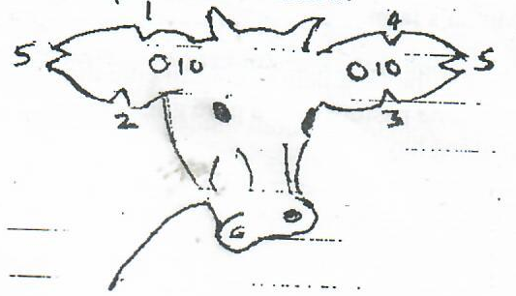
- Name the type of identification illustrated on the diagram. (1mk)
- ear notching
1x1=1 mark

- Give the identification number of the animal illustrated on the diagram . (1mk)
- animal no. 40
1x1=1mark

- using diagram, illustrate how you can identify animal numbers 36 and 24.(2mks)
Animal No.24 | Animal No. 36

- Apart from this method of identification, give two methods used in livestock to achieve the same purpose.
- Branding
- Ear tattooing
- Use of chains and straps
Any two 2x ½ =1mark
Q.21. Study the diagram below and answer questions that follow.

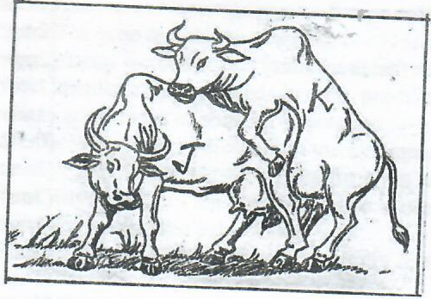
- Which of the above cows shows the signs of heat. (1mark)
J
1x1=1 mark

- Give one reason to confirm your answer (a) above. (1mark )
- J stands still when mounted by K.
1x1= 1mark
- State two benefits of natural mating system. (2marks)
- More accurate due to heat detection by males.
- Less laborious.
- Useful when heat signs cannot be detected.
Any 2x1=2marks
d) Name a disease that is easily spread by this method of mating. (1mark)
- Brucellosis/contagious abortion. 1x1=1mark
Q.22. The following diagram shows a part of a roof. Study it carefully and answer the questions that follow.

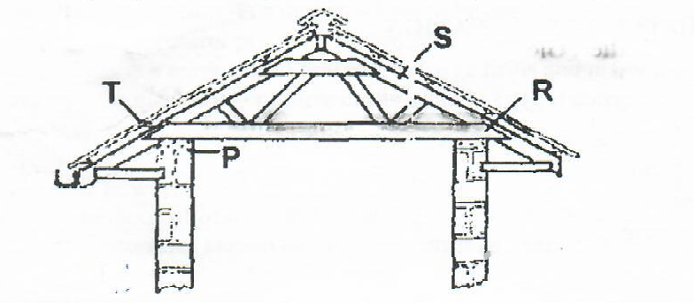

- Name the parts labelled P,T, R S. (2marks)
P-Wall plate. 1x ½ = ½ mark
T- Purlin . 1x ½ = ½ mark
R- Tie beam / cross tie. 1x ½ = ½ mark
S- Rafte 1x ½ = ½ mark
- State the functions of P and T. (2marks)
P- Hold the trusses securely.
1x1= 1 mark
T- Hold the roofing materials.
1x1= 1 mark
- Give two chemical preservatives for treating timber before use in the construction of farm structures
- far, creosol, tanex, used engine oil copper sulphate solution.2x ½ = 1mark

Q.23. Below is a diagram of power transmission system of a tractor engine study it and answer the questions that follow.

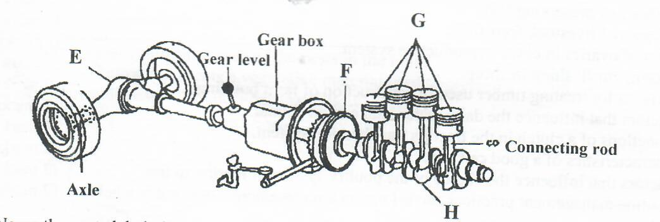
- Name the parts labeled E, F, G H . (2marks)
E-differential
F- Fly wheel
G-Piston
H- Crankshaft
4 x ½ = 2 marks
- State the function of E and H.
E- changes the direction of drive to right angles to power the wheel.
1X1= 1mark
H- Rotate and help the piston to move up and down.
1x1= 1 mark
- State two precaution when handling farm tools and equipments
- Tools should always be left in a safe place after use.
- Use of the tool for correct job.
- Tools should be maintained and service to remain in good working condition and last long.
- Tools should be handled correctly when in use to avoid damage to the tool and injury to the user.
- Use of safety device to reduce accidents and to maintain a safe working environment .
- All tools should be stored properly in tool cabinets or racks.
Any 2 x ½ = 1 mark

SECTION- C 40 MARKS (ANSWER ONLY TWO QUESTION IN THIS SECTION)
Q24. a) Describe the life cycle of a three host tick. (8marks)
- A larva climbs on the host.
- Larvae feed on first host.
- Engorged larvae drops on to the group and moult into nymph
- Nymph climbs o to the second host.
- Engorged nymph drops to the ground and moult into adult.
- Adult climb on the third host
- Engorged female drop to the ground and lay eggs.
- Egg hatches into larva. 8x1=8marks
b) Give three tools used in construction of a wooden fence stating the use of each.(3marks)
- Hand saw- this is for cutting timber to the recommended sizes.
- Claw hammer-for driving in nails into the work surface or out of the surface
- Plumb rod-ensures that the fence posts are vertical.
- Hole digger/soil auger-for digging the holes.
- Ramming rod-to firm the soil around the posts.
- Garden line- to establish straight lines. any 3x1=3marks
c) State five management practices done on an incubator. (5mks)
- Egg turning after every 6-8 hours each day around 180⁰(but not done in the first 24 hours and last 3days)
- Remove broken eggs
- Maintain temperature at the appropriate range always.
- Add water if necessary to maintain the appropriate humidity always.
- Remove infertile eggs on the 5th day.
5x1=5marks
d) State four factors that should be considered when selecting dairy goat for breeding.(4marks)
- Should be a high milk producer.
- Should be healthy.
- Should be fertile
- Should be docile/mild temperature
- Should have a good mothering ability
- Should be disease resistant/tolerant.
- Should be adaptable to area to be kept.
Any 4x1= 4marks

Q25.a) Explain any four factors considered in siting farm buildings and structures. (8marks)
- Location of homestead- homestead should be in a position where farmer has a full view of all enterprises in the farm.
- Security-structures should be safe from predictors and trespassers.
- Relationship- related structures should be close to each other e.g dairy unit and calf pen.
- Topography- gently sloping areas is most suitable to reduce construction cost.
- soil type- firm well drained soil
- Direction of prevailing wind-structures such as pig sty and latrines which produces foul smell should be constructed on the leeward side of the homestead.

b) Discuss foot-rot disease under the following sub-headings.
- Predisposing factors (5marks)
- Injury on the hooves
- Long overgrown hooves
- Muddy surrounding
- Unhygienic condition in cow shed
- Age of the animal.
5x1=5marks
- Symptoms ( 3x1 =3marks)
- Lameness
- Fever
- Lack of appetite
- Emaciations
- Swelling of the foot
- Rotten smell from hooves
- Grazing while kneeling for the sheep.
- Control 4x1=4marks
- Isolate the infected animals
- Provide clean and dry surrondings
- Regular hoof trimming
- Treat the animals using antibiotics
- Use of foot baths in dipping the animals.
Any 4x1=4marks
Q26.a) Give four functions of a cooling system in a tractor engine. (4marks)
- To remove excess heat from the engine.
- To maintain the engine operating temperature where it works most efficiently.
- To bring the engine up to the right operating temperatures as quickly as possible.
- To prevent the engine from overheating. 4x1= 4marks.
b) Describe five management practices carried out on piglets immediately after birth. (5marks)
- Check and ensure the piglet is breathing.
- Keep piglet in a warm place.
- Ensure the piglet suckle the mother within first 6-12 hours inorder to get colostrum which is rich in nutrients.
- Disinfect the naval cord to avoid naval illness or any possible infections.
- Ensure there is removal of the birth to prevent the sow from eating the piglet.
- Assist the piglet to suckle.
- Provide iron injection to avoid anaemia.
- Weigh the piglet and keep recording.
Any 5x1=5marks
c) Explain five factors that affect digestibility of food in livestock (5marks)
- Chemical composition of the feed e.g of ligrin or cellulose will influence digestibility.
- The form in which feed is offered to the animal e.g crushed maize is more digestible than whole gram.
- The species of the anima e.g digestibility of grass is higher in sheep than in pigs.
- The quantity of feed already present in the digestive system of an animal.
1mark for stating and explanation. 5x1=5marks
d) List six limitation of animal power as compared to tractor power. (6marks)
- More tedious than tractor.
- Animal get tired and slow down work
- Animal require extra land for grazing.
- Animal cannot be used throughout the day.
- Some animals are difficult to handle.
- Animal power is uneconomical on large scale production.
- Animals are likely to fall sick and may take long to recover.
Any 1x6=6marks

