443/2
AGRICULTURE
PAPER 2
FORM 3
TIME: 2 HOURS

INSTRUCTIONS:
This paper consists of 3 sections; A, B and C.
Answer all questions in section A and B and any two in section C.

1. State four reasons for castration in rams. (2 mks)
-Control breeding
-control breeding diseases
-faster growth
-increase quality of meat
-make them docile
-fatten them

2. List any four conditions that pre-dispose an animal to disease or injury.
(2 mks)
- Age of the animal
- Sex
- Colour
- Breed
- Environmental conditions
- Physiological conditions
- Heredity
- Overcrowding

3. State four functions of vitamins in Livestock. (2 mks)
- Help in blood clotting
- Act as organic catalyst
- Prevent diseases in livestock
- Help in bone formation
- Help in muscular activities

4. State four factors one would consider when choosing feed
- Availability of food
- Cost
- Nutrient composition
- Type of livestock
- Age of the animal

5. State four factors that may lead to dip wash being exhausted or weakened
while in the dip tank. (2 mks)

- Getting diluted by e.g rainwater
- Evaporation
- Leakage at the bottom
- Dirt/impurities from animal’s body.

6. Give two reasons why walls of dairy shed should be white washed instead of
painting with oil paints.
- To avoid poisoning by lead in paints
- Discourage insects
- To avoid tainting of milk.

7. List four tools used in laying concrete blocks. (2 mks)
- Trowel
- Plumb bob/line
- Mason’s square
- String line
- Spirit level
- Wood flat

8. State four reasons for treating timber used for fencing. (2 mks)
- To prevent warping
- To prevent rotting/damage by fungi
- Reduce damage by insects
- To enhance strength

9. State four harmful effects of ticks to livestock (2 mks)
- Transmit diseases
- Cause anaemia
- Cause irritation
- Lower quantity and value of skin

10. State four symptoms of liver fluke attack, that may be observed in animals
(2 mks)
- Digestive upsets
- Swollen abdomen
- Emaciation
- Recumbency leading to death
- Anaemia
- Oedema in joints

11. Outline four methods of controlling the fresh water snail. (2 mks)
- Drain stagnant water
- Physically killing the snail
- Routine drenching of animals
- Spray pasture with lime
- Burning pasture during the dry season

12. State four ways of preparing the low for furrowing. (2 mks)
- Deworming the sow
- Wash the sow
- Reduce feeding gradually
- Move the sow to the furrowing pen

13. Give two factors that may lead to conception failure after service in heifers.
(2 mks)
- Poor timing of service
- Poor nutrition
- Infertility(heifer/bull) – Formation/femation.

14. Give two causes of soft shell in eggs. (2 mks)
- Lack of calcium
- Some diseases e.g Newcastle

15. State four management practices that would ensure maximum harvest of
fish from fish pond. (2 mks)
- Control stocking rate
- Control water pollution
- Supply of fish food
- Aerating water
- Maintaining appropriate depth of water.

SECTION B: (20 MARKS)
16. Use the diagram below to answer the questions that follow.

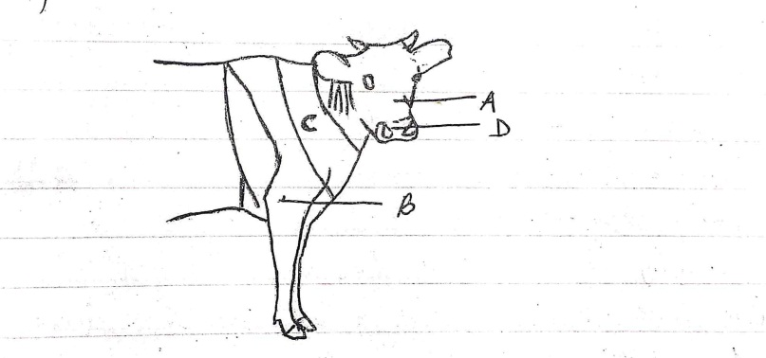
(a) Name the parts labeled A – D (2 mks)
A – Nose –bridge
B – Elbow
C – Wuthers
D – Muzzle

(b) Name the breed of dairy cattle with the highest butter fat content in milk.
(1 mk)
Jersey
(c) Distinguish between a large white and a landrace breeds of pigs (8 mks)

- Large white: White, broad and slightly dished snout and has upright ears .
- Landrace: White, straight snout and long drooping ears.

17. Use the diagram below to answer the questions that follow

(a) Name the disease or disorder that makes the animal behave as shown
above. (1 mk)
- Milk fever

(b) State three prevention measures of the above problem. (3 mks)
- Partial milking
- Feeding an animal with ration rich in phosphorous and calcium
- Allow animal to sunlight

(c) Define the term Pica as used in livestock nutrition. (1 mk)
- Deprived appetite when phosphorus is missing in an animal’s diet.

18. Use the diagram below to answer the questions that follow

(a) Name the structure shown above. (1 mk)
- Queen excluder

(b) State the importance of the above structure where it’s used.
(1 mk)
- Prevents the queen bee from laying eggs in all combs.

(c) State three pests that affect organisms that use the above structure.
(3 mks)
- Ants
- Wax moth
- Bee louse

19. (a) State 3 systems involved in outbreeding (3 mks)
- Outcrossing
- Cross breeding
- Upgrading (grading up)

(b) State two advantages of natural mating. (2 mks)
- More accurate
- Less laborious (No need of checking heat signs)
- Useful when heat period is not easily detected.

SECTION C: (40 MARKS)

20. (a) Discuss the factors considered during selection of a breeding stock.
(10 marks)
- Level of performance
- Body conformation
- Temperament or behavior
- Adaptability
- Fertility/prolificacy
- Hereditary defects
- Health
- Age: Select young animals
- Mothering ability
- Quality of products.
(NB: Consider the relevance of explanation on each. Award a whole mark for a well explained point )
(1 x 10)

(b) Discuss five methods used during identification of animals.(10 mks)
- Branding: Involves marking of animals on the skin with permanent marks using a hot iron with inscriptions.
- Neck strap or chain: Involves hanging metal plates bearing shapes or numbers around the neck of an animal using canvas leather strap or metal chain.
- Ear tagging: It employs use of plastic or metal tags bearing numbers or letters fixed through a hole on the ears of the animal.
- Tatooing: Employs use of permanent ink or dye on the skin of the animal.
- Ear notching: Ears of the animal are cut to make different shapes each standing for a certain value.

21. (a) Discuss the mechanical methods used to control ticks. (10 mks)
  - Burning the infested pastures: involves deliberate burning of pastures aiming at reducing tick population.
  - Interfering/altering the tick environment: Can be done through ploughing or top dressing pasture using lime or acaricide to make the environment less conducive for ticks.
  - Fencing: Controls interaction of the animal with others.
  - Starving the ticks: Achieved by keeping animals away from infested pastures through rotational grazing.
  - Hand picking/deticking: Involves manual removal of ticks from the animal and killing them. (2 x 5)

(b) Discuss the general effects of parasites on livestock. (10 mks)
  - Cause anaemia: Its brought by sucking parasites which take large volumes of blood from the host animal.
  - Deprive the host animal food: Compete for food with host animals leading to emaciation.
  - Cause injury and damage to tissues and organs: They break the skin of animal exposing it to secondary infection. Others affect internal organs.
  - Disease transmission: Some parasites act as vectors of some diseases spreading them from one animal to another.
  - Cause irritation: External parasites irritate animals through bites. Animals rub against objects – destruction of skin, fur or wool.
  - Obstruction to internal organs: parasites cause mechanical obstruction/blockage of internal passage – malfunctioning of organs. (2 x 5)

22. (a) Discuss the structural requirements of a calf pen. (14 mks)

- Concrete floors: for easy cleaning
- Adequate space: allows room for exercise, feeding and watering
- Single housing: prevents licking each other and spread of worms and diseases.
- Proper lighting: Allows enough light to help in synthesis of vit D.
- Proper drainage: Area should be well drained to prevent dampness.
- Draught free: Construction should not allow cold wind into the structure.
- Leak proof roof: Should not allow water through the roof.
(2 x 7)
(b) State six methods employed in parasites and disease control in
livestock. (6 mks)

- Vaccination
- Deworming
- Hoof trimming
- Docking
- Dipping and spraying
- Dusting

