NAME……………………………………………………ADM NO……………
CANIDATE’S SIGNATURE………………………………………………………
DATE………………………………………………………………………………

443/1
AGRICULTURE PAPER 1
TERM 1 2023
TIME: 2 HOURS

CHOGORIA – MURUGI ZONE EXAMINATION

INSTRUCTIONS TO CANDIDATES
- Write your name and Admission number
- This paper consist of three sections A, B and C
- Answer ALL he questions in section A and B and ANY TWO questions in section C in the spaces provided

FOR EXAMINERS’ USE ONLY
Section | Questions | Maximum Score | Candidate’s Score
A | 1-16
B | 17-20
C | 21
 | 22
 | 23

SECTION A: Answer all the questions in this section (30 Marks)
- Name three branches of horticulture (1 ½ marks)

- List three aspects of light that influence crops growth (1½ marks)

- a) What is mixed farming (1 mark)

b) Give three disadvantages of mixed farming to a small scale farmer (1½ marks)

- Give two ways how hard pans would be caused by cultivation (1 mark

- a) Give a reason why nitrogenous fertilizer should: (2 marks)
- Be stored under dry condition

- Be applied in most soils

- Be applied to an established crop

- Be applied frequently

- Distinguish between complete compound fertilizer and incomplete compound fertilizer (1 mark)

- State two mechanical methods of separating soil particles according to size during soil analysis (2 marks)

- Give two methods of controlling stalk borer in maize production (1 marks)

- State two reasons why too much air in the silo is undesirable in the process of silage making (1 mark)

- State three ways of controlling weeds in pure grass pastures (1 ½ marks)

- Give four advantages of title deed to a farmer (2 marks)

- Outline four advantages of a mixed-legume pasture over a pure-grass pasture (2 marks)

- Give four management practices that promote high herbage yields in pasture production (2 marks)

- Give four factors that a farmer should consider in siting a nursery (2 marks)

- Give four benefits of using vegetable propagation in orange production (2 marks)

- a) What is micro-catchment? (1 mark)

b) List any four types of micro-catchments (2marks)

- List four common bacterial diseases that affect crops (2 marks)

SECTION B: Answer all the questions in this section (20 Marks)
- Study the diagram below.
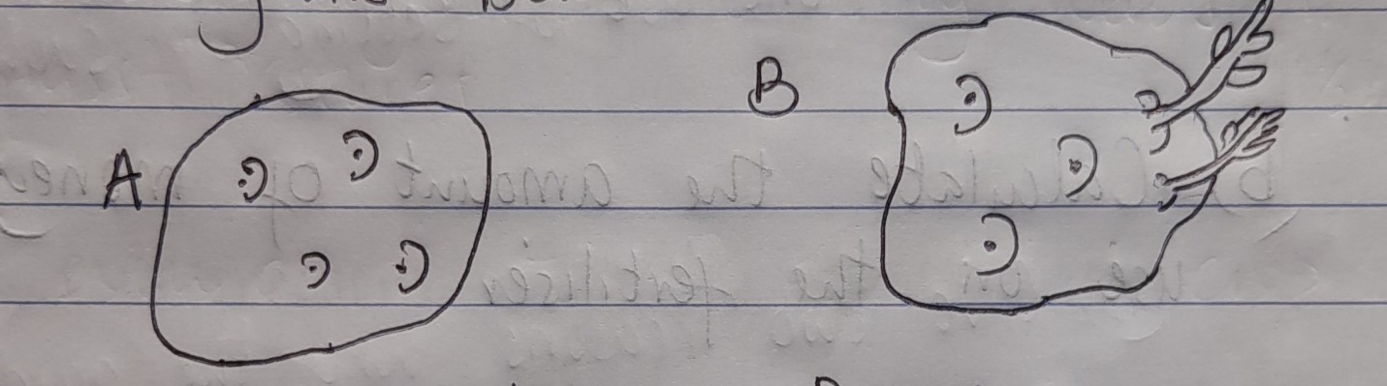
- Name the process above used to prepare Irish potatoes in readiness for planting (1 mark)

- (i) Which of the two potatoes is suitable for planting? (1 mark)

(ii) Give a reason for your answer in (b) (i) above (1 mark)

- Give two reasons why maize needs to be earthed (2 marks)

- A farmer growing maize on 10 hectares is to dress it with sulphate of ammonia (20%N) at the rate of 120kg of S.A per hectare. At the local market S.A is available in 50kg bags selling at Ksh. 1500 per bag.
- Calculate the amount of S.A the farmer needs to top-dress his crop of maize (3 marks)

- Calculate the amount of money he will use on fertilizer (2 marks)

- The diagram below illustrates a type of soil erosion. Study it carefully and answer the questions that follow.
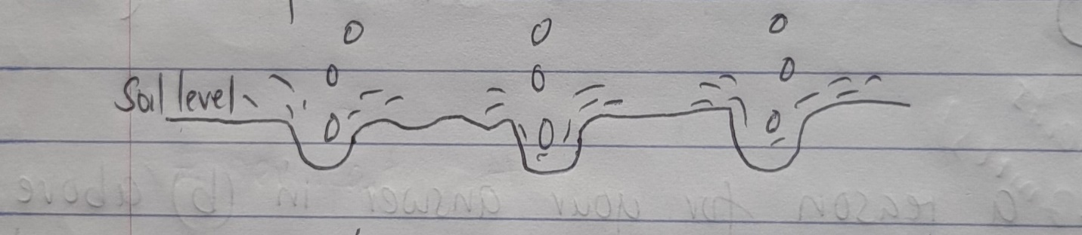
- Identify the type of erosion above (1 mark)

- Give two factors that may accelerate the rate of the type of erosion above (2 marks)

- Give two effects of the type of soil erosion shown above on the farm (2 marks)

- Study the diagrams labelled G and H
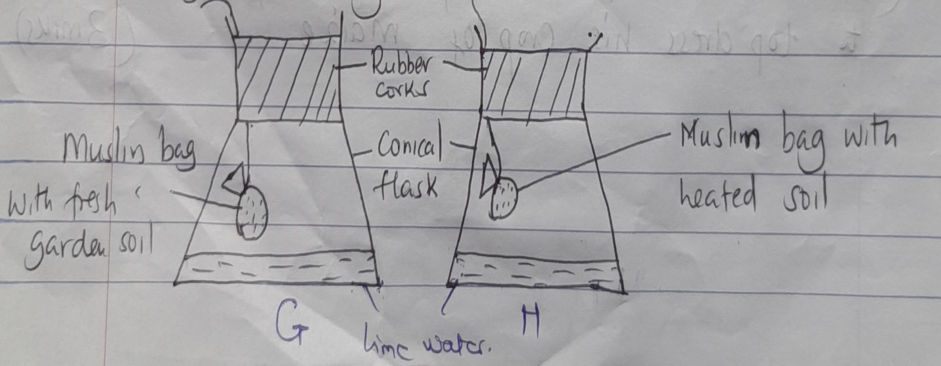
- Give one use of setting up such an experiment (1 mark)

- Give two reasons why the garden soil in the experiment H is heated (2 marks)

- Briefly explain what happens to the lime water in both experiment G and H

Experiment G (1 mark)

Experiment H (1 mark)

SECTION C: Answer TWO questions only in this section (40 Marks)
- a) Discuss ten cultural practices of controlling pests in a crop field (10 marks)
b) Outline five factors a farmer should consider before deciding on the type of irrigation in crop production (5 marks)
c) Describe the qualities of the mother plant that should be considered when selecting vegetative material for planting (5 marks)
- a) Discuss the factors considered when drawing a crop rotation programme (10 marks)
b) Explain the precautions that should be observed during harvesting of tea (5 marks)
c) Describe reasons for drainage as a method of land reclamation in crop production (5 marks)
- (i) Describe production of onions under the following subheadings
- Ecological requirement (3 marks)
- Land preparation (4 marks)
- Harvesting and marketing (3 marks)
- Breaking the tops in onions (1 mark)
- Two pests in onions (2 marks)
(ii) Explain seven ways soil fertility is maintained (7 marks)

