NAME:…………………………………………. ADM NO……… CLASS/STREAM…….
DATE: ………………… SCHOOL …………………………..
443/1
AGRICULTUREPAPER ONE
APRIL, 2023
TIME: 2 HOURS
MOMALICHE JOINT MOCKS
Instructions to Candidates:
- Write your name and ADM number in the spaces provided above.
- Sign and write the date of examination in space provided.
- This paper consists of three sections; A, B and C.
- Answer all the questions in section A and B.
- Answer any two questions in section C.
- All answers should be written in spaces provided in question paper.

FOR EXAMINER’S USE ONLY
SECTION | Question | Maximum score | Candidates score
A | 1 - 15 | 30
B | 16 - 19 | 20
C | 20-22 | 20
 |  | 20
 | Total score 90

SECTION A:(30MARKS)
Answer all the questions in this section.

1. State four advantages of intensive system of farming. (2mks)
………………………………………………………………………………………………..……………………………………………..………………………………..………………..…………………….………………………………………………..…………………….
2. Give four conditions likely to facilitate land fragmentation. (2mks)
………………………………………………………………………………………………..……………………………………………..………………………………..………………..…………………….………………………………………………..…………………….
3. a) List four post-harvest practices done on crops. (2mks)
………………………………………………………………………………………………..……………………………………………..………………………………..………………..…………………….………………………………………………..…………………….
b) What is earthing up in crop production? (1mk)
……………………………………………………………………….………………………………………………..…………………….
4. Give four reasons as to why burning as a method of bush clearing is not recommended. (2mks)
………………………………………………………………………………………………..……………………………………………..………………………………..………………..…………………….………………………………………………..…………………………………………..
5.a) Give the form in which the following elements are available to plants (1mk)
i) Nitrogen -
ii) Sulphur–

b) State two liming elements in crop production. (1mk)
………………………………………………………………………………………………..……………………………………
6. State four effects of ill- health and HIV /AIDs in agricultural production (2mks)
………………………………………………………………………………………………..……………………………………………..………………………………..………………..…………………….………………………………………………..…………………….
7. State the functions of the following components in a compost heap. (2mks)
- Ash…………………………………………………………

- Garden soil …………………………………………………

- Organic manure………………………………………………

- Stick………………………………………………………
8. State four factors that can enhance rooting in stem cuttings. (2mks)
………………………………………………………………………………………………..……………………………………………..………………………………..………………..…………………….………………………………………………..……………………
9. Outline four reasons a farmer should have breeding records in livestock production.
(2mks)
………………………………………………………………………………………………..……………………………………………..………………………………..………………..…………………….………………………………………………..…………………….
10. Give four ways of treating water for use in the farm. (2mks)
………………………………………………………………………………………………..……………………………………………..………………………………..………………..…………………….………………………………………………..…………………….
11. List Four methods of harvesting water in a farm. (2mks)
………………………………………………………………………………………………..……………………………………………..………………………………..………………..…………………….………………………………………………..…………………….
12. Give two methods of conserving forage. (1mk)
………………………………………………………………………………………………..……………………………………………..………………………………..………………..…………………….………………………………………………..…………………….
13. State four Farming activities that encourage soil erosion. (2mks)
………………………………………………………………………………………………..……………………………………………..………………………………..………………..…………………….………………………………………………..…………………….
14. State four roles of agriculture in national development (2mks)
………………………………………………………………………………………………..……………………………………………..………………………………..………………..…………………….………………………………………………..…………………….
15. State four advantages of budding. (2mks)
………………………………………………………………………………………………..……………………………………………..………………………………..………………..…………………….………………………………………………..…………………….
SECTION B: (20MKS)
Answer all questions in this section.
16. The diagrams below show an experiment that was carried out by Mwatate agriculture students. Study it carefully and answer the questions that follow.
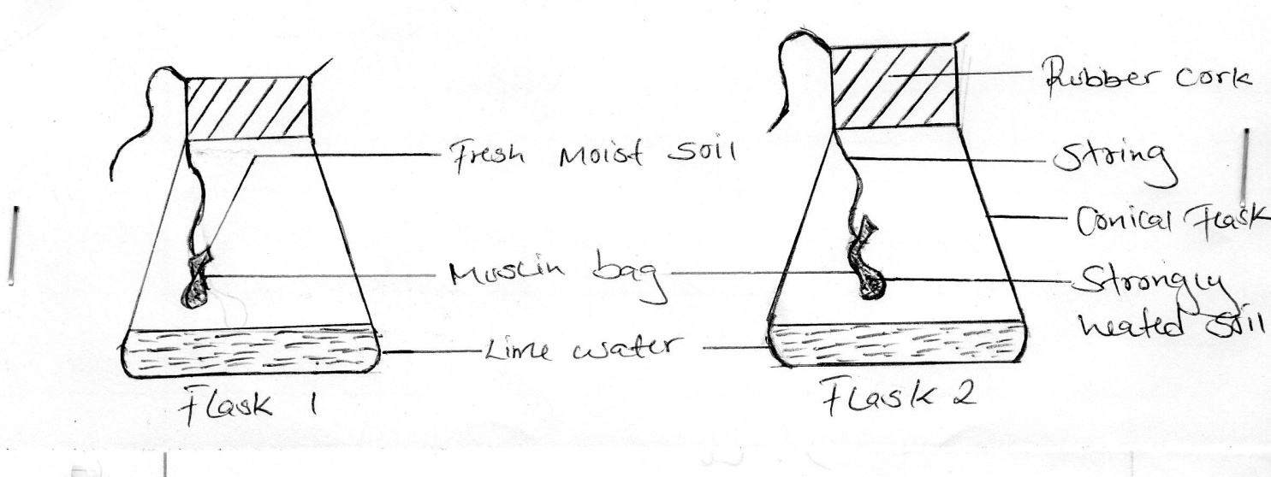
a) What was the aim of the experiment. (1mk)
………………………………………………………………………………………………..……………………………………
b) What observation did the students make in the two flasks at the end of the experiment. (2mks
Flask 1 ……………………………………………………………………………..

Flask 2 ………………………………………………………………..…………….
c) Give a reason for the observation made in flask 1 (1mk)
………………………………………………………………………………………………..…………………………………
d) Why did the students heat the garden soil in flask 2 strongly? (1mk)
………………………………………………………………………………………………..……………………………………
17. The diagram below illustrates materials, and a method of vegetative propagation. Study it and answer the questions that follow.

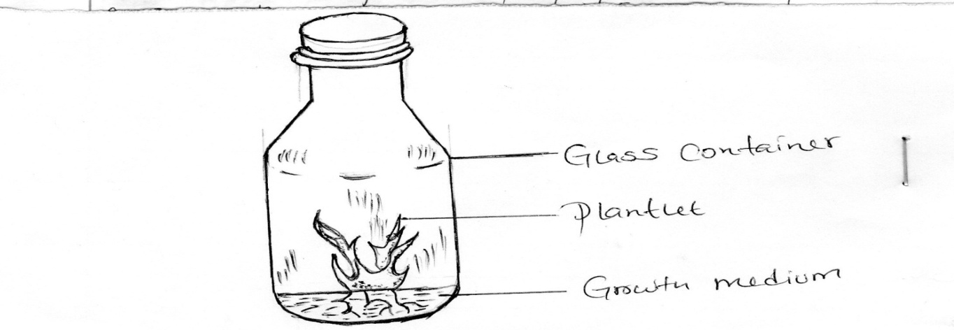
i) Identify the method of propagation illustrated above. (1mk)
………………………………………………………………
ii) Name a common crop propagated through the method. (1mk)
…………………………………………………………………
iii) Give three disadvantages of this method of propagation. (3mks)
………………………………………………………………………………………………..……………………………………………..………………………………..………………..………

18. The diagram below shows a bird which is a field crop pest. Study it and answer the question that follow.
a) Identify the pest (1mk)
…………………………………………………………………
b) State two damages caused to crops by the pest. (2mks)
………………………………………………………………………………………………..……………………………………………..
c) Give two methods which can be used to control the pest. (2mks)
………………………………………………………………………………………………..……………………………………………..………………………………..………………..……
19. a) Given that the spacing of coffee is 2.7m by 2.7m, calculate the plant population in 1 hectare (Ha) of land (2mks)
………………………………………………………………………………………………..……………………………………………..………………………………..………………..……………………………………………………………………………………………………………………..……………………………………………..
b) Give three reasons why crops should be planted at the correct spacing. (3mks)
………………………………………………………………………………………………..……………………………………………..………………………………..………………..…………………….………………………………………………..…………………….
SECTION C (40MARKS)
20. a) State four benefits of sowing annual crops early. (4mks)
………………………………………………………………………………………………..……………………………………………..………………………………..………………..…………………….………………………………………………..…………………….
b) Describe eight effects of fragmentation and sub division of land. (8mks)
………………………………………………………………………………………………..……………………………………………..………………………………..………………..…………………….………………………………………………..…………………….………………………………………………………………………………………………..……………………………………………..………………………………..………………..…………………….………………………………………………..…………………….………………………………………………………………………………………………..……………………………………………..………………………………..………………..…………………….………………………………………………..…………………….
c) Explain eight effects of weeds. (8mks)
………………………………………………………………………………………………..……………………………………………..………………………………..………………..…………………….………………………………………………..…………………….………………………………………………………………………………………………..……………………………………………..………………………………..………………..……………………
21. a) Describe the various field management practices for tomatoes. (8mks)
………………………………………………………………………………………………..……………………………………………..………………………………..………………..…………………….………………………………………………..…………………….………………………………………………………………………………………………..……………………………………………..………………………………..………………..…………………….………………………………………………..…………………….………………………..……………………………………………...………………………………………………..…………………….

b) State the precautions that should be observed when harvesting cotton. (4mks)
………………………………………………………………………………………………..……………………………………………..………………………………..………………..……………………………………………..……………………………………………...………………………………………………..…………………….
c)Explain four importance of crop rotation. (8mks)
………………………………………………………………………………………………..……………………………………………..………………………………..………………..…………………….………………………………………………..…………………….………………………………………………………………………………………………..……………………………………………..………………………………..………………..…………………….………………………………………………..…………………….………………………………..………………..…………………….………………………………………………..…………………….
22. a) Explain four factors to consider in choosing the type of irrigation to use in the farm.
(8mks)
………………………………………………………………………………………………..……………………………………………..………………………………..………………..…………………….………………………………………………..…………………….………………………………………………………………………………………………..……………………………………………..………………………………………………………………………
b) Describe five farming practices that destroy soil structure. (5mks)
………………………………………………………………………………………………..……………………………………………..………………………………..………………..…………………….………………………………………………..…………………….………………………………………………………………………………………………..……………………………………………..………………………………..………………..…………………….………………………………………………..…………………….………………………………………
c) Describe seven reasons why farmers need to keep good farm records. (7mks)
………………………………………………………………………………………………..……………………………………………..………………………………..………………..…………………….………………………………………………..…………………….………………………………………………………………………………………………..……………………………………………..………………………………..………………..…………………….………………………………………………..…………………….

