NAME…………………………………………………………..INDEX NO………………………………
SCHOOL……………………………………….ADM. NO……………………CLASS………………….
AGRICULTURE
443/1
FORM 4
DECEMBER 2021
TIME 2Hrs.
KCSE KENYA CERTIFICATE OF SECONDARY EXAMINATION
INSTRUCTIONS TO CANDIDATES
- Write your Name, Index No., School, Admission No. and Class in the spaces provided.
- Write the date of the examination in the spaces provided.
- This paper contains three sections A, B and C.
- Answer all the questions in section A and B and any two questions in section C.
- All answers should be written in the spaces provided in English
- Students should check the question paper to ascertain that all 6the pages are printed as indicated and that no questions are missing.
- For examiners’ use only.

section | questions | Maximum score | Students’ score
A | 1-16 | 30
B | 17-20 | 20
C | 21 | 20
 | 22 | 20
 | 23 | 20
TOTAL SCORE |  | 90

This paper contains 14 printed pages

Section A- 30 Marks; Answer all the questions in this section in the spaces provided
1 .Outline four activities that enable agriculture to be classified as a science (2mk)
………………………………………………………………………………………………………………………………………………………………………………………………………………………………………………………………………………………………………………………………………………………………………………………………………………………………………………………………………………………………………………………………………
2. State four characteristic of a good site for a nursery bed (2 mks)
……………………………………………………………………………………………………………………………………………………………………………………………………………………………………………………………………………………………………………………………………………………………………………………………………………………………………………………………………………………………………………………………………….
3. Give four reasons for intercropping (2 mks)
………………………………………………………………………………………………………………………………………………………………………………………………………………………………………………………………………………………………………………………………………………………………………………………………………………………………

4. Give four reasons why burning of land is discouraged (2 mks)
………………………………………………………………………………………………………………………………………………………………………………………………………………………………………………………………………………………………………………………………………………………………………………………………………………………………………………………………………………………………………………………………………
5. State four advantages of using certified seeds (2 mks)
………………………………………………………………………………………………………………………………………………………………………………………………………………………………………………………………………………………………………………………………………………………………………………………………………………………………………………………………………………………………………………………………………

6. List four characteristics of extensive farming system (2mk)
………………………………………………………………………………………………………………………………………………………………………………………………………………………………………………………………………………………………………………………………………………………………………………………………………………………………………………………………………………………………………………………………………
7. State four positive effects of wind in crop production (2mk)
………………………………………………………………………………………………………………………………………………………………………………………………………………………………………………………………………………………………………………………………………………………………………………………………………………………………………………………………………………………………………………………………………
8. State four benefits of adding organic manure to an acidic soil (2mk)
………………………………………………………………………………………………………………………………………………………………………………………………………………………………………………………………………………………………………………………………………………………………………………………………………………………………………………………………………………………………………………………………………
9. State four factors that determine the stage at which a crop is harvested. (2mk)
………………………………………………………………………………………………………………………………………………………………………………………………………………………………………………………………………………………………………………………………………………………………………………………………………………………………………………………………………………………………………………………………………………………………………………………………………………………………………………
10. State four advantages of applying lime as a measure of improving soil condition ( 2 mks)
………………………………………………………………………………………………………………………………………………………………………………………………………………………………………………………………………………………………………………………………………………………………………………………………………………………………………………………………………………………………………………………………………………………………………………………………………………………………………………

11. State four factors that influence the number of secondary cultivation in seedbed preparation ( 2 mks)
……………………………………………………………………………………………………………………………………………………………………………………………………………………………………………………………………………………………………………………………………………………………………………………………………………………………………………………………………………………………………………………………………….
12 State four negative effects of burning as a method of bush clearing (2mk)
………………………………………………………………………………………………………………………………………………………………………………………………………………………………………………………………………………………………………………………………………………………………………………………………………………………………………………………………………………………………………………………………………

13. State four disadvantages of minimum tillage (2mk)
………………………………………………………………………………………………………………………………………………………………………………………………………………………………………………………………………………………………………………………………………………………………………………………………………………………………………………………………………………………………………………………………………
14. State four factors that increase seed rate in crop production (2mk)
………………………………………………………………………………………………………………………………………………………………………………………………………………………………………………………………………………………………………………………………………………………………………………………………………………………………………………………………………………………………………………………………………
15. State two conditions when opportunity cost exists (1mk)
……………………………………………………………………………………………………………………………………………………………………………………………………………………………………………………………………………………………………………………….
16 Differentiate between nitrogen fixation and phosphorus fixation as used in agriculture ( 2mk)

……………………………………………………………………………………………………………………………………………………………………………………………………………………………………………………………………………………………………………………………………………………………………………………………………………………………………………………………………………………………………………………………………………………………………………………………….

SECTION B-20 MARKS; Answer all questions in this section.

17. Study the diagram below carefully and answer the questions that follow.
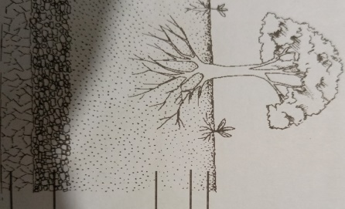
A
D
C
B
Name the layers labelled A, B, C and D (2 marks)

A-………………………………………………………………………………………………………
B-……………………………………………………………………………………………………..
C-……………………………………………………………………………………………………..
D-…………………………………………………………………………………………………….

State four significance of layer labelled A (2 marks)
………………………………………………………………………………………………………………………………………………………………………………………………………………………………………………………………………………………………………………………………………………………………………………………………………………………………………………………………………………………………………………………………………….
State how layer B can be improved for better crop production. (1 marks)
………………………………………………………………………………………………………………………………………………………………………………………………………………………………………………………………………………………………………………………

18. The diagrams below illustrate common weeds found in cultivated crop fields.
Study them carefully and answer the questions that follow.
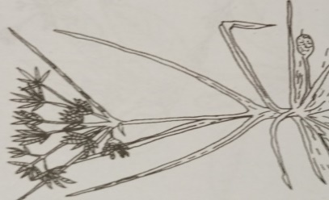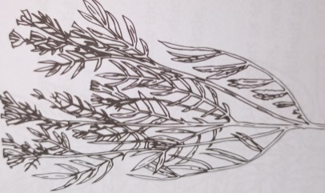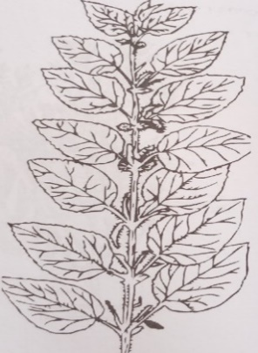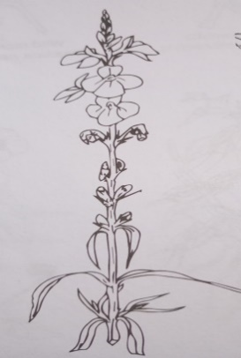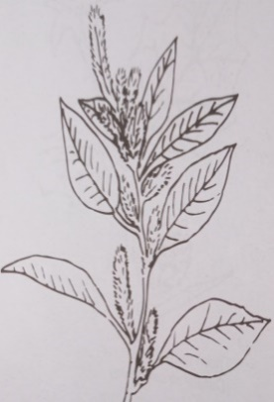
H
G
J
I
F

i)Name the weeds labelled F, G and H (1 ½ marks)
F- ………………………………………………………………………………………………………
G-………………………………………………………………………………………………………
H-……………………………………………………………………………………………………...

- State one reason that makes weed F difficult to control (1 mark) ………………………………………………………………………………………………………………………………………………………………………………………………………………………………………………………………………………………………
- State the one economic importance of each of the weeds (1 ½ marks)
G-………………………………………………………………………………………………………………………………………………………………………………………………………………
H-………………………………………………………………………………………………………………………………………………………………………………………………………………
J-………………………………………………………………………………………………………

………………………………………………………………………………………………………
State two cultural methods for controlling weed I (1 mark)
……………………………………………………………………………………………………………………………………………………………………………………………………………………………………………………………………………………………………………………………………………………………………………………………………………………………………………………………………………………………………………………………………….

19. The diagrams below show two types of irrigation please insert type
A B
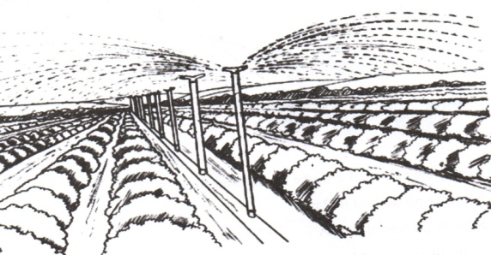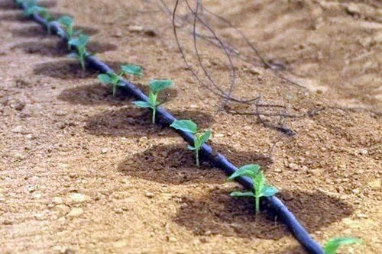
- Name the type of irrigation illustrated (2mks)
A……………………………………………………………………………………………………B……………………………………………………………………………………………………
- State two conditions that promote the use of the type of irrigation illustrated in A
(2mks)
………………………………………………………………………………………………………………………………………………………………………………………………………………………………………………………………………………………………………………………………………………………………………………………………………………………………
- List two disadvantages of using method A of irrigation over method B (2mks)
………………………………………………………………………………………………………………………………………………………………………………………………………………………………………………………………………………………………………………………………………………………………………………………………………………………………
- Name two other types of irrigation other than those shown above (2mk)
………………………………………………………………………………………………………………………………………………………………………………………………………………………………………………………………………………………………………………………

20. The proprietors of Mareira farm made the following transactions in the year 2020;
Purchase of feeds-2000,Purchase of seeds-1000,Purchase 0f fertilizers -1300,Fuel-1500,Disc plough100, 000,Sale of cabbages-35000,Sale of wheat-40000,Sale of milk-10000,Opening valuation was 120000,Closing valuation was 160000 andDebt receivable of 6000 for firewood delivered to a neighbouring farm.
Using the above information, prepare a profit and loss account for the farm for the year ending December 2020.

Did the farm make a profit or a loss (1 Mark)
………………………………………………………………………………………………………………………………………………………………………………………………………………

SECTION C -40 Marks; Answer any Two Questions in this Section
21. (a) State five disadvantages of communal land tenure system answer (5 mks)
………………………………………………………………………………………………………………………………………………………………………………………………………………………………………………………………………………………………………………………………………………………………………………………………………………………………………………………………………………………………………………………………………………………………………………………………………………………………………………………………………………………………………………………………………………………………………………………………………………………………………………………………………………………………………………………………………………………………………………………………………………………………………………………………………………………………………………………………………………………………………………………
………………………………………………………………………………………………………………………………………………………………………………………………………………………………………………………………………………………………………………………………………………………………………………………………………………………………………………………………………………………………………………………………………
(b) State and explain five methods of drainage in agricultural land (10mks)
………………………………………………………………………………………………………………………………………………………………………………………………………………………………………………………………………………………………………………………………………………………………………………………………………………………………………………………………………………………………………………………………………………………………………………………………………………………………………………………………………………………………………………………………………………………………………………………………………………………………………………………………………………………………………………………………………………………………………………………………………………………………………………………………………………………………………………………………………………………………………………………………………………………………………………………………………………………………………………………………………………………………………………………………………
………………………………………………………………………………………………………………………………………………………………………………………………………………………………………………………………………………………………………………………………………………………………………………………………………………………………………………………………………………………………………………………………………

(c) Explain five factors considered in a crop rotation program (5mks)
……………………………………………………………………………………………………………………………………………………………………………………………………………………………………………………………………………………………………………………………………………………………………………………………………………………………………………………………………………………………………………………………………………………………………………………………………………………………………………………………………………………………………………………………………………………………………………………………………………………………………………………………………………………………………………………………………………………………………………………………………………………………………………………………………………………………………………………………………………………………………………………....

………………………………………………………………………………………………………………………………………………………………………………………………………………………………………………………………………………………………………………………………………………………………………………………………………………………………………………………………………………………………………………………………………
22. (a) State and explain five Importance of agriculture in Kenyan economy (10mks)
……………………………………………………………………………………………………………………………………………………………………………………………………………………………………………………………………………………………………………………………………………………………………………………………………………………………………………………………………………………………………………………………………………………………………………………………………………………………………………………………………………………………………………………………………………………………………………………………………………………………………………………………………………………………………………………………………………………………………………………………………………………………………………………………………………………………………………………………………………………………………………………………………………………………………………………………………………………………………………………………………………………………………………………………………………………………………………………………………………………………………………………………………………………………………………………………………………………………………………………………………
(b) Describe the agronomic production of tomatoes under the following subheadings;
i) Transplanting of tomato seedlings. (10mks)
……………………………………………………………………………………………………………………………………………………………………………………………………………………………………………………………………………………………………………………………………………………………………………………………………………………………………………………………………………………………………………………………………………………………………………………………………………………………..........................……………………………………………………………………………………………………………………………………………………………………………………………………………………………………………………………………………………………………………………………………………………………………………………………………………………………………………………………………………………………………………………………………………………………………………………………………………………………………………………………………………………………………………………………………………………………………………………………………………………………………………………………………………………………………………………………………………………..........................………………………………………………………………………………………………………………………………………………………………………………………………………………………………………………………………………………………………………………………
………………………………………………………………………………………………………………………………………………………………………………………………………………
ii) Field management practices (5 marks)
………………………………………………………………………………………………………………………………………………………………………………………………………………………………………………………………………………………………………………………………………………………………………………………………………………………………………………………………………………………………………………………………………………………………………………………………………………………………………………………………………………………………………………………………………………………………………………………………………………………………………………………………………………………………………………………………………………………………………………………………………………………………………………………………………………
iii) Describe five ways in which biotic factors influence agricultural production (5mks)
………………………………………………………………………………………………………………………………………………………………………………………………………………………………………………………………………………………………………………………………………………………………………………………………………………………………………………………………………………………………………………………………………………………………………………………………………………………………………………………………………………………………………………………………………………………………………………………………………………………………………………………………………………………………………………………………………………………………………………………………………………………………………………………………………………………………………………………………………………………………………………………………………………………………………………………………………………………………………………………………………………………………………………………………………………………………………………………………………………………………………………………………………………………………………………………………………………………………………………………………………………………………………………………………………………………………………………………………………………………………………………………………………………………………………………………………………………………………………………………………………………………………………………………………………………………………………………………………………………………………
………………………………………………………………………………………………………………………………………………………………………………………………………………………………………………………………………………………………………………………………………………………………………………………………………………………………………………………………………………………………………………………………………

23. a)State five importance of budgeting in a farming enterprise (5 marks)
………………………………………………………………………………………………………………………………………………………………………………………………………………………………………………………………………………………………………………………………………………………………………………………………………………………………………………………………………………………………………………………………………………………………………………………………………………………………………………………………………………………………………………………………………………………………………………………………………………………………………………………………………………………………………………………………………………………………………………………………………………………………………………………………………………………………………………………………………………………………………………………………………………………………………………………………………………………………………………………………………………………………………………………………………………………………………………………………………………………………………………………………………………………………………………………………………………………………………………………………………………………………………………………………………………………………………………………………………………………………………………………………………………………………………………………………………………
b) State five ways through which farmers adjust to risks and uncertainties (5 marks)
……………………………………………………………………………………………………………………………………………………………………………………………………………………………………………………………………………………………………………………………………………………………………………………………………………………………………………………………………………………………………………………………………………………………………………………………………………………………………………………………………………………………………………………………………………………………………………………………………………………………………………………………………………………………………………………………………………………………………………………………………………………………………………………………………………………………………………………………………………………………………………………………………………………………………………………………………………………………….………………………………………………………………………………………………………………………………………………………………………………………………………………………………………………………………………………………………………………………………………………………………………………………………………………………………………………………………………………………………………………………………………………………………………………………………………………………………………………………………………………………………………………………………………………………………………………………………………………..………………………………………

c) State five ways in which labour productivity can be improved in the farm (5 marks)
………………………………………………………………………………………………………………………………………………………………………………………………………………………………………………………………………………………………………………………………………………………………………………………………………………………………………………………………………………………………………………………………………………………………………………………………………………………………………………………………………………………………………………………………………………………………………………………………………………………………………………………………………………………………………………………………………………………………………………………………………………………………………………………………………………………………………………………………………………………………………………………………………………………………………………………………………………………………………………………………………………………………………………………………………………………………………………………………………………………………………………………………………………………………………………………………………………………………………………………………………………………………………………………………………………………………………………………………………………………………………………………………………………………………………………………………………………………………………………………………………………………………………………………………………………………………………………………………………………………………………………………………………………………………………………………………………………………………………………………………………………………………………………………………………………………………………………………………………………………………………………………………………………………………………………………………………………………………………………………………………………………………………………………………………………………………………………………………………………………………………………………………………………………………………………………………………………………………………………………………………………………………………………………………………………………………………………………………………………………………………………………………………………………………………………………………………………………………………………………………………………………………………………………………………………………………………………………………………………………………………………………………………………………………………………………………………………………………………………………………………………………………………………………………………………………………………………………………………………………………………………………………………………………………………………………………………………………………………………………………………………………………………………………………………………………………………………

d)State five importance of a title deed to a farmer (5 marks)
………………………………………………………………………………………………………………………………………………………………………………………………………………………………………………………………………………………………………………………………………………………………………………………………………………………………………………………………………………………………………………………………………………………………………………………………………………………………………………………………………………………………………………………………………………………………………………………………………………………………………………………………………………………………………………………………………………………………………………………………………………………………………………………………………………………………………………………………………………………………………………………………………………………………………………………………………………………………………………………………………………………………………………………………………………………………………………………………………………………………………………………………………………………………………………………………………………………………………………………………………………………………………………………………
END

