NAME……………………..MARKING SCHEME………………………INDEX NO………………………………………………….....
SCHOOL…………………………………………………………………………ADM. NO…………………………CLASS………………….
AGRICULTURE
443/1
FORM 4
DECEMBER 2021
TIME 2Hrs.
KCSE KENYA CERTIFICATE OF SECONDARY EXAMINATION
INSTRUCTIONS TO CANDIDATES
- Write your Name, Index No., School, Admission No. and Class in the spaces provided.
- Write the date of the examination in the spaces provided.
- This paper contains three sections A, B and C.
- Answer all the questions in section A and B and any two questions in section C.
- All answers should be written in the spaces provided in English
- Students should check the question paper to ascertain that all 6the pages are printed as indicated and that no questions are missing.
- For examiners’ use only.

section | questions | Maximum score | Students’ score
A | 1-16 | 30
B | 17-20 | 20
C | 21 | 20
 | 22 | 20
 | 23 | 20
TOTAL SCORE |  | 90

This paper contains 12 printed pages

SECTION A- 30 Marks; Answer all the questions in this section in the spaces provided
1. Outline four activities that enable agriculture to be classified as a science (2mk)
i. entomology
ii. Genetics
iii. Crop pathology/ livestock pathology/ pathology
iv .soil science /pedology
v. reproduction/ selection and breeding
vi .parasitology
vii.Nutrition or digestion (4 x ½ =2mk)
2. State four characteristic of a good site for a nursery bed (2 mks)
- Near a reliable source of water (reject nearness)
- Well drained area with deep fertile soil (mark one aspect of soil)
- Gently sloping area/ relatively flat
- Secure area (reject security)
- Sheltered area
- Should not have been used for the same crop species in the previous season
- Should be accessible (4 x ½ mks)
3. Give four reasons for intercropping (2 mks)
- Maximum utilization of plant nutrient
- Control erosion when cover crop is included.
- Enable nitrogen fixation when leguminous crops are included.
- Smothers weed when cover crop is included.
- Diversification/spread risks
- Improve soil structure when a grass family crop is included.
- Control pest and diseases
- Maximizes on use of labor/saves on labor
- Maximizes utilization of land/ increase yield per unit area (4 x ½ mks)

4. Give four reasons why burning of land is discouraged (2 mks)
- Destroys soil organic matter/humus
- Kills soil living organism/decomposers
- Leads to loss/evaporation of soil moisture
- Destroys soil structure
- Destroy plants nutrient/cause volatilization.
- Causes mineral imbalance through ash accumulation/raises soil pH.
- Leads to soil erosion (4 x ½ mks)
5. State four advantages of using certified seeds (2 mks)
- Free from pest and diseases/healthy
- Has high germination percentage
- Clean/ free from weed seed
- High yielding
- Adapted to local ecological conditions
- True to type
- Require use of vigorously growing plants(reject faster) (4 x ½ mks)

6. List four characteristics of extensive farming system (2mk)
- Practiced on enlarge piece of land
- Low labour used per unit area
- low Capital used per unit area
- low yield obtained per unit area
- no soil and water conservation measures done that
- land left alone for long if not head (4 x ½ =2mk)
7. State four positive effects of wind in crop production (2mk)
- it blows atmospheric water causing cooling effect in plants
- Carries pollen grains and enabling cross pollination in crops/variation was new crop varieties
- Brows bring rain bearing clouds that bring rain for crop growth
- it's a source of wind power on the farm
- It encourages transpiration that increases uptake of water with mineral salts for crop growth. (4 x ½ =2mk)
8. State four benefits of adding organic manure to an acidic soil (2mk)
  - add nutrients when it decompose
  - Improves soil structure when it decomposes
  - It increases cation exchange capacity that reduce leaching
  - At moderate soil temperature by absorbing heat
  - It buffers soil pH preventing rapid changes in the soil chemical constitution
  - It improves water holding capacity
  - Reduces toxicity or bites toxins in soil due to pesticids question (4 x ½ =2mk)
9. State four factors that determine the stage at which a crop is harvested. (2mk)
- Market price
- Weather conditions
- Market demand
- Purpose /intended use.
- Concentration of required chemicals (4 x 1/2 = 2 marks)
10. State four advantages of applying lime as a measure of improving soil condition ( 2 mks)
i) Lowers soil acidity raises soil pH (modifies pH)
ii) Increases the calcium content of organic matter
iii) Improves soil structure through flocculation of soil particles/improves drainage.
iv) Facilitates the availability and absorption of Nitrogen and prosphorous
v) Improves legume nodulation and N-fixation (4 x 1/2 = 2 marks)

11. State four factors that influence the number of secondary cultivation in seedbed preparation.( 2 mks)
- Type of crop to be established/size of seed
- Moisture content of soil
- Type of soil
- Conditions of land after primary cultivation/ implements used for primary cultivation
- Amount of organic matter on the surface.
- Vulnerability of soil erosion/ slope of land/topography. (4 x 1/2 = 2 marks)
12. State four negative effects of burning as a method of bush clearing (2mk)
  - kills soil microorganisms and the composers
  - Leads to volatilization of soil nutrients
  - Destroys organic matter
  - Leads to accumulation of Ash that change soil pH
  - Leaves land barer encouraging soil erosion (4 x 1/2 =2mk)
13. State four disadvantages of minimum tillage (2mk)
  - there is poor aeration as soil is not disturbed
  - It is ineffective in controlling rhizomatous weeds with bulbs.
  - Results in buildup of soil-borne pests and pathogens
  - Causes poor water infiltration increasing surface runoff
  - Difficult in fields with a lot of crop residues (4 x 1/2 =2mk)
14. Factors that can increase seed rate in crop production (2mk)
- Seed impurity
- Low germination percentage
- Close spacing
- More seeds per hole / broadcasting
- Early planting / dry planting (4 x 1/2 =2mk)
15. State two conditions when opportunity cost exists (1mk)
When resources or inputs are Limited
When there are alternatives uses of resources and inputs number (2 x ½ =1mk)
16. Differentiate between nitrogen fixation and phosphorus fixation as used in agriculture
(2x1= 2mk)
Nitrogen fixation is the process of converting atmospheric nitrogen to forms of nitrate and ammonium ions that can be absorbed by plants for growth by retaining free-living or symbiotic bacteria while phosphorus fixation is the process through which phosphorus is converted two insoluble Aluminium compounds that become unavailable to plants question number

SECTION B-20 Marks; Answer all the questions in this section
17. Study the diagram below carefully and answer the questions that follow.
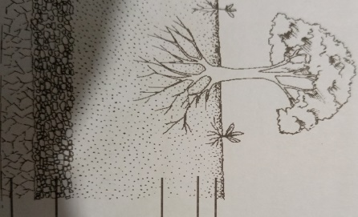
A
D
C
B
Name the layers labelled A, B, C and D (2 marks)
A-Top soil
B-Subsoil
C-Weathered rock
D-Parent rock
State four significance of layer labelled A (2 marks)
Contains highest amount of weathered mineral nutrients for crops
Contains highest amounts of soil air for root metabol9oism
Contains soil water for crop growth
Contains highest amounts of soil microorganisms/decomposers/nitrogen fixing bacteria
State how layer C can be improved for better crop production. (1 marks)
By chisel ploughing/sub-soiling to bring up leached mineral nutrients for crop growth.

18. The diagrams below illustrate common weeds found in cultivated crop fields.
Study them carefully and answer the questions that follow.
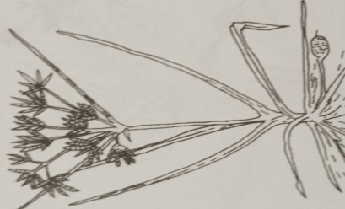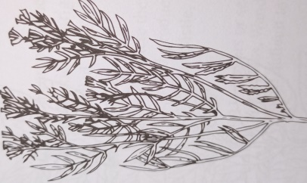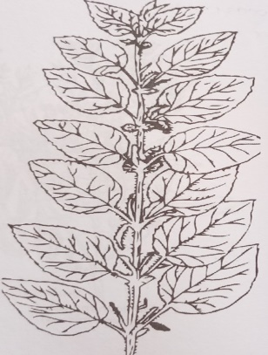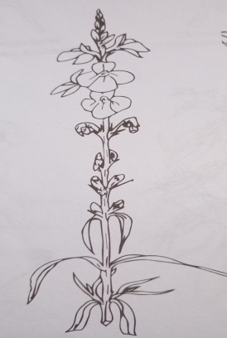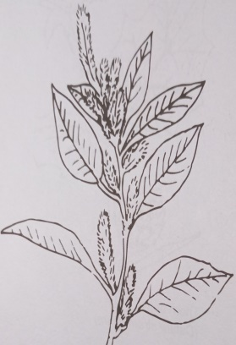
H
G
J
I
F

i)Name the weeds labelled F, G and H (1 ½ marks)
F –Sedge grass/Nut grass
G –Mexican Marigold
H-Stinging neetle/Urtica massaica

- State one reason that makes weed F difficult to control (1 mark)
Presence of underground bulbs/perrenating parts that continue growing after uprooting.
- State the one economic importance of each of the weeds (1 ½ marks)
G-Introduces bad flavour lowering quality of milk
H-irritates farmers reducing labour output
J-used as livestock feed reducing production costs
(3*1/2=1 ½ marks)
State two cultural methods for controlling weed I (1 mark)
Crop rotation
Rogueing
Use of clean planting materials

(2*1/2=1mark)
19. The diagrams below show two types of irrigation please insert type
A B
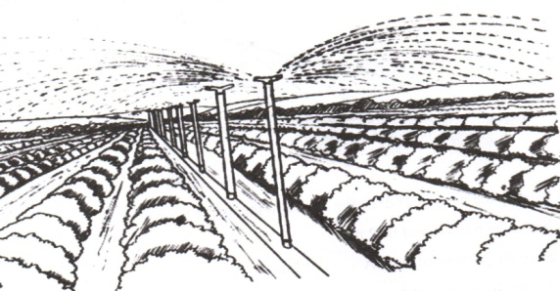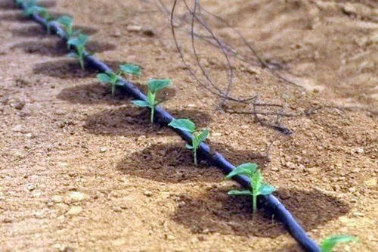
- identify the type of irrigation (2mks)
- Overhead irrigation or sprinkler irrigation
- Drip irrigation

- State two conditions that promote the use of the type of irrigation illustrated in A
(2mks)
- Water at high pressure
- Presence of wind breaks / border trees
- Availability of a lot of water
- List two disadvantages of using method A of irrigation over method B (2mks)
- Encourages fungal diseases as water accumulate on leaves
- Causes soil erosion when practiced on sloppy Land
- Requires establishment of a weed break which is expensive
- Utilizes / waste more water
- Name two other types of irrigation other than those shown above (2mks)
- Surface irrigation
- subsurface irrigation

20. The proprietors of Mareira farm made the following transactions in the year 2020;
Purchase of feeds-2000,Purchase of seeds-1000,Purchase 0f fertilizers -1300,Fuel-1500,Disc plough100, 000,Sale of cabbages-35000,Sale of wheat-40000,Sale of milk-10000,Opening valuation was 120000,Closing valuation was 160000 and Debt receivable of 6000 for firewood delivered to a neighbouring farm.
Using the above information, prepare a profit and loss account for the farm for the year ending December 2020. (4 marks)
Profit and loss account for Ngongongeri farm for the year ending December 2020
expenditure |  |  | income
Opening valuation  Purchases and expenses  Purchase of feeds-  ,Purchase of seeds-  Purchase 0f fertilizers -  Fuel-  Disc plough  Total  Net profit | shs | cts | Sales and receipts  Sale of cabbages-,  Sale of wheat-  Sale of milk-  firewood  Closing valuation  total | shs | cts
 | 120000  2000  1000, 1300, 1500,  100, 000  225,000  26000 |  |  | 35000  40000  10000  6000  160000  251000
 | 251000 |  |  | 251000

Heading (1 mark)
Entries (1*2=2 marks)
Net profit- (1 mark)

Did the farm make a profit or a loss (1 Mark)
Profit, 251000-225000=26000 (1 mark)

SECTION C -40 Marks; Answer any Two Questions in this Section
21. (a) State five disadvantages of communal land tenure system answer (5 mks)
- No individual responsibility for developing the land
- Low production as soil and water conservation are not carried out
- No permanent developments as land is communal
- Poor stock breeding program as animals graze together
- Pests parasites and diseases difficult to control
- Soil and land destruction as farmers make short term maximization of returns without adding fertility to the soil (1*5=5 mks)
(b) State and explain five methods of drainage in agricultural land (10mks)
- Use of open ditches in which excess water frozen by Gravity to natural Waterways lowering the water table
- Use of underground drain pipes with perforations on the upper half side where water seeps in from surrounding areas and drains away into natural Waterways lowering the water table
- Use of French drains in which dishes are done and back filled with stones gravel and covered with soil what are sips into the stone field ditches and flows into natural waterways thus lowering the water table
- Use of covered, raised bed raised bed with water channels in poorly drained soils where crops are grown and excess water flows into surrounding ditches and into a natural waterways lowering water table
- Pumping water mechanically from waterlogged low-lying Lodge to lower the water table
- Planting trees that bear deep roots like eucalyptus that grow to the water table and absorb excess water that the trees lose by transpiration lowering the water table (2*5=10 mks)

(c) Explain five factors considered in a crop rotation program (5mks)
- Crop root depth- deep rooted are alternated with shallow rooted crops
- Crop nutrient requirement – heavy feeder are alternated with crop of low nutrient requirement
- Weed control – crops associated with certain families of weed are alternated with those that are not associated to break their life cycles.
- Crop pest and diseases – crop attacked by similar pest and diseases should not follow each other on a program.
- Soil fertility – leguminous crops should be included in order to improve soil fertility
- Soil structure – a grass ley should be included to bide and improve the soil structure every six years (1*5=5 mks)

22. (a) Explain five Importance of agriculture in Kenyan economy (5mks)
- Supply of food to the population, helps save money used in agriculture sector of the economy.
- Provide direct and indirect employment, help earn income used to purchase agricultural goods
- Earn foreign exchange when agricultural produce like tea are exported to foreign countries
- Source of income/revenue used to purchase farm input promoting agriculture
- Source of raw material for industries like sisal that promote industrial development
- Provide market for industrial good and tools like wheelbarrow increasing financial transactions
- Promote international relationship, through creation of trading blocs like COMESA, EAC (1*5=5 mks)
(b) Describe the agronomic production of tomatoes under the following subheadings;
i) Transplanting of tomato seedlings. (5mks)
- Should be done when seedlings are pencil size thick/ one month old
- Nursery should be watered before to ease lifting of seedlings
- Use garden trowel to ensure that seedlings are lifted with lump of soil around roots
- Apply appropriate pesticide or the planting holes and thoroughly mix these with the soil.
- Lift only healthy and vigorous seedlings from the nursery
- Plant one seedling per hole at the same depth as was in the nursery
- Transplanting is preferably done in the evening or on a cloudy day
- Provide temporary shade to the transplanted seedlings.
- Water the seedlings as necessary.
- Place the soil around the seedlings and firm
- Holes dug are spaced at 60 – 100cm by 50 – 60cm
- Transplant onset of the rains/ when the soil has enough moisture (water transplanting holes)
- Transport the seedlings carefully/use a wheelbarrow
- Planting holes should be dug at 15cm deep. (5x1=5 marks)
ii) Field management practices (5 marks)
- Weeding lightly to prevent competition for growth factors
- Irrigation when dry to supplement water supply/mulching to prevent excessive loss of water by evaporation.
- Gapping to achieve correct plant population/maximize utilization of available resources
- Crop pest control to avoid damages /Crop disease control to avoid losses
- Staking to ensure clean fruit production/avoid attack by soil borne pests/enable easy application of chemical sprays
- Topdressing when tomatoes are 25 -30 cms high with 20 kgs. Nitrogen/100kgs CAN per Ha to provide nutrients (5x1=5 marks)

iii) Describe five ways in which biotic factors influence agricultural production (5mks)
- pathogens Transmit diseases
- pests feed on whole or parts of plants
- Pests injure plants providing secondary infection agents
- Suck blood from animal causing anaemia
- Acts on plant and animal remains to form humus
- Some cause diseases like pathogens
- Some kill and feed on other animals
- Some carryout cross pollination
- Some fix nitrogen into the soil
- They increase cost of production through control measures
- Pollute environment when chemical control is used (5x1=5 marks)

23. a)State five importance of budgeting in a farming enterprise (5 marks)
- Enable farmers to make long term and short term decision making/prevents impulsive over expenditure.
- Enable farmers to predict future returns
- Ensures farmers obtain maximum profits by investing in more profitable enterprises.
- Enable farmers to secure credit facilities/loans from financial institutions
- Used as a record for future reference during takeover or sale
- It pinpoints efficiency and weaknesses in the farming enterprise
- Enable periodic analysis of the farming business (5x1=5 marks)

b) State six ways through which farmers adjust to risks and uncertainties (5 marks)
- Diversification –if one enterprise fails he still earns an income from another enterprise.
- Selection of more certain enterprises
- Contracting to obtain earning irrespective of the seasons
- Insurance-insuring against loss of crops and livestock
- Input rationing-reducing input costs when other factors of production can result in lower production.
- Adopting modern methods of production to increase efficiency/reduce production costs
- Flexibility to production methods-farm buildings should allow conversion of buildings for different enterprises at minimum costs (5x1=5 marks)

c) State four ways in which labour productivity can be improved in the farm (4 marks)
Training the worker to improve skills/increase efficiency
Farm mechanisation to reduce drudgery/increase efficiency
Supervision of the farm labour to avoid malaise/underproduction
Increasing incentives/rate of pay per day/improving conditions of service (4x1=4marks)

d)State five importance of a title deed to a farmer (5 marks)
- Enable a farmer to borrow loans/can be used as security to obtain loans
- Enable permanent/long-term investment
- Allow a farmer to sell part/whole farm/lease part or whole piece of land.
- Shows ownership/prevents land disputes
- Make it easier to share land amongst the heirs (5x1=5marks)

