**Name: ……………………………………………... Index no ……..…......................................**

**School: …………………………………………….. Candidate’s sign …………………….......**

**Class………………………………………….…..… Adm No…………………...……………...**

**AGRICULTURE 443/1**

**JULY 2021**

**TIME: 2 HOURS**

**MOI HIGH SCHOOL-KABARAK**

**MOKASA I EXAMINATION**

***Kenya Certificate of Secondary Education (K.C.S.E.)***

**Agriculture**

**Paper 1**

**INSTRUCTIONS TO CANDIDATES:**

* *Write your name and index number in the spaces provided above.*
* *Sign and write the date of examination in the spaces provided above.*
* *This paper consists of three sections A, B and C.*
* *Answer all the questions in section A and B.*
* *Answer any two questions in section C.*
* *All answers should be written in the spaces provided.*
* *This paper consists of 13 printed pages.*
* *Candidates should check the question paper to ascertain that all the pages are printed as indicated and that no questions are missing.*
* *Candidates should answer all the questions in English.*

***For Examiner’s Use Only:***

|  |  |  |  |
| --- | --- | --- | --- |
| **SECTION** | **QUESTIONS** | **MAXIMUM SCORE** | **CANDIDATES SCORE** |
| A | 1-17 | 30 |  |
| B | 18-21 | 20 |  |
| C |  | 20 |  |
|  | 20 |  |
|  | **TOTAL SCORE** | **90** |  |

**SECTION A (30 MARKS)**

1. State **two** conditions under which opportunity cost is zero. (1mk)

………………………………………………………………………………………………..…………………………………………………………………………………………………..…………………………………………………………………………………………………..…

1. Name **three** branches of horticulture. $(1\frac{1}{2}mks)$

………………………………………………………………………………………………..…………………………………………………………………………………………………..…………………………………………………………………………………………………..…

1. State **four** factors a farmer should consider when choosing the farming system to undertake.

(2mks)

………………………………………………………………………………………………..…………………………………………………………………………………………………..…………………………………………………………………………………………………..…………………………………………………………………………………………………..…………………………………………………………………………………………………......

1. State **four** disadvantages of communal land tenure system. (2mks)

………………………………………………………………………………………………..…………………………………………………………………………………………………..…………………………………………………………………………………………………..…………………………………………………………………………………………………..…………………………………………………………………………………………………..……………………………………………………………………………………………………..

1. Give **four** pieces of information found on a land title deed. (2mks)

………………………………………………………………………………………………..…………………………………………………………………………………………………..…………………………………………………………………………………………………..…………………………………………………………………………………………………..……………………………………………………………………………………………………..

1. State **four** reasons for deep ploughing during land preparation. (2mks)

………………………………………………………………………………………………..…………………………………………………………………………………………………..…………………………………………………………………………………………………..…………………………………………………………………………………………………..…………………………………………………………………………………………………..……………………………………………………………………………………………………..

1. State **four** characteristics of a good top soil. (2mks)

………………………………………………………………………………………………..…………………………………………………………………………………………………..…………………………………………………………………………………………………..…………………………………………………………………………………………………..……………………………………………………………………………………………………..

1. Give **three** reasons for sub soiling. $(1\frac{1}{2}mks)$

…………………………………………………………………………………………………..…………………………………………………………………………………………………..…………………………………………………………………………………………………..…………………………………………………………………………………………………..

1. Differentiate between seed inoculation and seed dressing. (1mk)

………………………………………………………………………………………………..…………………………………………………………………………………………………..…………………………………………………………………………………………………..……………………………………………………………………………………………………..

1. State **four** effects of soil erosion. (2mks)

………………………………………………………………………………………………..…………………………………………………………………………………………………..…………………………………………………………………………………………………..…………………………………………………………………………………………………..…………………………………………………………………………………………………..……………………………………………………………………………………………………..

1. Outline **four** practices necessary to improve and maintain permanent pastures. (2mks)

………………………………………………………………………………………………..…………………………………………………………………………………………………..…………………………………………………………………………………………………..…………………………………………………………………………………………………..……………………………………………………………………………………………………..

1. State **two** causes of poor drainage on farmland. (1mk)

…………………………………………………………………………………………………………………………………………………………………………………………………………………………………………………………………………………………………………………………………………………………………………………………………………

1. State **four** reasons for mulching. (2mks)

………………………………………………………………………………………………..…………………………………………………………………………………………………..…………………………………………………………………………………………………..…………………………………………………………………………………………………..……………………………………………………………………………………………………..

1. Give the function of each of the following in the preparation of compost manure. (2mks))
2. Top soil

…………………………………………………………………………………………..………………………………………………………………………………………………..

1. Well rotten manure

…………………………………………………………………………………………..………………………………………………………………………………………………..

1. A thin layer of wood ash

…………………………………………………………………………………………..………………………………………………………………………………………………..

1. Long pointed stick

…………………………………………………………………………………………..………………………………………………………………………………………………..

1. State **four** deficiency symptoms of phosphorus. (2mks)

………………………………………………………………………………………………………………………………………………………………………………………………………………………………………………………………………………………………………………………………………………………………………………………………………………………………………………………………………………………………………………………………………………………………………………………………………………..

1. State **four** characteristics of nitrogenous fertilizers. (2mks)

………………………………………………………………………………………………..…………………………………………………………………………………………………..…………………………………………………………………………………………………..…………………………………………………………………………………………………..……………………………………………………………………………………………………..

1. State **four** reasons why a nursery is important in crop production. (2mks)

………………………………………………………………………………………………..…………………………………………………………………………………………………..…………………………………………………………………………………………………..…………………………………………………………………………………………………..…………………………………………………………………………………………………..……………………………………………………………………………………………………..

**SECTION B (20 MARKS)**

1. The illustrations labelled A and B show some farm structures used in soil and water conservation. Study them carefully and answer the questions that follow.

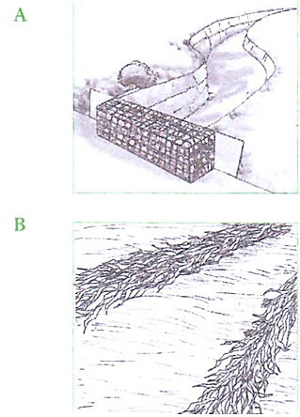

A B

1. Identify structures A and B. (1mk)

A…………………………………………………………………………………………….

B…………………………………………………………………………………………….

1. Name the type of soil erosion controlled by structures A and B. (2mks)

A…………………………………………………………………………………………….

B…………………………………………………………………………………………….

1. State **two** ways in which the structures help to control soil erosion. (2mks)

………………………………………………………………………………………………………………………………………………………………………………………………………………………………………………………………………………………………

1. The diagrams below illustrate irish potato seed preparation before planting. Study it carefully and answer the questions that follow.



1. Name the practice used in preparing the seed potato above before planting. (1mk)

………………………………………………………………………………………………………………………………………………………………………………………………

1. Describe the procedure followed in preparing the seed potatoes for planting. (3mks)

………………………………………………………………………………………………………………………………………………………………………………………………………………………………………………………………………………………………………………………………………………………………………………………………………………………………………………………………………………………………………………………………………………………………………………………............

1. Give **one** reason for carrying out the practice named above. (1mk)

………………………………………………………………………………………………………………………………………………………………………………………………

1. The photograph below shows an irish potato plant attacked by a disease. Study it and answer the questions that follow.

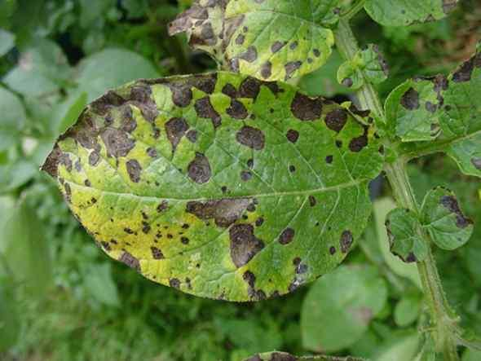

1. Identify the disease represented by the photograph. (1mk)

………………………………………………………………………………………………………………………………………………………………………………………………

1. Name the causative agent of the diseases. (1mk)

………………………………………………………………………………………………………………………………………………………………………………………………

1. Give **one** other crop that can be attacked by the same disease. (1mk)

………………………………………………………………………………………………………………………………………………………………………………………………

1. List **two** control measures of the disease. (2mks)

………………………………………………………………………………………………………………………………………………………………………………………………………………………………………………………………………………………………

1. The photographs below show common weeds C and D in pasture land. Study them carefully and answer the questions that follow.

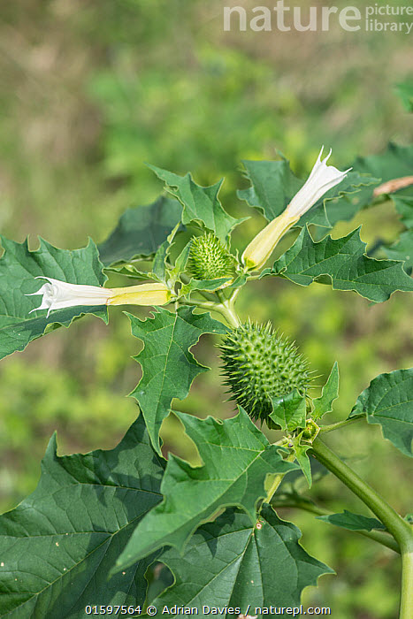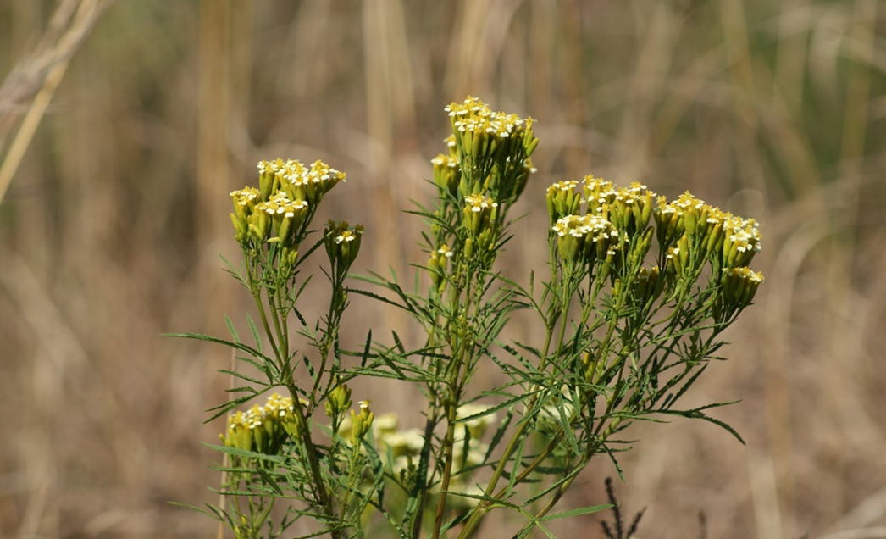

C D

1. Identify weeds C and D. (2mks)

C…………………………………………………………………………………………….

D…………………………………………………………………………………………….

1. Classify weed D according to plant morphology. (1mk)

………………………………………………………………………………………………………………………………………………………………………………………………

1. State the major problem posed by each of the weeds above in pasture land. (2mks)

C…………………………………………………………………………………………….

D…………………………………………………………………………………………….

**SECTION C (40MARKS)**

1. a) State **four** benefits of sowing annual crops early. (4mks)

b) Describe **eight** effects of fragmentation and sub division of land. (8mks)

c) Explain **eight** effects of weeds. (8mks)

1. a) Describe the various field management practices for tomatoes. (8mks)

b) State the precautions that should be observed when harvesting cotton. (4mks)

c)Explain **four** importance of crop rotation. (8mks)

1. a) Explain **four** factors to consider in choosing the type of irrigation to use in the farm.

(8mks)

b) Explain **five** farming practices that destroy soil structure. (5mks)

c) Describe **seven** reasons why farmers need to keep good farm records. (7mks)

………………………………………………………………………………………………..…………………………………………………………………………………………………..…………………………………………………………………………………………………..…………………………………………………………………………………………………..…………………………………………………………………………………………………..…………………………………………………………………………………………………..…………………………………………………………………………………………………..…………………………………………………………………………………………………..…………………………………………………………………………………………………..…………………………………………………………………………………………………..…………………………………………………………………………………………………..…………………………………………………………………………………………………..…………………………………………………………………………………………………..…………………………………………………………………………………………………..…………………………………………………………………………………………………..…………………………………………………………………………………………………..…………………………………………………………………………………………………..…………………………………………………………………………………………………..…………………………………………………………………………………………………..…………………………………………………………………………………………………..……………………………………………………………………………………………………..

………………………………………………………………………………………………..…………………………………………………………………………………………………..…………………………………………………………………………………………………..…………………………………………………………………………………………………..…………………………………………………………………………………………………..…………………………………………………………………………………………………..…………………………………………………………………………………………………..…………………………………………………………………………………………………..…………………………………………………………………………………………………..…………………………………………………………………………………………………..…………………………………………………………………………………………………..…………………………………………………………………………………………………..…………………………………………………………………………………………………..…………………………………………………………………………………………………..…………………………………………………………………………………………………..…………………………………………………………………………………………………..…………………………………………………………………………………………………..…………………………………………………………………………………………………..…………………………………………………………………………………………………..…………………………………………………………………………………………………..……………………………………………………………………………………………………..

………………………………………………………………………………………………..…………………………………………………………………………………………………..…………………………………………………………………………………………………..…………………………………………………………………………………………………..…………………………………………………………………………………………………..…………………………………………………………………………………………………..…………………………………………………………………………………………………..…………………………………………………………………………………………………..…………………………………………………………………………………………………..…………………………………………………………………………………………………..…………………………………………………………………………………………………..…………………………………………………………………………………………………..…………………………………………………………………………………………………..…………………………………………………………………………………………………..…………………………………………………………………………………………………..…………………………………………………………………………………………………..…………………………………………………………………………………………………..…………………………………………………………………………………………………..…………………………………………………………………………………………………..…………………………………………………………………………………………………..……………………………………………………………………………………………………..

………………………………………………………………………………………………..…………………………………………………………………………………………………..…………………………………………………………………………………………………..…………………………………………………………………………………………………..…………………………………………………………………………………………………..…………………………………………………………………………………………………..…………………………………………………………………………………………………..…………………………………………………………………………………………………..…………………………………………………………………………………………………..…………………………………………………………………………………………………..…………………………………………………………………………………………………..…………………………………………………………………………………………………..…………………………………………………………………………………………………..…………………………………………………………………………………………………..…………………………………………………………………………………………………..…………………………………………………………………………………………………..…………………………………………………………………………………………………..…………………………………………………………………………………………………..…………………………………………………………………………………………………..…………………………………………………………………………………………………..……………………………………………………………………………………………………..

………………………………………………………………………………………………..…………………………………………………………………………………………………..…………………………………………………………………………………………………..…………………………………………………………………………………………………..…………………………………………………………………………………………………..…………………………………………………………………………………………………..…………………………………………………………………………………………………..…………………………………………………………………………………………………..…………………………………………………………………………………………………..…………………………………………………………………………………………………..…………………………………………………………………………………………………..…………………………………………………………………………………………………..…………………………………………………………………………………………………..…………………………………………………………………………………………………..…………………………………………………………………………………………………..…………………………………………………………………………………………………..…………………………………………………………………………………………………..…………………………………………………………………………………………………..…………………………………………………………………………………………………..…………………………………………………………………………………………………..……………………………………………………………………………………………………..

………………………………………………………………………………………………..…………………………………………………………………………………………………..…………………………………………………………………………………………………................................................................................................................................................................................................................................................................................................................................................................................................................................................................................................................................................................................................................................................................................................................................................................................................................................................................................................................................................................................................................................................................................................................................................................................................................................................................................................................................................................................................................................................................................................................................................................................................................................................................................................................................................................................................................................................................................................................................................................................................................................................................................................................................................................................................................................................................................................................................................