NAME ……………………………………….. ADM. NO. …………………………
DATE………………………………..

443/2
AGRICULTURE

FORM 4 PAPER 2

TIME 2HRS

END OF TERM 2 EXAMINATIONS
INSTRUCTIONS TO CANDIDATES
- Write your name and admission in the spaces provided
- The paper consists of three sections A B & C
- Answer all the questions in section A & B
- Answer any two questions in section c
- Answer all the questions in English
For examiner only
Section | Questions | Max score | Candidates score
A | 1-19 | 30
B | 20-23 | 20
C | 24-26 | 20
 |  | 20
TOTAL SCORES |  | 90

SECTION A: (30 MARKS)

Answer ALL questions in this section in the spaces provided.

- State three ways used to improve production of indigenous cattle. (1½ marks)

- List four factors considered when formulating a livestock ration. (2 marks)

- List two methods of identifying pigs. (1 mark)

- State two reasons why walls of a dairy shed should be white washed instead of painting.(1 mark)

- Give two reasons for applying oil and grease on a rotary mower. (1 mark)

- Differentiate between cropping and harvesting in fish farming. (1 mark)

- (a) Name two common diseases that attack bees in a colony. (1 mark)

(b) Name the equipment used to make the bees less aggressive during harvesting of honey. (½ mark)

- Name two livestock diseases controlled through Artificial insemination. (1mark)

- (a) List two types of feed additives. (1 mark)

(b) Give two reasons why it is important to include additives in commercial feeds.

(1mk)

- Name four symptoms of Gumboro disease in poultry production. (2 marks)

- Name four light breeds of poultry. (2 marks)

- Give three methods of harnessing tractor power. (1½ mark)

- State four condition that encourage egg eating in poultry production (2mk)

- Give four reasons why breeding boar may be culled. (2 marks)

- Give four factors considered when siting a milking parlour. (2 marks)

- State four maintenance practices carried out on a wire fence. (2 marks)

- List four functions of the rumen in the digestion of feed in ruminants. (2marks)

- State the use of each of the following parts in a cattle dip. (2 marks)

- Roof

- Silt trap

- State three major routes of administering vaccine in a day-old chick
(1½ mark)

SECTION B (20mks)
20. a. a cow was given 120kg of a roughage feed. Out of that 40kg was lost as faeces,
10kg as urine and 5kg as gases. Calculate the digestibility of the feed. (3mks)

b. State two reasons for feeding livestock (2mks)

21 Study the illustrations of power transmission of a tractor below and answer the question
that follow

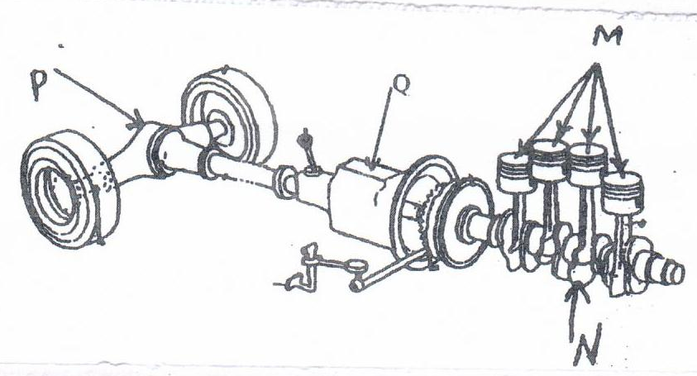

a. Identify and name the parts labeled M, N, P. (3mks)

b. State two functions of part Q (2mks)

22. a. Identify the practice illustrated below. (1mk)
___________________________________________
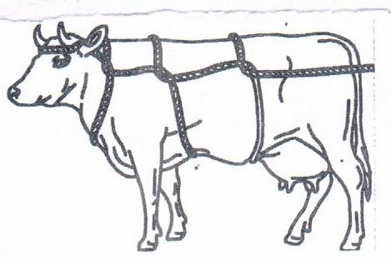

b. Give four occasions when it may be necessary to carry out the above practice. In
livestock. (2mks)

c. Give two animal conditions under which the method cannot be used (2mks)

23. The figure below shows a cow suffering from lack of certain minerals
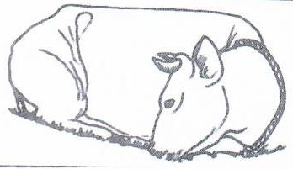

i. Name the condition the cow is suffering from (1mk)

ii. Identify the mineral deficient (1mk)

iii, State three characteristics of the condition named in (i) above (3mks)

SECTION C (40mKS)
Answer any two questions in section C
24. a. Describe factors to consider when selecting livestock for breeding. (10mks)

b. What are the signs for parturition in a sow? (4mks)

c. State six sign of broodiness in birds (6mks)

25. a. Describe the process of digestion in the following sections in the alimentary canal of a non-ruminant animal.
i. Mouth (1mk)

ii. Stomach (3mks)

iii. Small intestines (6mks)

b. State and explain factors that predispose livestock to diseases (10mks)

26. a. describe the use of various hand tools required for the construction of a
Wooden fence. (5mks)

b. outline the procedure of castrating a bull using a burndizo (7mks)

c, Describe the management practices that ensure clean milk production in a dairy
farm. (8mks)

