NAME ……………………………………….. ADM. NO. …………………………
DATE………………………………..

443/1
AGRICULTURE FORM 4
PAPER 1
TIME 2HRS
END OF TERM 2 EXAMINATIONS
Instructions to candidates
- Write your name and admission in the spaces provided
- The paper consists of three sections A B and C
- Answer all the questions in Section A and B
- Answer any two questions in section c
- Answer all the questions in English

For examiner only
Section | Questions | Max score | Candidates score
A | 1-17 | 30
B | 18-22 | 20
C | 23-25 | 20
 |  | 20
TOTAL SCORES |  | 90

SECTION a (30mks)
Answer all the questions in the spaces provided
1. Name the routine field practice done by;
a. Remove of extra suckers in banana stool. (½ mk)

b. Removal of old stems down to level of top foliage in pyrethrum (½ mk)

c. Removal of suckers from coffee bushes (½ mk)

2. State three characteristic of phosphate fertilizers. (1½ mks)

3. State two physical properties of soil that influence crop production (1 mk)

4. Outline four ways by which crop pests are classified (2 mks)

5. State three use of labour records in Agricultural (1½ mk)

6. Give four advantages of overhead irrigation in crop production (2 mks)

7. List three basic concepts in agricultural economics. (1½ mk)

8. Give four varieties of tomatoes grown for processing (2 mks)

9. State four pasture management practices done to enhance per unit area. (2 mks)

10. Name two macro-nutrients which are classified as;
a. Fertilized elements (1mk)
________________________________________
________________________________________
b. Liming elements (1mk)
________________________________________
________________________________________
11. Give three ways by which pruning helps to control disease in crops. (1½ mk)
________________________________________
________________________________________
________________________________________

12. State four ways in which weeds are exceedingly adapted to the environment (2 mks)

13. State four factors that determine the time at which a crop is planted. (2 mks)
________________________________________
________________________________________
14. Give four factors that affect the effectiveness of a pesticide. (2 mks)
________________________________________
________________________________________
15. State four reasons for staking tomatoes in crop production. (2 mks)
________________________________________
________________________________________
16. State three cultural methods of soil and water conservation (1½ mk)
________________________________________
________________________________________
17. State four benefits of having a land tittle deed to a farmer (2mks)
________________________________________
________________________________________
SECTION b (20mks)
Answer all questions in the spaces provided
18 The illustration below shows a newly constructed cut-off drain. Study it and answer the questions that follow.
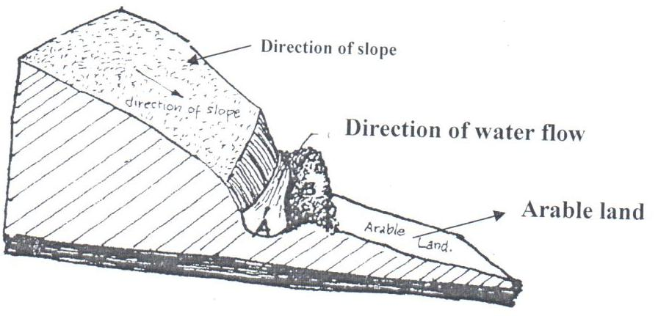

B

  - (i) How can part of the structure labeled B be stabilized after it has been constructed? (1mk)
…………………………………………………………………………………………………….
(ii) Identify the part of the cut-off drain labeled A. (1mk)
……………………………………………………………………………………………...........
  - Describe the procedure of constructing a cut-off drain. (2mks)
……………………………………………………………………………………………………………………………………………………………………………………………………………………………………………………………………………………………………………………………………………………………………………………………………………………
19 The experiment below was set to compare the porosity and water holding capacity of three different types of soils.
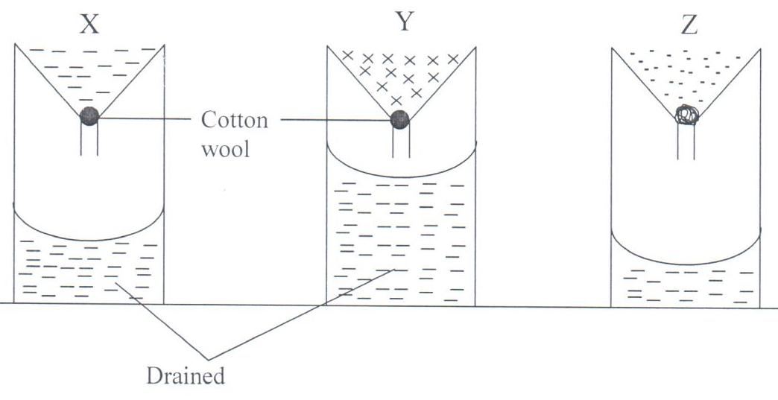
    - Identify the soils in each of the following funnels labeled X, Y and Z. (1½mks)

    - Which of the types of soil can be said to have the highest porosity rate? (½mk)
……………………………………………………………………………………………
    - Give reasons for your answers in (ii) above. (2mks)

    - Which type of soil would be suitable for planting paddy rice? (1mk)

    - Explain your answer in (iv) above. (1mk)

20 Below is a diagram of a Common East African Weed.
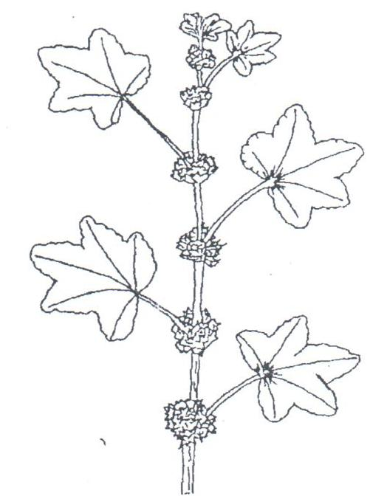
    - Identify the weed illustrated above. (1mk)

    - Give one harmful effect of the weed illustrated above to livestock. (1mk)

    - State two methods of controlling the weed illustrated above. (1mk)

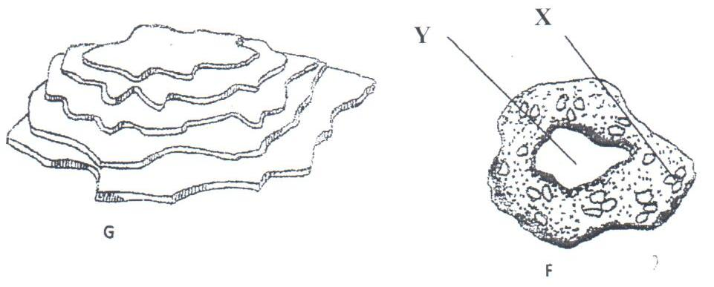
21 The diagrams below illustrate some soil structures. Study them and answer the questions that follow.

  - Identify the soil structures F and G. (1mk)

  - Name the part labeled X and Y in diagram F. (1mk)

  - Describe two ways through which structure G influence crop production. (2mks)

22 The diagrams labeled D and E below are illustrations of coffee established using two different formative pruning systems. Study them and answer the questions that follow.
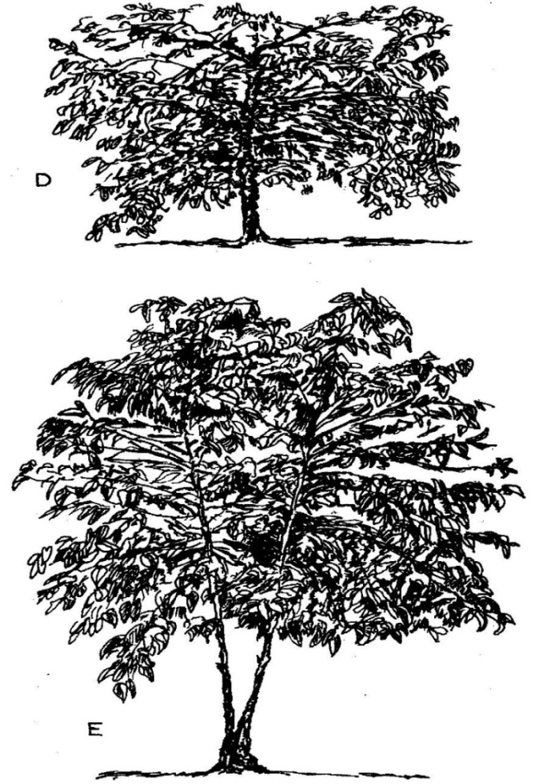

(a) Name the system of pruning illustrated in diagram D above. ( 1mk)

(b) Describe how the pruning system illustrated in diagram E is carried out. (2mks)

SECTION C (20mks)
Answer any two questions in section c
23. a. explain factors affecting rooting of cutting (5mks)

b. state and explain the factors that determine the spacing of crops when planting (10mks)

c, Give five ways in which government policy influence agriculture (5mks)

24. a, State and explain the cultural methods used in control of crop pests (8mks)

b. Describe the procedure of silage making (7mks)

c. State the observable indicators of economic development of a nation (5mks)

25. a. outline five advantages of adding organic manure into the soil (5mks)

b. Describe the precautions taken when harvesting tea (3mks)

c. Study the following information which was extracted from Mr. Mulong’os farm record on 31.2.12.2020 and answer the questions that follow.
Loan payable to bank – shs. 300,000
Five milking cows - shs. 250,000
400 layers - shs. 80,000
20 goats -shs. 30,000
Debt payable to coo-p society - shs. 20,000
Building and structures - shs. 600,000
Bonus payable to workers - shs 19,000
Cattle feeds - shs. 10,000
Animal drugs in store - shs. 4,000
Debt receivable - shs. 18,000
Breakages to repair - shs. 30,000
Cash to at hand - shs.20,000
Cash in bank - shs 30,000
Spray equipment - shs. 12,000

i. prepare a balance sheet for Mr. mulang’os farm using the information above (6mks)

ii. Was mr. Mulango farm business solvent or insolvent? (1mk)

d. Describe post-harvest practices carried out on maize (5mks)

