NAME ……………………………………….. ADM. NO. …………………………
DATE………………………………..

AGRICULTURE
FORM 3
TIME 2HRS
END OF TERM 2 EXAMINATIONS
Instructions to candidates
- Write your name and admission in the spaces provided
- The paper consists of three sections A B and C
- Answer all the questions in English
For examiner only
Section | Questions | Max score | Candidates score
A | 1-25 | 40
B | 26-29 | 30
C | 30-36 | 30
TOTAL SCORES |  | 100

SECTION A (40mks)
Answer all questions in spaces provided
1. State four reasons for planting sweet potatoes on ridges. (2mks)

2. List four farming practices that reduces the effect of water shortage in crops (2mks)

3. State four main characteristics of shifting cultivation (2mks)

4. State four types of micro-catchments (2mks)

5. Give four reasons for identification of cattle in cattle management (2mks)

6. List three signs of farrowing in a sow (1^{1/}₂ mks)

7. State two advantages of using embryo transplant (1mk)

8. Give the functional differences between a rip saw and a cross cut saw (1mk)

9. Apart from transmission of diseases, give three harmful effects of ticks in cattle. (1^{1/}₂ mks)

10. State four characteristics of crops that are used to prepare green manure. (2mks)

11. Name two classes of weeds according to plant morphology (1mk)

12. Name two conditions that may lead to subdivision of agriculture land. (1mk)

13. State four methods a farmer can use when preserving fish after harvesting. (2mks)

14. Give four methods of land reform practiced in Kenya. (2mks)

15. List four materials that can be used in constructing a Kenya Top Bar Hive (2mks)

16. State two functions of a queen bee in a colony (2mks)

17. State four reason for castrating male kids not required for breeding in a farm.
(2mks)

18. Distinguish between each of the following terms as used in livestock rearing practices.
  - Streamlining up and flushing

b. Kindling and farrowing (2mks)

19. State the functions of crop in poultry digestive system (1mk)

20. State three methods used in training crops (1^{1/}₂ mks)

21. State four practices carried out to increase light intensity in a field of crops. (2mks)

22. Give four ways of controlling weeds in a field of maize. (2mks)

23. State two uses of check dams in soil and water conservation (1mk)

24. Outline two ways used by farmers to harden-off seedlings in the nursery (2mks)

25. Name three factors that dictate livestock distribution in Kenya. (1^{1/}₂ mks)

Form 3 Section B (30mks)
Answer all the questions in this section in the spaces provided
26. Study the diagram below and answer the questions that follow. The illustrations represent a method of propagation.
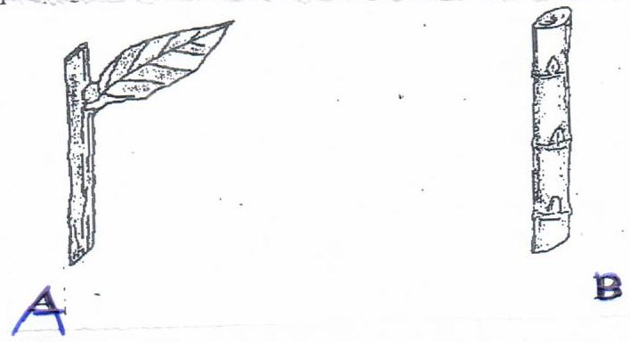

a. Name the crops that can be propagated by the illustration.
A. _________________________________________ (2mks

B. _________________________________________
b. Give three factors that promote the rooting of illustration A. (2mks)

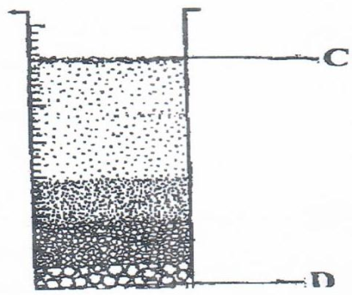
22. the diagram below illustrates an experiment using garden soil, study it correctly and answer the questions that follow,

a. What was the aim of the experiment (1mk)

b. Name the parts labeled C and D. (2mks)

c. Name the property of the soil being investigated. (1mk)

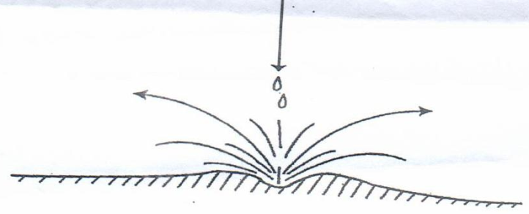
28. The illustration below shows a type of soil erosion. Study it an answer the questions that follow.

a. Identify the type of erosion illustrated above. (1mk)

b. Give two soil factors that influence the rate of soil erosion. (2mks)

c. name one agent of soil erosion. (1mk)

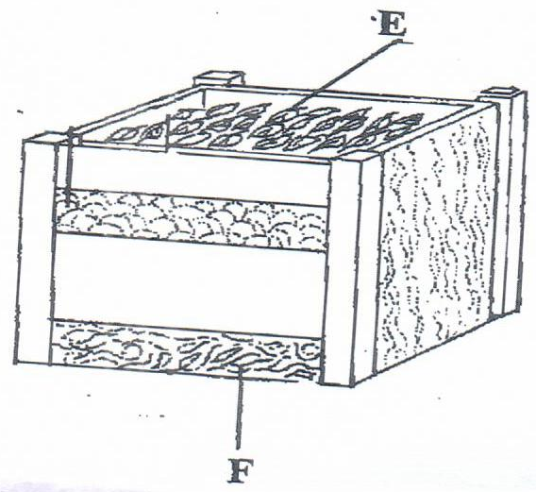
29. The diagram below represents a method of manure preparation. Study it carefully and answer the questions that follow.

a. Identify the type of manure being prepared (1mk)

b. Name the parts labeled E and F (2mks)

c. Give four disadvantages of organic manures (4mks)

Form 3 Section C (30mks)
Answer all the questions in the spaces provided
30. State and explain the method’s used in preparing materials in readiness for planting
(6mks)

31. a. State four reasons for land fragmentation (4mks)

b. Describe importance of land consolidation (4mks)

32. a. Give four ways in which trees help in soil conservation (4mks)

b. Describe the cultural of biological methods of controlling soil erosion (5mks)

33. Give four disadvantages of using hedges. (4mks)

34. Describe the benefits of adding organic mulch soil. (4mks)

35. Give four benefits of practicing irrigation in Kenya (4mks)

36. State the effects of strong winds in crop production. (5mks)

