NAME ……………………………………………………... ADM. NO. ……….……………………
DATE………………………………..
AGRICULTURE FORM 2
TIME 2HRS
END OF TERM 2 EXAMINATIONS

Instructions to candidates
- Write your name and admission in the spaces provided
- The paper consists of three sections A B and C
- Answer all the questions in section A, B and C
- Answer all the questions in English

For examiner use only
Section | Questions | Max score | Candidates score
A | 1-15 | 40
B | 16-21 | 30
C | 22-24 | 30
TOTAL SCORES |  | 100

SECTION A (40mks)
Answer all the question in the spaces provided
1. Distinguish between the following
a. olericulture and aquaculture (1mk)

b. mixed cropping and inter cropping (1mk)

2. State three factors that influence agriculture positivity (3mks)

3. State the advantages for carrying out leveling as a tertiary operation (3mks)

4. Give factors that influence the number of secondary cultivations seedbed preparation
(2mks)

5. State four environmental factors in Kenya (3mks)

6. State four qualities for parent plant which rootstock is obtained
for grafting. (3mks)

7. Give four reasons why burning of land is discouraged as a
method of land clearing (3mks)

8. State four disadvantages of broadcasting seeds during planting (3mks)

9. Outline four ideal characteristics of a dairy goat. (3mks)

10. Give methods of modifying soil Ph. (4mks)

11. Describe signs of good health in farm animals under the following
- Movement (½mk)

- Urine (½mk)

- Mucus membrane (½mk)

- Posture (½mk)

12. Name four tools must always be used together. (3mks)

13. Highlight four records you would advise a poultry farmer to keep. (2mk)

14. give four maintenance practices carried out on saws. (2mk)

15. Differentiate between a nursery bed and a seedling bed. (1mk)

SECTION B
Answer all the question in the spaces provided
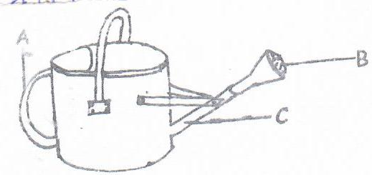
16. Study the illustration below and answer the questions that follow.

a. identify the equipment (1mk)

b. Name the parts labeled A, B, and C (3mks)
A _________________________________
B ________________________________
C ____________________________________
c. Give one use of the above equipment (1mk)

17. Below is a diagram showing a method of drainage, use it to answer the questions
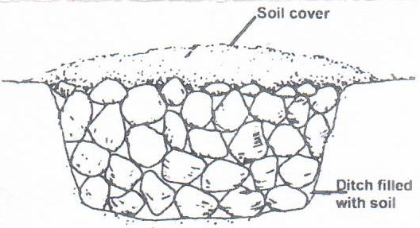
that follows.

a. Identify the above method of the method of drainage (1mk)

b. State one advantage of the methods of drainage. (1mk)

c. Outline three importance’s of drainage as a method of land reclamation (3mks)

18. a. Identify the methods of sampling down below
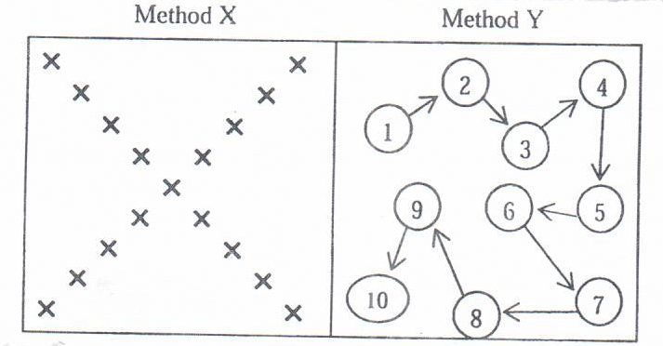

a. Give two reasons that should be avoided during soil sampling (2mks)

c. Name two sites that should be avoided during soil sampling (2mks)

19. A farmer applied 200 kgs for CAN (20%) per Hecate maize crop. Calculate the amount of nitrogen applied on his structure crop.
Show your workings (4mks)

20. The diagram below shows a territory operation carried out on a seedbed.
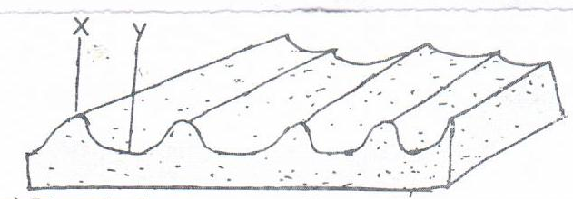

a. Identify the operation (1mk)

b. Name the parts labeled X and Y on the diagram (2mks)

c. State two importance of the operation name in (a) above (2mks)

21. The diagram represents a field produce. Use it to answer the questions
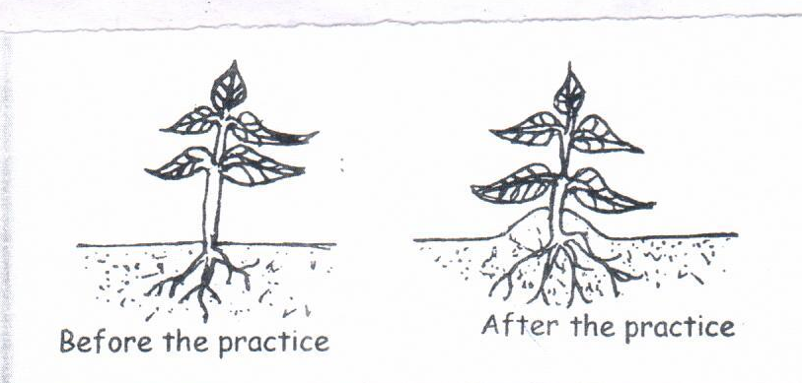
that follow.

a. identify the practice shown above (1mk)

b. give a reason for carrying out the above practice on the following crops
Irish potatoes
- Ground nuts

- Tobacco

- Maize (3 x 1 =3mks)

Section c (30mks)
Answer all the question in the spaces provided
22. a i. Give three types of nursery beds used in raising seedlings (3mks)

b. ii. Give two reasons for construction a shade over nursery (2mks)

iii. Describe factors that should be considered when siting a vegetable nursery
(5mks)

b. Name any three methods of layering used in crop propagation (3mks)

c. Name two methods of fertilizer applications (2mks)

23. name four biotic factors that affect agriculture and for each state one effect on
Agriculture (8mks)

24. Describe production of cabbages under the following subheadings.
a. land preparation (3mks)

b, Field management practices (6mks)

