NAME ……………………………………….. ADM. NO. …………………………
DATE………………………………..

443
AGRICULTURE FORM 1
TIME 2HRS
END OF TERM 2 EXAMINATIONS
Instructions to candidates
- Write your name and admission in the spaces provided
- The paper consists of three sections A B and C
- Answer all the questions in section A, B and C
- Answer all the questions in English
For examiner only
Section | Questions | Max score | Candidates score
A | 1-12 | 40
B | 13-17 | 30
C | 18-23 | 30
TOTAL SCORE |  | 100

Section A (40MKS)
Answer all questions in the spaces provided
1. List four methods of farming (4mks)

2. Name three underground water sources on the farms (3mks)

3 State four aspects of rainfall that a crop farmer should consider when choosing what to grow in certain regions. (4mks)

4. Name three surface irrigation methods (3mks)

5. a. State three benefits of rolling as a tertiary operation in seed bed preparation. (3mks)

b. State three methods of land clearing. (3mks)

6. State three types of spanners that can be found in a farm. (3mks)

7. State four maintenance practices done on a wheel barrow (4mks)

8. Name the appropriate tool for the following uses. (4mks)
i. Cutting thin sheets of metal when constructing a farm structure (1mk)

ii. Measuring length of timber when constructing (1mk)

9. State four practices on the farm that makes agriculture to be viewed as an art. (4mks)

10. Name the branch of horticulture involved in the production of the following crops
i. Cabbages ________________________________ (1mk)

ii. avocado _________________________________ (1mk)

11. State three factors influencing soil formation (3mks)

12. State two advantages of mixed farming (2mks)

SECTION B (30MKS)
Answer all questions in the spaces provided
13. The diagram below shows a chemical treatment of water study the diagram and
answer the questions that follow.
- Name the stages labelled A, B, C and D. 4 mks

- Name the chemical which are added in B. (1mks)

- State what happens at stage C. 1mk

d. Give three reasons for treating water in the farm (3mks)

14. The diagram below illustrates an experiment using garden soil. Study it carefully and answer the question that follows.
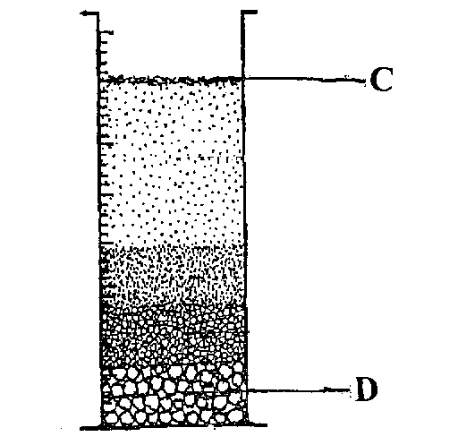

(a) What was the aim of the experiment? (1mrk)

(b) Name the parts labeled C and D. (2mrks)

(c) Name the property of soil being investigated. (1mrk)

15. Below are illustrations of farm tools and equipment. Study them carefully and answer the questions that follow.

a) Identify the above tools. M, N, P, and R (2mrks)

(b) State one main use of each tool. (1mrk)
M-
R-
(c) Explain one maintenance practice carried out on tool P. (1mrk)

16. Below is a land preparation operation. Study it and answer the questions that follow.
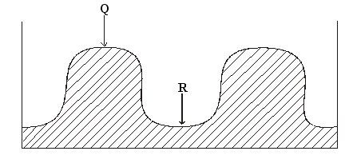
a) Identify the operation. (1mk)

b) Name the parts Q and R. (1mk)

c) Name one crop that can be planted in part labeled R.(1mk)

d) What is the advantage of planting the crop named in (c) above in the part labeled R. (1mk)

e) Identify one hand tool that can be used to carry out the operation (1mk)

17. Use the diagram below to answer the questions that follow

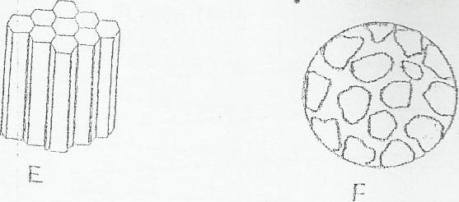

a) Identify each of the soil structures labeled E and F (1mark)

b) Give one place where the soil structure labeled F can be found. (1mark)

c) State three ways in which a farmer can improve the structure of waterlogged

clay soil. (3marks).

(d) Describe the effects of soil structure on crop production. (3mks)

Section c (30MKS)
Answer all questions in the spaces provided
18. give five farming practices that could be used to improve soil structures (5mks)

19. Describe the importance of agriculture to the country economy. (6mks)

20. State five safety precautions that should be observed in working with workshop tools.
(4mks)

21. State five methods of preventing water pollution. (5mks)

22. a. Give four effects of Hiv and Aids on agriculture. (4mks)

b. Name the two market forces that influence agriculture. (2mks)

23. give four reasons for carrying out minimum tillage. (4mks)

