Name|: …………………………………………… ADM No…….Class: .….Signature ……
FORM ONE AGRICULTURE
TIME: 1 ½ HOURS (50 MARKS)
INSTRUCTIONS
Answer all the questions in the spaces provided
- State four effects of HIV/AIDS and ill-health in agriculture. [4mks]
………………………………………………………………………………………………………………………………………………………………………………………………………………………………………..…………………………………………………………………………………………………………………………………………………………………………………………………
- State four importance of soil to crops. [4mks]
………………………………………………………………………………………………………………………………………………………………………………………………………………………………………..…………………………………………………………………………………………………………………………………………………………………………………………………
- Give two characteristics of clay soils. [2mks]
………………………………………………………………………………………………………………………………………………………………………………………………………………………………

- The illustrations below represent types of soil structures. Study them carefully and
Answer the questions that follow.
a) i) Identify the soil structures X and Y shown above. (1mk) ………………………………………………………………………………………………………
ii) Which of the soil structure you have named above is not suitable for
growing maize. (1 mk) …………………………………………………………………………………………………………
iii) Give one method of improving the soil structure you have mentioned in (ii) above (1mk)
………………………………………………………………………………………………………………………………………………………………………………………………………………………………………..…………………………………………………………………………………………………………………………………………………………………………………………………
- Name four tools required in transplanting of seedlings. [4mks]
………………………………………………………………………………………………………………………………………………………………………………………………………………………………………..…………………………………………………………………………………………………………………………………………………………………………………………………

6. The diagram below shows some workshop tools. Study them and answer the questions that follow
A B
- I
Identify the tools A and B (2mks)
A…………………………………………………..………………………………………
B…………………………………………………..………………………………………
(b) State the correct use of the tool labeled A (2mks)
…………………………………………………..………………………………………………
(c) Explain one maintenance practice carried out on the tool A (1mk)
…………………………………………………..………………………………………………
7. State four categories of farm tools and equipment (4mks)
………………………………………………………………………………………………………………………………………………………………………………………………………………………………………..…………………………………………………………………………………………………………………………………………………………………………………………………
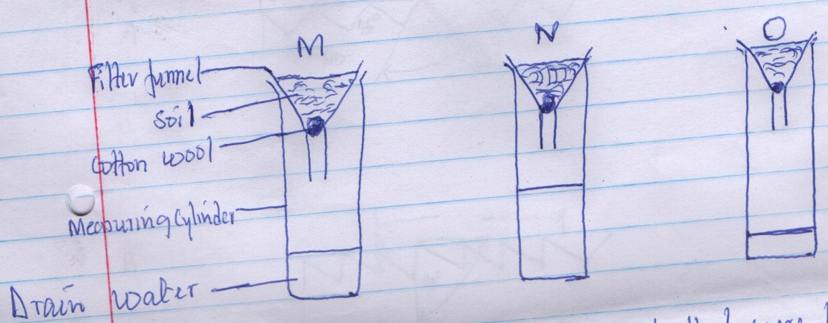
- The diagram below shows the results of an experiment set up to investigate certain properties of three different types of soil M,N and O. equal quantities of soil were used and same amount of water added to each soil. Study the set up carefully and answer the questions that follow.

- State the two properties of soil that were being investigated. [2mks]
………………………………………………………………………………………………………………………………………………………………………………………………
- Identify the soil in each of the set ups. [3mks]
M……………………………………………………………………………………
N……………………………………………………………………………………
O………………………………………………………………………………………
- Which type of soil would be suitable for growing beans. [1mk]
…………………………………………………………………………………………
- a) Describe four forms of livestock production [5mks]
………………………………………………………………………………………………………………………………………………………………………………………………………………………………………..…………………………………………………………………………………………………………………………………………………………………………………………………
b) i. Give two effects of soil PH on growth of crops. [2mks]
………………………………………………………………………………………………………………………………………………………………………………………………………………………………………..…………………………………………………………………………………………………………………………………………………………………………………………………
ii) Describe two ways by which a soil of PH 3 can be raised to a PH of 6. [2mks]
………………………………………………………………………………………………………………………………………………………………………………………………………………………………………..………………………………………………………………………………………
c) i) Name two tools a small- scale farmer would use in clearing a bushy piece of land. [1mk] ………………………………………………………………………………………………………………………………………………………………………………………………………………………………………..…………………………………………………………………………………………………………………………………………………………………………………………………
10. a) i) Describe four roles of horticultural crops to the economy of Kenya. [4mks]
………………………………………………………………………………………………………………………………………………………………………………………………………………………………………..…………………………………………………………………………………………………………………………………………………………………………………………………
b) State four biotic factors that influence crop production positively in agriculture.[4 mks]
………………………………………………………………………………………………………………………………………………………………………………………………………………………………………..…………………………………………………………………………………………………………………………………………………………………………………………………

