**Name: ……………………………………………... Index no …….…......................................**

**School: ……………………………………………. Candidate’s sign …………………….......**

**Class………………………………………………… Adm No…………………...……………...**

**AGRICULTURE 443/1**

**NOVEMBER 2021**

**TIME: 2 Hours**

**NAMBALE ACK JOINT EXAM 2021**

***Kenya Certificate of Secondary Education (K.C.S.E.)***

**Agriculture**

**Paper 1**

**INSTRUCTIONS TO CANDIDATES:**

* *Write your name and index number in the spaces provided above.*
* *Sign and write the date of examination in the spaces provided above.*
* *This paper consists of three sections A, B and C.*
* *Answer all the questions in section A and B.*
* *Answer any two questions in section C.*
* *All answers should be written in the spaces provided.*
* *This paper consists of 13 printed pages.*
* *Candidates should check the question paper to ascertain that all the pages are printed as indicated and that no questions are missing.*
* *Candidates should answer all the questions in English.*

***For Examiner’s Use Only:***

|  |  |  |  |
| --- | --- | --- | --- |
| **SECTION** | **QUESTIONS** | **MAXIMUM SCORE** | **CANDIDATES SCORE** |
| A | 1-17 | 30 |  |
| B | 18-21 | 20 |  |
| C |  | 20 |  |
|  | 20 |  |
|  | **TOTAL SCORE** | **90** |  |

**SECTION A (30 MARKS)**

1. State **two** conditions under which opportunity cost is zero. (1mk)

………………………………………………………………………………………………..…………………………………………………………………………………………………..…………………………………………………………………………………………………..………………….

1. Name **three** branches of horticulture. $(1\frac{1}{2}mks)$

………………………………………………………………………………………………..…………………………………………………………………………………………………..…………………………………………………………………………………………………..…………………

State **four** factors a farmer should consider when choosing the farming system to undertake. (2mks)

………………………………………………………………………………………………..…………………………………………………………………………………………………..…………………………………………………………………………………………………..…………………………………………………………………………………………………..………………………………………………………

1. State **four** disadvantages of communal land tenure system. (2mks)

………………………………………………………………………………………………..…………………………………………………………………………………………………..…………………………………………………………………………………………………..…………………………………………………………………………………………………..…………………………………………………………………………………………………..………………………………………………………………….

1. Give **four** pieces of information found on a land title deed. (2mks)

………………………………………………………………………………………………..…………………………………………………………………………………………………..…………………………………………………………………………………………………..…………………………………………………………………………………………………..………………………………………………………

1. State **four** reasons for deep ploughing during land preparation. (2mks)

………………………………………………………………………………………………..…………………………………………………………………………………………………..…………………………………………………………………………………………………..…………………………………………………………………………………………………..…………………………………………………………………………………………………..……………………………………………………………………………………………………………………………………………………………………………………

1. State **four** characteristics of a good top soil. (2mks)

………………………………………………………………………………………………..…………………………………………………………………………………………………..…………………………………………………………………………………………………..…………………………………………………………………………………………………..……………………………………………………………………………………………………………………………………………………………………….

1. Give **three** reasons for sub soiling. $(1\frac{1}{2}mks)$

…………………………………………………………………………………………………..…………………………………………………………………………………………………..…………………………………………………………………………………………………..……………………………………………………………………………………………………………………………………………………….

1. Differentiate between seed inoculation and seed dressing. (1mk)

………………………………………………………………………………………………..…………………………………………………………………………………………………..…………………………………………………………………………………………………..………………………………………………………………………………………………………………………………………………………….

1. State **four** effects of soil erosion. (2mks)

………………………………………………………………………………………………..…………………………………………………………………………………………………..…………………………………………………………………………………………………..…………………………………………………………………………………………………..…………………………………………………………………………………………………..……………………………………………………………………………………………………………………………………………………………………………………..

1. Outline **four** practices necessary to improve and maintain permanent pastures. (2mks)

………………………………………………………………………………………………..…………………………………………………………………………………………………..…………………………………………………………………………………………………..…………………………………………………………………………………………………..……………………………………………………………………………………………………………………………………………………………………….

1. State **two** causes of poor drainage on farmland. (1mk)

…………………………………………………………………………………………………………………………………………………………………………………………………………………………………………………………………………………………………………………………………………………………………………………………………………………………………………………………………………

1. State **four** reasons for mulching. (2mks)

………………………………………………………………………………………………..…………………………………………………………………………………………………..…………………………………………………………………………………………………..…………………………………………………………………………………………………..……………………………………………………………………………………………………………………………………………………………………….

1. Give the function of each of the following in the preparation of compost manure. (2mks))
2. Top soil

…………………………………………………………………………………………..…………………………………………………………………………………………………………………………..

1. Well rotten manure

…………………………………………………………………………………………..…………………………………………………………………………………………………………………………..

1. A thin layer of wood ash

…………………………………………………………………………………………..………………………………………………………………………………………………………………………….

1. Long pointed stick

…………………………………………………………………………………………..…………………………………………………………………………………………………………………………

1. State **four** deficiency symptoms of phosphorus. (2mks)

………………………………………………………………………………………………………………………………………………………………………………………………………………………………………………………………………………………………………………………………………………………………………………………………………………………………………………………………………………………………………………………………………………………………………………………………………………………………………………………………………………………………………………

1. State **four** characteristics of nitrogenous fertilizers. (2mks)

………………………………………………………………………………………………..…………………………………………………………………………………………………..…………………………………………………………………………………………………..…………………………………………………………………………………………………..………………………………………………………………………………………………………………………………………………………………………………………………………………………………………………………………………………………………………………………………………………………………………………………………………………

1. State **four** reasons why a nursery is important in crop production. (2mks)

………………………………………………………………………………………………..…………………………………………………………………………………………………..…………………………………………………………………………………………………..…………………………………………………………………………………………………..…………………………………………………………………………………………………..……………………………………………………………………………………………………………………………………………………………………………………  **SECTION B (20 MARKS)**

18.The table below shows output of maize in response to increase in D.A.P fertilizers on one hectare of land.

|  |  |  |  |  |
| --- | --- | --- | --- | --- |
| Fixed input land (in ha) | Variable input D.A.P in 30kg-bag | Total product maize yield in 90-kg bag | Average product (AP) maize in 90kg bag | Marginal product (M.P) in 90kg bag |
| 1  1  1  1  1 | 0  1  2  3  4 | 2  5  14  21  26 | -  -  -  -  - | -  -  -  -  - |

a) Fill in the table for average product (A.P) and marginal products (M.P) (5mks)

19.The diagrams below illustrate irish potato seed preparation before planting. Study it carefully and answer the questions that follow.



1. Name the practice used in preparing the seed potato above before planting. (1mk)

…………………………………………………………………………………………………………

1. Describe the procedure followed in preparing the seed potatoes for planting. (3mks)

……………………………………………………………………………………………………………………………………………………………………………………………………………………………………………………………………………………………………………………………………………………………………………………………………………………………………………………

1. Give **one** reason for carrying out the practice named above. (1mk)

……………………………………………………………………………………………………………

1. The photograph below shows an irish potato plant attacked by a disease. Study it and answer the questions that follow.

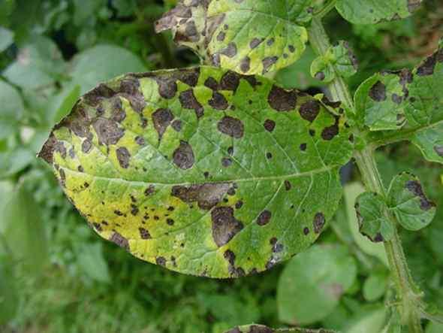

1. Identify the disease represented by the photograph. (1mk)

…………………………………………………………………………………………………………

1. Name the causative agent of the diseases. (1mk)

……………………………………………………………………………………………………………

1. Give **one** other crop that can be attacked by the same disease. (1mk)

……………………………………………………………………………………………………………

1. List **two** control measures of the disease. (2mks)

………………………………………………………………………………………………………………………………………………………………………………………………………………………………………………………………………………………………………………………………………

1. The photographs below show common weeds C and D in pasture land. Study them carefully and answer the questions that follow.

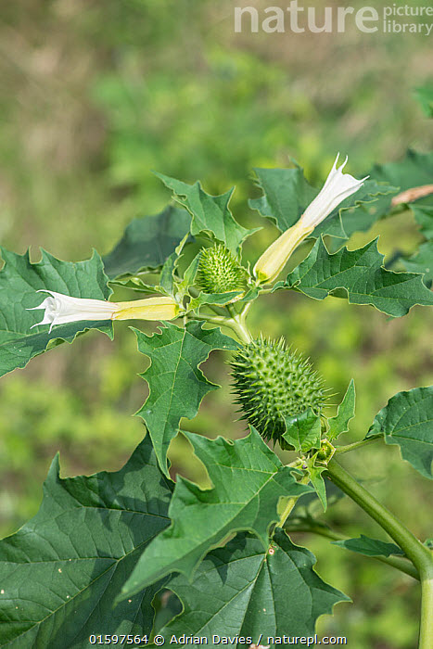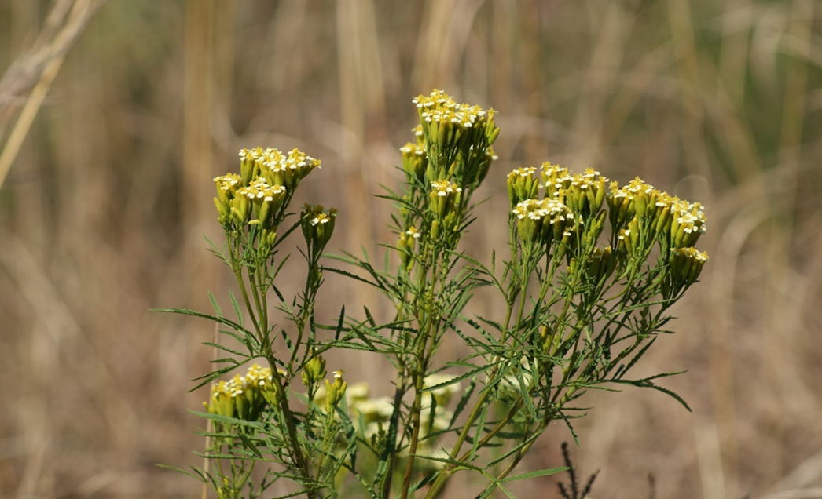

C D

1. Identify weeds C and D. (2mks)

C…………………………………………………D…………………………………………….

1. Classify weed D according to plant morphology. (1mk)

………………………………………………………………………………………………………………………………………………………………………………………………

1. State the major problem posed by each of the weeds above in pasture land. (2mks)

C…………………………………………………………………………………………….

D……………………………………………………………………………………………. **SECTION C (40MARKS)**

1. a) State **four** benefits of sowing annual crops early. (4mks)

b) Describe **eight** effects of fragmentation and sub division of land. (8mks)

c) Explain **eight** effects of weeds. (8mks)

1. a) Describe the various field management practices for tomatoes. (8mks)

b) State the precautions that should be observed when harvesting cotton. (4mks)

c)Explain **four** importance of crop rotation. (8mks)

24. The information below is on the financial and Asset valuation of school Farm at the end of the year 2002

Debts Payable 80,000/=

Dairy cattle 55,000/=

Maize in store 19,000/=

Buildings 125,000/=

Beans in store 4,000/=

Calves 5,000/=

Mature sheep 7,000/=

50 ha of land 260,000/=

Machinery 180,000/=

Cattle feed in store 4,000/=

Office Equipment 1,400/=

Tools in store 10,000/=

Bank Deposit 50,000/=

Debts receivable 11,000/=

KFA Loan 210,000/=

Bank Loan 100,000/=

Wages 41,200/=

Electricity Bills 100,500/

a) Draw up a balance sheet for the farm as at 31st Dec. 2002 using the above information. (12mks)

b) Determine the solvency of the farm, giving reasons. (1mk )

c) Describe **seven** reasons why farmers need to keep good farm records. (7mks)

………………………………………………………………………………………………..…………………………………………………………………………………………………..…………………………………………………………………………………………………..…………………………………………………………………………………………………..…………………………………………………………………………………………………..…………………………………………………………………………………………………..…………………………………………………………………………………………………..…………………………………………………………………………………………………..…………………………………………………………………………………………………..…………………………………………………………………………………………………..…………………………………………………………………………………………………..…………………………………………………………………………………………………..…………………………………………………………………………………………………..…………………………………………………………………………………………………..…………………………………………………………………………………………………..…………………………………………………………………………………………………..…………………………………………………………………………………………………..…………………………………………………………………………………………………..…………………………………………………………………………………………………..…………………………………………………………………………………………………..……………………………………………………………………………………………………………………………………………………………

………………………………………………………………………………………………..…………………………………………………………………………………………………..…………………………………………………………………………………………………..…………………………………………………………………………………………………..…………………………………………………………………………………………………..…………………………………………………………………………………………………..…………………………………………………………………………………………………..…………………………………………………………………………………………………..…………………………………………………………………………………………………..…………………………………………………………………………………………………..…………………………………………………………………………………………………..…………………………………………………………………………………………………..…………………………………………………………………………………………………..…………………………………………………………………………………………………..…………………………………………………………………………………………………..…………………………………………………………………………………………………..…………………………………………………………………………………………………..…………………………………………………………………………………………………..…………………………………………………………………………………………………..…………………………………………………………………………………………………..……………………………………………………………………………………………………………………………………………………………

………………………………………………………………………………………………..…………………………………………………………………………………………………..…………………………………………………………………………………………………..…………………………………………………………………………………………………..…………………………………………………………………………………………………..…………………………………………………………………………………………………..…………………………………………………………………………………………………..…………………………………………………………………………………………………..…………………………………………………………………………………………………..…………………………………………………………………………………………………..…………………………………………………………………………………………………..…………………………………………………………………………………………………..…………………………………………………………………………………………………..…………………………………………………………………………………………………..…………………………………………………………………………………………………..…………………………………………………………………………………………………..…………………………………………………………………………………………………..…………………………………………………………………………………………………..…………………………………………………………………………………………………..…………………………………………………………………………………………………..……………………………………………………………………………………………………………………………………………………………

………………………………………………………………………………………………..…………………………………………………………………………………………………..…………………………………………………………………………………………………..…………………………………………………………………………………………………..…………………………………………………………………………………………………..…………………………………………………………………………………………………..…………………………………………………………………………………………………..…………………………………………………………………………………………………..…………………………………………………………………………………………………..…………………………………………………………………………………………………..…………………………………………………………………………………………………..…………………………………………………………………………………………………..…………………………………………………………………………………………………..…………………………………………………………………………………………………..…………………………………………………………………………………………………..…………………………………………………………………………………………………..…………………………………………………………………………………………………..…………………………………………………………………………………………………..…………………………………………………………………………………………………..…………………………………………………………………………………………………..……………………………………………………………………………………………………………………………………………………………

………………………………………………………………………………………………..…………………………………………………………………………………………………..…………………………………………………………………………………………………..…………………………………………………………………………………………………..…………………………………………………………………………………………………..…………………………………………………………………………………………………..…………………………………………………………………………………………………..…………………………………………………………………………………………………..…………………………………………………………………………………………………..…………………………………………………………………………………………………..…………………………………………………………………………………………………..…………………………………………………………………………………………………..…………………………………………………………………………………………………..…………………………………………………………………………………………………..…………………………………………………………………………………………………..…………………………………………………………………………………………………..…………………………………………………………………………………………………..…………………………………………………………………………………………………..…………………………………………………………………………………………………..…………………………………………………………………………………………………..……………………………………………………………………………………………………………………………………………………………..

………………………………………………………………………………………………..…………………………………………………………………………………………………..…………………………………………………………………………………………………..............................................................................................................................................................................................................................................................................................................................................................................................................................................................................................................................................................................................................................................................................................................................................................................................................................................................................................................................................................................................................................................................................................................................................................................................................................................................................................................................................................................................................................................................................................................................................................................................................................................................................................................................................................................................................................................................................................................................................................................................................................................................................................................................................................................................................................................................................................................................................................................................

………………………………………………………………………………………………..…………………………………………………………………………………………………..…………………………………………………………………………………………………..............................................................................................................................................................................................................................................................................................................................................................................................................................................................................................................................................................................................................................................................................................................................................................................................................................................................................................................................................................................................................................................................................................................................................................................................................................................................................................................................................................................................................................................................................................................................................................................................................................................................................................................................................................................................................................................................................................................................................................................................................................................................................................................................................................................................................................................................................................................................................................................................

……………………………………………………………………………………………………………….

**THIS IS THE LAST PRINTED PAGE.**

**Balance sheet**

**School farm**

**As at 31st Dec 2002**

|  |  |
| --- | --- |
| **LIABILITIES** | **ASSETS** |
| **CURRENT LIABILITIES** | **CURRENT ASSETS** |
| Wages 41,200  Elect, Tel, Rent 100,500  Debts payable 80,000  **LONG TERM LIABILITIES**  KFA loan 210,000  Bank Loan 100,000  Total Liabilities 531,700  Owners equity 150,200 | Bank deposit 50,000  Debts receivable 11,000  Maize in store 19,000  Beans in store 4,000  Cattle feed in store 4,000  **FIXED ASSETS**  Tools in store 10,000  Office equipment 1,400  Mature sheep 7,000  Calves 5,000  Dairy cattle 5,500  Machinery 180,000  Building 125,000  50 ha of land 260,000 |
| 681,900 | 681,900 |

b. The farm is solvent. Assets can be sold to pay for the liabilities and have a balance

mks