TERM 2 2022 OPENER EXAM FORM 4
443/1
AGRICULTURE
PAPER 1
TIME: 2 HOURS
MARKING SCHEME
SECTION A (30 MARKS)
Answer all questions in this section
- Give two disadvantages of intensive system of farming. (1mk)
- Requires high initial capital/Expensive
- Is labour intensive
- Requires high level of management/skilled labour

- List four methods of farming. (2mks)
- Shifting cultivation
- Nomadic pastoralism
- Organic farming
- Mixed farming
- Agroforestry
- Give the meaning of the following terms:
a) Nitrogen fixation into the soil; (1mk)
- Process in which atmospheric nitrogen is converted to nitrates for plant uptake.
b) Phosphorus fixation in loss of soil fertility. (1mk)
Process in which phosphorous combines with other elements to form compounds that cannot be absorbed by plants
4. Give four reasons for keeping livestock health records on the farm. (2mks)
- Help in calculation of treatment and health costs
- Help in culling/selecting livestock
- Help in future diagnosis treatment and control measures
- Help determine the common diseases and parasites/prevent diseases and parasites
- Help to support livestock insurance claims
5. Explain the relationship between scarcity and choice as used in agricultural economics. (2mks)
- Scarcity is where production resources are limited in supply relative to demand; therefore a choice has to be made on which enterprise(s) to allocate the limited resources. *(Mark as a whole)*

6. Sate two reasons for land fragmentation in Kenya. (1mk)
- Buying/selling/paying debts/compensation
- Inheritance
- Settlement and resettlement
- Gifts/donations
- Shifting cultivation
7. Give four advantages of individual owner operator tenure system as practiced in Kenya. (2mks)
- Easy to acquire credit.
- Land disputes are minimized
- Long term investment is encouraged
- Incentive to conserve and improve land
- Easy to plan and make decisions
- Easy to sell/lease whole or part of the land

8. Sate four features that should be considered when choosing water pipes for use on the farm. (2mks)

- Durability
- Strength/ability to withstand pressure/thickness of the wall of the pipe
- Diameter/size of the pipe
- Workability/maneuverability of the pipe
- Colour
9. Give four reasons for treating water for use on the farm. (2mks)
- Remove chemical impurities/softening of water
- Kill disease causing organisms/kill germs/pathogens
- Remove bad smells and taste
- Remove impurities of solid particles
10. Give two reasons for carrying out each of the following operations in land preparation:
a) Rolling; (1mk)
- Increases seed soil contact
- Compacts soil/seed to protect it against agents of erosion
- Crushing large soil clods
b) Leveling. (1mk)
- Ensures uniform depth of planting/uniform germination/uniform fertilizer application
- Ensures uniform water level in paddy rice fields
- To remove depression which collect water leading to rotting of seeds
11. List two aspects of light that affect agricultural production (1mk)
- Light intensity
- Light duration
- Light wavelength
12. State four factors considered when determining the time of planting (2mks)
- Rainfall pattern/ moisture content of the soil
- Type of crop to be planted/growth habit
- Purpose of the crop
- Prevalence of pests, diseases, frost and other adverse ecological conditions
- Market demand
- Weather conditions at the time of harvesting
13. List four advantages of the title deed to a farmer (2mks)
- Reduces land disputes
- Acts as security of land ownership
- Can be used as security to secure loans
- Encourages farmers to carry out long term investments in the farm
14. Name the plant part used for vegetative propagation of each of the following plants: (2mks)
(a) Cassava
- Stem cuttings/stems
(b) Sisal
- Bulbils
- Suckers
(c) Pyrethrum
- Splits
(d) Sweet potatoes.
- Vines
- Root tubers
15. Name four settlement schemes that the Kenyan government started as a result of the success of the Million Acre Scheme. (2 marks)
- Jet schemes
- Haraka schemes
- Shirika schemes
- Lari settlement schemes
- The squatter’s settlement schemes
- Harambee settlement schemes
16. What is the meaning of seed dressing (1mk)
- Seed dressing is the process of coating seeds with appropriate insecticides or fungicide chemicals to prevent the seed from soil borne diseases
17. What four factors would you advise a farmer to consider when siting a tomato nursery (2mks)
- Type of soil
- Nearness to water source
- Topography
- Security
- Previous cropping
- Well sheltered place
SECTION B (20 MARKS)
18. The following is a list of plant nutrients; Copper, Calcium, Nitrogen, Molybdenum, Zinc,
Phosphorus, Carbon, Sulphur, Iron and Magnesium.
Which of the above plant nutrients are:
(a) Macro-nutrients (1mk)
- Calcium;
- Nitrogen;
- Phosphorous;
- Carbon;
- Sulphur;
Magnesium. *Mark as a whole*
(b) Micro-nutrients (1mk)
- Copper;
- Molybdenum;
- Zinc;
- Iron. *Mark as a whole*
(c) Fertilizer elements (1mk)
- Nitrogen,
- Phosphorus
- Potassium.
*Mark as a whole*
(d) Liming elements. (1mk)
- Calcium;
- Magnesium ;
- Sulphur.
*Mark as whole*
(e) Mineral whose deficiency causes blossom end rot in tomatoes (1mk)
- Calcium
19. a). A farmer was advised to apply 150 kg CAN (21%N) per hectare while topdressing his maize crop. Calculate the amount of nitrogen applied for two hectares (3mks)
100kg CAN-------------------21kgN
150kgCAN----------------150kgCANx 21kg N
100kgCAN
=31.5kgN/ha
2 hectares = 31.5x2 = 63kg N/2 ha
b) Give two forms in which Nitrogen is absorbed by plants (2mks)
- Nitrate ions
- Ammonium ions

20. Below are illustrations of types of weeds. Study them and answer the questions that follow.
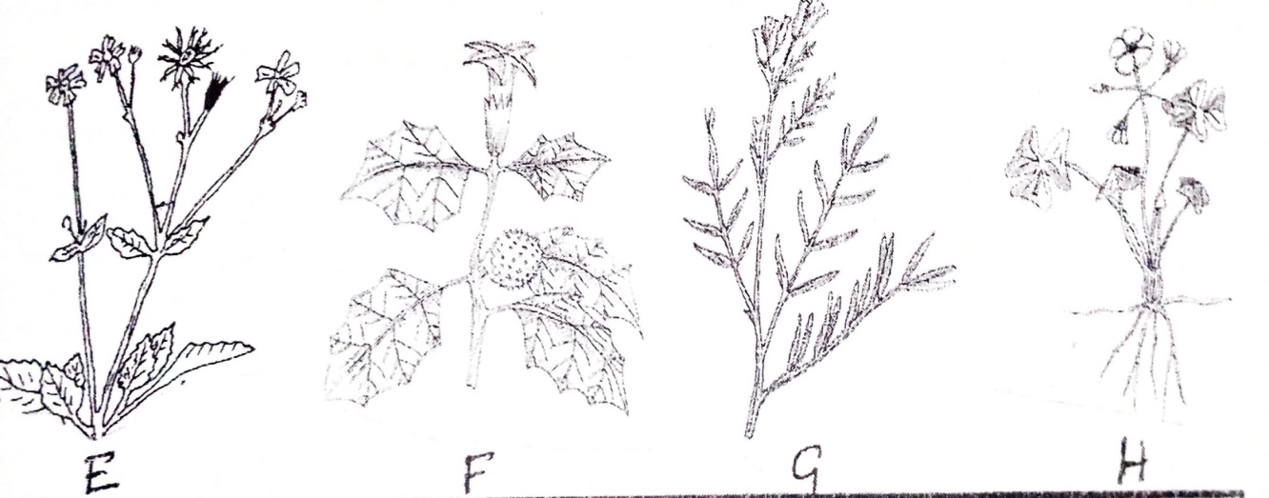
- Identify the weeds labelled E, F, G and H. (4mks)
E- Black jack (Bidens pilosa)
F- Thorn apple (Datura stramonium)
G- Mexican marigold (Tagetes minuta)
H-Oxalis (Oxalis latifolia)
- Why is it difficult to control weed H (1mk)
- Has bulbs which are underground and difficult to remove
21. Below shows an experiment set up and observations made after 24 hours. Study it and answer the questions below
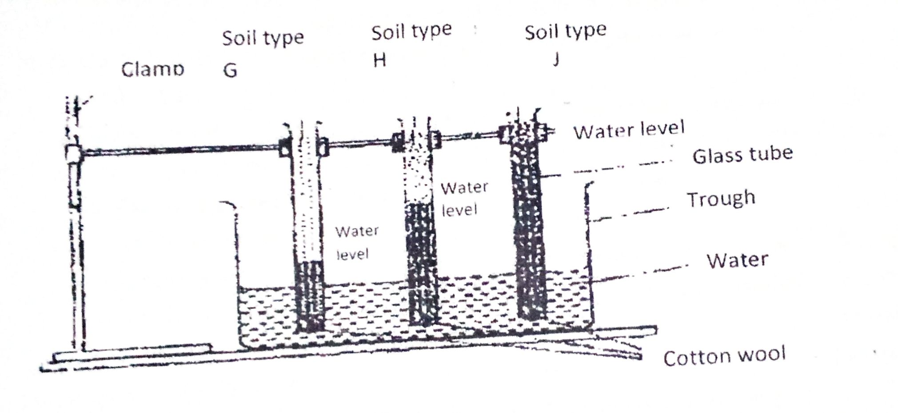
- What is the experiment below designed to study (1mk)
- Capillarity
- Names soil types G, H and J (3mks)
G-Sandy
H-Loamy
J- Clayey
- How can a farmer improve the structure of soil type G (1mk)
- Addition of organic manure/ organic matter
SECTION C (40 MARKS)
Answer any two questions from this section
22. (a) Explain seven physical methods of pest control. (7mks)
- Use of lethal temperature to kill the pests;
- Proper drying of produce to make it hard for pest to penetrate;
- Flooding drowns and kills pests;
- Suffocation to kill the pests in air tight containers;
- Physical killing of the pests /trapping and killing;
- Use of scarecrows /scaring away the pests;
- Use of physical barriers to prevent infestation by the pests;
- Use of electromagnetic radiation to kill the pests.
(b) Explain eight factors that contribute to the competitive ability of weeds. (8mks)
- Some produce large seed quantities to enhance survival chances;
- Some remain viable in the soil for a long time to await favorable conditions to germinate
- Some are easily and successfully dispersed to enhance chances of survival;
- Some have ability to propagate vegetatively into new plants;
- Some have extensive root system to enhance survival in drought conditions;
- Some have adaptations to survive where water/nutrients are limited through water and food storage modifications
- Some have a short life cycle which is completed early before adverse climatic conditions set in
- Some irritate animals as a protective measure against grazing, trampling/some are tolerant to pests and diseases.
- Some are heavy feeders they make food faster than crop establishes.
- Some weeds have allelopathic effects which suppresses growth of other plants enhancing their survival.
(c) Describe the harvesting of coffee. (5mks)
- Pick red ripe berries/cherries;
- Spread the berries on sisal mats and sort them out into Grades 1, 2 and 3 (Mbuni)
- Deliver grades 1 and 2 to the factory for pulping same day;
- Dry grade 3;
- Deliver grade 3 to factory at the end of harvesting season;
- Picking interval of 7 - 14 days.
23 a) Explain eight factors that can encourage soil erosion. (8mks)
- Lack of ground cover exposes soil to agents of soil erosion/removal of cover crops
- Steep slopes increase the speed of surface run-offs hence erosive power of water
- Light/sandy soils are easily carried away by agents of soil erosion.
- Shallow soils are easily saturated with water and carried away
- High rainfall intensity on bare ground/leads at detachment of soil hence run off
- Frequent cultivation/over cultivation pulverizes the soil making it easy to detach and carry away.
- Overstocking leads to overgrazing which destroys ground cover exposing it to agents of erosion.
- Burning/deforestation destroys vegetation cover and exposes soil to agents of erosion.
- Ploughing up and down the slope creates channels which speed up and increases the erosive force.
- Cultivation of river banks destroys riverine vegetation and destroys soil structure exposing it to agents of erosion.
- Cultivating the soil when too dry destroys soil structure making it easy to be eroded.
- Long slopes increases volume speed of run off hence increasing erosive power of water.
- High rainfall amount increase saturation of soil hence increase in soil erosion
*(Do not award if factor and effect not qualified/well explained)*
b) Describe the seven management practices that should be carried out on a vegetable nursery after sowing seeds until the seedlings are ready for transplanting. (7mks)
- Mulching to conserve moisture
- Erection of shade to minimize evapotranspiration
- Weed control to reduce competition with seedlings for nutrients, light, space etc.
- Pest and disease control to ensure healthy and vigorously growing seedlings
- Pricking out/thinning to minimise competition for growth elements
- Fertilizer application to supplement nutrients in the soil
- Watering to ensure adequate moisture supply
- Hardening off/removing shade/reducing watering to acclimatize the seedling to conditions in the field.
- Removal of mulch immediately after germination
c) Outline five ways in which high temperature affects agricultural production in Kenya. (5mks)
- Increases incidences of some pests/parasite and diseases
- Improves quality of certain crops e.g. fruits, pineapples, paw paws
- Lowers quality of certain crops e.g. pyrethrum
- Increases rate of evapotranspiration/wilting in plants
- Increases rate of growth for early maturity in crops
- Limits distribution of exotic livestock breeds
- Lowers production in livestock
- Influences design of farm buildings and structures
- Lowers labour productivity
24. a) Describe the production of cabbages under the following sub-headings:
(i) Seedbed preparation; (3mks)
- Land should be prepared early during the dry season /land should be cleared
- Land should be prepared to minimum tilth
- Holes are dug at a depth of 10cm and spacing of 0.9x0.6m for large varieties and 0.6x0.6m for smaller varieties.
(ii) Transplanting of seedlings. (7mks)
• Nursery is first watered so that seedlings can be lifted with ease.
• Only healthy and vigorous seedlings should be selected.
• Lift the seedlings with a lump of soil attached to the roots
• Add about 15 gm/1 teaspoonful of phosphatic fertilizer to the planting hole/mix with soil
• Firm the soil around the base of seedlings
• Water the seedlings as appropriate/if necessary
• Apply mulch around seedling/erect shade if necessary.
• Transplanting should be done on a cloudy day or late in the evening when it is not too hot.
b) State biotic factors and explain how they influence crop production in agriculture. (5mks)
• Nitrogen fixing bacteria: - convert atmospheric nitrogen to nitrates for plant uptake
• Pollinators: - transfer pollen grains from the anther of a flower to the stigma of the same flower or different flower.
• Decomposers; - organisms which breakdown organic plant and animal remains to release nutrients for plants/aerate the soil

• Pests: - Attack crops by eating plant parts, piercing and sucking sap and introduce/spread disease causing micro-organisms
• Pathogens;-they cause diseases
• Predators;-reduce pest population
• Weeds;-compete for nutrients/space/light/moisture/spread pests/suppress growth
c) Explain five ways in which HIV/AIDS limits agricultural production (5mks)
Shortage of labour;
Lack of motivation to invest in agriculture
Increased cost of living leading to low investment in agriculture/lack of resources for Agricultural production
Government and NGOs are spending a lot of time and resources controlling the disease instead of investment in agriculture.
Lack of market for agricultural produce

