Name:……………………………………………………………..Class:…………….Adm No:…….
FORM 3 – 2022
AGRICULTURE EXAM
PAPER 1

SECTION A
Answer all the questions in this section in the spaces provided.
- Name two classes of weeds on the basis of the following.
- Growth cycle (1mk)

- Plant morphology (1mk)

- State four reasons for land fragmentation in Kenya. (2mks)

- Give four advantages of individual owner operator tenure system as practised in Kenya. (2mks)

- Give four methods of breaking seed dormancy. (2mks)

- State four disadvantages of organic mulch in crop production. (2mks)
- Give four practices carried out in a tree nursery. (2mks)

- State four reasons for staking tomatoes. (2mks)

- List three methods of treating water for use on the farm. (1 ½ mks)

- Give two examples for each of the following categories of water pipes.
- Metal pipes (1mk)

- Hose pipes (1mk)

- What is organic farming? (1mk)

- State four problems that may be brought about by hardpans in crop land. (4mks)

- State four information contained in a land title deed. (2mks)

- Mention the simultaneous processes that lead to the formation of erosional characteristics of a gully. (4mks)

- State three factors that determine the depth of planting. (1 ½ mks)

SECTION B (20MKS)
Answer all the questions in this section in the spaces provided.
- The diagram below shows a soil water conservation structure.
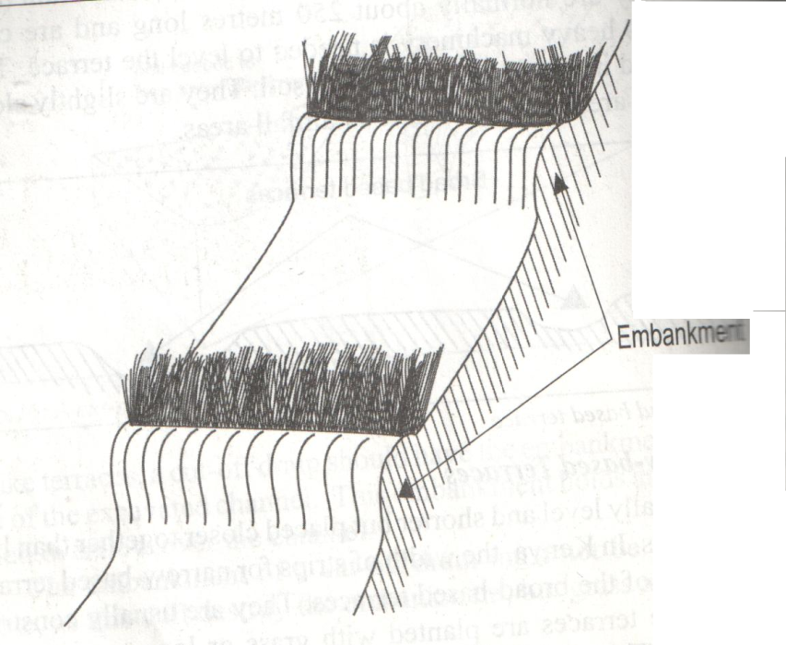
- Identify the method of soil and water conservation shown in the diagram. (1mk)

- State three practices that can be carried out on the above structure to make it stable. (3mks)
- State any other structure that can be used in soil and water management. (1mk)

- The diagram K, L, M and N below represents types of soil structures. Study the diagrams carefully and the answer the questions that follow.
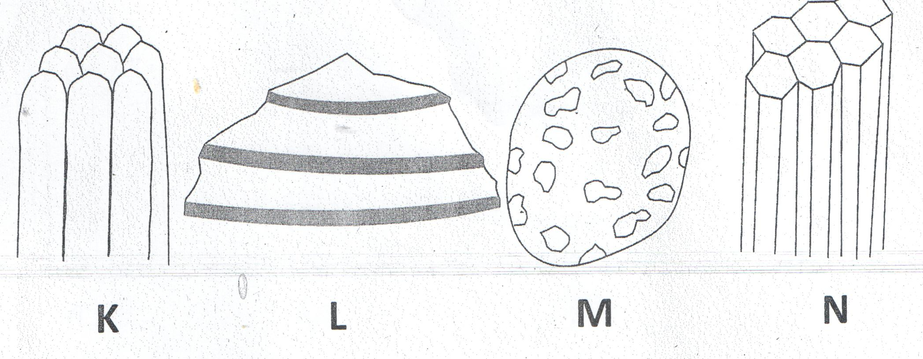
- Identify the soil structures labeled L , N and M. (3mks)
L -
M –
N –
- Give one difference between soil structure K and N. (1mk)

- How can the soil structure labeled M be improved? (1mk)

- A plot of land measures 6.6m long by 3.6m wide. This plot is prepared for planting cabbages at a spacing of 60cm by 60cm. the outermost row starts at 30cm from the edges all around the plot. Calculate:
- The number of the rows falling on the width side of the plot.(2mks)

- The number of cabbage seedlings that should be planted on the plot. (3mks)

- Study the illustrations given below and then answer the questions that follow
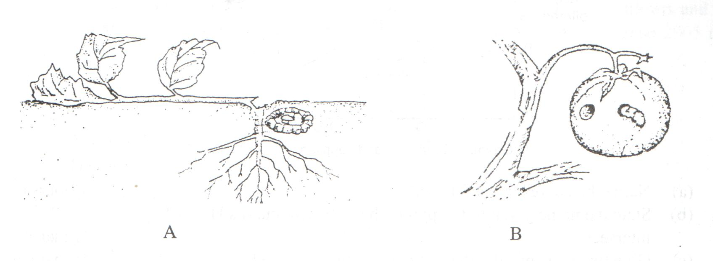
- Identify the pests shown by illustrations A and B. (1mk)

- State two effective methods of controlling each of the pests labeled A and B.
A (2mks)

B (2mks)

Section C (40mks)
Answer any two questions from this section in the spaces provided.

- Outline safety precautions when using herbicides. (12mks)
b) Outline physical measures that have been employed in the control of pests. (8mks)
- Explain five effects of soil erosion. (5mks)
b) Describe the field production of tomatoes from transplanting to harvesting. (15mks)
- Describe advantages of sub-surface irrigation. (7mks)
b) Explain contribution of agriculture to National development. (12mks)
c) Define agriculture. (1mk)

