MARKING SCHEME

TERM 2 2022 OPENER EXAM FORM 3
AGRICULTURE
Time: 2 Hours

SECTION A ( 30 Marks)
- What is the gestation period of the following animals (2 marks)
- Cow 270 to 285
- Sow 113 to 117
- Ewe 150
- Rabbit 28 to32
- Differentiate between the following breed of livestock. (2 marks)
- New Zealand white and Californian white
New Zealand white is white and has red eyes while Californian white is white in colour with one or more of the following parts being black; ears, nose, paws and tail.
- Large white and landrace
Large white- it is long, large and white pig skin may have a few blue spots.
Landrace-white in colour
- State four characteristics of fertile soil (2marks)
Good depth
Proper drainage
Good water holding capacity
Adequate nutrient supply
Correct soil pH
- List four different methods of drainage. (2marks)
Open ditches
Underground drain pipes
French drains
Cambered beds
Pumping
Planting trees
- Name four reasons for carrying out minimum tillage. (2marks)
To reduce the cost
To control soil erosion
To conserve moisture
To prevent the disturbance of roots
To prevent exposure of humus
- State four precautions a farmer should take when using workshop tools. (2marks)
Tools should always be left in a safe place after use.
Use the correct tool for the correct job.
Tools should be maintained and serviced to remain in good working condition and last longer.
Use of safety devices such as fire extinguishers and first aid kits in the workshop to reduce accidents.
Tools should be handled correctly when in use to avoid damage to the tool and injury to the user.
All tool should be stored properly in tool cabinets or in tool racks.

- State four ways in which the level of education and technology affects agriculture development in Kenya (2 marks)
Proper methods and time of doing things such as planting at the right time and spacing
Use of the type and the amount of input
Applying the input at the right place
Making right decisions based on the right observation
- Name four types of livestock farming. (2marks)
Pastoralism
Fish farming (aquaculture)
Bee keeping (apiculture)
Poultry keeping
- Stare four sign of parturition in goats. (2marks)
The udder become firm and the tits enlarge
The muscle at either side of the tail slacken
Restlessness I s shown by pawing on the ground, rising up and lying down frequently
Separating itself from the of the flock
A clear discharge from the vulvar

- Name four methods of identification in livestock. (2 marks)
Branding
Tattooing
Ear tagging
Ear notching
Neck trap or chain
- Name four methods of preserving fish. (2marks)
Smoking
Freezing
Salting
Sun drying
- State four symptoms caused by Round Warm in cattle (2 marks)
Anorexia under heavy infestation
Stiff dry coat or staring coat
Dehydration and pale mucosa
Eggs and adults are seen in faeces
General emaciation
Animal may have diarrhoea
Pot-bellies especially young animals
Anaemic conditions where infestation is heavy

- Name four factors that may predispose an animal to diseases. (2marks)
Species of an animal
Breed of an animal
Age of an animal
Sex of an animal
Color of an animal

- Name any four common vegetables grown in Kenya. (2marks)
Leaf vegetable.
Root vegetable
Tuber vegetable
Fruit vegetable
Stem vegetable
Pod vegetable
- List four post-harvesting practices. 2 marks)
Winnowing
Threshing /shelling
Drying
Cleaning
Sorting and grading
Dusting
Processing
Packaging

SECTION B (50 MARKS)

- A, Differentiate between ruminant and non-ruminant. (6marks)
Ruminants | Non ruminants
Chew the cud | Do not chew cud
Four stomach chambers/polygastric | Monogastric
Regurgitating food | Food is swallowed once
Can digest cellulose | Cannot digest cellulose
No digestion in the mouth | Digestion start in the mouth
Digestion and absorption take place in the rumen | Digestion and absorption take place in the small intestine
Have alkaline saliva | Neutral saliva

B, using the person’s square method to compute a 100kg ration with 20kg DCP from Oats which contains 10% DCP and Simsim seed which containing 60% DCP. (4marks)
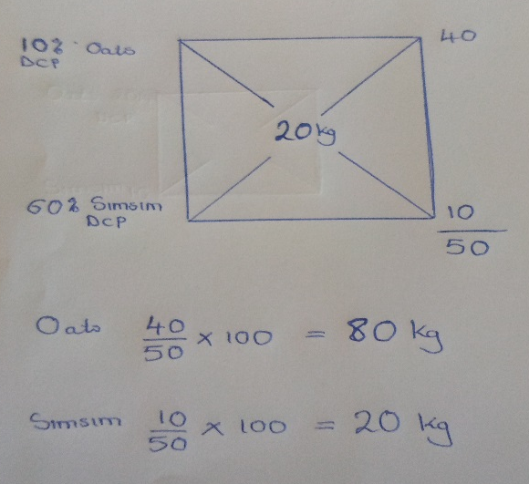

- The diagram below show a practice in crop production.
- Give the identity of the management practice illustrated above. (1mark)
trelishing
- Give two reason for carrying out the above field management practice. (2marks)
Facilitate easy carrying out of routine practices e.g. spraying
Prevent soiling of fruits/clean fruits harvest
Control fruits from being infected by soil borne pests
Plant is well aerated

- A plot measuring 4m X 3m was prepared for planting cabbages at a spacing of 60cm X60 cm. calculate the plant population in the plot. Show your working (3marks)
Plant population = (4mx100) x 3mx100
spacing 60cmx60cm =33+ 1

Award
1MF formula
1MF calculate
1M = Right answer

- A famer was advice to apply 150kg CAN/ha while topdressing the maize crop. CAN contains 21% N. calculate the amount of nitrogen applied/ha (3marks)
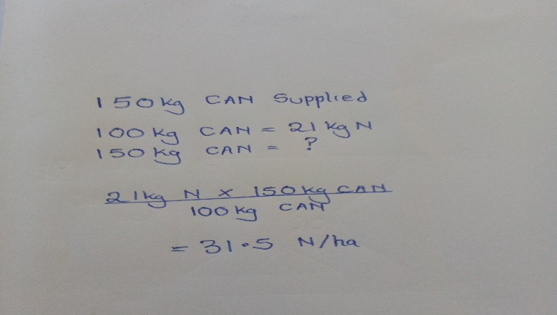
- The drawing below shows the cross-section of a house under construction. Study it carefully and answer questions that follow.
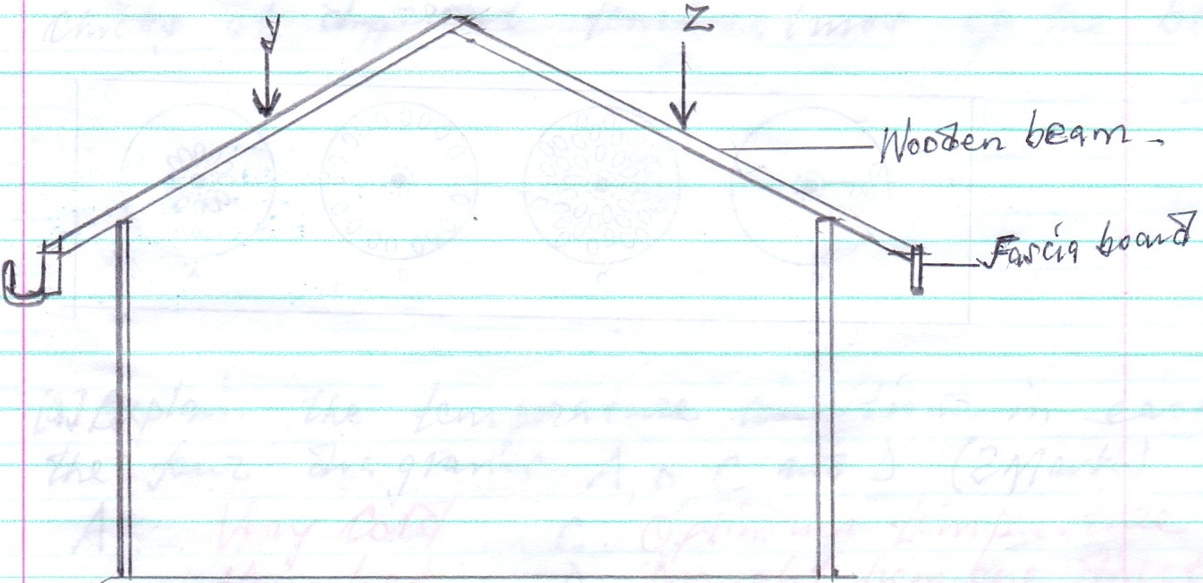
- Assuming that the wooden beams are strong enough to hold the roof load .What is the most likely thing to happen when the roof load exerted presses at point Y and Z .(1mark)
The span of the building expands at the top out wards;[
- On the diagram provided draw and label two constructional features you would add to this structure in order to make it more efficient.(2marks)
Tie beam/cross tie;-Rafter batten;-Struts
- State two importance of the fascia board in the farm building.(2marks)
Protects the rafter from attack by pests/disease/weather;-Attachment of gutters;-Add beauty to the structure
- Name any six uses of crushes in livestock production. (6 marks)
Milking
Hoof trimming
Taking body temperature
Artificial insemination
Pregnancy test
Dehorning
Treating sick animal
Vaccination
Controlling
- The illustration below shows a pig farrowing pen .Study it and answer questions that follow.
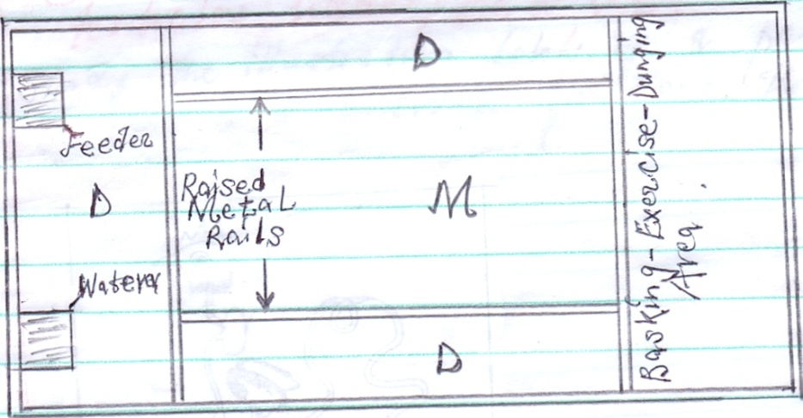
- What is the use of the raised metal rails.(1mark)
Protect the sow from lying/trampling on the piglets
- Give two uses for the parts labeled D(2marks)
Dunging area;-Exercise area;-Basking area for piglets;-Resting area;
- Name seven sign of farrowing. (7 marks)
Restlessness
The vulvar turn red and swollen
Udder become full with milk
The sow start building nest
Clear discharge of mucus from the vulvar
Slackening of pelvic muscle
Thick milk fluids from the tits

- Below is an illustration representing a practice carried out in sheep? Study it and answer questions that follow.
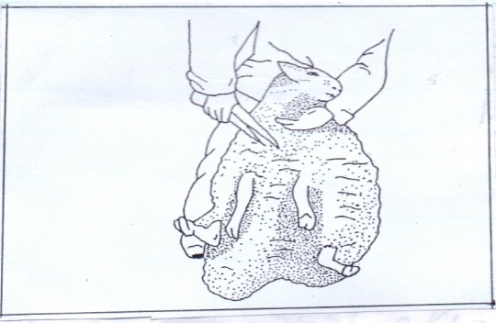
- Identify the practice illustrated above.(1mark)
Wool shearing
- Name the tool used in the above practice (1mark)
Wool shear

- State two precautions taken when carrying out the above practice.(2marks)
Done during a dry season
Care taken not to cut skin, testicles, udder, teats
- Name five methods used in docking. (5marks)
Elastrator and rubber ring
Burdizzo and knife
Knife
Hot iron

SECTION C (20 MARKS)
(Answer one question between 21 and 22)
- Describe the factors to consider when selecting a breeding stock (20marks)
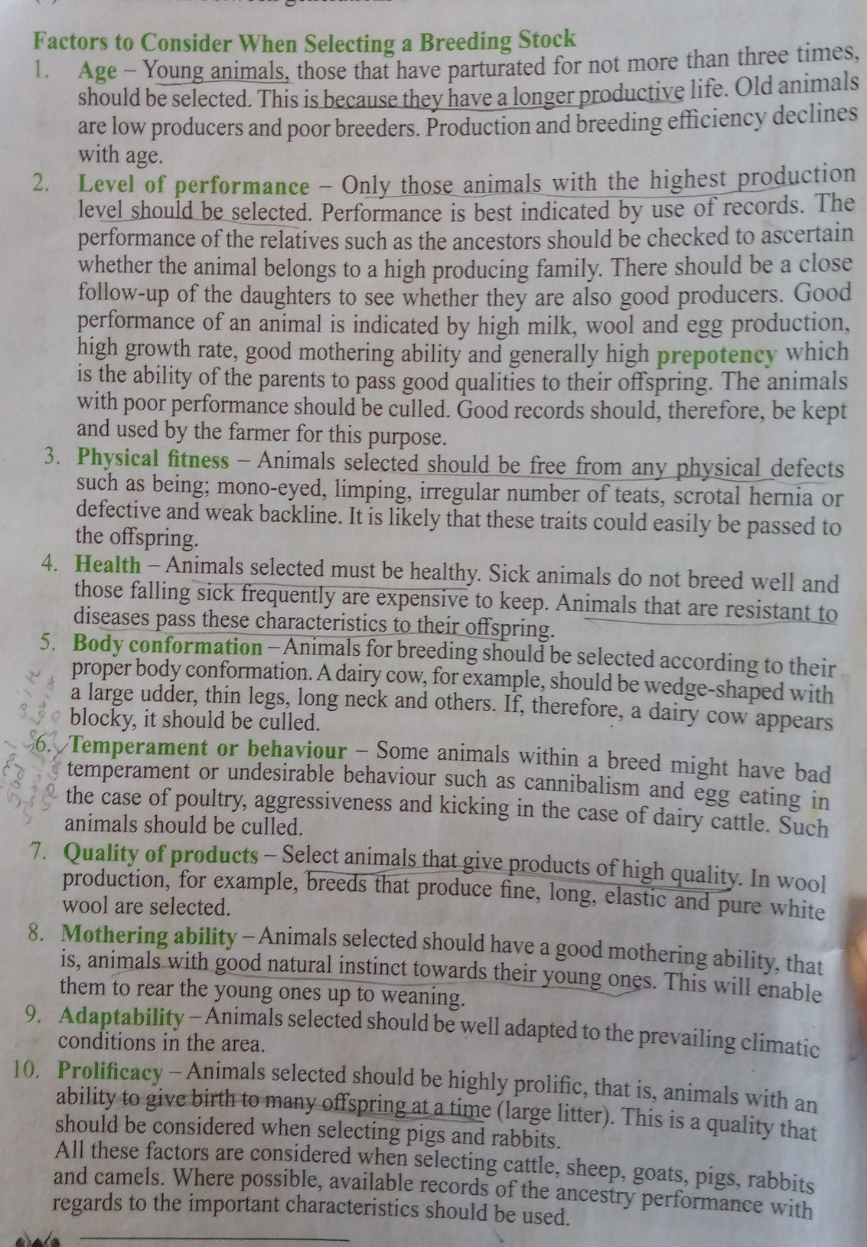
(Klb page 8)

- Discuss the process of egg formation in poultry (20 marks)

