Name:……………………………………………………………..Class:…………….Adm No:…….
FORM 1 – 2022
END OF TERM TWO
AGRICULTURE EXAM

INSTRUCTIONS.
Answer all the questions in the spaces provided.

- Give four reasons for ridging in potato production. (2mks)

- List four activities carried out in secondary cultivation. (2mks)

- Name two methods of water collection in the farm. (1mk)

- State any six art activities in agriculture. (3mks)

- List four advantages of mixed farming. (4mks)

- List four characteristics of a crop grown for green manure. (4mks)

- What is organic farming? (1mk)

- State four characteristics of large scale farming system. (4mks)

- Mention the importance of agriculture in Kenya’s economy. (4mks)

- State four human factors that affect agriculture. (4mks)

- State four methods of drainage. (2mks)

- State two reasons why nomads move with their livestock from place to place. (1mk)

- State four problems associated with shifting cultivation. (2mks)

- State four characteristics of clay soil. (2mks)

- What is agro forestry? (1mk)

- Why is it important to prepare land before planting? (4mks)

- Name four types of water pumps. (2mks)
- What is pollution? (1mk)

- State six characteristics of a fertile soil. (3mks)

- State six ways in which soil loses fertility. (3mks)

- Examine the farm tools drawn below and then answer the questions that follow.
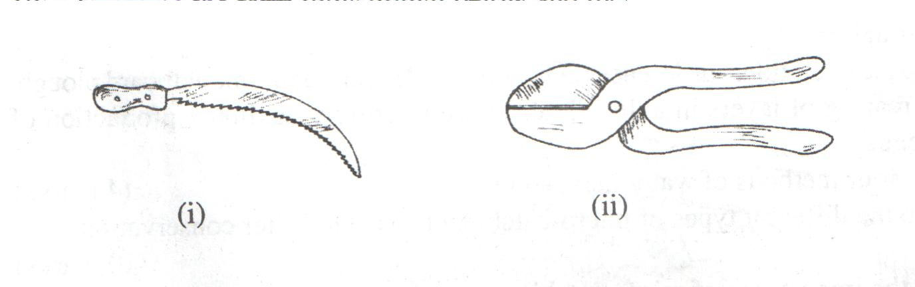
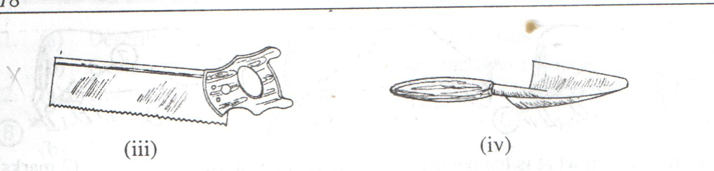

- Identify the tools. (2mks)

- State the uses of the tools (ii) and (iv). (2mks)

- State four maintenance practices carried out on tool. (2mks)

- Name four types if tools used in smoothing wood. (2mks)

- Differentiate between a drenching gun and a bolus gun. (2mks)

- State four reasons why it is important to maintain farm tools and equipment. (4mks)

- What is the functional difference between a cold chisel and a wood chisel? (2mks)

- The following is an illustration of a compost heap.
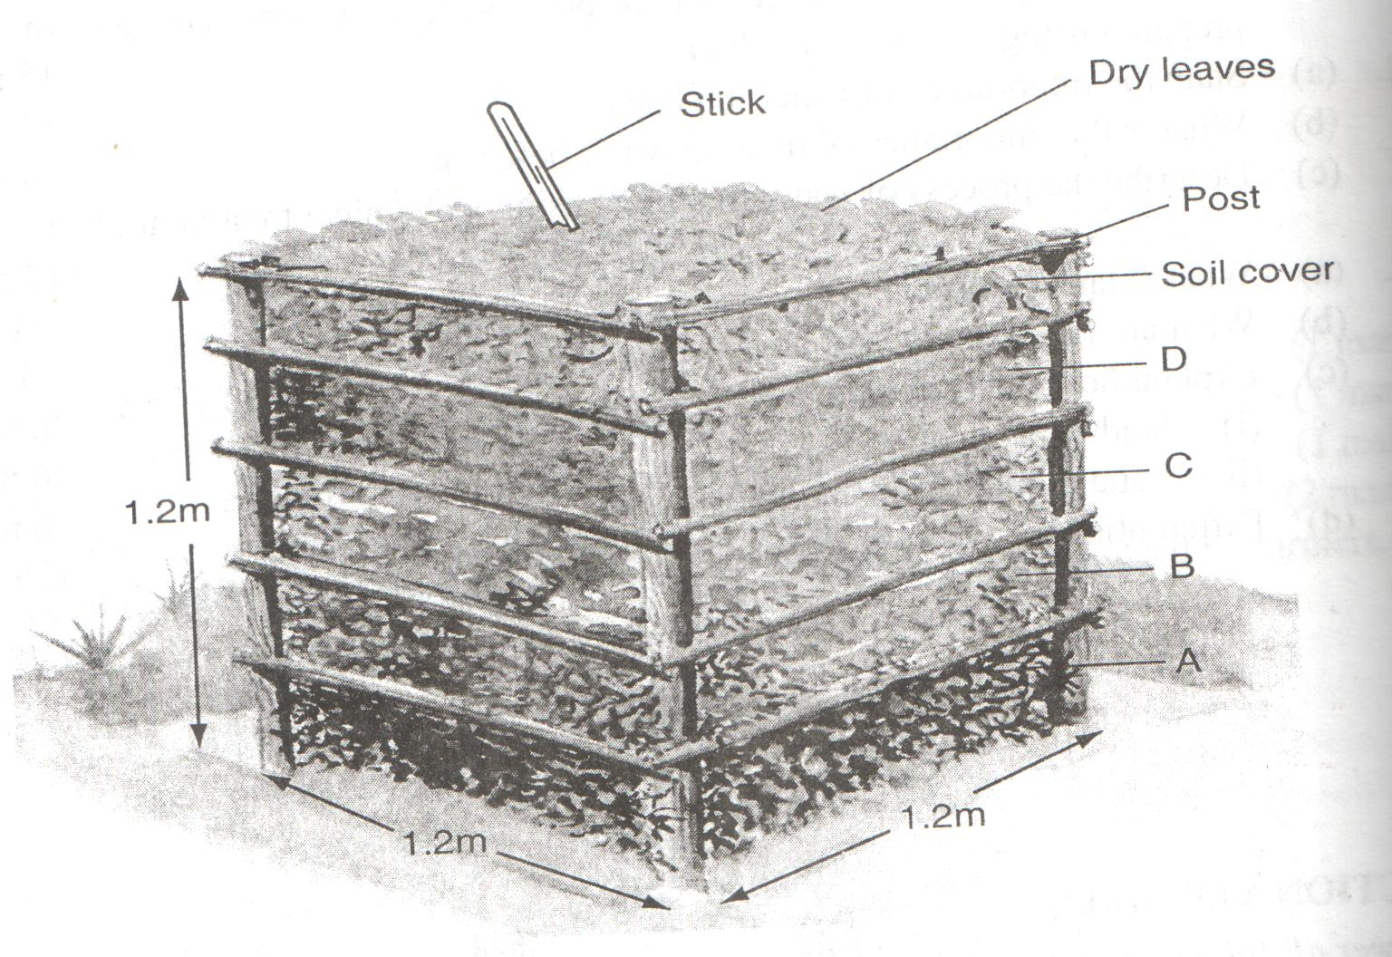

- Label parts A, B, C and D (2mks)

- What is the use of each of the part labeled? (1mk)

- Give two reasons why is compost manure not commonly used in the farms. (1mk)

