GLACIATION
1. (a) (i) What is an ice sheet? (2mks)
(ii) Give two reasons why there are no ice sheets in Kenya (2mks)
(iii) Explain three factors that influence the movement of the ice from the place where it has accumulated (6mks)
(b) Describe how an arête is formed (4mks)
(c) The diagram below shows types of moraines in a valley glacier

(i) Name the type of moraines marked S, T and V (3mks)
- Explain four positive effects of glaciation in lowland areas. (8mks)
2. a) (i) What is a glacier? (2mks)
(ii) Distinguish between valley glaciers and ice sheets (4mks)
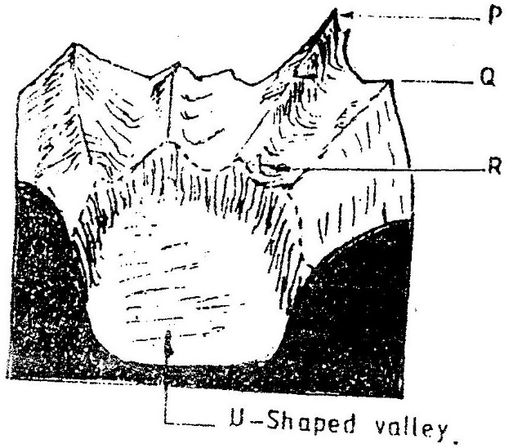
3. The diagram below shows a glaciated upland area

(a) Name the feature marked P, Q, and R (2mks)
(b) How is a U- shaped valley formed? (5mks)
4. a) Describe how pyramidal peak is formed. (6mks)
b) Explain the significance of upland glaciated features to human activities.
(6mks)
c) Students from a school near Mt. Kenya were planning to carry out a field study on the glaciated features on the top of the mountain.
(i) Give the reason why it would be difficult to undertake the field study on the glaciated features on the mountain. (4mks)
(ii) Describe how students would use a photograph of Mt. Kenya to identify the glaciated features on the mountains. (3mks)
5. Differentiate between snout and snow niche. (4mks)
6. Name three glaciers on Mt. Kenya. (3mks)
7. Describe the formation of a glacial trough. (3mks)
8. What is ice cap? (2mks)
9. Name three resulting features of glacial erosion on Mt. Kenya (3mks)
10. What is a nivation hollow? (2mks)

