UNDERGROUND WATER
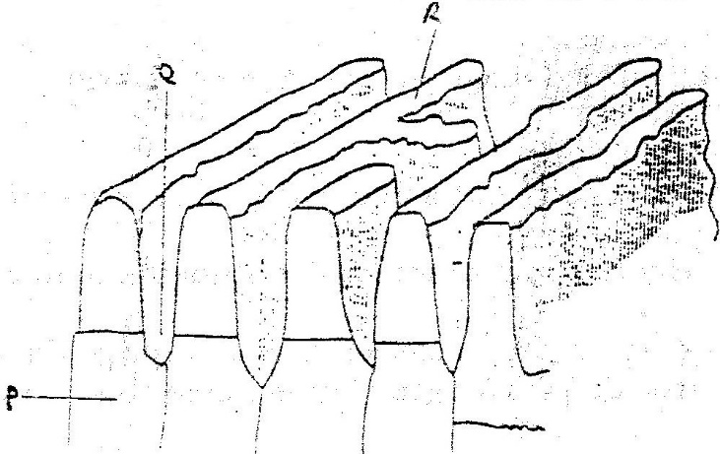
1. The diagram below show some features of a Karst scenery. Use it to answer questions (a)

a) Name the features marked P, Q, and R. (5mks)
b) Describe carbonation as a process of Chemical weathering (3mks)

2. State three conditions necessary for the development of Karst scenery, (3mks)
3. Give two reasons why there are few settlements in a Karst landscape. (4mks)
4. Explain factors influencing formation of springs. (8mks)
5. Distinguish between the following.
(i) Effluent streams and influent streams. (4mks)
(ii) Artesian basins and artesan well. (4mks)
6. Name three surface features of Karst landscape. (3mks)
7. What are stalactites? (2mks)
8. Explain the significance of limestone regions. (8mks)

