TRANSPORT AND COMMUNICATION.
1. State the causes of the decline in the use of letter writing as a means of communication in Kenya. 5 mks
2. (a) Give three advantages of railway over road transport. 3 mks
(b) The map below shows the extent of the oil pipeline in Kenya. Use it to answer question (b).
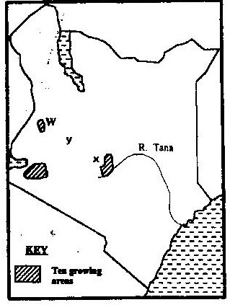

Name the towns marked X and Y which are served by the pipeline. 2 mks
(c) State two disadvantages of using pipelines as means of transporting oil.
(d) Use the map drawn below of St. Lawrence sea way to answer the questions that follow.

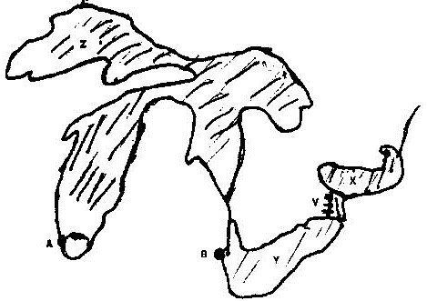

(i) Name the towns A and B
(ii) Name lakes X, Y, Z
(iii) Name canal marked V 3.
3. Use the sketch map of Lake Victoria below to answer question (a).
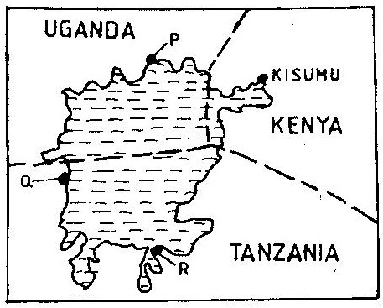

(a) Name the lake ports marked P, Q, and R 3 mks
(b) Outline two advantages of using containers while handling goods at the port of Kisumu. 2 mks
4. (a) Give three reasons why road transport is used more than air transport in
East Africa. 3 mks
(b) In what three ways does Kenya benefit from air links with the rest of the world? 3 mks
5. Use the map of East Africa below to answer question (a).
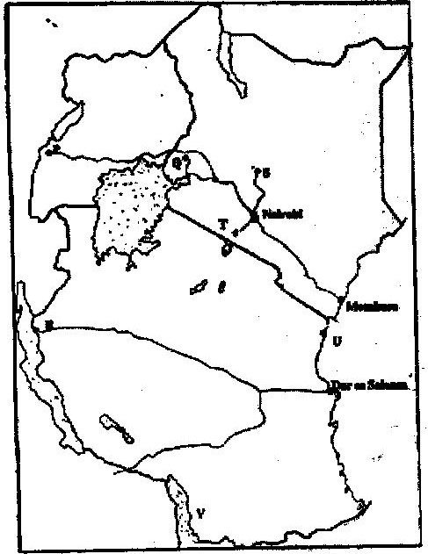

(a) Name the railway terminuses marked P, Q and R. 3 mks
(b) Give the main commodities transported by the railway lines marked S and T. 2 mks
(c) Name the port marked U and the lake marked V. 2 mks
(d) State four reasons why road network is more widespread than railway network in East Africa. 4 mks
(e) One of the problems facing road transport is the high frequency of accidents. Explain four conditions of roads in Kenya that may lead to accident. 8 rnks
6. Give four benefits of the efforts the government is data in streamlining pubic transport sector. 4 mks
7. Outline two major problems affecting the development of trans- African highway in Africa. 2 mks
8. State two major problems hindering river transport in Kenya. 2 mks
9. Suggest three benefits of the proposed Southern bypasses to be constructed in Kenya. 3 mks
10. (a) Define containerization.
(b) Outline three merits of using containerization as a method of transportation. 3mks
11. (a) State three problems facing railway transport in Kenya. 3 mks
(b) Identify importance of railway transport in a country. 4 mks
12. Differentiate between 'transport' and communication. 4 mks
13. Apart from cell phones, mention other two modern methods of communication.
2 mks
14. State advantages of using cell phones communication. 3 mks
15. State reasons why St. Lawrence sea way was set up by the government of USA.
4 mks
16. (a) Define:
(i) Transport
(ii) Communication 4 mks
(b) Apart from water transport, list the other modes of transport. 2 mks
(c) Name the two types of waterways used in transportation. 2 mks
17. (a) Give three reasons why river transportation in Africa is poorly developed.
3 mks
(b) Name the major ocean routes of the world. 3 mks
(c) State the advantages of water transport. 6 mks
18. (a) Account for the poor rail linkages j, between the African countries. 2 mks
(b) Name three trans-continental rail lines in Africa. 3 mks
(c) What are the advantages and disadvantages of transporting goods by rail?
6 mks
19. (a) Why is railway transport less used in Africa? 4 mks
(b) Name two railway systems in Africa. 2 mks
(c) Discuss the advantages and disadvantages of railway transport. 4 mks
20. State the advantages of road transport. 4 mks
21. (a) What is containerization? 2 mks
(b) Discuss advantages and disadvantages of containerization. 6 mks
(c) State advantages and disadvantages of air transport. 6 mks
22. Identify the main types of communication. 4 mks
23. (a) Name two trans-African highways 2 mks
(b) What are the benefits of trans-African highways? 2 mks
(c) Explain the problems facing the trans-African highways. 4 mks
24. Discuss the role of transport and communication in economic development of Africa. 4 mks
25. (a) State the problems facing transport and communication in Africa. 4 mks
(b) Outline the efforts being made to solve these problems. 4 mks
26. (a) (i) Identify the obstacles that face navigation along the St Lawrence
seaways. 3 mks
(ii) State ways in which navigation on the seaway was improved. 4 mks
(b) Explain the benefits of the St. Lawrence seaway on the economies of the United States of America and Canada. 6 mks

