MINING
1. The table below shows petroleum production in thousand barrels per day for countries in the Middle East in April 2006. Use it to answer question (a)

Country | Production in ‘000” barrels
Iran  Kuwait  Qatar  Saudi Arabia  United Arab Emirates  Iraq | 3800  2550  800  9600  2500  1900

a) (i) What is the difference in production between the highest and the
lowest producer (1mk)
(ii) What is the total amount of petroleum produced in April 2006 in
the region? (1mk)
b) State three conditions that are necessary for the formation of petroleum (3mks)
2. Use the map of East Africa below to answer questions (s).

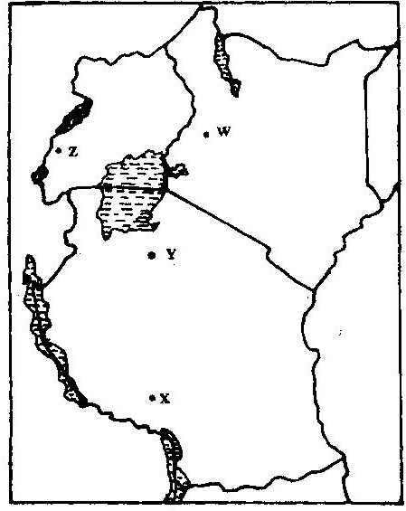

a) (i) Name the railway terminuses marked P, Q R (3mks)
(ii) In each case give the main commodity transported by the railway
lines marked s and T. (2mks)
b) (i) State four reasons why road network is more widespread than railways in East Africa. (4mks)
(ii) One of the problems facing road transport is the high frequency of accidents. Explain four conditions of roads in Kenya that may lead to accidents. (8mks)
c) i) Name three physical regions through which River Tana passes
(3mks)
ii) Explain thee effects of land pollution can be controlled
d) State four ways through which land pollution can be controlled (4mks)
3. The diagram below show the occurrence of petroleum in the earth’s crust.
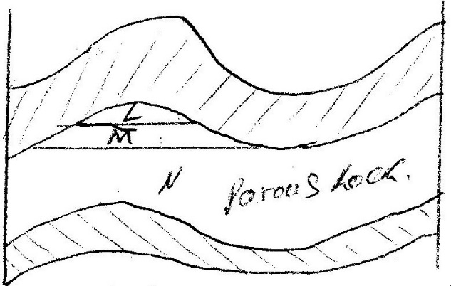
Use it to answer questions (a)

a) Name the substances in the areas labeled L. M and N (3mks)
b) Give two by-products obtained when crude oil is refined (2mks)
4. Use the map of Africa to answer question (a) (i)
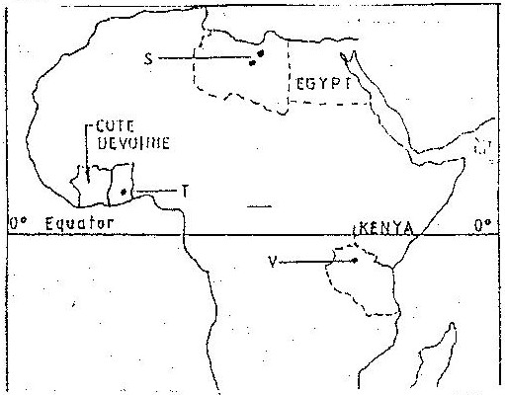

i) Name the minerals mined in the areas marked S, T and V.
ii) State two formation in which mineral ores occur.
b) Explain four problems, which Zambia experiences in the exportation
of copper.
c) Explain three ways in which coal contributes to the economy of
Zimbabwe.
d) Describe three negative effects of open cast mining on the environment.
5. a) Explain how deep shaft mining is done (2mks)
b) Disadvantages of using the above method (2mks)
6. Explain four effects of land dereliction on the environment. (4mks)
7. Describe how panning mining is carried out. (3mks)
8. Identify four problems facing gold mining in South Africa. (4mks)
9. (a) In what ways has Kenya benefited from the mining of soda ash in Lake
Magadi? (2mks)
(b) What are the negative effects of mining on the environment? (4mks)
10. (a) Explain what is meant by placer mining. (2mks)
(b) Name three mining methods.
11. Describe the occurrence and exploitation of Trona in Kenya till it is ready for
marketing.
12. Name seven significances of minerals in Kenya. (7mks)
13. Explain diamond and gold in South Africa under following headings:
- Occurrence
- Extraction
- Benefits to the economy
- Problems (10mks)14. Name five uses of soda ash.

