SETTLEMENT.
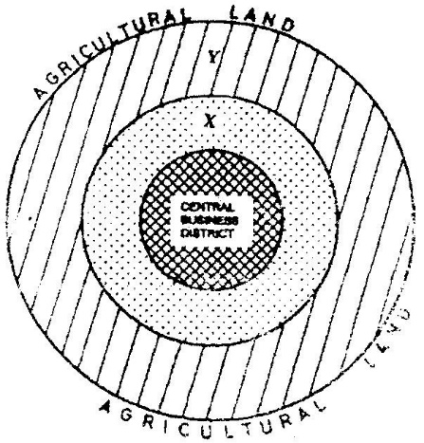
1. The diagram below represents the functional zones of urban centre. Use it to answer question (a)

(a) (i) Name the zones marked X and Y. 2 mks
(ii) List three functions of the Central Business District. 3 mks
2. (a) Name two types of human settlements. 2 mks
Use the sketch below to answer question (b)
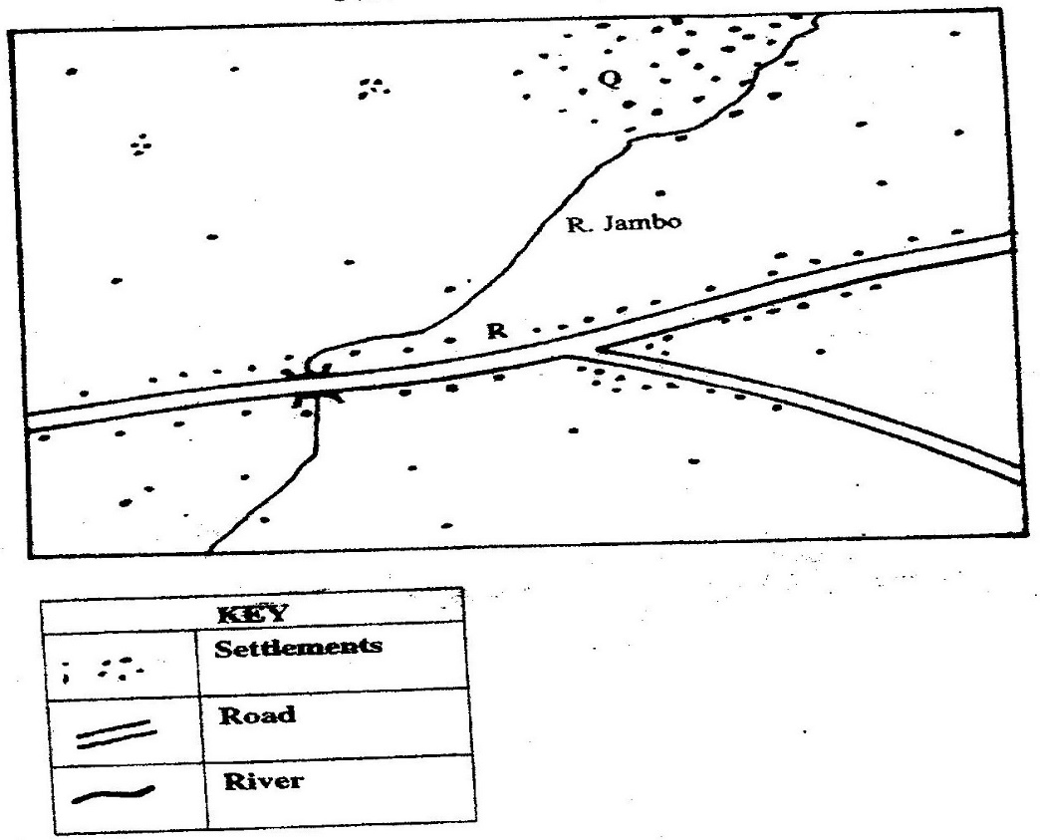

(b) Settlement patterns marked Q A R. 2 mks
3. (a) Name two types of rural settlement patterns. 2 mks
(b) Apart from urban-rural migration, name two other types of migration.
2 mks
(c) State three factors that may lead to urban-rural migration. 3 mks
4. State three factors which led to the development of Mombasa into a major sea port in the region. 3 mks
5. (a) What is urbanization? 2 mks
(b) Give two differences in the functions of New York and Nairobi cities.
4 mks
6. Apart from pollution, explain four problems experienced in urban centres. 8 mks
7. Explain similarities and differences between Nairobi and New York cities. 8 mks
8. State two main functions of rural settlements. 2 mks
9. Explain four problems that are experienced in Nairobi as one of the major urban centres in Kenya. 4 mks
10. List three factors that have led to rapid growth of Mombasa town. 3 mks
11. State ways through which the Kenyan government is using to solve problems of Nairobi city. 5 mks
12. (a) Differentiate between the terms settlement and urbanization. 4 mks
(b) Identify factors influencing settlement. 4 mks
(c) State the factors influencing patterns of settlement. 5 mks
13. (a) By use of relevant examples, explain the distribution of urban centres in
East Africa. 5 mks
(b) Explain 4 human factors which may lead to development of towns.
14. (a) Explain factors leading to the growth of Kisumu as a Lake Port. 8 mks
(b) What are the functions of Thika town? 5 mks
15. Explain the problems facing New York City. 6 mks
16. (a) Outline the main differences between the cities of New York and Nairobi.
4 mks
(b) Compare the port of Mombasa to the port of Rotterdam. 8 mks
17. Discuss the effects of urbanization. 4 mks

