CLIMATE.
1. (a) (i) What is climate? (2mks)
(ii) Explain two effects of climate change on the physical environment
2. The table below represents rainfall and temperature figures for a town in Africa. Use it to answer the questions that follow

Month | J | F | M | A | M | J | J | A | S | O | N | D
Temp (⁰C) | 27 | 28 | 28 | 28 | 27 | 25 | 25 | 24 | 25 | 26 | 27 | 26
Rainfall (mm) | 25 | 38 | 99 | 140 | 277 | 439 | 277 | 69 | 142 | 201 | 71 | 25
(a) Calculate the annual range of temperature for the town (2mk)
(b) Calculate the total annual rainfall for the town. (2mks)
(c) State two characteristics of the climate experienced in the town. (2mks)
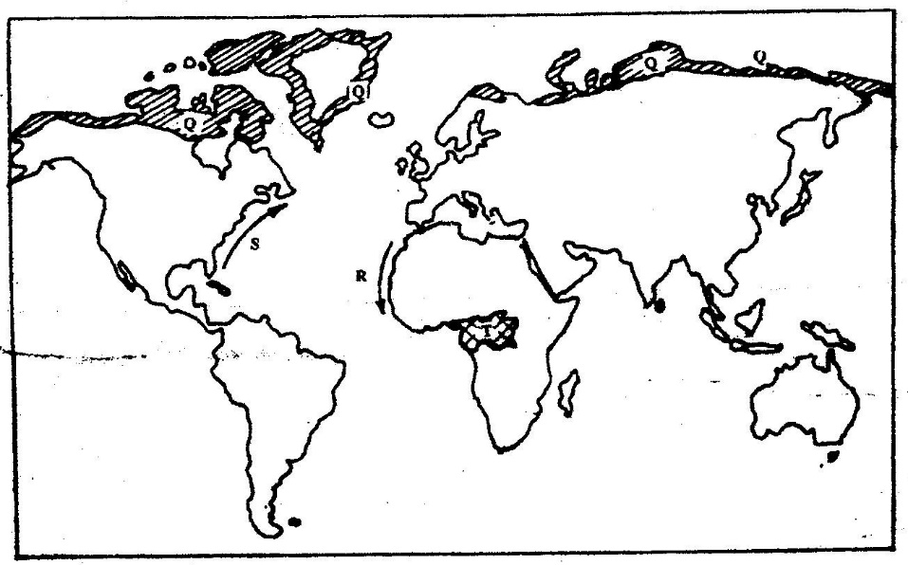
3. Use the map below to answer questions (a) and (b)

(a) Name:
(i) The type of climate found in the shaded area marked Q (1mk)
(ii) The ocean current marked R and S (2mks)
(b) Describe the characteristics of the type of climate found in the shaded area marked T (8mks)
(c) Explain how the following factors influence climate
(i) Altitude (4mks)
(ii) Distance from the sea (4mks)
(d) (i) Describe a suitable site where you would locate a weather station
in your School (2mks)
(ii) Give reasons why a Stevenson’s screen is:
- Painted White (2mks)
- Has louvers (2mks)
4. Describe the characteristics of natural vegetation associated with equatorial
climate (4mks)
5. Give five characteristics of hot desert climate (5mks)
6. How does the following factors influence climate?
(i) Wind/air masses.
(ii) Latitude.
7. Explain characteristics of climatic conditions experienced in the Kenyan highlands. (8mks)
8. Explain four ways in which mountains influence climate. (8mks)
9. What is greenhouse effect? (2mks)
10. How do human activities influence climate change? (6mks)
11. How does clearance of vegetation cause climate change? (3mks)
12. Define climate. (2mks)
13. What is isothermal layer? (2mks)

