ACTION OF WIND AND WATER IN ARID AREAS.
1. The diagram below represents a barchan. Use it to answer questions (a)
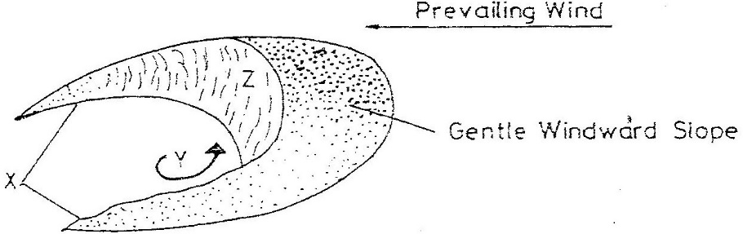

(a) Name
(i) The feature marked X (1mk)
(ii) The air current marked Y (1mk)
(iii) The slope marked Z (1mk)
(b) Give two ways in which wind transports its load (2mks)
2. a) (i) Two process through which wind erodes the surface
(ii) Three ways through which wind transports its load
b) (i) How an oasis is forced
(ii) How zeugens are formed
c) You are supposed to carry out a field study of a semi-arid area in Kenya.
(i) Two ways of preparing for the Field study
(ii) Information that would be collected through observation of the arid area
(iii) Measures to be recommended for controlling desertification.
3. Explain the process of abrasion. (2mks)
4. Name four features of wind erosion. (4mks)
5. Describe formation of zeugens, (4mks)
6. List features of wind deposition. (4mks)
7. Describe formation of wadis. (5mks)
8. Differentiate between suspension and saltation. (4mks)
9. Name four types of desert surface (4mks)
10. Identify and describe the processes of wind erosion. (6mks)
11. (a) Explain how wind transports its load.
(b) State the factors influencing wind transportation. (3mks)
12. Explain the formation of the following features:
(a) Bajadas.
(b) Pediments. (6mks)
13. Students carried out field study on desert landforms.
(i) State two type of information they collected through observation.
(ii) Which measures would they have recommended to control desertification?

