PHOTOGRAPH WORK.
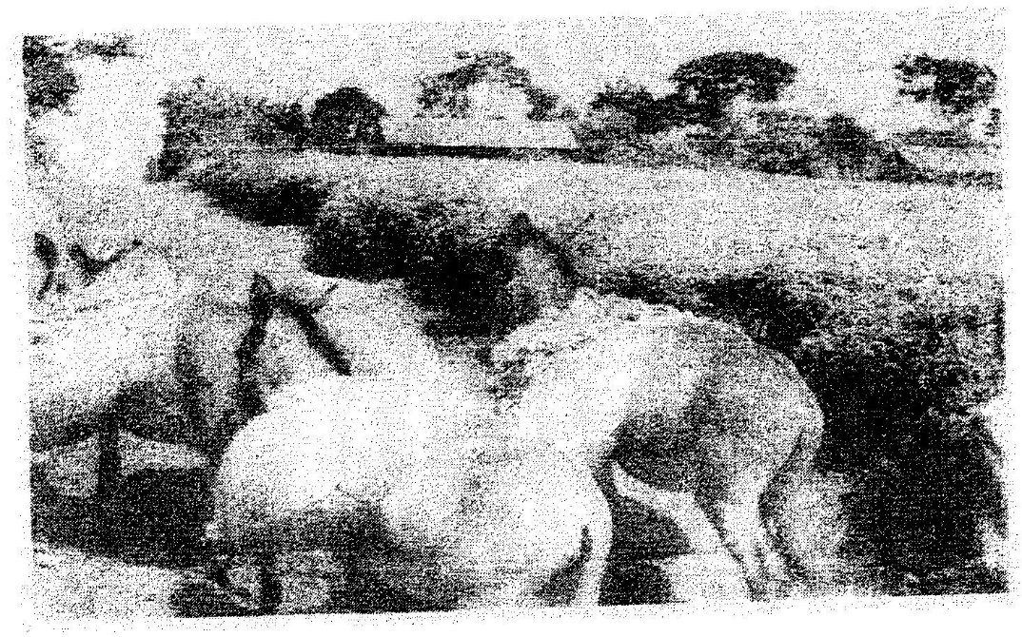
1. The photograph provided shows a tea growing area in Kenya. Use it to answer questions (a) and (b)

a) (i) What evidence in the photograph shows that this is a ground
general-view type of photograph? (2mks)
(ii) Draw a rectangle measuring 15cm by 10cm to represent the area of the photograph. On it sketch and label the main features shown on the photograph. (5mks)
(iii) Identify two features from the photograph that show that this is a small scale tea farm. (2mks)
b) Describe the stages involved in the cultivation of tea from land preparation to the stage shown on the photograph.
- (i) Name two districts in the Eastern province where tea is grown.
(2mks)
(ii) Explain four ways in which the Kenya Tea development agency (KTDA) assists small scale tea farmers in Kenya (8mks)
2. What is the type of photograph shown?
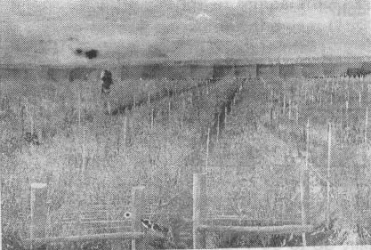

3. Name each of the following:
(i) Crop under cultivation (2mks)
(ii) Type of farming (2mks)
(iii) Other groups of crops in this type of farming. (2mks)
(iv) The province in Kenya where this photograph was taken. (2mks)
4. Name five problems facing this type of farming in Kenya. 5mks
5. Name two major export destinations (countries) for farm produce shown. (2mks)
6. Name three physical features at the background of the photograph. (3mks)
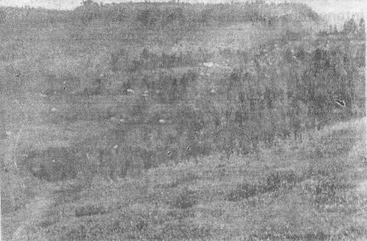
7. Draw a rectangle of 12cm by 7cm to represent the area covered by the photograph.

