PHOTOGRAPHIC WORK
1. The photograph below provided shows a tea growing are in Kenya use it to
answer question (a) and b)
i) What is the evidence in the photograph that this is a ground general photograph.
- It focuses on all/ many objects.
- It does not focus on particular object.
- The objects become progressively smaller towards the background.
- Photograph captures the general appearance of the area.
ii) Draw a rectangle measuring 15cm by 10 cm to represent the area of the photograph on the sketch and label the main features shown on the photograph.
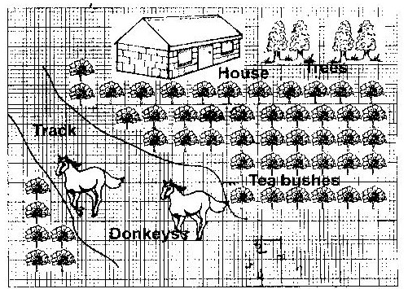

iii) The stages involved in cultivation of tea from land preparation to the stage shown in the photograph.
- The land is cleared of vegetation
- The land is ploughed /tilled.
- Seedlings are planted in nursery and allowed to grow to 20 cm.
- Seedlings are planted in rows which are about 1.5 metres apart.
- The plants are weeded and manure / mulching applied regularly.
- Once the bushes start growing. The tips of branches are oruried regularly to encourage plant to form more branches.
- The crop is harvested every two weeks once it attains maturity.
- After harvesting, the green tea leaves are transported to the factory within 24hrs.
iv) Identify two features from the photograph that shows that this is a small scale tea farm.
- The simple houses
- Mode of transport by use of donkeys
- Untrimmed edges of tea bushes
- Dry maize stalks near the houses.
2. Ground general photograph.
3.
- Flowers
- Horticulture/horticultural farming
- Fruits/vegetations
- Rift valley province
- Fruits/Vegetables

4.
- Inaccessible feeder roads
- Inadequate refrigeration facilities
- Improper marketing system
5.
- Netherlands/Switzerland
- Germany
- Britain
- France
6.
- Escarpment
- Hills/mountains
- Valleys
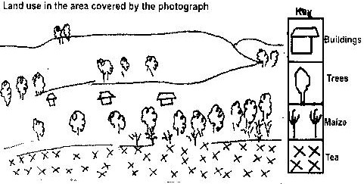
7.

