OCEANS, SEAS AND THEIR COASTS.
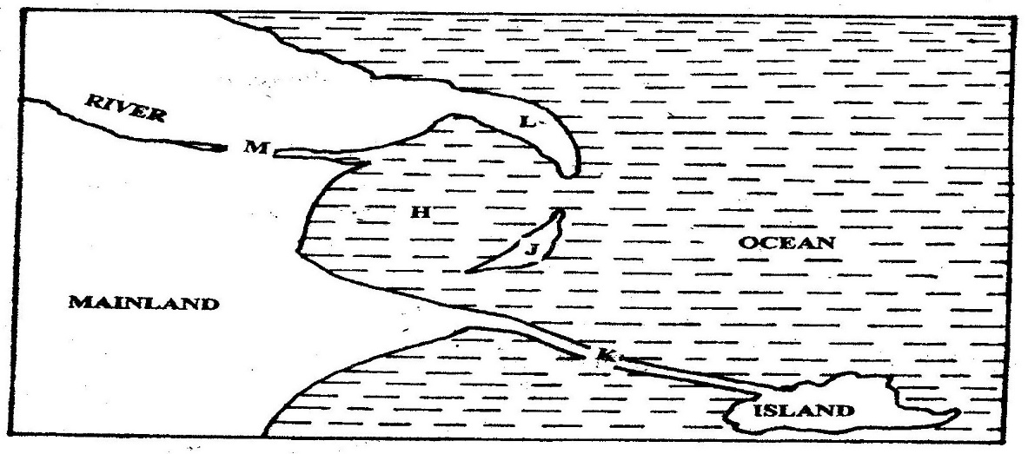
1. Use the diagram below to answer question (a)

(a) Name the coastal features marked H, J, K, L and M (5mks)
(b) (i) State four conditions necessary for the formation of a beach (4mks)
(ii) Describe three processes involved in marine erosion (6mks)

(c) You are planning to carry out a field study on the depositional features along the coast of Kenya
(i) State five objectives you would formulate for your study (5mks)
(ii) Give five methods you would use to record the information
collected (5mks)
2. (a) Name two types of submerged coasts. (2mks)
(b) Explain now the following factors determine effectiveness of wave
erosion along the coast.
(i) Nature of the material transported by waves
(ij) Nature of the coastal rocks. (4mks
3. State two causes of submerged coasts. (2mks)
4. Name two features that result from submergence of coasts. (2mks)
5. Define term coastline (2mks)
6. What are destructive waves? (2mks)
7. Name three resultant features of wave erosion. (3mks)
8 Describe formation of cliff. (5mks)
9. Describe formation of a wave-cut platform. (5mks)
10. Name three types of coast. (3rnks)
11. (a) Describe formation of coral coast. (5mks)
(b) Explain the significance of coral coast to Kenya.
12. Distinguish between shingle beaches and sand beaches. (6mks)
13. Name three types of submerged coasts. (3mks)
14. Name two types of movements of ocean water. (2mks)
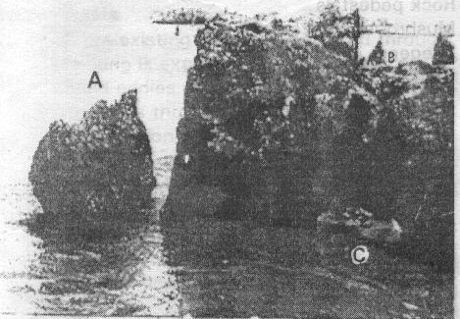
15.

(a) Name features marked A, B, and C.
(b) Describe the formation of feature marked C.

