MAPS AND MAP WORK
1. (a) (i) 14km (1 3.9-14.1 km)
(ii) 134° (133°-135°)
(b) • Availability of transport evidenced by railway\road to transport
sisal.
• Large tracts of land with scanty settlements allow expansion of far due to availability of land.
• The area receives low rainfall as evidenced by presence of scrub which discourages growing of other cash crops.
• Gentle sloping land evidenced by spaced contours ideal for mechanization.
• Supply of labour evidenced by nucleated settlement around Mwatunge.
(c) (i)
• Escarpments/steep slopes have few or no settlements.
• There are no settlements in the forested areas.
• Most settlements are found near\along roads\motorable tracks.
• South East area is sparsely settled.
• There are many settlements around shops.
• There are few settlements along rivers.
• Sisal estate has no settlements.
(ii) Citing evidence from the map, give two economic activities carried out in the area covered by the map other than sisal farming.
ACTIVITY EVIDENCE
Cattle keeping Cattle dips/scrub
Trading Shops
Transport Railway\road
Crop growing Sisal plantation
2. a) Ans; 114031
b) (i) Ans; 317° (316°- 318°)
(ii)
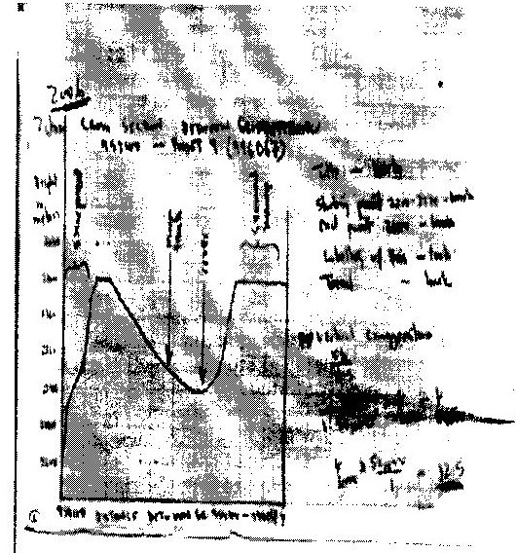

(iii)
c) • Rivers
• River valleys
• Scarp slope\escarpment\scarp face
• Gentle slope
• Seasonal swamp
• Woodland
d) i) Two types of physical factors that influenced the location of
Nyahururu town.
• Availability of water from the nearby rivers for domestic and industrial uses.
• The high altitude (over 2,300m) which makes the area experience cool climate ideal for settlement.
• Gentle sloping terrain ideal for settlement\road construction shown by contours wide apart.
• Presence of Thomson Falls which are a tourists' attraction and encourage settlement by construction of tourist houses.
• Availability of building stones from nearby quarry for construction of houses.
e) Describe drainage of the area covered by the map.
• The area has many rivers\ high density of rivers.
• The water courses are generally permanent.
• Some rivers end in swamps.
• There is a pond 020130.
• Main rivers includes Iguameti, Nyahururu.
• There are rapids at Thompsons falls.
• There is parallel drainage pattern along the escarpment.
• There are papyrus swamps and seasonal swamps.
• Rivers have denclintic drainage pattern.
3. a) 873m
b) Ans- 15 km ± 0.2 KM. (1 5km-1 5.2km)
c) Ans. -0 30"
d) Citing evidence from the map describe the relief of the area shown.
• Land rises from about 600m to about 2,200m above sea level.
• The highest point is Vuria peak at 2208 m \lowest point is about 600m.
• The landscape is generally hilly\numerous hills\mountains\ many ridges eg. Mugange hills ridges\Muraru ridge\ many spurs.
• There is a highland mass in the Mugange Wundanyi area which slopes downwards in all directions. ^{J}
• There is river valley of river Voi which has pronounced meanders.
• Some areas are plain e.g. Lower valley Kisushi.
• South-Eastern part is gently sloping.
• Central, Western and Northern side has steep slopes.
e) State differences between a map and a plan.
• The scale of a plan is large while the scale of map may be large or small.
• Plan is drawn to show specific information while map shows general information.
• Plan shows many details of specific feature while map shows few details of many features.
f) Explain two importance of scale in maps.
- Express relationships between objects on map and in real life enabling one to estimate or measure size.
- Control arrangement of symbols avoiding overcrowding.
- Controls space as large scale gives more details than the small scale maps.
4. (a) (i) 139° ± 1° (138 - 140°)
(ii) 7.2 km ± 0.1 (7.1 - 7.3 km)
(b) (i) Relief of the area covered by the map.
- The highest area is Nandi escarpment/187m above sea level.
- The lowest area is to the south West which is about 1140 m above sea level.
- The east is a plain\Kanu plain/plateau
- North western part is hilly with some steep slopes
- To the North Eastern is the Nandi escarpment
- The northern part is dissected by rivers
- The South-west is a basin occupied by a lake.
- There are numerous river valleys with steep sides in the highlands and are broad in the lowlands.
(ii) Influence of relief on settlements.
- The steep slopes/escarpment have been avoided because they are unsuitable for construction of houses/for farming.
- There are a few settlements on the hilly areas because the slopes are gentler.
- The plains are densely settled as the land is flat/gently sloping.
- The basin are avoided as the land is water logged/flooded/swampy.
(c) Economic activity Evidence
- Quarrying - Quarry
- Trading - Markets
- Transportation - Roads/railway/main tracks/foot paths
- Processing - Sisal factory
- Manufacturing - Ginnery/flour mills
(d) (i)
- The river has many meanders
- The river has tributaries/confluences
- The river disappears into a swamp
- The river has a wide flood plain
- The river is at its old age stage (ii) Advantages of studying rivers through field work.
- It enables students to relate what is learnt in classroom to what is in the field.
- Students are able to measure and calculate the velocity of a river and its size.
- Students are able to count the number of tributaries.
- Students are able to gauge the impact of the river on the area.
- They are to find out the uses of the river.
- It allows students to acquire appropriate attitude towards environment.
- It breaks classroom monotony for students and teachers.
- It allows students to use their observation skills to make conclusion.

