BUSINESS FORM 4 PAPER TWO MARKING SCHEME

- (a) Advantages of departmental stores
- Access to specialised goods/ service from the relevant / shops / particular type of goods. Personalised / attention to customers.
- Access to auxiliary / after sales services - which may easily be available within the shops.
- One can save time by shopping under one roof.
- Prices of goods are relatively low = making consumers save/ buy more .
- One can access a variety of goods under one roof.
- Use of credit i debit cards - relieving customer the need of carrying cash.
- Access new products which a customer may not have been aware of.

b) Explain five roles played by licensing as a government regulatory tool. (10mks)
- Licensing provides the government with a platform to monitor the type of goods moving in and outside the country.
- Through licensing the government can get the total number of businesses operating in the country
- Licensing is used by the government a tool to prevent illegal business activities.
- Licensing ensures that professional standard as stipulated by the government are adhered to against which a license can be withdrawn for a business which does not stick to the standards.
- Ensures that business people do not provide harmful goods and services to the citizens.
- Ensures that there is a healthy competition between people involved in the same business activities.

- (a) Explain five services that the central bank of Kenya offers to commercial banks.

- Accepts deposits for safe-keeping i.e. banker to commercial banks.
- Licenses the operation of commercial bank Supervises the banking operations.
- Provide clearing house for interbank transaction.
- Ask as a mediator / arbitrator for commercial bank in case of any disputes.
- Lends money to commercial banks.
- Provide advisory services on banking on economic matters to commercial banks.
- Provide them with currency
- Replaces old notes and coins with new ones.
- It repatriates excess foreign currency.

(b)

Dr | Capital a/c |  |  |  |  | Cr
Bai c/d |  | 24.000Bank |  |  |  | 24,000
 | 24,000 |  |  |  |  | 24,000
Dr |  |  | Bank a/c |  |  | Cr
Capital |  | 24,000Purchases |  |  |  | 18,000
 |  |  |  | Bal c/d |  | 6,000
 | 24,000 |  |  |  |  | 24,000
Dr |  |  | Cash a/c |  |  | Cr
Sales |  | 18,900Rent |  |  |  | /150
Sales |  | 5,625Commission |  |  |  | ^900
 |  |  |  | Bal c/d |  | 23,475
 | 24,525 |  |  |  |  | 24,525
Dr |  |  | Sales a/c |  |  | Cr
Bal c/d |  | 24,525Cash |  |  |  | 18,900
 |  |  |  | Cash |  | 5,625
 | 24,525 |  |  |  |  | 24,525
Dr |  | Purchases a/c |  |  |  | Cr
Bank |  | 18,000Bal c/d |  |  |  | 18,000
 | 18,000 |  |  |  |  | 18,000

 | Dr | Commission a/c |  |  | Cr
 | Cash | 900 |  | Bai c/d | 900
 |  | 900 |  |  | 900
 | Dr | Commission a/c |  |  | Cr
 | Bank | 150 |  | Bal c/d | 150
 |  | 150 |  |  | 150

- a) Describe five channels followed in exporting agricultural product. (10mks)
- Farmer marketing board -> foreign consumers
- Farmer —agent - foreign wholesaler - foreign retailer -foreign consumer
- Farmer foreign wholesaler foreign retailer foreign consumer
- Farmer -foreign retailer -foreign consumer
- Farmer -foreign fanner‘s representative - foreign wholesaler -foreign retailer - foreign consumer
- Farmer - foreign consumer

b) |  |  |  |  | Milka Traders
 |  |  |  | Trading, Profit & Loss A/c
 |  | For the year ended 31 December 2020
 | Shs |  | Shs |  |  |  |  | Shs | cts
Opening stock |  |  | 25,000 |  | Sales |  |  | 600,000
Add purchase | 360,000 |  |  |  |  |  |  | 40,000 | 560,000
+ C inwards | 2,000
Less returns out | 20,000 |  | 342,000
Gas |  |  | 367,000
Less C. stock |  |  | 22,000
COS |  |  | 345,000
Gross profit c/d |  |  | 215,000
 |  |  | 560,000 |  |  |  |  |  | 560,000
General expenses |  |  | 88,000 |  | Gross profit b/d |  |  |  | 215,000
Carriage out |  |  | 3,000 |  | Add disc. Received |  |  |  | 5,000
Rent |  |  | 1,000
Bad debts |  |  | 80,000
Net profit c/d |  |  | 48,000
 |  |  | 220,000 |  |  |  |  |  | 220,000
 |  |  |  |  | Net profit |  |  |  | 48,000

- (a) Reasons why a country imposes taxes on citizens
- Raise government revenue - to cater for various government expenditure
- Reduce income disparity - by facilitating fair distribution of incomes and resources by taxing rich more
- Discourage consumption - of harmful products and engagement in illicit activities
- Control inflation - by reducing money supply through reduction of people‘s disposable income
- Correct unfavourable balance of payments- by taxing imported products more to discourage importation
- Influence business location e.g. high tax on urban centres make entrepreneurs to go to rural areas
- To subsidize various undertakings for the benefit of the society

b)
 |  | Cooperatives |  |  |  |  |  |  |  | Public limited cos
1 |  | Formed by a min of 10 |  |  |  |  |  | 1 |  | Min 7 members /shareholders
2 |  | Registered by commissioner of cooperatives |  |  |  |  |  | 2 |  | Registered by registrar of companies
3 |  | Managed by committee elected by members at |  |  |  |  |  | 3 |  | Managed by Board of directors
 |  |  | AGM
4 |  | Governed by cooperative by – laws |  |  |  |  |  | 4 |  | Governed by Articles of Association
5 |  | Formed with service motive (to serve members) |  |  |  |  |  | 5 |  | Formed for profit motive
6 |  | Members have acommon bond |  |  |  |  |  | 6 |  | Members have nothing in common
7 |  | Controlled by government through the ministry |  |  |  |  |  | 7 |  | There is no government control
 |  |  | of cooperative development.

- (a) Using a diagram illustrate the effects of a positive shift of a demand curve on the equilibrium point, price and quantity. (10 marks)

Price | ^{D}1
 | ^{D}o |  | S
 |  |  | o
Pe₁ |  | E₁
 | ^{E}o
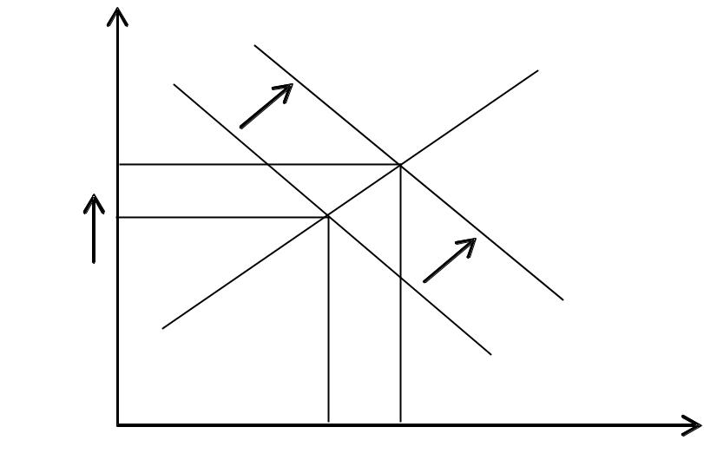  Pe_{o} |  |  | D₁
 | S_{o}
 |  |  | D_{o}
Qe₁

Quantity
b) Features of land as a factor of production
- Basic factor of production. Production cannot take place without land.
- Lack geographical mobility- land cannot be moved geographically from one location to another.
- Uneven in quality – the land quality differs from one place to place.
- Suffers from diminishing returns after some time the quality of land reduces.
- Quality can be improved – use of technology and fertilizers can improve the quality of land.

- (a) Benefits that Mmanyi Enterprise may derive from constructing their own warehouse.
- Bulk buying; they can buy stock in large scale because they have storage facilities
- They can be able to meet market demands since they stock the right quantities required by the customers.
- Seasonal goods can be stocked in order to satisfy customer‘s seasoned needs
- Variety of goods can be stocked to promote customer‘s satisfaction
- Security of goods is offered untiln they are demanded.
- Preparation of goods for sale such as branding, parking, sorting while in the warehouse is made easier.
- Suitable design- they can construct a warehouse suitable for their own needs
- Construction of one‘s warehouse is economical

(b) Importance of filing documents in an organization
- Easy retrieval of documents
- Keeps office very tidy
- Safety of documents
- Documents are kept neat
- Documents are kept away from unauthorised persons
- Space is well utilized
- Information for future reference is kept
- Filed documents are used as evidence in case of disputes

