SUNRISE ONE TERM 1 EXAMINATION 2023
Kenya Certificate of Secondary Education (K.C.S.E)
Name…………………………………………………………………Adm No….………… Class………

School ………………………………………………………………Candidates Signature………….
Date………………….
TERM 1 2023 Student Target
565 / 1
BUSINESS STUDIES PAPER ONE
Form 4
April 2023
Time: 2 Hours

INSTRUCTIONS TO CANDIDATES
- Answer all the questions in the spaces provided.

For Examiner’s Use Only (100 Marks)
Question No | 1 | 2 | 3 | 4 | 5 | 6 | 7 | 8 | 9 | 10 | 11 | 12 | 13
Marks

14 | 15 | 16 | 17 | 18 | 19 | 20 | 21 | 22 | 23 | 24 | 25

ACHIEVED

- Highlight four ways in which a well laid out business structure is likely to lead to the success of the business. (4mks)
………………………………………………………………………………………………………………………………………………………………………………………………………………………………………………………………………………………………………………………………………………………………………………………………………………………………………………………………
- List four characteristics of money . (4mks)
………………………………………………………………………………………………………………………………………………………………………………………………………………………………………………………………………………………………………………………………………………………………………………………………………………………………………………………………
- Give the following transactions, indicate the account to debit and the account to credit.
(4mks)
TTransaction | AA/c to Dr | AA/c to Cr
ii} Received damaged goods from a customer (Ukweli traders)
ii} Received an invoice from a wholesaler Upendo traders
iii} Issued a credit note to Pwani traders
iv} Received rent by cheque

- State four non- price competitions that firms in oligopoly market structures may engage in as an attempt to capture more customers and realize greater sales volume. (4mks) ………………………………………………………………………………………………………………………………………………………………………………………………………………………………………………………………………………………………………………………………………………………………………………………………………………………………………………………………

- List four errors which may make the trial balance fail to balance. (4mks) ………………………………………………………………………………………………………………………………………………………………………………………………………………………………………………………………………………………………………………………………………………………………………………………………………………………………………………………………
- The following information was extracted from the books of Juma stores on 31st march 2010
Sh
- Stock 1st april 2010 8000
- Stock 31st march 2011 9000
- Purchases 4500
- Sales 21000
Calculate
- Margin (2mks)

- Rate of stock turnover. (2mks)

- State four factors that are likely to lead to a young population in a country. (4mks) …………………………………………………………………………………………………………………………………………………………………………………………………………………………………………………………………………………………………………………………………………………………………………………………………………………………………………………………

- Record the following transaction in the relevant ledger account. (4mks)
- Kibet started business with sh.100, 000 in cash on 1st Jan 2008.
- Bought motor van for sh.27, 500 cash on 2nd Jan 2008.
- Fixtures bought on credit from shop flitters for sh.11, 500 on 3rd Jan 2008.
- Paid amount owing in cash to shop flitters on 7th Jan 2008.

- Watch the following types of advertising with its appropriate description in the table below.
Product advertising, informative advertising, institutional advertising, competitive advertising.
(4mks)
 | Description | Type
(a) | Treats awareness about a product.
(b) | Promotes the name of manufacturer.
(c) | Persuade the consumer to buy a product.
(d) | Promotes a particular brand of product.

- Calculate the net profit or loss made from the following details: (4mks)

Drawing during the year 20,000
Additional capital 120,000
Capital on 31.12.2010 300,000
Investment 80,000

- Give four reasons why the government levy taxes. (4mks)
………………………………………………………………………………………………………………………………………………………………………………………………………………………………………………………………………………………………………………………………………………
………………………………………………………………………………………………………………

- State four reasons why Railway transport is unpopular in Kenya when compared to road. (4mks) ………………………………………………………………………………………………………………………………………………………………………………………………………………………………………………………………………………………………………………………………………………………………………………………………………………………………………………………………
- For each of the following cases, name the motive for holding money. (4mks)
Case | Motive
a) To meet daily transport expenses.

b) To meet any unforeseen circumstances.

c) To take advantage of anticipated future in price.

d) To pay for daily food requirement.

- Enumerate four reasons why an insured may not be compensated despite an insured risk occurring. (4mks)
……………………………………………………………………………………………………………………………………………………………………………………………………………………………………………………………………………………………………………………………………………………………………………………………………………………………………………………………
- The following diagram shows demands and supply curve of commodity.
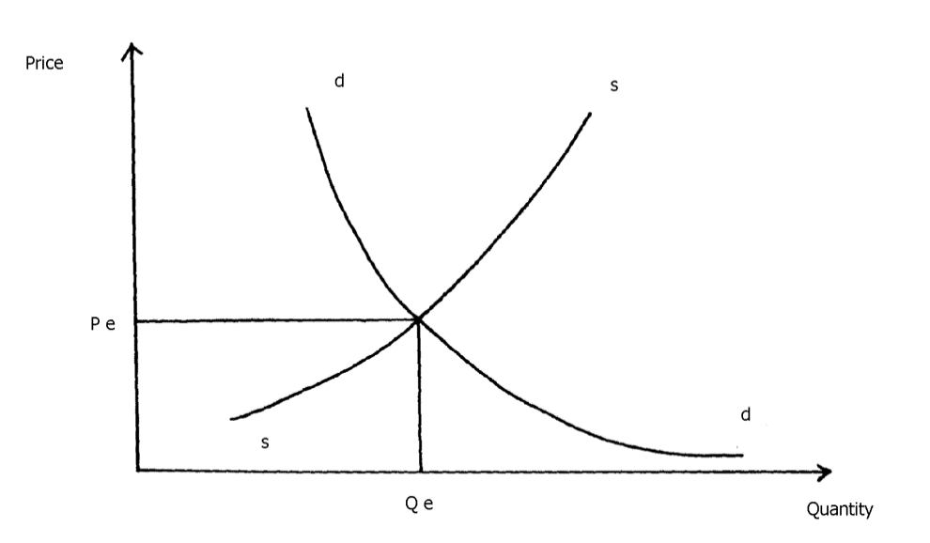
State four things that will happen if the supply of the commodity is increased while demand remains constant. (4mks)

………………………………………………………………………………………………………………………………………………………………………………………………………………………………………………………………………………………………………………………………………………………………………………………………………………………………………………………………
- Highlight four ways in which the utility / usefulness of a product can be increased. (4mks) ………………………………………………………………………………………………………………………………………………………………………………………………………………………………………………………………………………………………………………………………………………………………………………………………………………………………………………………………
- Mention four ways in which the Kenyan government is creating an enabling environment to attract investments. (4mks) ………………………………………………………………………………………………………………………………………………………………………………………………………………………………………………………………………………………………………………………………………………………………………………………………………………………………………………………………
- Give four differences between an ordinary share and a preference share. (4mks)
………………………………………………………………………………………………………………………………………………………………………………………………………………………………………………………………………………………………………………………………………………………………………………………………………………………………………………………………
- Trimer limited has opened a factory in a rural shopping Centre called Massawa. Outline four ways in which the people living in the surrounding areas may benefit from the factory. (4mks)
……………………………………………………………………………………………………………………………………………………………………………………………………………………………………………………………………………………………………………………………………………………………………………………………………………………………………………………………………………………

- For each of the following transaction of Kinyua traders, identify the source document and the journal in which the information is recorded. (4mks)
 | Transaction | Source document | Journal
(a) | He bought goods worth ksh.40,000 on credit from jitahidi
(b) | Kinyua returned some goods in jitahidi traders worth ksh. 2000
(c) | Peter a customer bought goods worth ksh.5,000 on credit
(d) | Peter returned goods worth Ksh. 1000 to Kinyua traders
- State four roles of intermediaries in the chain of distribution. (4mks) ………………………………………………………………………………………………………………………………………………………………………………………………………………………………………………………………………………………………………………………………………………………………………………………………………………………………………………………………
- Name four types of printed messages that may be sent through facsimile (4mks) …………………………………………………………………………………………………………….. ………………………………………………………………………………………………………………………………………………………………………………………………………………………………………………………………………………………………………………………………………………
- Highlight four benefits of national income statistics to a country (4mks) ………………………………………………………………………………………………………………………………………………………………………………………………………………………………………………………………………………………………………………………………………………………………………………………………………………………………………………………………
- Outline four ways in which natural resource may be of benefit to a country. (4mks)
………………………………………………………………………………………………………………………………………………………………………………………………………………………………………………………………………………………………………………………………………………………………………………………………………………………………………………………………
- Outline four difficulties faced by human being in satisfying their wants. (4mks)
…………………………………………………………………………………………………………………………………………………………………………………………………………………………………….…………………………………………………………………………………………………………………..…………………………………………………………………………………………………

